Received 00th January 20xx,
- Departamento de Química Orgánica I, Facultad de CC. Químicas, Universidad Complutense de Madrid, 28040 Madrid, Spain.
- Departamento de Tecnología Química y Ambiental, Universidad Rey Juan Carlos, 28933 Madrid, Spain.
- Departamento de Química Analítica y Análisis Instrumental, Facultad de Ciencias, Universidad Autónoma de Madrid, 28049 Madrid, Spain.
- Departamento de Nanoestructuras, Superficies, Recubrimientos y Astrofísica Molecular, Instituto de Ciencia de Materiales de Madrid (ICMM-CSIC), 28049 Madrid, Spain.
- Departamento de Química Inorgánica, Facultad de Ciencias, Universidad Autónoma de Madrid, 28049 Madrid, Spain.
- Instituto Madrileño de Estudios Avanzados en Nanociencia (IMDEA-Nanociencia), Cantoblanco, 28049 Madrid, Spain.
- Institute for Advanced Research in Chemical Sciences (IAdChem), Universidad Autónoma de Madrid, 28049 Madrid, Spain.
- Condensed Matter Physics Center (IFIMAC), Universidad Autónoma de Madrid, 28049 Madrid, Spain.
Electronic Supplementary Information (ESI) available: Experimental and computational methods and additional materials characterization and electrochemical measurements. See DOI:10.1039/x0xx00000x
‡ These authors contributed equally to this work.
Accepted 00th January 20xx
DOI: 10.1039/x0xx00000x

Oxygen Reduction Using a Metal-Free Naphthalene Diimide-Based Covalent Organic Framework Electrocatalyst
Sergio Royuela,^{‡ab} Emiliano Martínez-Periñán,^{‡c} Marina P. Arrieta,ª José I. Martínez,^{d} M. Mar Ramos,^{b} Félix Zamora,*^{efgh} Encarnación Lorenzo*^{cfg} and José L. Segura*ª
A novel naphthalene diimide-based covalent organic framework (NDI-COF) has been synthesized and successfully exfoliated into COF nanosheets (CONs). Electrochemical measurements reveal that the naphthalene diimide units incorporated into NDI-CONs act as efficient electrocatalysts for oxygen reduction in alkaline media, showing its potential for the development of metal-free fuel cells.
Platinum and platinum-containing compounds have long been regarded as the best catalysts for the oxygen reduction reaction (ORR), the key electrochemical process in fuel cells,^{1, 2} since they allow the reaction mechanism to occur via a 4-electron pathway.³ However, the growing energy demands and the limited reserves of Pt in nature, together with its high cost, have led to the development of a new generation of fuel cells based on other transition metals or organic materials.⁴ Initially, non-noble metal-based catalysts were explored to replace Pt based materials. Thus, transition-metal-coordinated nitrogen-doped carbon catalysts have attracted great attention as ORR electrocatalyst in alkaline electrolytes.⁵ More recently, metal-free porous materials including nitrogen-doped carbon materials such as porous polymers,⁶ covalent triazine frameworks (CTFs),⁷ N-doped graphene⁸ and N-doped ordered mesoporous graphitic arrays,⁶ have been explored, owing to their high catalytic activity and good durability.
Nowadays, covalent organic frameworks (COFs) have come forth as alternative nanometer-scale porous frameworks with promising properties in several fields.^{9, 10} COFs offer predictive design criteria to organize redox-active groups into crystalline and high surface-area polymer networks that adopt two-dimensional (2D) layered structures.¹¹ Chemically robust COFs have been obtained using linkages such as imines,¹² β-ketoenamines¹³ and imides.¹⁴ In this sense, imide-based polymers are known for their high thermal stability, good chemical resistance, and outstanding electrochemical properties.¹⁵ Among imide derivatives, naphthalene diimides (NDI) have been considered as promising electron acceptors in organic field-effect transistors (OFETs)¹⁶ and complex supramolecular structures.¹⁷ Nevertheless, reports of naphthalene diimide-based COFs are still very scarce in the literature and to the best of our knowledge limited to only three examples.¹⁸⁻²⁰
Scheme 1 Schematic representation of the synthesis of NDI-COF.
In this work, a new 2D imide-based COF containing electrochemically active NDI units in its structure, NDI-COF, has been synthesized and further exfoliated into COF nanosheets (CONs). Incorporating NDI as an electron-poor building block makes the material energetically favourable to accept electrons from oxygen. This allows the direct use of NDI-COF as a suitable ORR catalyst, unlike previously studied COFs which require a combination with metal species and/or an additional pyrolysis process.²¹⁻²³
NDI-COF was synthetized by condensation reaction between 1,4,5,8-naphthalenetetracarboxylic dianhydride (NTCDA) and 1,3,5-tris(4-aminophenyl)benzene (TAPB) under solvothermal conditions by heating the mixture at 120 °C for 4 days (Scheme 1). The resulting solid was washed and activated with supercritical CO₂ to give a light brown solid of NDI-COF (see the ESI for details). Fourier-transform infrared spectroscopy (FTIR) analysis of NDI-COF showed the presence of the characteristic bands from the six-membered imide ring. Thus, the bands at 1715 and 1675 cm⁻¹ correspond to the asymmetric and symmetric stretching vibrations of the C=O group, while the band at 1340 cm⁻¹ is assigned to the C-N-C stretching vibration.^{18, 20} Furthermore, the spectrum does not show the presence of the N-H or C=O bands from the amino and anhydride monomers, nor the intermediate amic amid C=O band around 1650 cm⁻¹ (Fig. S1 and S2). The solid state ¹³C cross-polarization magic angle spinning NMR (¹³C-CP/MAS-NMR) spectrum of NDI-COF shows a signal at 164.4 ppm corresponding to the carbonyl carbon of the six-membered imide ring (Fig. 1a). Two additional overlapping signals centered at 143.3 and 129.5 ppm were assigned to the aromatic carbons from the naphthalenyl and phenyl moieties. The formation of a crystalline material was confirmed by powder X-ray diffraction (PXRD) and in silico experiments performed using the Gaussian09,²⁴ and CASTEP²⁵ software packages. Four structural models, the eclipsed stacking (AA), the staggered stacking (AB), and two intermediate situations with partial layer offsets were modelled (see ESI for details). PXRD of NDI-COF shows three diffraction peaks at 3.0°, 5.7° and 7.3°, which correspond to the (100), (200) and (210) facets, respectively (Fig. 1b). The experimental data agrees best with the simulated eclipsed model with a 1/6 layer offset and Pawley refinement produced a hexagonal unit cell with a = b = 36.019 Å, c = 7.086 Å, α = β = 90° and γ = 120°, with refinement results of Rwp = 6.05 % and Rp = 4.00 %. The porosity of NDI-COF was investigated by N₂ sorption isotherms at 77 K (Fig. 1c), from which a Brunauer-Emmett-Teller (BET) surface area of 1138 m²g⁻¹ and a total pore volume of 0.777 cm³g⁻¹ were derived. The pore size distribution calculated by non-local density functional theory (NLDFT) is centered at 2.5 nm, which agrees with the expected value from the layer offset model. Finally, the thermal stability of NDI-COF was studied by thermogravimetric analysis (TGA) revealing that the material is stable up to 500 °C (Fig. S4).
The presence of the electroactive NDI moiety in the NDI-COF structure prompted us to study it as ORR electrocatalyst. To this end, we first addressed the issue of the COF processability to get a suitable material dispersion in the electrode. In that sense, liquid phase exfoliation (LPE) assisted by sonication is an easy and scalable method to disrupt the non-covalent interactions between COF layers and produce COF nanosheets (CONs).²⁶ In fact, by simple varying the processing conditions (solvent, power, time, etc.), different 2D-COFs have been successfully exfoliated,²⁷ even in water.²⁸ Thus, the LPE conditions for water based NDI-CONs colloids were optimized (see the ESI for details). The colloidal character of the resulting suspension was corroborated by the Tyndall effect upon irradiation with a laser beam (inset Fig. 2a). The hydrodynamic sizes of the NDI-CONs were determined by dynamic light scattering (DLS) measurements showing mainly a monomodal size distribution of ca. 690 nm (Fig. 2a). Transmission electron microscopy (TEM) (Fig. 2b and S5) evidenced the formation of thin transparent layers and their selected area electron diffraction (SAED) pattern (inset Fig. 2b) gave further evidence of the crystallinity of NDI-CONs. Fig. 2c shows an atomic force microscopy (AFM) topographic image of water NDI-COF colloids deposited by drop-casting onto SiO₂ in which nanosheets with lateral dimensions of hundreds of nanometers and an average apparent height of 6-7 nm are observed (Fig. S6).

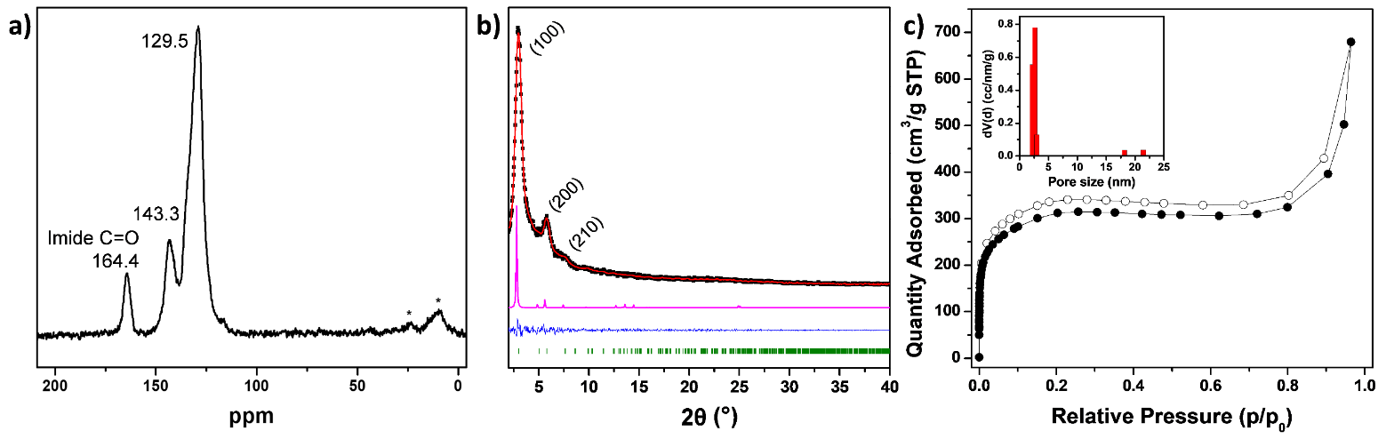
Fig. 1 a) ¹³C-CP/MAS-NMR spectrum of NDI-COF. Asterisks indicate spinning side bands. b) PXRD analysis of NDI-COF: experimental (black), Pawley refined (red), difference (blue), simulated using AA stacking mode with a 1/6 layer offset (pink). Reflection positions are shown by tick marks. c) N₂ sorption isotherms for NDI-COF. Inset shows the pore size distribution calculated by NLDFT.

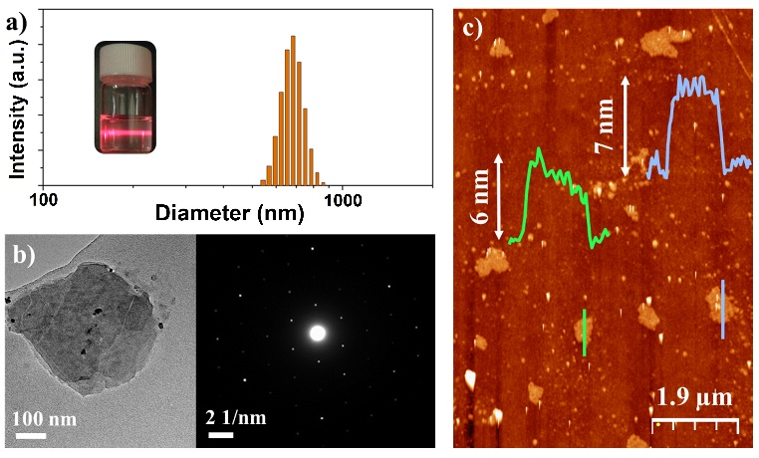
Fig. 2 Characterization of NDI-CONs: a) DLS measurement and Tyndall effect (inset). b) TEM image and SAED analysis (inset). c) AFM topography image of several NDI-CONs deposited on SiO₂ and their height profiles (insets).
The NDI-CONs colloids were then drop-casted onto glassy carbon electrodes (GC) and used to test the ORR electrocatalytic activity of this nanomaterial, hereafter termed NDI-CON/GC. For this purpose, static and hydrodynamic electrochemical measurements were carried out using 0.1 M NaOH as supporting electrolyte. As a first step, we characterized the electrochemical behaviour of NDI-CON/GC in the absence of oxygen (Fig. S13a, red curve), in order to ascertain the electrochemical processes that are taking place at the nanomaterial-modified electrode during the applied scan potential. As can be observed, in the first cathodic scan a reduction peak appears at -0.38 V vs. SCE. This process is ascribed to the electrochemical reduction of the electroactive NDI moiety. A small oxidation peak is detected in the backward anodic scan, which corresponds to the oxidation of the reduced specie generated in the cathodic scan in a quasi-reversible redox process. The lack of total reversibility can be a consequence of the modest electrically conducting behaviour of COF materials.²⁹ It can also be observed how the capacitance current increases compared with the bare GC electrode’s cyclic voltammetry (Fig. S13, black curve). This fact is a clear consequence of the electroactive area increase due to the 2D structure of the exfoliated NDI-COF.^{30, 31}
Once the electrochemical behaviour of NDI-CON/GC had been established, we proceeded to study its response in the presence of oxygen (saturated O₂ 0.1 M NaOH solution). As can be seen in Fig. 3a, red curve, the potential of the O₂ reduction wave clearly shifts towards more positive values compared with the bare GC electrode. The oxygen reduction in this case takes place at the same potential at which the NDI moiety is reduced, as has been proved with the modification of a bare GC electrode with the NDI-monomer (Fig. 3a, blue curve). The good redox activity and semiconducting nature of the NDI motive³² may facilitate the electron transfer to oxygen speeding up the sluggish kinetics of oxygen reduction and therefore catalyzing the ORR.³³ As consequence, the current intensity increases compared to the bare GC electrode, which confirms the great trend of NDI-CONs to assist the ORR. SEM (Fig. S14) and AFM images (Fig. S15) revealed that NDI-CON did not suffer any morphological changes after catalysis.
In order to determine the number of electrons involved in the electrochemical process the hydrodynamic electrochemical response of an NDI-CONs modified electrode was studied at a GC disk-Pt ring electrode (Fig. 3b). The calculated value of near 3.6 is significantly higher to that calculated for the bare GC electrode, ca. 2.4 (Fig. S16). Based on the described mechanism for ORR in basic medium, the value of 3.6 indicates that the process has two contributions but with a clear preference for the desired 4-electron pathway.³⁴ This fact makes NDI-CON an attractive material for anion-exchange membrane fuel cells (AEMFCs).
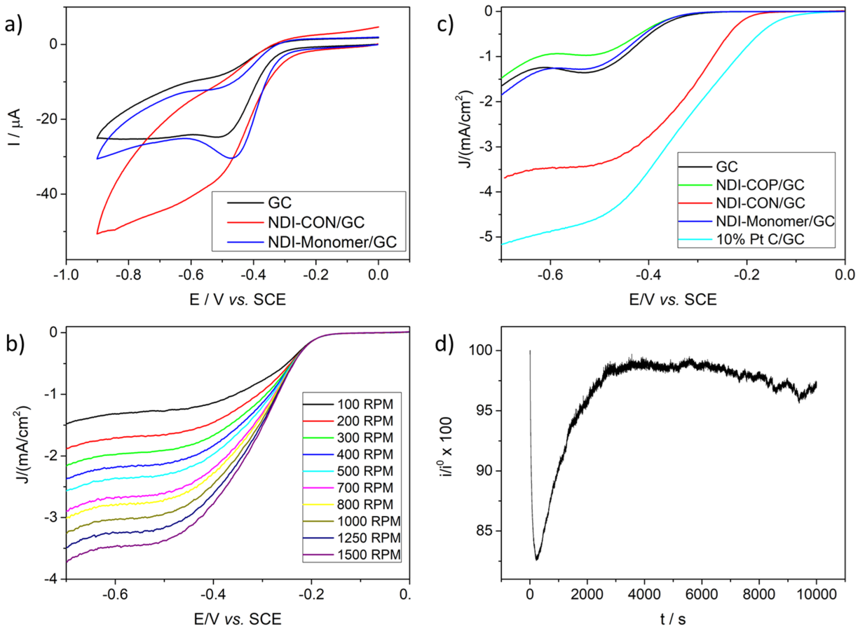
Fig. 3 a) Cyclic Voltammetry of GC electrode (black), NDI-CON/GC electrode (red) and NDI-monomer/GC electrode (blue) in 0.1 M NaOH O₂ saturated solution. b) Hydrodynamic linear sweep voltammetry of NDI-CON/GC in 0.1 M NaOH O₂ saturated solution at different rotation rates and 10 mV/s. c) Hydrodynamic linear sweep voltammetry of GC (black), NDI-CON/GC (red), NDI-polymer/GC (green), NDI-monomer/GC (blue) and 10% Pt C/GC (cyan) electrodes in 0.1 M NaOH O₂ saturated solution at 1500 rpm and 10 mV/s. d) Current intensity stability of NDI-CON/GC electrode operating in 0.1 M NaOH O₂ saturated solution at a constant potential (- 0.5 V vs. SCE).
Intrigued by the potential influence of the NDI-COF ordered structure in these results we prepared and evaluated the electrochemical response of a GC electrode modified with the same amount of an equivalent amorphous NDI-polymer (see the ESI for details). In this case, the material does not present a two-dimensional layered structure, and therefore the porosity is really low compared to that of NDI-COF. The hydrodynamic electrochemical behaviour of the NDI-CON/GC disk electrode was compared with those of the bare GC electrode, the NDI-polymer-modified GC electrode and a 10% Pt supported on carbon modified GC electrode (Fig. 3c). The effect of NDI-CONs on ORR is clearly demonstrated if we compare the onset potential of the bare GC (-0.37 V vs. SCE) and NDI-CON/GC (-0.25 V vs. SCE) electrodes. A potential shift of 120 mV toward positive potential clearly improves the electrochemical process with respect to the unmodified GC electrode. In contrast, NDI-polymer/GC performs worse as ORR electrocatalyst, as can be observed in Fig. 3c. In this sense, the lack of well-defined pores in NDI-polymer avoids O₂ diffusion and its insulating properties, compared to the bare GC electrode, determine its poor electrocatalytic performance. This result shows how a change in the microstructure of the material dramatically affects its electrocatalytic activity towards the ORR and the relevant role that the COF’s ordered structure plays in the electrochemical process.
To complete the electrochemical characterization of the NDI-CON/GC electrode, the stability of the current intensity in operational conditions was tested. Fig. 3d shows that during the first seconds, the current decreases down to 83 % of its initial value as consequence of the discharge of the double layer generated by the electrode polarization and the reduction of O₂ molecules that initially are adsorbed on the electrode. Nevertheless, after ca. 3000 seconds almost 100 % of the initial current is recovered, due to the NDI-CON activation during the electrocatalyst process. Therefore, NDI-CON requires ca. 3000 seconds to activate itself in the best operational conditions. Then, the current keeps almost constant for 10000 s, which is the maximum time assayed, losing only ca. 3 % of its initial value. It is also worth mentioning that the material has a strong tolerance to methanol crossover (Fig. S17), which represents an important advantage over platinum-based ORR electrocatalysts.
In summary, it should be highlighted that although there are some materials that cause a potential shift of the ORR process towards more positive values than that described in this work, either they contain metals in their structure,²² require an additional pyrolysis step before being applied,²³ or in some cases are used in combination with other conductive nanomaterials.³⁵ Therefore, some important benefits of the new NDI-COF synthesized here are that it is not only metal free, but also no additional pyrolysis process has to be applied before its use. Instead, the electrocatalytic activity is a consequence of the specific electroactive moiety selected for the design of this new COF electrocatalyst. Even more, as far as we know, in this work we describe for the first time that the electroactive moiety of a COF is responsible of its ORR electrocatalytic activity. This finding opens a new research field on how the electrochemical properties of COF precursors may affect the electrocatalytic behaviour of the final material for different applications.
Financial support from the Spanish Government (projects MAT2016-77608-C3-1-P, MAT2016-77608-C3-2-P, CTQ2017-84309-C2-1-R, MAT2017-85089-C2-1-R, FJCI-2017-33536 and RYC-2015-17730), the UCM (INV.GR.00.1819.10759) and the Madrid Regional Government (TRANSNANOAVANSENS-CM (S2018/NMT-4349)) is acknowledged.
Conflicts of interest
There are no conflicts to declare.
Notes and references
1 J. Wu and H. Yang, Acc. Chem. Res., 2013, 46, 1848-1857.
2 M. Shao, Q. Chang, J.-P. Dodelet and R. Chenitz, Chem. Rev., 2016, 116, 3594-3657.
3 E. Martínez-Periñán, I. Bravo, S. J. Rowley-Neale, E. Lorenzo and C. E. Banks, Electroanal., 2018, 30, 436-444.
4 G. Wu and P. Zelenay, Acc. Chem. Res., 2013, 46, 1878-1889.
5 M. Zhou, H.-L. Wang and S. Guo, Chem. Soc. Rev., 2016, 45, 1273-1307.
6 Z. Xiang, Y. Xue, D. Cao, L. Huang, J.-F. Chen and L. Dai, Angew. Chem., Int. Ed., 2014, 53, 2433-2437.
7 W. Yu, S. Gu, Y. Fu, S. Xiong, C. Pan, Y. Liu and G. Yu, J. Catal., 2018, 362, 1-9.
8 L. Qu, Y. Liu, J.-B. Baek and L. Dai, ACS Nano, 2010, 4, 1321-1326.
9 M. S. Lohse and T. Bein, Adv. Funct. Mater., 2018, 28, 1705553.
10 S. P. S. Fernandes, V. Romero, B. Espiña and L. M. Salonen, Chem. Eur. J., 2019, 25, 6461-6473.
11 X. Zhan, Z. Chen and Q. Zhang, J. Mater. Chem. A, 2017, 5, 14463-14479.
12 J. L. Segura, M. J. Mancheño and F. Zamora, Chem. Soc. Rev., 2016, 45, 5635-5671.
13 S. Kandambeth, A. Mallick, B. Lukose, M. V. Mane, T. Heine and R. Banerjee, J. Am. Chem. Soc., 2012, 134, 19524-19527.
14 Q. Fang, Z. Zhuang, S. Gu, R. B. Kaspar, J. Zheng, J. Wang, S. Qiu and Y. Yan, Nat. Commun., 2014, 5, 4503.
15 D.-J. Liaw, K.-L. Wang, Y.-C. Huang, K.-R. Lee, J.-Y. Lai and C.-S. Ha, Prog. Polym. Sci., 2012, 37, 907-974.
16 M. M. Durban, P. D. Kazarinoff and C. K. Luscombe, Macromolecules, 2010, 43, 6348-6352.
17 E. Castaldelli, E. R. Triboni and G. J.-F. Demets, Chem. Commun., 2011, 47, 5581-5583.
18 L. Jiang, Y. Tian, T. Sun, Y. Zhu, H. Ren, X. Zou, Y. Ma, K. R. Meihaus, J. R. Long and G. Zhu, J. Am. Chem. Soc., 2018, 140, 15724-15730.
19 J. Lv, Y.-X. Tan, J. Xie, R. Yang, M. Yu, S. Sun, M.-D. Li, D. Yuan and Y. Wang, Angew. Chem., Int. Ed., 2018, 57, 12716-12720.
20 G. Wang, N. Chandrasekhar, B. P. Biswal, D. Becker, S. Paasch, E. Brunner, M. Addicoat, M. Yu, R. Berger and X. Feng, Adv. Mater., 2019, 31, 1901478.
21 W. Ma, P. Yu, T. Ohsaka and L. Mao, Electrochem. Commun., 2015, 52, 53-57.
22 D. Wu, Q. Xu, J. Qian, X. Li and Y. Sun, Chem. Eur. J., 2019, 25, 3105-3111.
23 Q. Xu, Y. Tang, X. Zhang, Y. Oshima, Q. Chen and D. Jiang, Adv. Mater., 2018, 30, 1706330.
24 M. J. Frisch, G. W. Trucks, H. B. Schlegel, G. E. Scuseria, M. A. Robb, J. R. Cheeseman, G. Scalmani, V. Barone, B. Mennucci, G. A. Petersson, H. Nakatsuji, M. Caricato, X. Li, H. P. Hratchian, A. F. Izmaylov, J. Bloino, G. Zheng, J. L. Sonnenberg, M. Had and D. J. Fox, Gaussian 09, Revision A.01, 2009.
25 J. Clark Stewart, D. Segall Matthew, J. Pickard Chris, J. Hasnip Phil, I. J. Probert Matt, K. Refson and C. Payne Mike, Z. Kristallogr. Cryst. Mater., 2005, 220, 567-570.
26 I. Berlanga, M. L. Ruiz-González, J. M. González-Calbet, J. L. G. Fierro, R. Mas-Ballesté and F. Zamora, Small, 2011, 7, 1207-1211.
27 I. Berlanga, R. Mas-Ballesté and F. Zamora, Chem. Commun., 2012, 48, 7976-7978.
28 P. Albacete, A. López-Moreno, S. Mena-Hernando, A. E. Platero-Prats, E. M. Pérez and F. Zamora, Chem. Commun., 2019, 55, 1382-1385.
29 C. R. Mulzer, L. Shen, R. P. Bisbey, J. R. McKone, N. Zhang, H. D. Abruña and W. R. Dichtel, ACS Cent. Sci., 2016, 2, 667-673.
30 Poonam, K. Sharma, A. Arora and S. K. Tripathi, J. Energy Storage, 2019, 21, 801-825.
31 J. Sun, A. Klechikov, C. Moise, M. Prodana, M. Enachescu and A. V. Talyzin, Angew. Chem., Int. Ed., 2018, 57, 1034-1038.
32 X. Guo, F. S. Kim, M. J. Seger, S. A. Jenekhe and M. D. Watson, Chem. Mater., 2012, 24, 1434-1442.
33 S. Roy, A. Bandyopadhyay, M. Das, P. P. Ray, S. K. Pati and T. K. Maji, J. Mater. Chem. A, 2018, 6, 5587-5591.
34 D. R. Dekel, J. Power Sources, 2018, 375, 158-169.
35 J. Guo, C.-Y. Lin, Z. Xia and Z. Xiang, Angew. Chem., Int. Ed., 2018, 57, 12567-12572.

