SOUND-GESTALT
Concha García González

This article talks about artistic practices that use distributed sound as main artistic material, considering it an expansion of the concept of sculpture. We understand the term expansion as Rosalind Krauss used it to talk about the sculpture of the 60´s: an expanded field where the sculpture was expressed itself as not-landscape and not-architecture, spreading out dialectically and thus establishing other new structural possibilities. The distributed sound also opens the way to creating new structures: as it is also involved with the temporal condition of the sound, we can speak about shapes; it´s a shape understood as a forming process, as growth, as externalization of dynamic forces. The concept of shape as we are developing recalls the Gestalt definition developed by Carl Einstein: dialectical process as a result of tensions, which is related with the concepts of noise, of event, of not continuity; a process related with verbal action and with the destruction of the semantic unity: an element that could generate new connections and therefore, new meanings.
1.- When we say sound, the sonic material we are talking about is the continuum which comes from the substitution of the traditional musical sound into the frequency, therefore the substitution of the symbolic by means of the real and from the musical written symbol to the continuum of the space of all the possible frequencies. This sound material has different parameters from the traditional musical material, based on the rhythm and pitch. The concept of timbre has been described by Jean Claude Risset as the particular quality of a sound, which allows identifying the sound source but also allows distinguishing from another one. Some sound works could be understood as timbre compositions or timbre distributions around the space. Technological developments allow us to work with fixed sounds, that is, recorded sounds or edited recorded sounds: this possibility prepares the concept of sound object. This new concept, introduced by Pierre Schaffer puts the emphasis on sound materiality and the possibility of a reduced listening that is, listening separated from sound sources and it´s causes.
2.- When we talk about listening, we need, inevitably to talk about the body. Body experience is the filter through which we understand, we arrange, and we set up a hierarchy for the world. Our body structure and the one of the environments we inhabit magnetize the space and add symbolisms to the elements we use to communicate (either daily communication or artistic communication). The basic elements of the space we live in, the lived space, are the directions, conditioned by our body structure and the schemes derives from it, as well as from the physical laws of the environment we inhabit, defined mainly by the gravitational force: the directions up-down, front- back, right –left, center-periphery and resulting from them, the horizontal and vertical planes and the trajectories … Those axes are so full of symbolism that are not interchangeable because they condition our space perception. Our body modulates spaces when we say a single word, creates motoric spaces when we get swept away by the rhythm of music. Understanding is experiencing the accord between what we try and what is given, between the intentions and what actually takes place, considering our body as the anchor in the world. And, in addition, “(…) our body experience teaches us to settle the space in the existence.”
3.- When we talk about distributed sound, we are implicitly talking about technologies used to distribute sound, whose main representative are the loud- speakers systems spread over the performance space: acusmonium: spacial narrative tools. The sound is distributed among the loud- speakers, creating a new space.
4. - When we talk about the space generated by sound material, we are talking about the space-form, a concept introduced by Denis Smalley that refers to the space created by the projected sound, whose perception is transmodal, because it involves both touch and proprioception. In order to perceive this space- form in an integrated manner, we should disregard temporal evolution, collapsing the sound experience in the present moment. It could happen when there coexist different sound planes in the same space (this could be the equivalent of a drawing with different depth or perspective planes).
5. - This approach to the distributed continuum sound, allow us to understand sound shapes as if it were elastic crystals submerged in a topological geometry, also relating to the representability (or “figurability”) work described by Sigmund Freud. The deployment of those Gestalts in the space, specifically oriented, following directions and trajectories, which are involved in our body- anchored spacial learning process, allows us to create discourses using spacial metaphors. Those metaphors are related with the metaphors we live by and the ones we use to create meaning: time- space metaphors full of symbology that could both destroy the perceptive automatisms and involve relationships that generate self-knowledge and self-perception.
6. - How does this composition of space take place? Which strategies could be found? Which structural principles govern those compositions?
The distributed sound is always in motion: sound objects generally have dynamic morphologies because there are several factors at play that modify their morphology: interactions between sounds, reverberations, spacial architectures…But in some cases, once the sound is projected, sound objects could be perceived as objects with static and unchangeable qualities or as objects that evolve in a timescale not perceived as an event. In this case, we perceive them as fixed sound objects, and it is possible to talk about sound mass. We use the mass criteria to define them: Pierre Schaeffer defined mass as “that property of the physical matter that in opposition to other ones (as texture or speed, for example) corresponds to the allocation of all the frequencies of the sound”. Sound material could be distributed in space, following different structures with narrative or conceptual purposes. In sound- works, we could find schemes as emerging-transition- vanishing (the most common one) or attack-sustain-release. Nevertheless, the breakdown of the traditional compositional schemes could give rise to other structures, as pitches slightly transformed into flat signal. The sustained sound shapes (or sustained sound events) could recall the existence of a timeless space which doesn´t change or that evolves very slowly, causing a shift in perception.
Some sound objects can be characterized by processes of growth and movement and the metaphors related to them. These processes have directional tendencies, and we already know that directions are neither equivalent nor interchangeable for our perception. They could be unidirectional, and thus, the choice of the direction will determine meaning. Thus, an ascending direction will evoke an abstract boundless space related with lightness, as the sky and the air seem to be boundless. A flat direction calls our perceptive attention to other properties as density and texture and adding frequencies effect. A descending direction will evoke the concept of falling as if the sound were attracted by a lower region. Parabolic or undulating directions could be used with dramatic or narrative purposes. Cyclic directions could evoke growth, as we´ve already seen that its firmly rooted in our perception the idea of irradiation from a center. The multidirectional trajectories are endlessly related with physical phenomena as agglomeration, shrinking and expanding, convergence and divergence… and depending on their spacial distribution, evoke actions with different degree of lightness or heaviness: dragging- floating- raising- be thrown, drifting- swimming- floating- flying- disappearing.
Gravitational forces, understood as forces of attraction and repulsion generated by sounds distributed in the space were defined by François Bayle as one of the called static archetypes. They are determined by the physical laws that govern our environment, and include the idea of the horizon, temperature, climate… that is, parameters that define our lived space and are related to the essence of our existence. Therefore, there is an attraction to stability in lower regions of the space, and the notion of cadency is associated with the resolution of tension.
A high pitch long drawn out generates tension asking for resolution. In our physical space it would be the same: it´s due to the big amount of energy needed to keep an object fairly high. If we talk about composition in plastic arts, the shapes placed in the upper part of the space of representation must be compensated by shapes in the lower part. The resolution of the tension could be solved as a resolution of dissonance: it´s not necessary to end with the stability of the consonance. This means that a sound plane could be implicit, for example a continuous one- way movement of a sound would be the equivalent to a glissando.
It is also possible to generate perspectival spaces in a sound space as a way to articulate sound shapes. In sound art, the term is used to define the relations of movement, position and scale among sound shapes, viewed from the listener´s vantage point. In those perspectival spaces we perceive trans-modal and inter-sensory transferences. Perceptions are rooted in the listener as recipient, so, all that I perceive is put into perspective in relation to my human scale and my body: in relation to my point of view. Denis Smalley identifies in those aural situations the relations among three views: prospective space, panoramic space and circumspace. Proxemics as Edward T. Hall defined them (the use of space in interpersonal communication) and proxemics distances or spaces are involved in those spaces: the intimate distance for touching and whispering, where vision, smell, hearing and body heat are involved, that ranges from 15 cm. to 50 cm.; the personal distance: the bubble of protection for interactions among good friends or family members that range from 50 cm. to 120 cm.; the social distance for interactions among acquaintance, ranged from 120 cm. to 3.7 m. and public distance, used for public speaking, from 3.7 m to 7.5 m. or more.
The prospective hearing space is a frontal image extended laterally to create the panoramic space, which is shaped by the simple stereo listening. Circumspace extends the panoramic space to encompass the listener. Through the duration of a sound work, it is possible to experience different views, opening and closing the perspective view: like make a zoom in photography. When the space is closed, there´s no perspective or it is masked: our attention is focused on the space of the intimate or personal distance (depending on the distance). This intimate space could be emphasized with the magnification of a sound texture. The closer the perspective view is, the bigger the feeling of tightness is. The prospective hearing space could be seen as a window through which I behold the horizon.
It’s possible to recall or denote close or distant spaces using different sound shapes: lower pitches seem to be closer, and body rooted (let us think of the subwoofer physicality). On the contrary, low pitches could vanish the perspectival space if we compare them with easy to locate, sharpness and clearness of high pitches.
Circumspace is concerned with relations over time. In sound art, is possible to find contradictory spaces, possibilities impossibilities, multiple points of view, nested spaces (one space into another one), and links between those panoramic spaces, always with the listener as the point of reference.
Many sound works are conceived to be experienced in a situation far away from the concert hall performance; therefore, they could be composed to be experienced with changing points of reference: the listeners walk around a space, creating a polyphony of spaces. One special case is an immersive space, filled with sound mass surrounding the egocentric space. In this space with no dominant directions, the listener is invited to walk around looking for different points of view. In sound installations or site-specific works, besides hearing, more senses could be involved, maybe with performative actions, visual and tactile elements… This frees the listener from a continuous hearing. If the performative space is completely changeable, the listener could move freely between aural spaces, so the egocentric space is mobile so the listener could be more aware of the interdependent relation between egocentric space and the image created by sound.
Another criteria to distribute sound in the space is the creation of behaviors based on principles or laws, decisions or instructions and following relations of dominance-sub ordinance, conflict- coexistence. Those works coexist with traditional ones composed with classical criteria: activity-inactivity, stability-instability- equal-unequal, cause-consequence.
7. - As graphic summary, the images below, represent a morphological analysis of the sound material we´ve been talking about: the one created to be distributed on the space. In this case is a three dimensional representation of a sound work based on the sound spectrum: sound shapes created depicting the vibrations per seconds (that is the frecuencies) and their relationship with amplitude adding the temporal dimension.We´ve used the Acousmographe, developed at Groupe de Recherches Musicales(GRM) in Paris. It is a software dedicated to the graphic representation of electronic, computer music and sound art synchronized with listening and technical representations of sound wave (amplitude and spectral analysis). It was designed as a tool for study and analysis of fixed sounds. Realized in three versions over more than two decades, today is still affected by research and development activity. In this case, these images depict fragments of a sound score of a sound work composed with fixed sounds. The score includes a preliminary morphological analysis of the sound shapes as we´ve seen: the first step consists of creating symbols related with the sound analysis: movements, trajectories, type of sound, attack and decay…creating different layers over imposed to the sound spectrum. In our case, the symbols were:
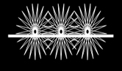 | A train-like sound, implying a trajectory and full of kinetic energy. It´s a motion rootedness: rooted to a solid plane.
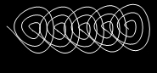 | A train-like sound that never departs:
  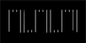 | A parabolic sound (more gestural)
 | An oscillated sound always identical: a kind of industrial sound.
 | A sound like irregular falling rocks.
 | A motion launching texture. A texture with two different moments: a drag movement followed by a circular one. A kind of glass.
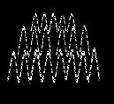 | Water-sound: a spring-like sound or flowing water. A kind of granular noise.
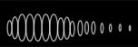 | A pneumatic sound with a fast beginning and a slow- down end. It always has the same rhythm.  A dilated sound. Decelerate.
 | An spiral –like texture, with glass sounds. A motion process related to a central point: a rotational variation.
 | A crackled sound followed by irregular falling rocks. This clacked sound always implies the change of the events, or alters the concurrent event in some way.
   | Both signals represent the sounds of the choir, which disappears to transform into noise or into a pitch or chord. It could sounds “in unison” or simultaneous. Indicate the mix of treated human voices
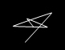 | This represents a kind of bird-like sound, with a reflected sound: a sort of echo, with higher pitch.
 | A gong like sound, Tibetan Singing Bowls, or bells.
   | One sound becomes another: a pitch (the white one)or a noise-like sound: engine sound, (the dotted one)
  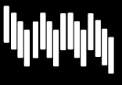 | A percussive event, sometimes with pitch reminiscences.
 | A mixture between footstep and a percussion sound.
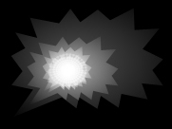 | A kind of pneumatic explosion.
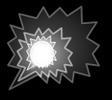 | More scratchy
 | A note: piano note, or pitch sound or a chord. Sometimes the note
 | A mixture of engines, rhythmic machines: industrial sound-scape: a low-fidelity soundscape, full of potential energy. Accumulative processes that tend towards noise.
Fig. 1.- Symbols used for the morphological analysis, and their explanation. The shapes chosen reflect the type of sound material of the sound work.

After the morphological analysis of sound shapes and mass, and only if if the sound work is going to be spacialized in an acusmonium or loudspeaker orchestra, it could be done a score of space, where all the placements (considering all the loud-speakers) and movements of sound shapes are represented.

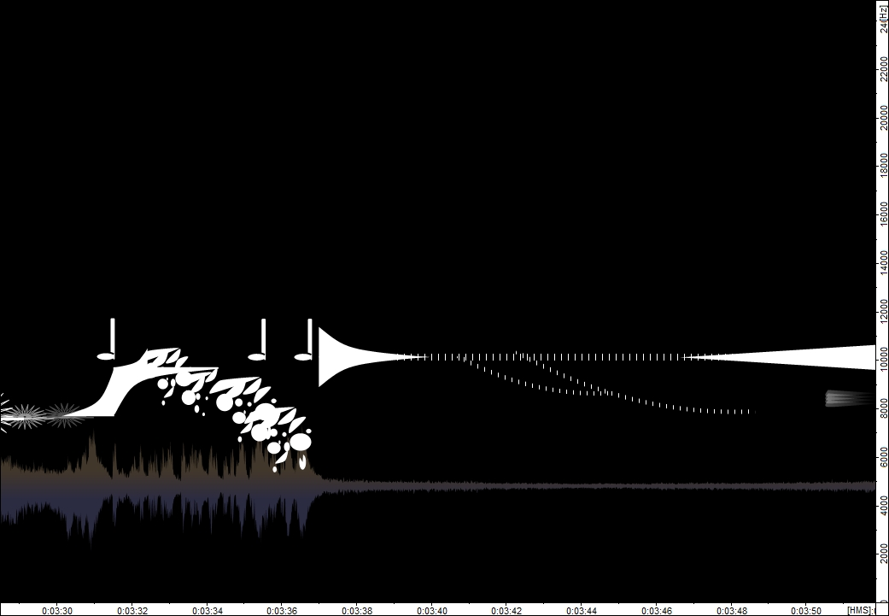
Fig. 2 This picture represents a fragment of the sound work: from the minute 3:29 to 3:52. In white, events, process, sound shapes. In gray, sound signal depicting frecuencies and amplitude.

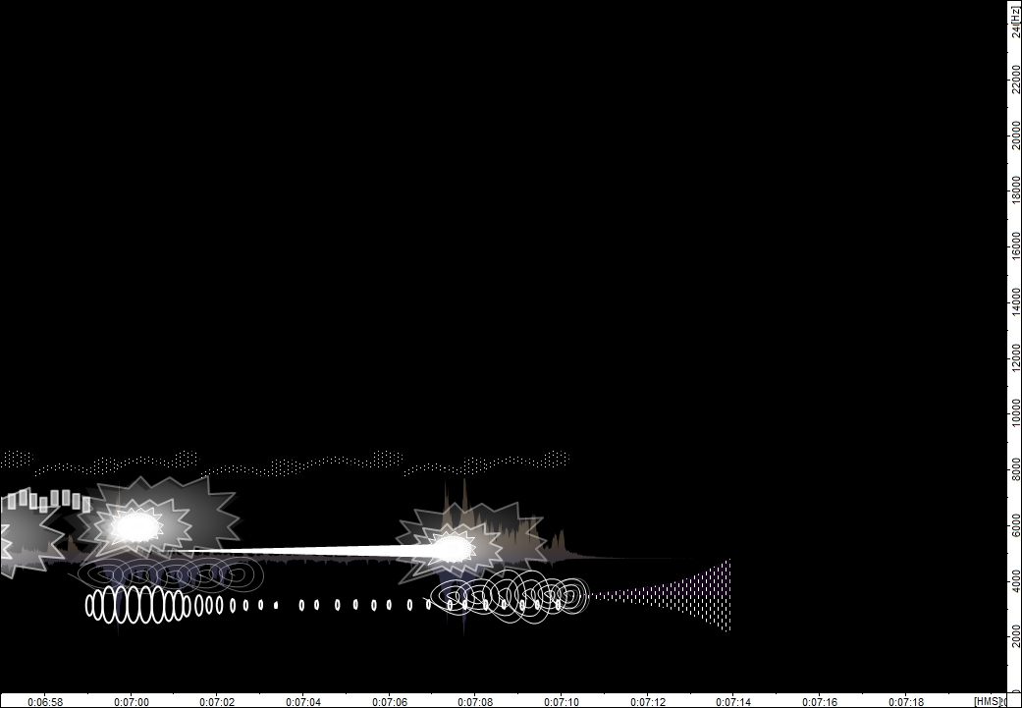
Fig. 3 The end of the sound work: from 6:57 to 7:18.

8. - As a conclusion, we could say that the materialization of sound allows the sound to be understood in the same terms than other artistic materials. When it is distributed into the space by means of technological devices, it is possible to talk about spacial discourse. The shapes or sound Gestalts thus created could take part, from an epistemological and phenomenological point of view in our way of understanding lived space, lived environments and how we are related with them. Through different sound shapes and formative processes, it´s possible to generate virtual spaces that could increase our spacial consciousness and also allow us to talk about space discourse. Those sound experiences enable us to participate in an expanded experience of sculpture, reshaped and transformed by this sound objects.
9.- Notes and references:

Krauss, Rosalind. (1979, Spring). Sculpture in the Expanded Field. OCTOBER, 8. pp.:30-44.
Einstein, Carl. "Gestalt and Concept (Excerpft)." OCTOBER Winter 2004. Pp.: 169-76.
Kittler, Friedrich A. Gramophone, film, typewriter. Standford: Standford University Press, 1999. p.:24.
Risset, Jean- Claude.”Timbre et synthèse des sons”. Le Timbre, métaphore pour la composition. Ed. Barrière, J. B. Paris: IRCAM/Christian Bourgois, 1991. 239-260.
Chion, Michel. El Arte De Los Sonidos Fijados. Ed. Centro de Creación Experimental. Cuenca: Universidad Castilla- La Mancha, 1991.
The concept vas introduced by Pierre Schaeffer. It refers to every sound phenomenom perceived as a whole, as a coherent entity, and listened with a reduced listening, that refers to the sound material itself instead of the sound sources.. Schaeffer, Pierre. Tratado De Los Objetos Musicales. Madrid: Alianza Música, 1996.
Otto Friedrich Bollnow, in his work Hombre y Espacio, develops the concept. Bollnow, Otto Friedrich. Hombre y Espacio. Barcelona: Editorial Labor, S.A., 1969.
Merleau- Ponty, M. Fenomenología De La Percepción. Trad. Jem Cabanes. Barcelona: Ediciones Península, 1975. p.:165.
The acusmonium could be understood as a loud- speakers orchestra, that is, an instrument destined to sound projection and spacialization. The term comes from the one conceived by François Bayle and created by Jean Claude Lallemand in 1974.
Smalley, D. (2007, Space Form and the acousmatic image. Organised Sound, 12, 35.
As Denis Smalley says, “proprioception involves the tensing and relaxing of muscles in relation to all types of body movement”. Ibid.: p.:5.
The representability or figurability appears in chapter VI of the Interpretation of Dreams. Throught it, the unconscious looks for a displacement in order to appear into a manifest content: the dream. They are made up of visual images. Freud, Sigmund. Interpretación de los sueños, 1. Alianza Editorial, Madrid, 2011.
Schaeffer, Pierre. Ibidem. p.:225.
Bayle, François (1993), Musique acousmatique. Propositions... Positions. Paris: INA-GRM/Buchet-Chastel.
Smalley, D. Ibid. p.:14.
The cultural anthropologist Edward Hall coined the term in 1963, to define “the interrelated observations and theories of man´s use of space as a specialized elaboration of culture” Edward. T. La Dimensión Oculta. México: Siglo XXI, 1972.
The free software could be downloaded here: INA GRM. 2012. Web. http://www.inagrm.com/accueil/outils/acousmographe

