Supplementary material

Spatiotemporal characteristics of the stereoscopic anisotropy

Ichasus Llamas-Cornejo & Ignacio Serrano-Pedraza*

Department of Experimental Psychology, Faculty of Psychology, Universidad Complutense de Madrid, Campus de Somosaguas, Madrid, 28223, Spain

*Corresponding author: iserrano@ucm.es

- Derivation of equations 2, 3, 5, and 6 from the main document.
The disparity sensitivity function (DSF) used in the study is a version of the function used by (Kelly, 1975) but extended to three parameters (Burgess, 1994; Klein & Levi, 1985; Peterson & Eckstein, 2012). The fitted function is the next:
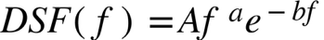,

The spatial frequency (f_{p}) where the DSF has a peak is obtained as follows:
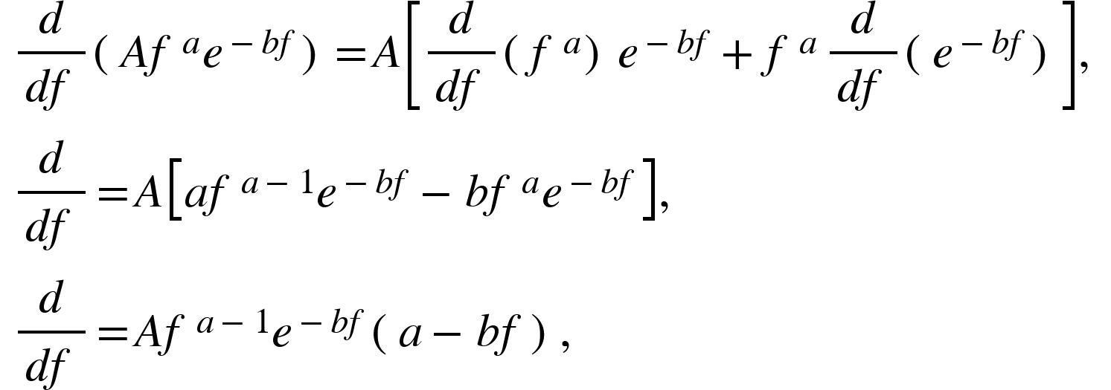
We set it equal to zero:
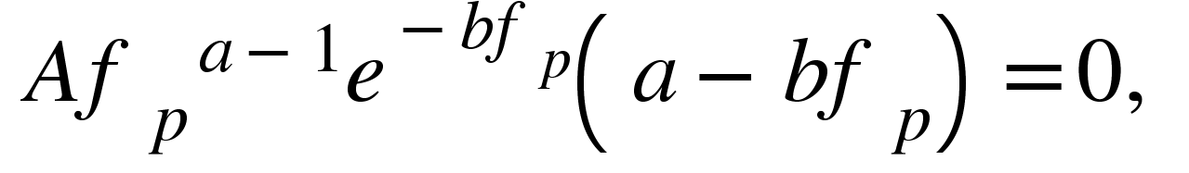

And then we solve for f_{p}:
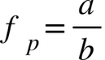; (Equation 2 from the main document).
Therefore, the maximum sensitivity value (max) is computed as follows:
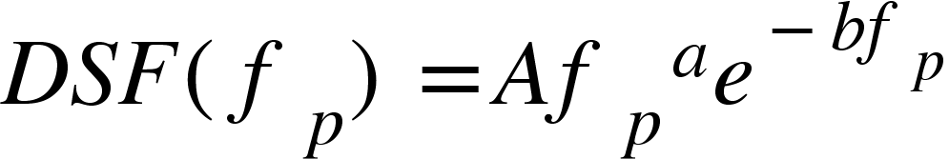,
Where DSF(f_{p})=max,
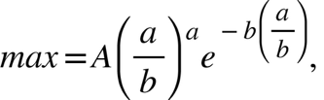
simplifying,
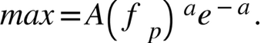 (Equation 6 from the main document).

Next, we obtained the spatial frequency where we have the maximum resolution, f_{SR} (i.e., spatial stereoresolution). This spatial frequency value corresponds to a particular sensitivity s, and the spatial frequency has to be greater than the peak spatial frequency f_{p} (right side of the DSF).
This equation links f_{SR} with s (we will use f instead of f_{SR}, for simplicity):
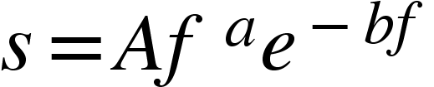,
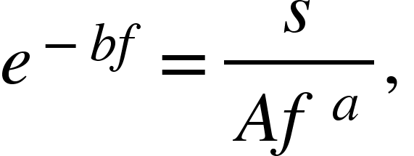
we take the $1/a$ power,
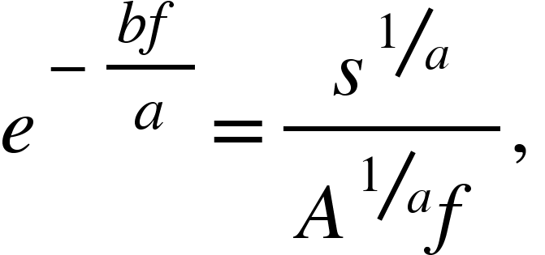
we multiply both sides by $-bf/a$ to obtain the form 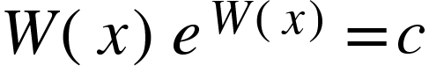; where W is the Lambert W function, and $x=-bf/a$.
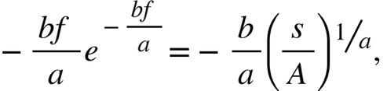
Given that 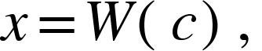
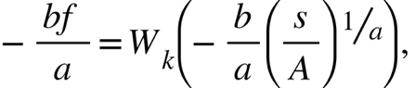
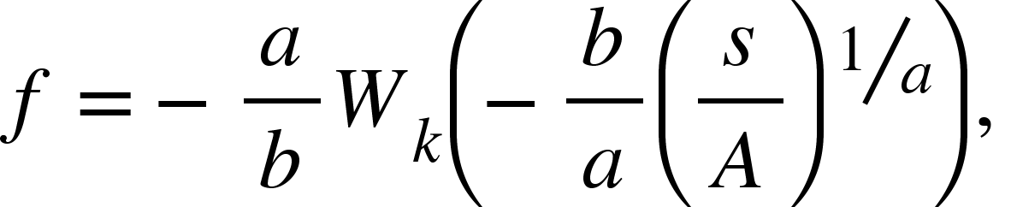
Where 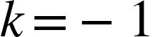 for the right root (spatial frequencies higher than f_{p}).
Thus, the final equation with f_{SR} = f , is:
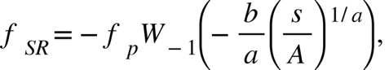 (Equation 3 from the main document).

Finally, the equation 5 of the main document is identical to the equation 3 but it was used to estimate the full width at half maximum (FWHM), of the DSF, in octaves. The parameter s is replaced by max/2 and f_{sup}, and f_{inf} are obtained using for the right root and 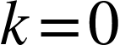 for the left root of the Lambert W function.
Therefore f_{sup} and f_{inf} are calculated using the following equations:
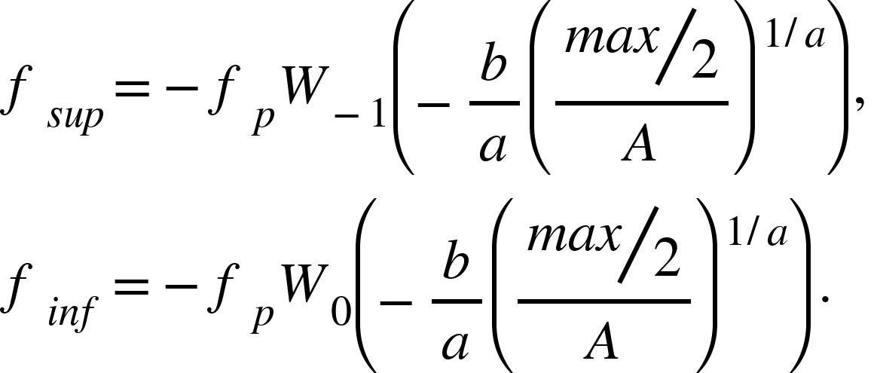 (Equation 5 from the main document).

- Derivation of equation 12 from the main document.
To obtain the disparity thresholds from the correlation map we follow a procedure where in one step we fitted a four-parameter Gaussian function to the averaged correlations using a nonlinear least-square approach. The fitted equation is the next:
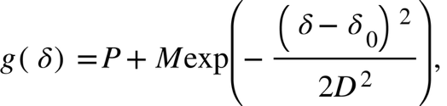
where P, is the pedestal (baseline), M is the amplitude above the pedestal, D is the standard deviation, and $δ_{0}$ is the center of the gaussian (i.e., mean). Given that peak of the Gaussian is $\max\left(g\left(δ\right)\right)=P+M$, for $δ$ = $δ_{0}$, we calculated the full width at half maximum (FWHM) for the equation $g\left(δ\right)$.
We set the half maximum to
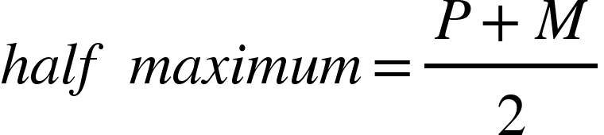,
Then we solve this equation
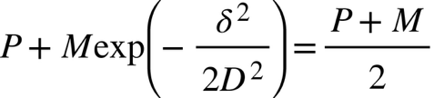,
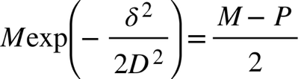,
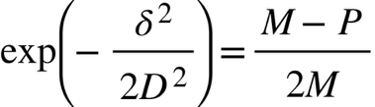,
we take the natural logarithm:
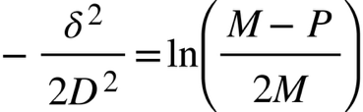,
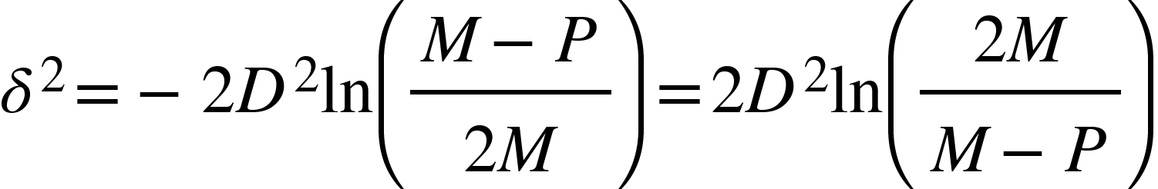,
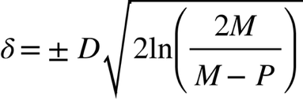,

Finally, the full width at half maximum (FWHM) is:
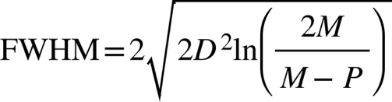. (Equation 12 from the main document).

References
Burgess, A. E. (1994). Statistically defined backgrounds:performance of a modified nonprewhitening observer model. Journal of the Optical Society of America A, 11(4), 1237. https://doi.org/10.1364/JOSAA.11.001237
Kelly, D. H. (1975). Spatial frequency selectivity in the retina. Vision Research, 15(6), 665–672. https://doi.org/10.1016/0042-6989(75)90282-5
Klein, S. A., & Levi, D. M. (1985). Hyperacuity thresholds of 1 sec: theoretical predictions and empirical validation. Journal of the Optical Society of America A, 2(7), 1170. https://doi.org/10.1364/JOSAA.2.001170
Peterson, M. F., & Eckstein, M. P. (2012). Looking just below the eyes is optimal across face recognition tasks. Proceedings of the National Academy of Sciences, 109(48). https://doi.org/10.1073/pnas.1214269109

