Evaluation of the oxygen reduction reaction electrocatalytic activity of post-synthetically modified covalent organic frameworks
Marcos Martínez-Fernández,‡ª Emiliano Martínez-Periñán,‡ ^{bf} José I. Martínez,^{c} Marta Gordo-Lozano, ª Félix Zamora,^{defg} José L. Segura*ª and Encarnación Lorenzo*^{bef}
ª Departamento de Química Orgánica I, Facultad de CC. Químicas, Universidad Complutense de Madrid, 28040 Madrid, Spain. ^{b} Departamento de Química Analítica y Análisis Instrumental, Facultad de Ciencias, Universidad Autónoma de Madrid, 28049 Madrid, Spain. ^{c} Departamento de Nanoestructuras, Superficies, Recubrimientos y Astrofísica Molecular, Instituto de Ciencia de Materiales de Madrid (ICMM-CSIC), 28049 Madrid, Spain. ^{d} Departamento de Química Inorgánica, Facultad de Ciencias, Universidad Autónoma de Madrid, 28049 Madrid, Spain. ^{e} Instituto Madrileño de Estudios Avanzados en Nanociencia (IMDEA-Nanociencia), Cantoblanco, 28049 Madrid, Spain.^{f} Institute for Advanced Research in Chemical Sciences (IAdChem), Universidad Autónoma de Madrid, 28049 Madrid, Spain.^{g} Condensed MatterPhysics Center (IFIMAC), Universidad Autónoma de Madrid, 28049 Madrid, Spain.
‡M. M-F and E. M-P contributed equally to this work.

KEYWORDS
COF, covalent organic frameworks, napthalenediimide, electrocatalysis, oxygen reduction reaction, metal-free, pyrolysis-free
ABSTRACT
The pyrolysis of organic precursors to produce heteroatomic-doped carbonaceous materials has emerged as a powerful tool to construct metal-free heterogeneous electrocatalysts due to their low cost and their environmental friendliness. However, the lack of control in the atomic positions or the location of the chemical functionalities makes it difficult to establish structure-property relationships. Herein, we report an easy strategy to compare the electrocatalytic ORR performance of metal-free and non-pyrolyzed materials by post-synthetic modification of covalent organic frameworks (COFs) via click-chemistry. This method facilitates the evaluation of different active centres using materials with the same morphology and prevents active sites agglomeration by covalently anchoring these moieties inside of a porous and crystalline framework. In this study we developed a series of diimide-based materials (XDI_{0.17}-COFs) with a loading of 7.65*10⁻⁴ mol of active site/mg of host COF. The bulk COFs have been delaminated to perform electrode modification by drop-casting. Finally, the electrocatalytic response towards the ORR has been studied in alkaline media obtaining the best results for the NDI_{0.17}-COF with an onset potential of 0.77 V (vs RHE) and a limiting current of 4.2 mA/cm² by a preferred pathway towards the water electroreduction. Finally, an adequate combination of Density Functional Theory with the thermochemical Gibbs free energy formalism has been used to theoretically rationalize the ORR mechanism in these metal-free and non-pyrolyzed materials. We have obtained theoretical ORR overpotentials for each COF system agreeing with the experimental observation, which correlate with the ability of the NDI, BzDI and PDI molecular blocks to accommodate electrons. Our work provides a guideline on how to study the electrocatalytic performance of different organic moieties in metal-free and non-pyrolyzed COFs avoiding their de novo synthesis by using the click post-synthetic methodology.
Introduction
Despite the high bond energy (498 kJ/mol)¹ of the oxygen molecule, the cleavage of the O=O bond is an essential and highly efficient process produced in nature.^{2, 3} Inspired by the aerobic respiration, the oxygen reduction reaction was proposed as an ideal counter-reaction for the energy conversion technologies, such as hydrogen fuel-cells or metal/air batteries, due to its green nature.³ To overcome the slow kinetics of the ORR⁴ both nature and artificial O=O cleavage requires the assistance of catalysts to lower the activation barrier of this process.⁵ Regarding to the energy conversion technologies, even though the platinum-based electrocatalysts are still offering the best performances, the scarcity and the high prices of this precious metal hinder the implementation of these compounds in commercial devices.^{6, 7} Different electrocatalysts have been used in the past years, which are classified according to the pathway followed in the oxygen reduction. A two-electron reduction produces H₂O₂ as the ORR product, while the four-electron pathway yields the direct conversion to H₂O.⁸ On the one hand, the 2e⁻ reduction produces an incomplete reduction and a lower electric current, undesirable for energy conversion but interesting for hydrogen peroxide generation.⁹ On the other hand, due to the higher electric current generated by the 4e⁻ pathway and the green nature of the final product, the four electron reduction use to be the pathway of choice in energy-related applications such as metal-airbatteries.¹⁰ Several strategies have been used to control the electronic pathway followed⁹ as well as the catalyst composition in ORR. Among them, two stand out: i) reduce the platinum load of the electrocatalyst,¹¹ and ii) totally eliminate the Pt of the catalyst composition.^{1, 3, 12} Regarding the latter one, there is an increasing interest in the obtainment of metal-free electrocatalysts (MFE) due to environmental reasons. Several new materials have been tested in the last-few-years including graphene-derivatives or carbonaceous compounds, carbon nanotubes, carbon or boron nitrides… etc. Recent studies revealed that the introduction of polarized sp² carbon-light heteroatom (such as N, O, F, P, S) bonds dispersed in a conductive carbon matrix creates actives sites towards the ORR.^{7, 13-16}
Conventional methods for the obtainment of MFE requires the heteroatomic doping of carbonaceous derivatives upon treatment with reactants bearing the light heteroatoms, yielding heterogeneous distributions of these elements.¹⁷ Thus, the most widespread strategy to obtain homogeneously doped carbons is the pyrolysis of organic precursors. Among them, covalent organic frameworks (COFs) stand out among the best candidates.^{11, 13, 14, 18} COFs are a class of polymers with superior properties such as intrinsic crystallinities, large surface areas (in some cases up to 4000 m²/g), pre-designability and mouldability of the networks which can be obtained via pre-synthetic (during the network formation) or post-synthetic (after the polymerization) approaches.¹⁹⁻²¹ The structure of the COFs is proposed to template the pyrolysis to homogeneously doped carbons.^{13, 22} However, we envisaged that the MFE based in non-pyrolyzed COFs could produce an improvement on the performance yielded by these materials avoiding the energetic costs associated to the pyrolytic process. Furthermore, during the pyrolytic process the formation of the active sites is hardly controlled and among all the functional groups produced only some of them are the active ones.¹⁴ On the other hand, pyrolytic treatments usually produce the loss of the porous features of the final MFEs which are highly desirable to favour the oxygen diffusion and increase the accessible active sites.^{23, 24} In addition, the synthetic methods for the synthesis of highly crystalline COFs is often tedious²⁵ and pyrolytic treatment causes the loss of the most noteworthy attribute of COFs, their characteristic atomic order. Thus, COF-based non-pyrolyzed MFEs has emerged as an innovative class of electrocatalysts. In this field, different organic moieties have already been incorporated into the skeleton of COFs and some of them have been recognized as active units towards the ORR, being some examples thiophene derivatives,^{7, 26} polychlorotriphenylmethyl radicals,²⁷ pyrenetetraone²⁸ and naphtalenediimide.^{29, 30} However, all this electrocatalyst were synthetized by the novo synthetic procedure, which is usually tedious since to achieve the crystallization COF usually requires to carry out trial-and-error screening of the synthetic conditions which delays the evaluation of novel active units.
Here, we report an easy strategy to study different metal-free and non-pyrolyzed organic active sites and their electrocatalytic performance in the ORR of different active sites covalently anchored to the same covalent organic framework. With this aim, we have synthesized a series of porous and crystalline COFs endowed with aromatic diimides with increasing π-surfaces, i.e. benzene diimide (BzDI), naphthalenediimide (NDI), and perylenediimide (PDI) to evaluate how the electronic structure of this diimides affects to the ORR performance.³¹ Thus, we decided to anchor the different moieties described by click chemistry to a well-known DMTA-TAPB-COF to obtain the series of surface-embedded electrocatalysts (XDI_{0.17}COFs) summarized in figure 1. By using this strategy, the COF skeleton acts as a host preventing the agglomeration of the active units, increases the surface-volume ratio of the active units and ensures a close contact with the electrode due to its layered macrostructure.^{32, 33} The post-synthetic strategy used in this work avoids the difficulties commonly associated to the obtainment of crystalline phases in the synthesis of COFs³⁴ and facilitates the evaluation of the activity towards the ORR of different active units embedded in identical networks.

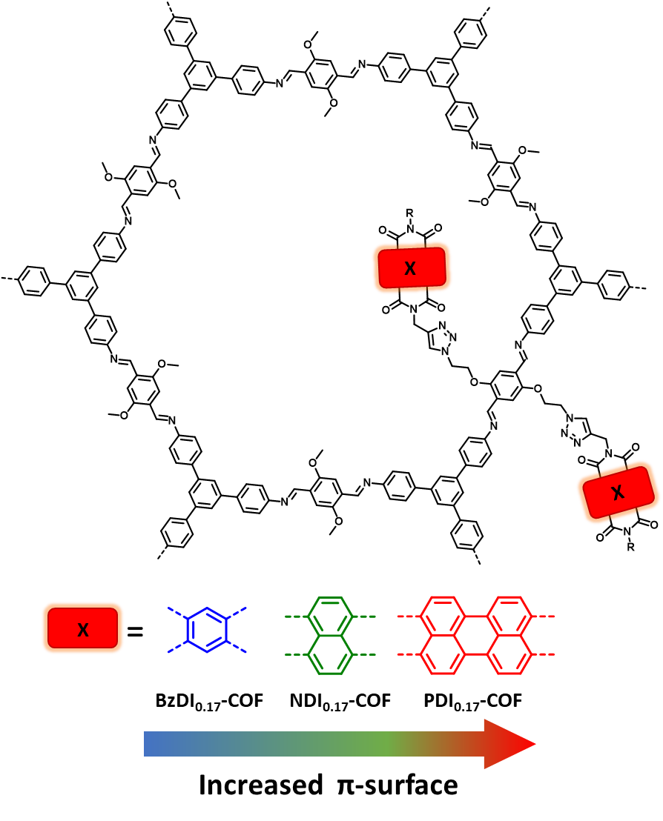
Figure 1. Schematic representation of XDI_{0.17}COFs where X represents the different π-surfaces from left to right: Benzene, Naphthalene and Perylene.
Results and Discussion.
Synthesis and characterization
To anchor the different diimides by click chemistry to DMTA-TAPB-COF, we synthesized the corresponding suitably functionalized building blocks. On the one hand, the synthesis of the diimides was accomplished by the imide condensation reaction between the commercial anhydrides, aliphatic amines and 3-propargylamine obtaining the corresponding XDI-alkynes (Scheme 1B and supporting information, experimental section). On the other hand, for the modification of the COF following the post-synthetic procedure, the synthesis of the novel Azide_{0.17}-COF was carried out. To address this end, a terephthaldehyde derivative endowed with two azide funcionalities (BAETA) was synthetized by a two-step synthetic procedure. The first step involves two Williamson mono-etherification reactions of the previously reported dihydroxyterephthaldehyde (DHTA) to afford the dibrominated derivative (BBETA). The subsequent reaction with sodium azide displaces the pendant bromine electrophiles of the BBETA intermediate to yield the target BAETA (Scheme 1A). It should be noticed that despite other azide-based COFs were reported in literature, this protocol allowed us to implement the azide moieties to the TAPB-DMTA-COF previously described by Jiang and col.³⁵ The main reason is that TAPB-DMTA-COF presents superior stability to hydrolysis than other azide-pendant COFs based on boronate esthers³⁶ or polarized imine-linkages³⁷ which were used in literature to anchor azide moieties and perform click post-functionalization. We envisaged that the stability of the COF skeleton is a key feature to design electrocatalysts since the ORR experiments need to be performed in acidic or alkaline media.³ Furthermore, we decided to use a two carbon-spacer between the azide and the ether functional groups, instead of the larger linker used by Dichtel and co-workers,³⁷ to avoid pore saturation, ensuring quantitative reaction with the terminal alkynes aim of this study.

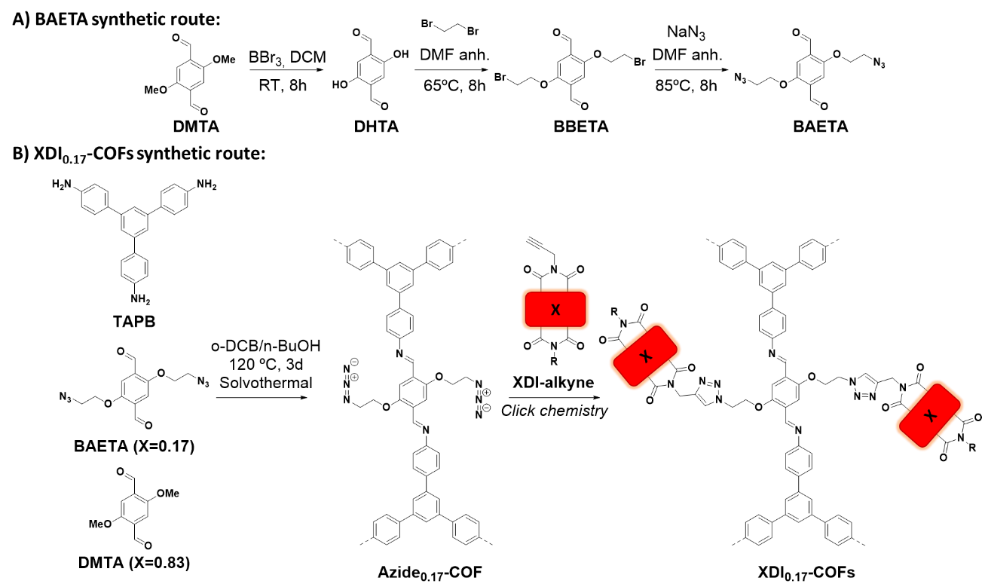
Scheme 1. A) Synthetic route for BAETA monomer. B) Synthetic route towards XDI_{0.17}COFs (The full COF structure was omitted for clarity purposes).
Azide_{0.17}-COF was synthetized by solvothermal reaction between TAPB, DMTA and BAETA in a 1,2-dichlorobenzene/n-butanol (1/1) mixture, in a vacuum-sealed Pyrex vessel at 120 °C for 3 days (Scheme 1B). On the one hand, the successful polymerization of Azide_{0.17}-COF was followed by Fourier transformed infrared (FTIR) spectroscopy (Figure S1) which shows the fading of the signals corresponding to the aldehyde (1667 cm⁻¹) and amine (3430 y 3350 cm⁻¹) functionalities, the retainment of the azide band (at 2100 cm⁻¹) and the emergence of the imine signal (1618 cm⁻¹).³⁸ To estimate the real azide contents, we plotted a standard curve based on the protocol described by Jiang and co-workers³⁵ by employing the characteristic stretching bands of the azide functional group around 2100 cm⁻¹ and using BAETA monomer as equivalent for Azide_{1.00}-COF as the standard. In this manner, the real content was by interpolation of the integrated area of the FTIR spectra (in absorption) of Azide_{0.17}-COF between 2050 and 2177 cm⁻¹, obtaining a 0.1643% of real azide functionalities in the COF (Figure S2), which is close to the 1/6 ratio. On the other hand, ¹³C cross-polarization magic angle spinning nuclear magnetic resonance (¹³C-CP-MAS-NMR) spectra confirms the network formation by the emergence of the imine signal at 154.48 ppm.³⁹ In addition, signals from 149.5 to 109.9 ppm correspond to the aromatic fragments of the COF skeleton, while the signals at 68.53 and 54.30 ppm correspond to the alpha anisochronous carbons next to the azide and ether functionalities, respectively (Figure S3).
The synthesis of XDI_{0.17}COFs was accomplished by the cooper(I) catalyzed Hüisgen’s azide-alkyne cycloaddition reaction (Scheme 1B). The progress of the heterogeneous reaction was monitored by FTIR with the disappearance of the XDI alkyne-hydrogen (≡C-H) stretching band around 3260 cm⁻¹ and the azide tension at 2100 cm⁻¹, ensuring a molar loading around 7.65*10⁻⁴ mol of XDI unit/mg of host COF. In addition, the signals corresponding to the non-reacting functionalities were retained. Thus, the imine band at 1618 cm⁻¹ and the imide symmetric and asymmetric stretching bands appear at 1772 and 1722 cm⁻¹ for BzDI_{0.17}-COF, 1706 and 1666 cm⁻¹ for NDI_{0.17}-COF and 1697 and 1661 cm⁻¹ for PDI_{0.17}-COF, in concordance with that observed in the corresponding molecules (Figure 2A and figures S4-S6). On the other hand, all the solids were characterized by ¹³C-CP-MAS-NMR, revealing the disappearance of the azide alpha carbons as expected for a quantitative reaction, as well as the imide functionalities at 167, 164 and 163 ppm for BzDI_{0.17}-COF, NDI_{0.17}-COF and PDI_{0.17}-COF, respectively (Figure 2B and figures S7-S9).
The porosity of the activated materials was evaluated through the nitrogen sorption isotherms at 77 K (Figure 2C and figures S10-S13). Azide_{0.17}-COF showed a type IV isotherm revealing its mesoporous nature, in concordance with that previously reported for COFs based on the TAPB-DMTA-COF skeleton.³⁸ On the other hand, XDI_{0.17}COFs showed a reduction of the nitrogen uptake, due to the introduction of the bulky electroactive units. Brunauer-Emmet-Teller (BET) equation was applied to the isotherms to calculate the BET surface area of the COFs (Figures S14-S17). In this way, Azide_{0.17}-COF displayed 1460 m²g⁻¹ of surface area which was considerably reduced by the introduction of the electroactive units to 177 m²g⁻¹ for BzDI_{0.17}-COF, 158 m²g⁻¹ for NDI_{0.17}-COF, and 23 m²g⁻¹ for PDI_{0.17}-COF, in concordance with the experimental correlation founded with the XDI size in the PXRD and similar experiments in literature.⁴⁰ Furthermore, the pore volume at 0.95 p/p⁰ also was considerably reduced after the introduction of the XDI moieties from 0.921 cm³g⁻¹ for Azide_{0.17}-COF to 0.142 cm²g⁻¹, 0.153 cm³g⁻¹ and 0.028 cm³g⁻¹ for BzDI_{0.17}-COF, NDI_{0.17}-COF and PDI_{0.17}-COF, respectively. Likewise, the pore size distribution was reduced from 3.2 nm to 2.3 nm (BzDI_{0.17}-COF), 2.0 nm (NDI_{0.17}-COF) and 1.7 nm (PDI_{0.17}-COF) (Figures S18-S21).
Powder X-Ray Diffraction (PXRD) technique was used to analyze the crystalline nature of all the samples (Figure 2D and figures S22-S25). First, Azide_{0.17}-COF presents 6 prominent diffraction maxima which correspond to the diffraction pattern of the parent TAPB-DMTA-COF previously described by Jiang and col.³⁵ The diffraction maxima centred at 2.9° corresponds to the (100) diffraction plane, while the diffraction maxima registered at 4.9°, 5.7°, 7.4°, 13.7° and 25.4° can be assigned to (110), (200), (210), (220) and (001) reflections. A large battery of DFT-based calculations was carried out by using an adequate combination of the Gaussian16⁴¹ and QUANTUM ESPRESSO⁴² software packages to solve the crystalline structure of the different XDI_{0.17}COFs as well as the Azide_{0.17}-COF within the present study (see further details on computational details in ESI, Section S1). Results of these simulations reveal that all the crystal structures exhibit a purely hexagonal symmetry with lattice parameters of the monolayers ranging between 36.9 and 37.6 $Å$. In all cases, the preferred stacking configuration is the eclipsed one showing very similar interlayer distances ranging between 3.53 and 3.62 $Å$ (Figure 3). Theoretically simulated diffractograms on the basis of the optimized crystal structures of Figure 3 show an excellent agreement with the experimental ones, mimicking even the high-angle features directly related with the preferred AA packing fashion and interlayer distances, which reinforce the validity of the structures obtained by the simultaneous structure + cell DFT geometrical optimizations. These values were corroborated by performing Pawley refinement by using GSAS-II⁴³ software (Figure S26), which lattice parameters (Table S1) show negligible differences which those exposed previously. Finally, these results in good agreement with those reported in literature for the post-modification of the original COF with different moieties.^{40, 44, 45} As expected, post-synthetic modification via Hüisgen reaction doesn’t produce displacement of these diffraction maxima, confirming that the COF lattice remains unaltered after post-functionalization. However, the introduction of the diimide moieties produces a gradual reduction of intensity of the diffraction maxima proportionally to the sizes of the unit introduced in the pores.^{40, 44, 45} Thus, these XDI_{0.17}COFs could be considered as an organized pattern of the TAPB-DMTA-COF embedding electroactive moieties covalently anchored to the pore walls with random orientations.

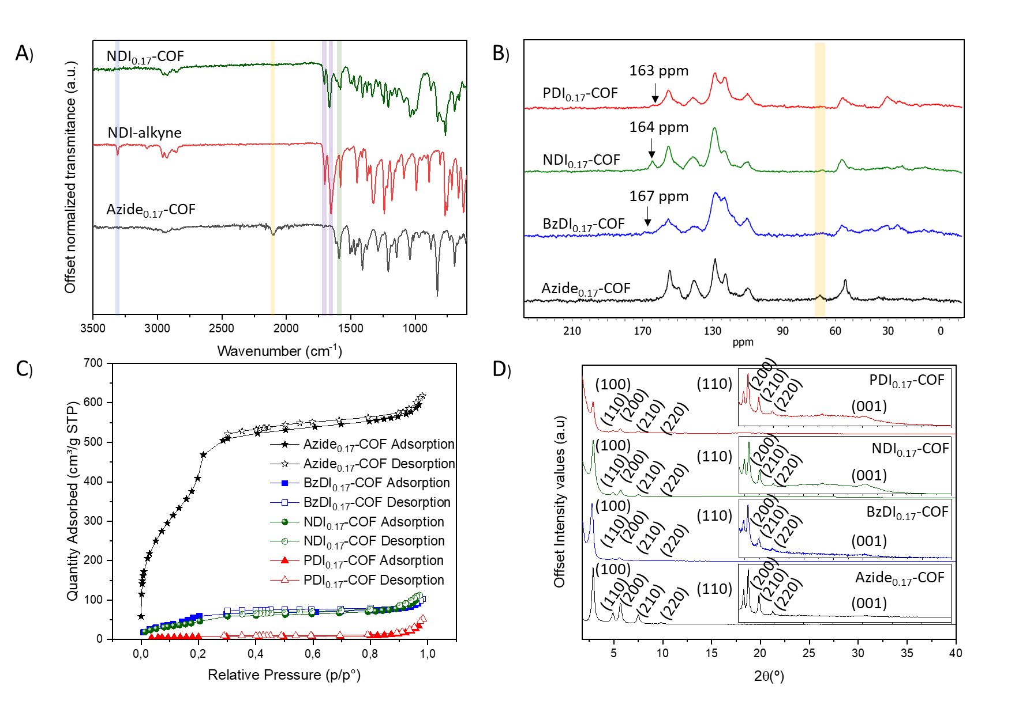
Figure 2. A) Comparison between the FTIR spectra of Azide_{0.17}-COF (black), NDI-Alkyne (red) and NDI_{0,17}-COF (Alkyne disappearance highlighted in blue, azide disappearance highlighted in yellow, imide and imine retainment highlighted in purple and green, respectively). B) ¹³C-CP-MAS-NMR of Azide_{0.17}-COF (black), BzDI_{0.17}-COF (blue), NDI_{0,.17}-COF (green) and PDI_{0.17}-COF (red). C) N₂ sorption isotherms at 77 K Azide_{0.17}-COF (black), BzDI_{0.17}-COF (blue), NDI_{0,.17}-COF (green) and PDI_{0.17}-COF (red). D) PXRD patterns of Azide_{0.17}-COF (black), BzDI_{0.17}-COF (blue), NDI_{0,.17}-COF (green) and PDI_{0.17}-COF (red). Inset shows diffractograms magnification from 4° to 40°.

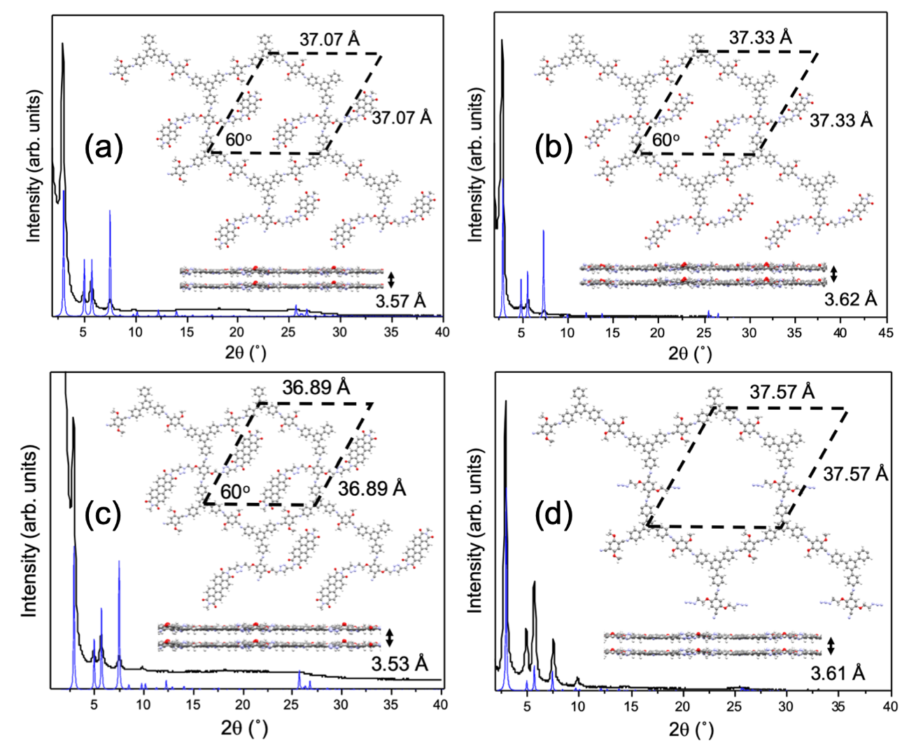
Figure 3. Comparison between the experimental and the theoretically simulated diffractograms obtained from the resulting optimized structures for the: (a) NDI-COF, (b) BzDI-COF, (c) PDI-COF, and (d) Azide-COF. Top and side pictorial views of the structures are also shown in each panel, indicating the resulting optimized unit cell. It is important to notice that the preferential interlaminar stacking for all the compounds is the eclipsed configuration, showing in all cases a very similar interlayer distance.
Thermal stabilities of the XDI_{0.17}COFs were tested through thermogravimetric analysis (TGA) (Figures S27-S29). Thermograms of BzDI_{0.17}-COF and NDI_{0.17}-COF revealed a weight loss of 24% at around 380 °C and showed a progressive mass decrease of 15% until 700 °C according to the degradation of the COF skeleton.⁴⁴ Meanwhile, PDI_{0.17}-COF displayed three weight losses at around 252 °C (4%) and 425 °C (21%) which corresponds to the degradation of the long aliphatic chains which bears PDI⁴⁶ and the COF network, respectively. Finally, a mass decrease of 12 % was observed until 700 °C according to the previous reported literature.⁴⁴
The morphologies of the products were studied through surface electron microscopy (SEM) in a JEOL 7600F microscope. SEM micrographs showed a polygranular rod-like composition for the Azide_{0.17}-COF, revealing that the morphology of the COF remains unaltered from the TAPB-DMTA-COF by introducing the azide moiety as anchoring point (Figure S30). Furthermore, after the click post-functionalization the XDI_{0.17}-COF retains the rod-like macrostructure of the parent Azide_{0.17}-COF, manifesting the “soft” behaviour of the Hüisgen’s reaction during the post-synthetic modification of the COF materials (Figure 4A and figures S31-S33). These morphologies seem suitable to properly delaminate the COF’s layered nanostructure into covalent organic nanosheets (also known as CONs)⁴⁷ and allow the electrode modification for the ORR electrocatalysis experiments via drop-casting. In this way, 1mg of XDI_{0.17}COFs were introduced in commercial 20 mL glass vials and suspended in 5 mL of THF/H₂O (7/3) mixture, acidulated with 5.5 µL of HCl (36 %) and subdued to an ultrasonic bath (35 kHz and 80 W) during 30 min. The non-exfoliated material was pulled apart via ultracentrifugation at 6000 rpm for 45 min and the colloidal XDI_{0.17}CONs were collected from the supernatant using a glass pipette. The colloidal nature of the obtained suspension was corroborated by Tyndall effect upon irradiation with a laser beam. SEM micrographs revealed the layered morphology of the XDI_{0.17}-CONs, consequence of the disruption of the non-covalent interactions between the COF layers (Figure 4B and S34-S36). Furthermore, heterogeneous distributions of sizes and shapes were observed for all the products. Transmission electron microscopy (TEM) revealed the thin structure of the obtained XDI_{0.17}-CONs (Figures S37-S39). Finally, dynamic light scattering (DLS) was employed to measure the hydrodynamic sizes of the colloidal XDI_{0.17}-CONs, obtaining a bimodal distribution centered around 260 nm and 950 nm for the three products (Figure 4C and figures S40-S42), in concordance with the experimental evidence found in electronic microscopy.
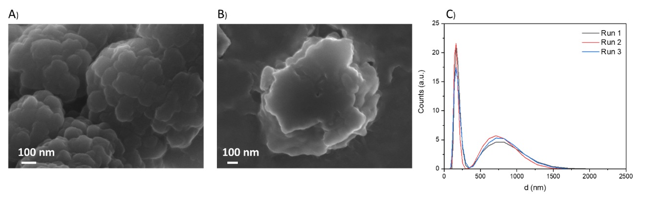
Figure 4. A) SEM micrograph of BzDI_{0.17}-COF (90.000x; scale bar 100 nm). B) SEM micrograph of BzDI_{0.17}-CONs (65.000x; scale bar 100 nm). C) DLS distributions of BzDI_{0.17}-CONs in water.
For the electrochemical measurements, 1 mg of XDI_{0.17}COFs and 1 mg conductive Carbon SuperP in 1 mL of a mixture EtOH/H₂O (7/3) acidulated with 5.5 µL of HCl (36 %) were suspended using an ultrasonic bath (45 kHz and 80 W) during 60 min. A GC electrode was modified with the obtained suspensions by drop-casting. The electrochemical behaviour of XDI_{0.17}COFs/Carbon SuperP/GC were studied by cyclic voltammetry in basic medium (0.1 M NaOH) in the absence of oxygen (Figure 5A) and compared to that of Carbon SuperP/GC. As can be observed, for the three XDI_{0.17}COFs under study two main quasi reversible redox pairs appear at E1_{red}=-0.42 V/E1_{ox}=-0.15 V vs. SCE and E2_{red}=-1.00 V/E2_{ox}=-0.47 V vs. SCE. According with the literature, both redox processes are ascribed to the reversible enolation of carbonyl groups of diimides.^{48, 49} Slight potential variations and important current intensities differences are detected among the electroactive groups under study (BzDI, NDI and PDI) as a consequence of the different π-surface of the structure. NDI_{0.17}-COF presents the higher current intensity (see Figure 5A, red curve), which indicates the redox process is favoured in comparison with that observed for PDI_{0.17}-COF (see Figure 5A, blue curve) and BzDI_{0.17}-COF (see Figure 5A, black curve). This result suggests a better ions accessibility to the electroactive center within the pore and an improvement of electron transfer of the electroactive center with the electrode material.
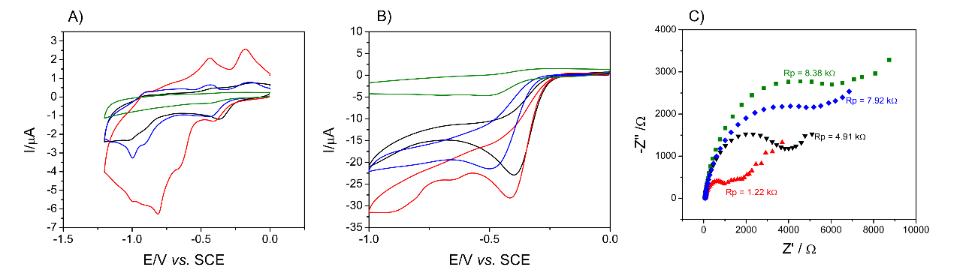
Figure 5. Cyclic voltammograms of bare Carbon SuperP/GC (green) and modified with BzDI_{0.17}-COF (black), NDI_{0.17}-COF (red), PDI_{0.17}-COF (blue) in a 0.1 M NaOH solution in the absence A) and in the presence B) of saturated O₂ at 10 mV/s. C) Nyquist plot obtained from EIS experiments using bare Carbon SuperP/GC (green) and modified with BzDI_{0.17}-COF (black), NDI_{0.17}-COF (red), PDI_{0.17}-COF (blue) in a O₂ saturated 0.1 M NaOH solution (E_{app} = -0.4 V Vs SCE).
We have compared the electrochemical response of NDI_{0.17}-COF with that of other COFs containing NDI groups as a part of the skeleton (TAPT-NDI COF, Figure S41) and free NDI small molecule analogues (TAPT-NDI A, Figure S41), reported previously by us.²⁹ Thus, NDI_{0.17}-COF (Figure S41, blue curve) present an intermediate behaviour between that of the two previously reported NDI derivatives (TAPT-NDI COF; Figure S43, black curve and TAPT-NDI A; Figure S43, red curve). NDI-TAPT-COF only shows a redox pair peak at E⁰=-0.55 V vs. SCE, while NDI-TAPT-A shows two redox pairs at E⁰= -0.80 and E⁰=-0.84 V vs. SCE. In the case of NDI_{0.17}COF, all redox couples observed in NDI-TAPT-COF and NDI-TAPT-A are barely visible in its voltammogram. This behaviour is consequence of the intermediate degree of freedom of the NDI fragment in the case of NDI_{0.17}-COF, since the NDI fragment is inside the pores of the COF network. However, in the NDI-TAPT-COF, the NDI fragments are part of the COF structure and in the NDI-TAPT-A, the NDI fragments are as free molecules.
The potential electrocatalytic effect of the modified electrodes XDI_{0.17}-COF/Carbon SuperP/GC toward ORR were studied by analysing their electrochemical behaviour in the presence of molecular oxygen, using a O₂ saturated 0.1 M NaOH solution (Figure 5B). The catalytic currents observed in all cases, demonstrate the ORR electrocatalytic effect of all XDI_{0.17}COFs respect to the Carbon SuperP/GC electrode (E_{ONSET}=-0.33 V vs. SCE). Some differences are observed among them. The best electrocatalyst in terms of lower ORR onset potential and higher current intensity is NDI_{0.17}-COF, showing -0.25 V vs. SCE as onset potential. Very close in term of onset potential (-0.25 V vs. SCE) is also obtained for BzDI_{0.17}-COF although the current intensity is lower. Differences in the onset potential (-0.29 V vs. SCE) and in the intensity are observed for PDI_{0.17}-COF.
The electrochemical characterization for ORR electrocatalysis in static conditions has been completed using electrochemical impedance spectroscopy (EIS) for the ORR electron transfer. The Nyquist plot obtained for each modified electrode (Figure 5C) clearly shows differences among the XDI_{0.17}-COF/Carbon SuperP/GC electrodes. The electron transfer of ORR is favoured in the case of NDI_{0.17}-COF (Rp= 1.22 kΩ) in comparison with BzDI_{0.17}-COF (Rp= 4.91 kΩ) and PDI_{0.17}-COF (Rp= 7.92 kΩ), showing in all cases less resistance for ORR electron transfer than Carbon SuperP/GC electrodes (Rp= 8.38 kΩ).
Rotating disk-ring electrodes (GC/Pt) were modified with XDI_{0.17}-COFs/Carbon SuperP suspensions or only with Carbon SuperP (used as comparison) and employed to study the ORR in hydrodynamic conditions by linear sweep voltammetry (Figure 6A). Best results have been obtained using NDI_{0.17}-COF/Carbon SuperP/GC (E_{ONSET}= -0.24 V vs. SCE) and a limit current close to -4 mA/cm²) compared with Carbon SuperP/GC electrode (E_{ONSET}= -0.36 V vs. SCE and I_{lim} = -1.51 mA/cm²). Moderate results were obtained when BzDI_{0.17}-COF/Carbon SuperP/GC or PDI_{0.17}-COF/Carbon SuperP/GC are used (in agreement with the results obtained in statics CV of Figure 5B). The number of electrons involved in the ORR were calculated from Eq. (1)
- $n=4\frac{i_{D}}{i_{D}+\frac{i_{R}}{N}}$
Where n is the number of electrons, N is the collection efficiency of the ring (0.37 for the present geometrical arrangement) and i_{D} and i_{R} are the measured currents for the disk and ring electrodes, respectively. The number of electrons exchanged during the ORR have been plotted versus the potential applied (Figure 6B). An increase in the number of electrons involved in the ORR is observed in the case of XDI_{0.17}-COFs/Carbon SuperP/GC electrodes, compared to Carbon SuperP/GC electrodes (2.4 electrons). Furthermore, when NDI_{0.17}-COF/Carbon SuperP/GC is employed the number of exchanged electrons increase until 3.7, which is quite close to 4, suggesting a preference for the 4-electron ORR mechanism over the 2-electron mechanism, which is preferred for energy applications. BzDI_{0.17}-COF/Carbon SuperP/GC and PDI_{0.17}-COF/Carbon SuperP/GC electrocatalysts also increase the number of electrons exchanged during the ORR, but the increase is not so high, 3.1 electrons, suggesting a coexistence of both ORR mechanisms (2 and 4 electrons) in the same proportions. Tafel slopes have been obtained from the hydrodynamic sweep voltammograms of XDI_{0.17}-COFs/Carbon SuperP/GC (Figure 6C). Absolute values of Tafel slopes obtained for XDI_{0.17}-COFs/Carbon SuperP/GC are smaller than that obtained for Carbon SuperP/GC (Tafel Slope = 103 mV/dec), which confirms the electrocatalytic effect of the XDI_{0.17}COFs. The obtained values for BzDI_{0.17}-COF, NDI_{0.17}COFs and PDI_{0.17}-COF are 76.7, 79.7 and 81.5 respectively, which are close between them, but are still a bit far from the Tafel slope of 10% Pt-C/SuperP/GC electrode (68.5 mV/dec). Despite of this difference, a significance reduction is obtained, pointing out to more effective metal free ORR electrocatalysts.
The stability of the XDI_{0.17}-COFs/Carbon SuperP/GC during ORR experiments has been tested applying a fixed potential of -0.4 V vs. SCE for 20 ks in hydrodynamic conditions in an O₂ saturated 0.1 M NaOH solution (Figure 6D). All XDI_{0.17}-COFs/Carbon SuperP/GC electrocatalysts show similar behaviour regarding stability, consisting of an initial decrease of around 20% of their initial activity during the first 200 s and after that the activity remains almost constant until the end of the experiment, losing only an additional 10% of the initial activity during 20 ks. We can consider that these are excellent results, taking into account the organic nature of the non-pyrolized metal-free electrocatalytic materials. Table 1 summarize the main electrochemical results comparing all XDI_{0.17}-COFs/Carbon SuperP/GC and Carbon SuperP/GC. These results point out the influence of the electronic character of the moieties anchored to the COF skeleton, as well as the porosity of the final material. In this manner, structures with similar porosity values (BzDI_{0.17}-COF and NDI_{0.17}-COF) revealed the influence of the aromatic surface. Meanwhile the structure with less porous features (PDI_{0.17}-COF) leaded to the worst electrocatalytic behaviour, showing a clear influence on the ionic accessibility to the active sites for an efficient catalytic response.
Table 1. Summary of the main electrochemical parameters of all XDI_{0.17}-COFs/Carbon SuperP/GC and Carbon SuperP/GC.
Electrode | E_{onset} vs. SCE / mV | j_{lim} / mA/cm² | Tafel Slope / mV/dec | R_{p} / kΩ | ORR number of electrons | Ƞ_{experimental} / V | Ƞ_{theoretical} / V
NDI_{0.17}-COF/Carbon SuperP/GC | -240 | -4.2 | 79.7 | 1.22 | 3.7 | 0.46 | 0.61
BzDI_{0.17}-COF/Carbon SuperP/GC | -290 | -3.8 | 81.5 | 4.91 | 3.1 | 0.51 | 0.64
PDI_{0.17}-COF/Carbon SuperP/GC | -300 | -3.4 | 76.7 | 7.92 | 3.1 | 0.52 | 0.68
TAPB-DMTA-COF | -300 | -2.87 | 76.7 | 4.72 | 3.1 | 0.52 | -
Carbon SuperP/GC | -330 | -1.51 | 103 | 8.38 | 2.4 | 0.55 | -

Figure 6. Hydrodynamic linear sweep voltammetry A) and number of electrons exchanged in ORR at different potentials B) using RRDE of GC/Pt (disc/ring) modified with BzDI_{0.17}-COF/Carbon SuperP (black), NDI_{0.17}-COF/Carbon SuperP (red), PDI_{0.17}-COF/Carbon SuperP (blue) TAPB-DMTA-COF/Carbon SuperP (cyan) and Carbon SuperP (green) in a O₂ saturated 0.1 M NaOH solution at 10 mV/s and 1000RPM. C) Tafel slope of ORR electrocatalysis obtained from results in A). D) Current intensity stability of BzDI_{0.17}-COF/Carbon SuperP/GC (black), NDI_{0.17}-COF/Carbon SuperP/GC (red), PDI_{0.17}-COF/Carbon SuperP/GC (blue) electrodes operating in O₂ saturated 0.1 M NaOH solution at a constant potential (-0.4 V vs. SCE).
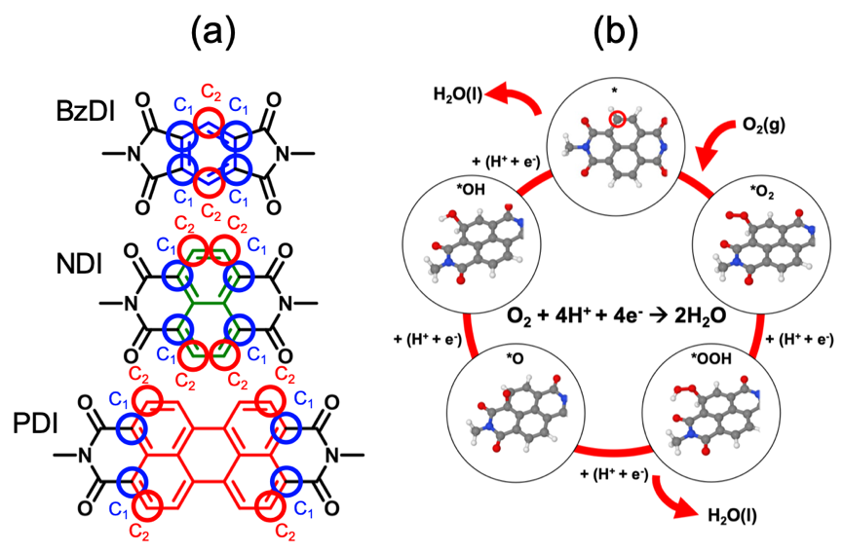
Figure 7. a) Active ORR sites detected within the NDI, BzDI and PDI moeties by DFT-based calculations named as C1 (blue circles) and C2 (red circles), and b) optimized adsorption configurations for the most active C2 site in the NDI ligand for the *O2, *OOH, *O and *OH ORR intermediates within the optimized NDI0.17-COF. These adsorption configurations are essentially the same for all the three ligands.
To theoretically propose a viable ORR mechanism for these systems we have studied the ORR intermediate steps involving the adsorption of O₂, O, OH, OOH and H₂O on the most favourable active sites within the three COF structures under study, as well as their associated free energies within the Gibbs free-energy formalism (see further details in ESI, section 1). In a first step, in all the structures we have identified two favourable active sites to develop the ORR reaction on the NDI, BzDI and PDI moieties. These two active sites are the C atoms named as C₁ and C₂ in Figure 7a, with Bader point charges of +0.42 and +0.44 e⁻, respectively, and the highest adsorption energies for all the intermediates; although in all the three cases the most favourable is the C₂ active site over the C₁ one, with slightly stronger adsorption energies with reference to the C₁ active site. As a representative example, Figure 7b shows the optimized adsorption configurations on the C₂ site in the NDI ligand for the *O₂, *OOH, *O and *OH ORR intermediates within the optimized NDI_{0.17}-COF. It is important to remark that the adsorption configurations of all the ORR intermediates are very similar for all the three ligands. Interestingly, adsorption of *O in all cases in the sense that it prefers to be adsorbed on a C₁—C₂ bridge, independently of whether the starting point of the relaxation has the O atom originally located “on-top” a C₁ or a C₂.
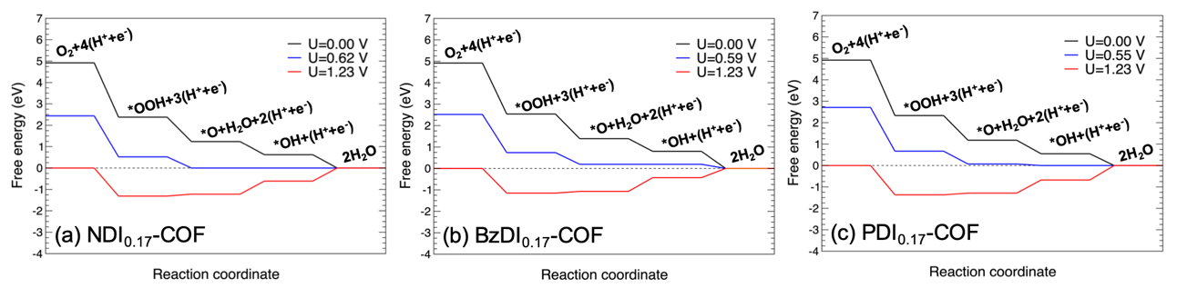
Figure 8. Free energy change of ORR at 298.15 K and pH=0 for the best-performing C₂ active site on the: (a) NDI_{0.17}-COF, (b) BzDI_{0.17}-COF, and (c) PDI_{0.17}-COF at different electrode potentials. The calculated working potential is indicated by the blue line, being the potential for which the first reaction step becomes downhill with reference to the rest of steps. The ORR overpotential for each case, yielding the ORR catalytic performance, can be easily obtained as the difference between the fuel cell potential of 1.23 V minus the working potential for each COF system.
According to all the above mentioned, we have investigated the ORR catalytic performance, involving four electron transfer steps, for the C₂ active site in all the COF structures. Free energy diagrams constructed for the XDI_{0.17}-COFs are shown in Figure 8 at 298.15 K and pH=0 at different electrode potentials (U=0 V, working potential in each case and 1.23 V). As expected, all the three free-energy reactions are downhill at U=0 V, which indicates that thermodynamically the four-electron reaction pathway is clearly favorable. For the NDI_{0.17}-COF and the PDI_{0.17}-COF the potential determining step is the formation of the second H₂O molecule, whilst for BzDI_{0.17}-COF the determining reaction step is the formation of *OH from *O. From the theoretical analysis, among the three compounds studied, the NDI_{0.17}-COF manifests the highest ORR catalytic activity on account of its highest working potential of 0.62 eV, which yields an ORR overpotential of Ƞ_{ORR}=0.61 V. BzDI_{0.17}-COF and PDI_{0.17}-COF exhibit a slightly poorer, although also good, catalytic activity with working potentials of 0.59 and 0.55 V, and associated ORR overpotentials of 0.64 and 0.68 V, respectively. At this point, it is worth mentioning that these results accurately resemble the experimentally observed ORR catalytic performances, being the NDI_{0.17}-COF the best candidate, followed in efficiency by BzDI_{0.17}-COF and PDI_{0.17}-COF, respectively (Table 1).
As a proof of concept, in an attempt to rationalize the origin of the small differences in the η_{ORR} of the different COFs, and since within this kind of COF systems the electronic properties of the molecular building blocks keep almost unaltered with reference to their molecular states, we have computed different electronic properties of the NDI, BzDI and PDI molecular systems (neutral, anion and cation forms) in order to establish a correlation with the obtained η_{ORR} values of 0.61, 0.64 and 0.68 V (see details of these calculations in ESI), respectively. Since the ORR catalytic mechanism involves the sequential capture of 4 electrons, we have calculated the adiabatic electronic affinities (AEAs) of the molecular systems to check which system is able to accommodate electrons in a more efficient way. As a result of these new calculations we have obtained values for adiabatic electronic affinities for the NDI, BzDI and PDI molecular systems of -2.57, -2.26 and -1.92 eV, respectively, which correlate with the obtained η_{ORR} values, in the sense that the higher energy release and the more optimal stabilization towards the gain of electrons is observed for the NDI with an AEA value of -2.57 eV, being the system with the best theoretical catalytic performance with a theoretical η_{ORR} of 0.61 V. This rationalization results also consistent by the correlation between AEAs of -2.26 and -1.92 eV and η_{ORR} of 0.64 and 0.68 V for BzDI and PDI, respectively.
Interestingly, the experimental overpotentials are lower than their theorical counterpart which were calculated for isolated molecules, with a constant difference around 0.15 V for all the products. These results suggest there is a cooperativity effect between components of the XDI_{0.17}COFs/Carbon SuperP/GC composites towards the oxygen electroreduction which is not considered in DFT calculations. However, the constant difference between the theoretical and experimental overpotential values means that the theorical calculations reveal close evidence in the ORR mechanism and provide powerful information for the NDI modification to enhance the electrocatalytic response by chemical modulation of this active center.
Conclusions
In summary, we have developed a new strategy to evaluate the performance of organic molecules as metal-free and non-pyrolyzed electrocatalysts. This work, facilitates the evaluation of novel active sites by the covalently anchoring by click chemistry in crystalline and porous networks which prevents the active site agglomeration, increases the surface-volume ratio and ensures a close contact with electrodes. To demonstrate this, a family of electroactive diimide-based XDI_{0.17}-COFs by the post-synthetic modification of the novel Azide_{0.17}-COF, was carried out by varying the “X” aromatic surface between the diimide functional groups from benzene to perylene with a molar loading of 7.65*10⁻⁴ mol of active site/mg of host COF. These XDI_{0.17}-COFs retain the crystalline features of the parent Azide_{0.17}-COF with a hexagonal eclipsed stacking of the network, locating the XDI units embedded inside the COF cavities and covalently anchored to the pore walls. Dispersion of these compounds by LPE produced XDI_{0.17}-COFs colloids which can be used for glassy carbon electrodes modification by drop-casting. Electrochemical studies revealed that most convenient moieties under study, for energy-related application was the NDI_{0.17}-COF through the 4-electron pathway with an onset potential 0.77 V (vs RHE) and a limiting current of 4.2 mA/cm². DFT theorical calculations were used to evaluate the ORR mechanism, confirming that the naphtalenediimide moieties show the best performance towards the oxygen electroreduction. It is also worth pointing out that comparison between the ORR electrocatalytic performance of NDI_{0.17}-COF with that of other non-pyrolyzed and metal-free COF-based electrocatalysts (Table S2) reveals equiparable results in terms of onset potential and current density in addition to the easier access to crystalline porous COFs offered by the click chemistry post-functionalization methodology. Despite that these results are still far from those offered by other derived-carbons produced by pyrolytic treatment of organic precursors (Table S3), we envisage that this easy strategy, avoiding de novo synthesis, could accelerate the discovery of novel non-pyrolyzed and metal-free COF-based electrocatalyst.

Supporting Information
The Supporting Information is available free of charge at
***
Supporting information includes: Materials and methods (Section 1), COF characterization by PXRD, FTIR, ¹³C-CP-MAS-NMR, N₂ sorption isotherms, TGA SEM, TEM and DLS (Section 2), additional electrochemical measurements (Section 3) and experimental procedures (Section 4).
AUTHOR INFORMATION
Corresponding Author
* José L. Segura. E-mail: segura@ucm.es
*Encarnación Lorenzo: E-mail: encarnacion.lorenzo@uam.es
Author Contributions
‡These authors contributed equally. Marcos Martínez-Fernández: Investigation, Data curation, Visualization, Writing –original draft, Writing –review & editing. Emiliano Martínez-Periñán: Investigation, Data curation, Visualization, Writing –original draft, Writing -review & editing. José I. Martínez: Conceptualization, Investigation, Data curation, Visualization, Writing –original draft, Writing –re- view & editing. Marta Gordo-Lozano Investigation, Data curation, –original draft, Writing –review & editing F. Zamora: Conceptualization, Investigation, Visualization, Writing –review & editing. José L. Segura: Conceptualization, Investigation, Visualization, Supervision, Writing – review & editing, Funding acquisition, Project administration. Encarnación Lorenzo: Conceptualization, Investigation, Visualization, Supervision, Writing –review & editing, Funding acquisition, Project administration

Funding Sources
This work was financially supported by Ministerio de Ciencia e Innovación of Spain MICINN (PID2019- 106268GB-C33; RED2018-102412-T; PID2020-116728RB-I00, PID2019- 106268GB-C32, Grants No. PID2020-113142RB-C21 and No. PLEC2021-007906, funded MCIN/AEI/10.13039/501100011033), Comunidad de Madrid (P2018/NMT-4349 TRANSNANOAVANSENS Program; SI3/PJI/2021-00341, Grants No. S2018/NMT-4367 and No. Y2020/NMT6469), the UCM (INV.GR.00.1819.10759).

ACKNOWLEDGMENT
This work was financially supported by MICINN (PID2019- 106268GB-C33; RED2018-102412-T; PID2020-116728RB-I00, PID2019- 106268GB-C32), Comunidad de Madrid (P2018/NMT-4349 TRANSNANOAVANSENS Program; SI3/PJI/2021-00341) and the UCM (INV.GR.00.1819.10759). MMF and MGL acknowledges Comunidad de Madrid for a predoctoral contract. “JIM acknowledges funding from Ministerio de Ciencia e Innovación of Spain (Grants No. PID2020-113142RB-C21 and No. PLEC2021-007906, funded MCIN/AEI/10.13039/501100011033), and Comunidad de Madrid (Grants No. S2018/NMT-4367 and No. Y2020/NMT6469)."

REFERENCES
1. Ma, R.; Lin, G.; Zhou, Y.; Liu, Q.; Zhang, T.; Shan, G.; Yang, M.; Wang, J., A review of oxygen reduction mechanisms for metal-free carbon-based electrocatalysts. npj Computational Materials 2019, 5 (1), 78.
2. Gewirth, A. A.; Varnell, J. A.; DiAscro, A. M., Nonprecious Metal Catalysts for Oxygen Reduction in Heterogeneous Aqueous Systems. Chemical Reviews 2018, 118 (5), 2313-2339.
3. Shao, M.; Chang, Q.; Dodelet, J.-P.; Chenitz, R., Recent Advances in Electrocatalysts for Oxygen Reduction Reaction. Chemical Reviews 2016, 116 (6), 3594-3657.
4. Wagner, F. T.; Lakshmanan, B.; Mathias, M. F., Electrochemistry and the Future of the Automobile. The Journal of Physical Chemistry Letters 2010, 1 (14), 2204-2219.
5. Grumelli, D.; Wurster, B.; Stepanow, S.; Kern, K., Bio-inspired nanocatalysts for the oxygen reduction reaction. Nature Communications 2013, 4 (1), 2904.
6. Di Noto, V.; Pagot, G.; Negro, E.; Vezzù, K.; Kulesza, P. J.; Rutkowska, I. A.; Pace, G., A formalism to compare electrocatalysts for the oxygen reduction reaction by cyclic voltammetry with the thin-film rotating ring-disk electrode measurements. Current Opinion in Electrochemistry 2022, 31, 100839.
7. Li, D.; Li, C.; Zhang, L.; Li, H.; Zhu, L.; Yang, D.; Fang, Q.; Qiu, S.; Yao, X., Metal-Free Thiophene-Sulfur Covalent Organic Frameworks: Precise and Controllable Synthesis of Catalytic Active Sites for Oxygen Reduction. Journal of the American Chemical Society 2020, 142 (18), 8104-8108.
8. Bajracharya, S.; ElMekawy, A.; Srikanth, S.; Pant, D., 6 - Cathodes for microbial fuel cells. In Microbial Electrochemical and Fuel Cells, Scott, K.; Yu, E. H., Eds. Woodhead Publishing: Boston, 2016; pp 179-213.
9. Wang, N.; Ma, S.; Zuo, P.; Duan, J.; Hou, B., Recent Progress of Electrochemical Production of Hydrogen Peroxide by Two-Electron Oxygen Reduction Reaction. Advanced Science 2021, 8 (15), 2100076.
10. Debe, M. K., Electrocatalyst approaches and challenges for automotive fuel cells. Nature 2012, 486 (7401), 43-51.
11. Wang, M.; Wang, C.; Liu, J.; Rong, F.; He, L.; Lou, Y.; Zhang, Z.; Du, M., Efficient Ag/Ag2O-Doped Cobalt Metallo-Covalent Organic Framework Electrocatalysts for Rechargeable Zinc-Air Battery. ACS Sustainable Chemistry & Engineering 2021, 9 (17), 5872-5883.
12. Yang, Y.; Lu, Y.; Zhang, H.-Y.; Wang, Y.; Tang, H.-L.; Sun, X.-J.; Zhang, G.; Zhang, F.-M., Decoration of Active Sites in Covalent–Organic Framework: An Effective Strategy of Building Efficient Photocatalysis for CO2 Reduction. ACS Sustainable Chemistry & Engineering 2021, 9 (39), 13376-13384.
13. Yang, C.; Tao, S.; Huang, N.; Zhang, X.; Duan, J.; Makiura, R.; Maenosono, S., Heteroatom-Doped Carbon Electrocatalysts Derived from Nanoporous Two-Dimensional Covalent Organic Frameworks for Oxygen Reduction and Hydrogen Evolution. ACS Applied Nano Materials 2020, 3 (6), 5481-5488.
14. Xu, Q.; Tang, Y.; Zhang, X.; Oshima, Y.; Chen, Q.; Jiang, D., Template Conversion of Covalent Organic Frameworks into 2D Conducting Nanocarbons for Catalyzing Oxygen Reduction Reaction. Advanced Materials 2018, 30 (15), 1706330.
15. Zhou, N.; Wang, N.; Wu, Z.; Li, L., Probing Active Sites on Metal-Free, Nitrogen-Doped Carbons for Oxygen Electroreduction: A Review. Catalysts 2018, 8 (11), 509.
16. Yan, X.; Wang, B.; Ren, J.; Long, X.; Yang, D., An Unsaturated Bond Strategy to Regulate Active Centers of Metal-Free Covalent Organic Frameworks for Efficient Oxygen Reduction. Angewandte Chemie International Edition n/a (n/a).
17. Xu, Q.; Qian, J.; Luo, D.; Liu, G.; Guo, Y.; Zeng, G., Ni/Fe Clusters and Nanoparticles Confined by Covalent Organic Framework Derived Carbon as Highly Active Catalysts toward Oxygen Reduction Reaction and Oxygen Evolution Reaction. Advanced Sustainable Systems 2020, 4 (9), 2000115.
18. Zhang, J.; Zhang, G.; Jin, S.; Zhou, Y.; Ji, Q.; Lan, H.; Liu, H.; Qu, J., Graphitic N in nitrogen-Doped carbon promotes hydrogen peroxide synthesis from electrocatalytic oxygen reduction. Carbon 2020, 163, 154-161.
19. Segura, J. L.; Royuela, S.; Mar Ramos, M., Post-synthetic modification of covalent organic frameworks. Chemical Society Reviews 2019, 48 (14), 3903-3945.
20. Gomes, R.; Bhattacharyya, A. J., Carbon Nanotube-Templated Covalent Organic Framework Nanosheets as an Efficient Sulfur Host for Room-Temperature Metal–Sulfur Batteries. ACS Sustainable Chemistry & Engineering 2020, 8 (15), 5946-5953.
21. Yang, S.; Li, T.; Cheng, Y.; Fan, W.; Wang, L.; Liu, Y.; Bian, L.; Zhou, C.-H.; Zheng, L.-Y.; Cao, Q.-E., Covalent Organic Framework Isomers for Photoenhanced Gold Recovery from E-Waste with High Efficiency and Selectivity. ACS Sustainable Chemistry & Engineering 2022, 10 (30), 9719-9731.
22. Huang, Y.; Kong, F.; Tian, H.; Pei, F.; Chen, Y.; Meng, G.; Chang, Z.; Chen, C.; Cui, X.; Shi, J., Ultrauniformly Dispersed Cu Nanoparticles Embedded in N-Doped Carbon as a Robust Oxygen Electrocatalyst. ACS Sustainable Chemistry & Engineering 2022, 10 (19), 6370-6381.
23. Zhang, H.; Zhu, M.; Schmidt, O. G.; Chen, S.; Zhang, K., Covalent Organic Frameworks for Efficient Energy Electrocatalysis: Rational Design and Progress. Advanced Energy and Sustainability Research 2021, 2 (4), 2000090.
24. Zhao, X.; Pachfule, P.; Thomas, A., Covalent organic frameworks (COFs) for electrochemical applications. Chemical Society Reviews 2021, 50 (12), 6871-6913.
25. Haase, F.; Lotsch, B. V., Solving the COF trilemma: towards crystalline, stable and functional covalent organic frameworks. Chemical Society Reviews 2020, 49 (23), 8469-8500.
26. Chang, S.; Li, C.; Li, H.; Zhu, L.; Fang, Q., Stable Thiophene-sulfur Covalent Organic Frameworks for Oxygen Reduction Reaction(ORR). Chemical Research in Chinese Universities 2022, 38 (2), 396-401.
27. Wu, S.; Li, M.; Phan, H.; Wang, D.; Herng, T. S.; Ding, J.; Lu, Z.; Wu, J., Toward Two-Dimensional π-Conjugated Covalent Organic Radical Frameworks. Angewandte Chemie International Edition 2018, 57 (27), 8007-8011.
28. García-Arroyo, P.; Martínez-Periñán, E.; Cabrera-Trujillo, J. J.; Salagre, E.; Michel, E. G.; Martínez, J. I.; Lorenzo, E.; Segura, J. L., Pyrenetetraone-based covalent organic framework as an effective electrocatalyst for oxygen reduction reaction. Nano Research 2022, 15 (5), 3907-3912.
29. Martínez-Fernández, M.; Martínez-Periñán, E.; Royuela, S.; Martínez, J. I.; Zamora, F.; Lorenzo, E.; Segura, J. L., Covalent organic frameworks based on electroactive naphthalenediimide as active electrocatalysts toward oxygen reduction reaction. Applied Materials Today 2022, 26, 101384.
30. Royuela, S.; Martínez-Periñán, E.; Arrieta, M. P.; Martínez, J. I.; Ramos, M. M.; Zamora, F.; Lorenzo, E.; Segura, J. L., Oxygen reduction using a metal-free naphthalene diimide-based covalent organic framework electrocatalyst. Chemical Communications 2020, 56 (8), 1267-1270.
31. Li, Q.; Zhang, S.; Dai, L.; Li, L.-s., Nitrogen-Doped Colloidal Graphene Quantum Dots and Their Size-Dependent Electrocatalytic Activity for the Oxygen Reduction Reaction. Journal of the American Chemical Society 2012, 134 (46), 18932-18935.
32. Liu, X.; Hu, M.; Wang, M.; Song, Y.; Zhou, N.; He, L.; Zhang, Z., Novel nanoarchitecture of Co-MOF-on-TPN-COF hybrid: Ultralowly sensitive bioplatform of electrochemical aptasensor toward ampicillin. Biosensors and Bioelectronics 2019, 123, 59-68.
33. Li, H.; Kou, B.; Yuan, Y.; Chai, Y.; Yuan, R., Porous Fe3O4@COF-Immobilized gold nanoparticles with excellent catalytic performance for sensitive electrochemical detection of ATP. Biosensors and Bioelectronics 2022, 197, 113758.
34. Yan, T.; Lan, Y.; Tong, M.; Zhong, C., Screening and Design of Covalent Organic Framework Membranes for CO2/CH4 Separation. ACS Sustainable Chemistry & Engineering 2019, 7 (1), 1220-1227.
35. Xu, H.; Gao, J.; Jiang, D., Stable, crystalline, porous, covalent organic frameworks as a platform for chiral organocatalysts. Nature Chemistry 2015, 7 (11), 905-912.
36. Chen, L.; Furukawa, K.; Gao, J.; Nagai, A.; Nakamura, T.; Dong, Y.; Jiang, D., Photoelectric Covalent Organic Frameworks: Converting Open Lattices into Ordered Donor–Acceptor Heterojunctions. Journal of the American Chemical Society 2014, 136 (28), 9806-9809.
37. Ji, W.; Xiao, L.; Ling, Y.; Ching, C.; Matsumoto, M.; Bisbey, R. P.; Helbling, D. E.; Dichtel, W. R., Removal of GenX and Perfluorinated Alkyl Substances from Water by Amine-Functionalized Covalent Organic Frameworks. Journal of the American Chemical Society 2018, 140 (40), 12677-12681.
38. Xu, Q.; Tao, S.; Jiang, Q.; Jiang, D., Designing Covalent Organic Frameworks with a Tailored Ionic Interface for Ion Transport across One-Dimensional Channels. Angewandte Chemie International Edition 2020, 59 (11), 4557-4563.
39. Martín-Illán, J. Á.; Rodríguez-San-Miguel, D.; Castillo, O.; Beobide, G.; Perez-Carvajal, J.; Imaz, I.; Maspoch, D.; Zamora, F., Macroscopic Ultralight Aerogel Monoliths of Imine-based Covalent Organic Frameworks. Angewandte Chemie International Edition 2021, 60 (25), 13969-13977.
40. Xu, Q.; Tao, S.; Jiang, Q.; Jiang, D., Ion Conduction in Polyelectrolyte Covalent Organic Frameworks. Journal of the American Chemical Society 2018, 140 (24), 7429-7432.
41. Frisch, M. J.; Trucks, G. W.; Schlegel, H. B.; Scuseria, G. E.; Robb, M. A.; Cheeseman, J. R.; Scalmani, G.; Barone, V.; Petersson, G. A.; Nakatsuji, H.; Li, X.; Caricato, M.; Marenich, A. V.; Bloino, J.; Janesko, B. G.; Gomperts, R.; Mennucci, B.; Hratchian, H. P.; Ortiz, J. V.; Izmaylov, A. F.; Sonnenberg, J. L.; Williams; Ding, F.; Lipparini, F.; Egidi, F.; Goings, J.; Peng, B.; Petrone, A.; Henderson, T.; Ranasinghe, D.; Zakrzewski, V. G.; Gao, J.; Rega, N.; Zheng, G.; Liang, W.; Hada, M.; Ehara, M.; Toyota, K.; Fukuda, R.; Hasegawa, J.; Ishida, M.; Nakajima, T.; Honda, Y.; Kitao, O.; Nakai, H.; Vreven, T.; Throssell, K.; Montgomery Jr., J. A.; Peralta, J. E.; Ogliaro, F.; Bearpark, M. J.; Heyd, J. J.; Brothers, E. N.; Kudin, K. N.; Staroverov, V. N.; Keith, T. A.; Kobayashi, R.; Normand, J.; Raghavachari, K.; Rendell, A. P.; Burant, J. C.; Iyengar, S. S.; Tomasi, J.; Cossi, M.; Millam, J. M.; Klene, M.; Adamo, C.; Cammi, R.; Ochterski, J. W.; Martin, R. L.; Morokuma, K.; Farkas, O.; Foresman, J. B.; Fox, D. J. Gaussian 16 Rev. C.01, Wallingford, CT, 2016.
42. Giannozzi, P.; Baroni, S.; Bonini, N.; Calandra, M.; Car, R.; Cavazzoni, C.; Ceresoli, D.; Chiarotti, G. L.; Cococcioni, M.; Dabo, I.; Dal Corso, A.; de Gironcoli, S.; Fabris, S.; Fratesi, G.; Gebauer, R.; Gerstmann, U.; Gougoussis, C.; Kokalj, A.; Lazzeri, M.; Martin-Samos, L.; Marzari, N.; Mauri, F.; Mazzarello, R.; Paolini, S.; Pasquarello, A.; Paulatto, L.; Sbraccia, C.; Scandolo, S.; Sclauzero, G.; Seitsonen, A. P.; Smogunov, A.; Umari, P.; Wentzcovitch, R. M., QUANTUM ESPRESSO: a modular and open-source software project for quantum simulations of materials. Journal of Physics: Condensed Matter 2009, 21 (39), 395502.
43. Toby, B. H.; Von Dreele, R. B., GSAS-II: the genesis of a modern open-source all purpose crystallography software package. Journal of Applied Crystallography 2013, 46 (2), 544-549.
44. Royuela, S.; Gil-San Millán, R.; Mancheño, M. J.; Ramos, M. M.; Segura, J. L.; Navarro, J. A. R.; Zamora, F., Catalytically Active Imine-based Covalent Organic Frameworks for Detoxification of Nerve Agent Simulants in Aqueous Media. Materials 2019, 12 (12), 1974.
45. Mu, Z.-J.; Ding, X.; Chen, Z.-Y.; Han, B.-H., Zwitterionic Covalent Organic Frameworks as Catalysts for Hierarchical Reduction of CO2 with Amine and Hydrosilane. ACS Applied Materials & Interfaces 2018, 10 (48), 41350-41358.
46. Adel, R.; Gala, E.; Alonso-Navarro, M. J.; Gutierrez-Fernandez, E.; Martín, J.; Stella, M.; Martinez-Ferrero, E.; de la Peña, A.; Harbuzaru, A.; Ramos, M. M.; Ortiz, R. P.; Segura, J. L.; Campoy-Quiles, M., Comparing the microstructure and photovoltaic performance of 3 perylene imide acceptors with similar energy levels but different packing tendencies. Journal of Materials Chemistry C 2022, 10 (5), 1698-1710.
47. Cui, W.-R.; Zhang, C.-R.; Jiang, W.; Liang, R.-P.; Wen, S.-H.; Peng, D.; Qiu, J.-D., Covalent Organic Framework Nanosheet-Based Ultrasensitive and Selective Colorimetric Sensor for Trace Hg2+ Detection. ACS Sustainable Chemistry & Engineering 2019, 7 (10), 9408-9415.
48. Wu, X.; Qi, Y.; Hong, J. J.; Li, Z.; Hernandez, A. S.; Ji, X., Rocking-Chair Ammonium-Ion Battery: A Highly Reversible Aqueous Energy Storage System. Angewandte Chemie International Edition 2017, 56 (42), 13026-13030.
49. Tsai, H.-H.; Lin, T.-J.; Vedhanarayanan, B.; Tsai, C.-C.; Chen, T.-Y.; Ji, X.; Lin, T.-W., A 1.9-V all-organic battery-supercapacitor hybrid device with high rate capability and wide temperature tolerance in a metal-free water-in-saltelectrolyte. Journal of Colloid and Interface Science 2022, 612, 76-87.
For table of contents use only
A series of diimide-based active sites with variation of the aromatic surface from benzene to perylene to study how the active site is involved in the oxygen reduction reaction (ORR) electrocatalysis through a novel post-synthetic strategy.

