Running head: Tendency and ability processes

Life is…great!
Emotional attention during instructed and uninstructed ambiguity resolution in relation to depressive symptoms

Alvaro Sanchez, Jonas Everaert, Laura M.S. De Putter, Sven C. Mueller, & Ernst H.W. Koster
Ghent University, Belgium

* Corresponding author:
Alvaro Sanchez
Ghent University
Department of Experimental Clinical and Health Psychology
Henri Dunantlaan 2
B-9000 Ghent
Belgium
Tel: +0032 09 264 91 05
Fax: +0032 09 264 64 89
E-mail:alvaro.sanchezlopez@ugent.be

This is a postprint accepted version of the published manuscript: Sanchez, A., Everaert, J., De Putter, L. M., Mueller, S. C., & Koster, E. H. (2015). Life is … great! Emotional attention during instructed and uninstructed ambiguity resolution in relation to depressive symptoms. Biological psychology, 109, 67–72.
The final article is available at: https://doi.org/10.1016/j.biopsycho.2015.04.007

Abstract
Attention and interpretation biases are closely involved in depression-related processing of emotional material. However, it is unclear whether attention and interpretation biases reflect a processing tendency (i.e., driven by schemas or prior learning) or an ability-related process (i.e., dependent on attentional control). This study tested how depressive symptom severity, attention bias, and interpretation bias are related under tendency versus ability processing conditions. Fifty-two participants completed two versions of the scrambled sentences test (to measure interpretation bias) while eye movements were recorded (to measure attention bias) in separate experimental sessions. To assess tendency and ability processes, participants were instructed to unscramble the sentences by reporting the first sentence that comes to mind (tendency version; session 1) and to unscramble the sentences in a fixed, positive manner (ability version; session 2). Results showed that depressive symptom severity was correlated with attention bias under both tendency and ability conditions. Analyses showed that attention bias (i.e., the fixation time spent on positive versus negative words) acted as an intervening variable in the relation between depressive symptoms and interpretation bias only during ability processes. These findings suggest that depression-linked biases in attention reflect both processing tendencies and ability-related processes in attentional control, with attentional control as a relevant mechanism in the subsequent interpretation of emotional material. Implications for cognitive theories and cognitive training methods are discussed.

Keywords: depression, cognitive bias, attention, interpretation, attentional control

Highlights
- Relations among depressive symptom severity, attention and interpretation biases were examined under tendency and ability processing conditions
- Attention biases were measured online via eye tracking in tendency an ability versions of an interpretation task
- Depression-linked attention biases emerged under both processing tendency and ability conditions
- Attention biases acted as an intervening variable in the relation between depressive symptom severity and interpretation biases under ability conditions
- Ability-related attention biases may regulate how individuals elaborate on new emotional information

Introduction
A wealth of empirical research has provided evidence for depression-related emotional biases in attention and interpretation. Whereas healthy people are biased toward positive material, depressed people allocate attention disproportionally more to negative compared with positive or neutral material (De Raedt & Koster, 2010; Peckham, McHugh, & Otto, 2010) and draw more negative than positive meanings on ambiguous information (Wisco, 2009). These biases in attention and interpretation seem closely related. Attention biases modulate encoding (Everaert, Duyck, & Koster, 2014) and retrieval (Everaert & Koster, 2015) of emotional interpretations drawn on ambiguous material. At present, however, the nature of attention and interpretation biases is not well-understood.
Some theoretical models of depression (Clark, Beck, & Alford, 1999; Ingram, 1984; Williams, Watts, MacLeod, & Mathews, 1997) assume that emotionally biased cognitive processes¹ reflect processing tendencies driven by schemas. Schemas refer to a coherent set of memory representations gravitating around beliefs about the self and others (e.g., “I am a failure”). The knowledge represented in these schemas could be recruited in automatic and goal-driven or strategic ways to guide attention allocation and interpretation while processing new emotional information. In support of this hypothesis, some studies have shown that prior learning experiences can shape attention allocation toward emotionally congruent material (Anderson, Laurent, & Yantis, 2011; Fulcher, Mathews, Mackintosh, & Law, 2001; Hickey & van Zoest, 2013; Rohner, 2004; Schmidt, Belopolsky, & Theeuwes, 2014).
Other cognitive views on depression (Hertel, 1997; Joormann, Yoon, & Zetsche, 2007; Joormann, 2010) propose that cognitive biases reflect regulatory deficits in cognitive or attentional control. Attentional control refers to a person’s ability to exert top down control to focus attention on task-relevant stimuli and to inhibit attention toward task-irrelevant stimuli. Here, emotional biases in attention toward negative material would reflect deficits in cognitive control processes, such as deficient cognitive inhibition of negative material in working memory. In support of this notion, research has demonstrated such depression-related difficulties in inhibition and attentional control (De Lissnyder, Koster, Derakshan, & De Raedt, 2010; Derakshan, Salt, & Koster, 2009; Goeleven, De Raedt, Baert, & Koster, 2006; Joormann, 2004).
While schema-based and impaired cognitive control accounts of depression differ with respect to their prediction regarding the nature of emotional biases in attention and interpretation, both theoretical perspectives have received some empirical support. At present, however, a direct test comparing how tendency versus ability processes are involved in the interplay between attention and interpretation biases during elaboration on emotional material has yet to be conducted. This lingering issue motivated the current study.

This study
To illuminate the nature of attention and interpretation biases related to depression, empirical tests could be derived from defining features of tendency-driven versus ability-driven processes with respect to the malleability of the cognitive biases in attention and interpretation. If attention and interpretation biases reflect processing tendencies, then these biases could be overridden by verbal instruction and/or top-down control (Hertel, 1994). Alternatively, if these biases are related to a reduced ability to control or regulate emotion processing, than they would be less malleable via verbal instruction and thus require more sophisticated interventions to modify the processing biases (Calkins, McMorran, Siegle, & Otto, 2014; Siegle, Ghinassi, & Thase, 2007).
The present study aimed to investigate relations between depressive symptom severity, attention bias, and interpretation bias while distinguishing between processing tendency and ability processes based on assumptions regarding their malleability. We adapted a recently designed method to model attention – interpretation relations (Everaert et al., 2014) to tap into tendency and ability processes. The original study design involved the use of eye tracking (to measure attention bias) while participants performed a scrambled sentences test (to measure interpretation bias). This test requires participants to create self-referent statements using five of the six presented words (e.g., “I am a born winner” derived from the item “born I winner am loser a”). In this study, participants with varying depressive symptom levels took part in two different lab sessions in which they completed a processing tendency (session 1) or ability (session 2) version of the scrambled sentences test. In the tendency version, participants were asked to report the first unscrambled sentence that came to mind (i.e., to assess individual differences in the tendency to interpret ambiguous information in a negative or positive manner). In the ability version, participants were asked to unscramble all emotional sentences in a positive manner (i.e., to assess individual differences in the ability to draw positive meanings on ambiguous information). Modeling relations between depressive symptom severity, attention bias, and interpretation bias, several cognitive models (Ingram, 1984; Joormann et al., 2007; Williams, Watts, MacLeod, & Mathews, 1988) and prior research (Everaert et al., 2014; Everaert, Tierens, Uzieblo, & Koster, 2013) point out that depression-related biases in attention can regulate the process of interpretation. Therefore, we hypothesized that attention bias (indexed by the relative fixation time on positive versus negative words in a scrambled sentence) would mediate the relation between depressive symptom severity and interpretation bias (indexed by the number of positively versus negatively unscrambled sentences). We expected such an indirect effect for both tendency and ability processes.

Method

Participants
Fifty-two undergraduate students (39 women; age range: 17-27) with a broad range of Beck Depression Inventory – II (BDI-II) (Beck, Steer, & Brown, 1996; Van der Does, 2002) scores were recruited. All participants were native Dutch speakers with normal or corrected-to-normal vision. They provided informed consent and were paid 15 euro. The study was approved by the faculty review board at Ghent University.

Depressive symptom severity
The BDI-II assessed depressive symptom severity. On 21 items rated on a four-point scale, respondents indicated the extent to which they suffered from depressive symptoms in the past two weeks. This measure has good reliability and validity in both healthy and depressed samples (Beck et al., 1996; Van der Does, 2002). The internal consistency was α=.94 in this study. At testing, a mean score of 9.85 (SD=9.39; range: 0-37) was observed, with 38 individuals reporting minimal, 5 mild, 6 moderate, and 3 severe symptom levels.

Stimuli
A total set of 43 Dutch scrambled sentences (24 emotional, 19 neutral sentences) was drawn from the stimulus pool designed for a prior study (Everaert et al., 2014). All scrambled sentences were self-referent and six words long. Each emotional scrambled sentence presented one positive and one negative target word (e.g., “winner” and “loser” in “am winner born loser a I”). Target words were matched between valence categories on word length, word class, and CELEX-based word frequency using WordGen (Duyck, Desmet, Verbeke, & Brysbaert, 2004).² There were no differences between negative and positive target words on these lexical variables (F-s<1). To control for parafoveal processing of adjoining words (Schotter et al., 2012) and wrap-up effects (i.e., differential reading times for sentence-final versus sentence-internal words; Rayner, Kambe, & Duffy, 2000), word position within each scrambled sentence was randomized with the constraint that emotional words occurred neither next to each other nor as the first or last word within a scrambled sentence. In addition, the positive word was presented before the negative word in exactly half of the emotional scrambled sentences. Criteria employed for the emotional scrambled sentences were also applied to neutral target words (e.g., “cinema” and “theatre” in “the I theatre visit cinema often”) in the neutral sentences.

Assessment of cognitive biases
The experimental task design was modeled after Everaert et al. (2014) who used a combination of an interpretation task (a computerized version of the Scrambled Sentences Test; SST; Wenzlaff & Bates, 1998) with online measurement of attention bias (via eye tracking).
The basic experimental design. Each trial of the SST started with the presentation of a fixation cross at the left side of the screen until participants fixated the point for 200 ms. The following stimulus display presented either a neutral or an emotional scrambled sentence. Each scrambled sentences occurred at the center of the screen on a single line in black mono-spaced lowercase Arial (font size 25pt) against a white background. Participants were instructed to mentally unscramble the sentences to form a grammatically correct and meaningful statement using five of the six words (e.g., “I often visit the theatre” in a neutral trial; “I am a born winner”, in an emotional trial), as quickly as possible. Upon completion, participants pressed a button to continue to the response trial part. Here, each word of the scrambled sentence was presented with a number prompting participants to report their unscrambled solution to the experimenter using the corresponding numbers (to reduce socially desirable responding). The response display was presented until response or for maximum of 8000 ms. Figure 1 provides an example of a trial sequence.
After a 3-trial practice phase with only neutral scrambled sentences, participants started the test phase. The test phase presented 40 scrambled sentences dispersed over 5 blocks with 3 blocks of only emotional sentences and 2 blocks of only neutral scrambled sentences. The neutral blocks were always presented between emotional blocks to reduce priming effects (i.e., emotional – neutral – emotional – neutral – emotional). Each block randomly presented 8 scrambled sentences. Interpretation bias was indexed by the number of positively versus negatively unscrambled sentences over the total correctly completed emotional (positive and negative) sentences (see the ‘cognitive bias indices’ section).
While participants performed the SST, their gaze behavior was recorded during the stimulus display trial parts of the task via eye-tracking. This enabled online measurement of visual attention while participants actively selected competing positive and negative stimuli (e.g., ““winner” and “loser” in “am winner born loser a I”) to elaborate on the target item relevant to the process of making meaning (e.g., “I am a born winner” versus “I am a born loser”). Eye movement registration provides sensitive parameters (e.g., fixation times) to index emotional biases in attention allocation in such a reading context (Rayner, 1998).
Tendency versus ability processes. As noted in the introduction, the malleability of the processing biases through top-down control is, by definition, a distinguishing feature of tendency-driven versus ability-driven processing biases. It is proposed that tendency processes can be overridden by verbal instruction whereas ability-related regulatory impairments are less malleable via instruction. This defining feature can be used to pit these different views on the nature of cognitive biases against each other. In this study, we used this basic feature to create two different versions of the SST: one version to index individual differences in the tendency to interpret ambiguous information in a negative or positive manner, and the other variant to assess individual differences in the ability to draw positive meanings on ambiguous information.
The tendency and ability version of the basic task design only differed with regard to the task instructions provided to the participants. In the tendency version, participants received the standard task instructions and were asked to report the first unscrambled sentence that came to mind. In the ability version, participants were instructed to unscramble all emotional sentences to create grammatically correct and positive self-statements in the emotional blocks and to follow standard task instructions during neutral blocks. The tendency and ability version of the SST were completed in two separate experimental sessions. All participants first completed the tendency version and one week later the ability version. The long time interval prevented memory-effects in the second session (even after a short retention interval participants recalled <7 unscrambled solutions in a previous study; see Everaert, Duyck, et al., 2014).
The same set of scrambled sentences was used in each version of the SST. Note that the blocks of trials were presented in a different order between the sessions to control for serial position effects. Three types of block combinations across the two SST versions were constructed. We ensured that the emotional and neutral blocks in the first session did not appear in the same order in the second session. Participants were randomly presented with one of the three possible block combinations.

Cognitive bias indices
The same indices of attention and interpretation bias were computed for the tendency and the ability versions of the SST. Following calculations were made for each task variant. To obtain a measure of attention bias, we considered the total fixation time (i.e., the sum of the duration across fixations) on the positive versus negative target words in the emotional scrambled sentences (i.e., the areas of interest). This parameter is a commonly reported index of attention bias that is sensitive to individual differences in depressive symptom severity (Armstrong & Olatunji, 2012; Ellis, Beevers, & Wells, 2011; Everaert et al., 2014). A relative bias score (i.e., positive versus negative) was calculated within-subjects (Everaert et al., 2014). The total fixation time on positive words was divided by the total fixation time on emotional (positive and negative) words in the emotional scrambled sentences. Note that this relative index controls for inter-individual baseline fixation differences due to inter-individual variability in reading performance.
For interpretation bias, a positive bias index was computed by dividing the number of positively unscrambled sentences by the total number correctly completed emotional (positive and negative) sentences.

Eye tracking
Participants’ eye movements were recorded using a Tobii TX300 eye-tracker system. This system employs a dual-Purkinje eye-tracking method (Crane & Steele, 1985) and samples eye-gaze coordinates at 300 Hz (e.g., a coordinates’ estimation every 3.3 ms). Both stimuli presentation and eye movements’ recording were controlled by E-prime Professional software (Schneider, Eschman, & Zuccolotto, 2012). The eye-tracking system synchronized automatically with the program at the start of each trial. Participants were seated approximately 60 cm from the eye tracker capture. Eye movement signals were converted to visual fixation data by using E-prime extensions for Tobii (i.e., Clearview PackageCalls). Visual fixations were considered when longer than 100 ms. Areas of interest were the negative and positive target words in each emotional scrambled sentence.

Procedure
The study involved two separate experimental sessions. In the first session, participants provided informed consent and completed the BDI-II. This was followed by the tendency version of the SST, which was combined with eye tracking. A 9-point grid calibration procedure was repeated before each emotional block of the SST, drifts from proper calibration were checked at the start of each trial, and the system was recalibrated when necessary. The experimenter recorded the participants’ verbal responses (i.e., the coded unscrambled sentences) manually without providing feedback. Participants were given the opportunity to take a short break after each test block to ensure optimal concentration. In the second experimental session, one week later, participants completed the ability version of the SST, which was again combined with eye-tracking. We adhered to the same protocol as in the first session. Each experimental session lasted between 20-30 min.

Statistical analyses
The data-analytic strategy comprised two steps. First, we inspected bivariate correlations between depressive symptom severity (BDI-II scores) and biases in attention (percentage of the total fixation time spent on positive words) and interpretation (percentage of positively unscrambled sentences) during tendency and ability processes. This was done to investigate associations between the variables under study. Second, to examine how tendency and ability processes in attention and interpretation biases operate in depression, we tested a mediation model in which attention bias intervenes as mediator in the relationship between depressive symptom severity and interpretation bias. Note that model building was based on theoretical hypotheses by cognitive models (Ingram, 1984; Joormann et al., 2007; Williams et al., 1988) and prior research findings (Everaert et al., 2014, 2013).
We tested the mediation model separately for tendency and ability processes using a bootstrapping approach (Preacher & Hayes, 2008). By relying on confidence intervals to determine the significance of the indirect effect, this statistical method avoids problems associated with traditional approaches (e.g., unrealistic assumptions regarding multivariate normality) (see Hayes, 2009). We examined the significance of the total effect (i.e., effect of depressive symptom severity on interpretation bias without taking into account attention bias; path c), the direct effect (i.e., effect of depressive symptom severity on interpretation bias after controlling for attention bias; path c’), and the indirect effect (i.e., effect of depressive symptom severity on interpretation bias via attention bias; path a × b). The estimated 5000 bias-corrected bootstrap 95% confidence intervals should not contain 0 to be significant (Preacher & Hayes, 2008).

Results

Correlational analysis
Table 1 presents the correlations between depressive symptom severity and emotional biases in attention and interpretation for tendency and ability processes.
Processing tendency. There were negative correlations between depressive symptom severity and both attention and interpretation biases, suggesting that lower depressive symptom severity levels are linked to more positive emotional biases in both attention and interpretation. Attention and interpretation biases were also positively correlated with one another. This indicates that a greater attention bias toward positive compared to negative material is linked to more positive compared to negative interpretations of ambiguous information.
Processing ability. Depressive symptom severity was negatively correlated with attention bias, but was not related to interpretation bias. Attention bias was again positively correlated with interpretation bias, showing that a higher ability to interpret ambiguous information in a positive manner is linked to a more positive emotional bias in attention.
Processing tendency and ability associations. Across-session correlations indicate that attention and interpretation biases during tendency and ability processing are relatively independent. Interpretation tendency and ability were only marginally related (r=.26, p=.06), and no significant correlations between attention biases emerged across sessions (r=.08, p=.58).

Bias-corrected bootstrapping analysis
Bias-corrected bootstrapping analyses with 5000 samples were conducted separately for tendency and ability processes. For tendency processes, we tested a mediation model with depressive symptom severity as the independent variable, interpretation bias as the dependent variable, and attention bias as the mediator. For ability processes, we tested an indirect effect model (cf. the non-significant relation between depressive symptom severity and interpretation bias) with depressive symptom severity as the independent variable, interpretation bias as the dependent variable, and attention bias as the intervening variable (Mathieu & Taylor, 2006).
Processing tendency. Bootstrapping analysis estimated the indirect effect of depressive symptom severity on interpretation bias via attention bias between 95%-CI: [-.0025, .0009] suggesting that the indirect effect is not significantly different from zero at p<.05 (indirect effect coefficient=-.0006, SE=.0008). The total effect, c=-.019 (SE=.0024), t=-7.90, p<.001, 95%-CI: [-.0236, -.0141], and the direct effect, c’=-.0183 (SE=0.0025), t=-7.22, p<.001, 95%-CI: [-.0233, -.0132] were significant. These results indicate that, for tendency processes, attention bias did not mediate the relation between depressive symptom severity and interpretation bias. Instead, depressive symptom severity seems to have a direct effect on interpretation bias.
Processing ability. The indirect effect of depressive symptom severity on interpretation bias via attention bias was negative (indirect effect coefficient=-.0007, SE=.0005) and statistically different from zero (p<.05). The bias-corrected bootstrap confidence interval was entirely below zero, 95%-CI: [-.0020, -.0001]. This suggests that, for ability processes, attention bias acts an intervening variable in the relation between depressive symptom severity and interpretation ability. Both the total effect, c=-.0014 (SE=.001), t=-1.36, p=.18, 95%-CI: [-.0035, .0007], and the direct effect, c’=-.0007 (SE=0.0011), t=-0.70, p=.49, 95%-CI: [-.0028, .0014], were not significant. The significant indirect effect and the non-significant total and direct effects provide support for the proposed indirect effect model.

Discussion
This study examined relations between depressive symptom severity, attention, and interpretation bias under tendency-driven and/or ability-driven processing conditions of new emotional material. The results showed (1) that depressive symptom severity was related to attention biases during tendency as well as ability processes, and (2) an indirect effect of depressive symptom severity on interpretation bias via attention bias as an intervening variable only for ability processes. These main findings are discussed in turn.
The significant correlations found between depressive symptom severity and attention biases during both tendency-driven and ability-driven processes suggest that depression-linked biases in attention may reflect influences of both schemas/prior learning and attentional control. This pattern of relations provides evidence for cognitive models of depression assuming that emotionally biased cognitive processes reflect processing tendencies driven by memory representations (Clark et al., 1999; Ingram, 1984; Williams et al., 1997) as well as for cognitive views asserting that emotionally biased cognitive processes reflect regulatory deficits in attentional control (Joormann et al., 2007; Joormann, 2010). It also aligns with research indicating that depression-related attention biases can be guided by prior learning experiences of emotional material (Anderson et al., 2011; Fulcher et al., 2001; Hickey & van Zoest, 2013; Rohner, 2004; Schmidt et al., 2014) but also with research showing that depression-related attention biases are linked to deficient attentional control in the inhibition of negative information (De Lissnyder et al., 2010; Derakshan et al., 2009; Goeleven et al., 2006; Joormann, 2004). Interestingly, the indices of attention bias during tendency and ability processes were not correlated. This suggests that tendency-based biases and ability-driven deficits in emotional attention reflect relatively independent mechanisms that may influence emotional attention processing differently depending on the nature of the task.
This study also showed that attention bias acts as an intervening variable between depressive symptom severity and interpretation bias for ability processes, while this was not true for tendency processes. This finding suggests that attention operations linked to deficits in attentional control in depression may act as a relevant mechanism in the subsequent elaboration on or interpretation of emotional material. This finding provides further support for predictions by impaired cognitive control accounts of depression (Joormann et al., 2007; Joormann, 2010) and adds to prior research evidence testing the hypothesized indirect effect of depression-linked attention biases on the elaboration of new emotional information (Everaert et al., 2014, 2013). The absence of evidence for an indirect effect of depressive symptom severity on interpretation bias via attention bias for tendency processes does not rule out the role of tendency-based cognitive biases in depression. It only indicates that the current mediation model does not adequately represent the interplay between depressive symptom severity, attention bias, and interpretation bias. This is further suggested by the significant correlations between depressive symptom severity levels and attention biases for tendency as well as ability processes. Future research may need to provide a more direct measure of memory bias or dysfunctional schemas to explicitly model this effect in relation to depressive symptoms and attention bias to capture their interplay during tendency processing.
The current observations have implications for the implementation of cognitive training methods to modify attention biases. Traditional attention bias modification procedures rely on experimentally established contingencies between to-be-detected targets and the location of positive or negative stimuli (MacLeod, Rutherford, Campbell, Ebsworthy, & Holker, 2002). However, these procedures have yielded mixed findings and overall small effect sizes in modifying attention bias and reducing symptoms of anxiety and depression (Beard, Sawyer, & Hofmann, 2012; Hallion & Ruscio, 2011; Mogoașe, David, & Koster, 2014). One explanation for these modest effect sizes may be that both processing tendencies as well as abilities need to be targeted where typically only one of these aspects is trained. It would be important to consider the plasticity or malleability of these different constituents of processing biases in depression. To effectively train or modify biases, future attention training procedures may need to target self-regulatory control in attention allocation. This could be achieved, for example, by increasing awareness of how attention is directed toward positive and negative stimuli when one processes emotional material (Bernstein & Zvielli, 2014) or by improving general cognitive control (Siegle et al., 2007). As a result of targeting self-regulatory control processes, this type of training procedures may also alter the emotional content of the interpretations drawn on emotionally ambiguous material.
The present study is not without limitations. First, the cross-sectional design precludes conclusions regarding the assumed influence of attention bias on interpretation for ability processes. As mentioned, direct proofs of cause-and-effect relations require experimental manipulation of attention bias (e.g., via cognitive control training) to examine training-related changes in interpretation bias. Second, the non-clinical nature of the recruited sample and the assessment of depressive symptom severity via a self-report measure limit the generalizability of our findings to depression. Further investigation of attention and interpretation biases during tendency and ability processes need to test whether similar dysfunctions cut across different samples representing the depression course (i.e., samples of non-depressed at-risk, clinically depressed, and formerly depressed individuals). Despite this limitation, the current findings remain of interest given that the magnitude of negative cognitive biases (e.g., in attention, interpretation) are a linear function of depressive symptom severity with cognitive shift from a positivity bias in healthy people to facilitated processing of negative information in clinically depressed people (Beck & Haigh, 2014; Clark et al., 1999).
In conclusion, this study aimed to advance insight into the attention – interpretation bias interplay in healthy and subclinically depressed individuals. Our findings suggest that depression-linked attention processing biases emerge both under processing tendency and ability conditions and, moreover, that an ability-dysfunction in attention may regulate how individuals elaborate on new emotional information.

Acknowledgements
This research was supported by a grant of the Research Foundation Flanders (FWO, reference 117438) awarded to Alvaro Sanchez and a grant BOF10/GOA/014 for a Concerted Research Action of Ghent University awarded to Ernst Koster. We thank Mark Rabijns, Marjolein Rossignol and Jeroen Barbé for their help in the data collection.

References
Anderson, B. A., Laurent, P. A., & Yantis, S. (2011). Value-driven attentional capture. Proceedings of the National Academy of Sciences of the United States of America, 108(25), 10367–10371. doi:10.1073/pnas.1104047108
Armstrong, T., & Olatunji, B. O. (2012). Eye tracking of attention in the affective disorders: A meta-analytic review and synthesis. Clinical Psychology Review, 32(8), 704–723. doi:10.1016/j.cpr.2012.09.004
Beard, C., Sawyer, A. T., & Hofmann, S. G. (2012). Efficacy of attention bias modification using threat and appetitive stimuli: A meta-analytic review. Behavior Therapy, 43, 724–740. doi:10.1016/j.beth.2012.01.002
Beck, A. T., & Haigh, E. A. P. (2014). Advances in cognitive theory and therapy: The generic cognitive model. Annual Review of Clinical Psychology, 10, 1–24. doi:10.1146/annurev-clinpsy-032813-153734
Beck, A. T., Steer, R. A., & Brown, G. K. (1996). Manual for the Beck Depression Inventory - II. San Antonio, TX: Psychological Corporation.
Bernstein, A., & Zvielli, A. (2014). Attention Feedback Awareness and Control Training (A-FACT): Experimental test of a novel intervention paradigm targeting attentional bias. Behaviour Research and Therapy, 55, 18–26. doi:10.1016/j.brat.2014.01.003
Calkins, A. W., McMorran, K. E., Siegle, G. J., & Otto, M. W. (2014). The effects of computerized cognitive control training on community adults with depressed mood. Behavioural and Cognitive Psychotherapy, 1–12. doi:10.1017/S1352465814000046
Clark, D. A., Beck, A. T., & Alford, B. A. (1999). Scientific foundations of cognitive theory and therapy of depression. New York: John Willey and Sons Ltd.
Crane, H. D., & Steele, C. M. (1985). Generation-V dual-Purkinje-image eyetracker. Applied Optics, 24(4), 527. Retrieved from http://www.ncbi.nlm.nih.gov/pubmed/18216982
De Lissnyder, E., Koster, E. H. W., Derakshan, N., & De Raedt, R. (2010). The association between depressive symptoms and executive control impairments in response to emotional and non-emotional information. Cognition & Emotion, 24(2), 264–280. doi:10.1080/02699930903378354
De Raedt, R., & Koster, E. H. W. (2010). Understanding vulnerability for depression from a cognitive neuroscience perspective: A reappraisal of attentional factors and a new conceptual framework. Cognitive, Affective & Behavioral Neuroscience, 10(1), 50–70. doi:10.3758/CABN.10.1.50
Derakshan, N., Salt, M., & Koster, E. H. W. (2009). Attentional control in dysphoria: An investigation using the antisaccade task. Biological Psychology, 80, 251–255. doi:10.1016/j.biopsycho.2008.09.005
Duyck, W., Desmet, T., Verbeke, L. P. C., & Brysbaert, M. (2004). WordGen: A tool for word selection and nonword generation in Dutch, English, German, and French. Behavior Research Methods, Instruments, & Computers, 36(3), 488–499. doi:10.3758/BF03195595
Ellis, A. J., Beevers, C. G., & Wells, T. T. (2011). Attention allocation and incidental recognition of emotional information in dysphoria. Cognitive Therapy and Research, 35(5), 425–433. doi:10.1007/s10608-010-9305-3
Everaert, J., Duyck, W., & Koster, E. H. W. (2014). Attention, interpretation, and memory biases in subclinical depression: A proof-of-principle test of the combined cognitive biases hypothesis. Emotion, 14(2), 331–340. doi:10.1037/a0035250
Everaert, J., & Koster, E. H. W. (2015). Interactions among emotional attention, encoding , and retrieval of ambiguous information : An eye-tracking study. Emotion, 15(2), 2–6. doi:10.1037/emo0000063
Everaert, J., Tierens, M., Uzieblo, K., & Koster, E. H. W. (2013). The indirect effect of attention bias on memory via interpretation bias: Evidence for the combined cognitive bias hypothesis in subclinical depression. Cognition & Emotion, 27(8), 1450–1459. doi:10.1080/02699931.2013.787972
Fulcher, E. P., Mathews, A., Mackintosh, B., & Law, S. (2001). Evaluative learning and the allocation of attention to emotional stimuli. Cognitive Therapy and Research, 25(3), 261–280. doi:10.1023/A:1010732328104
Goeleven, E., De Raedt, R., Baert, S., & Koster, E. H. W. (2006). Deficient inhibition of emotional information in depression. Journal of Affective Disorders, 93(1-3), 149–157. doi:10.1016/j.jad.2006.03.007
Hallion, L. S., & Ruscio, A. M. (2011). A meta-analysis of the effect of cognitive bias modification on anxiety and depression. Psychological Bulletin, 137(6), 940–958. doi:10.1037/a0024355
Hayes, A. F. (2009). Beyond Baron and Kenny: Statistical mediation analysis in the new millennium. Communication Monographs, 76(4), 408–420. doi:10.1080/03637750903310360
Hertel, P. T. (1994). Depression and memory: Are impairments remediable through attentional control? Current Directions in Psychological Science, 3(6), 190–193. doi:10.1111/1467-8721.ep10770707
Hertel, P. T. (1997). On the contributions of deficent cognitive control to memory impairments in depression. Cognition & Emotion, 11(5/6), 569–583. doi:10.1080/026999397379890a
Hickey, C., & van Zoest, W. (2013). Reward-associated stimuli capture the eyes in spite of strategic attentional set. Vision Research, 92, 67–74. doi:10.1016/j.visres.2013.09.008
Ingram, R. E. (1984). Toward an information-processing analysis of depression. Cognitive Therapy and Research, 8(5), 443–477. doi:10.1007/BF01173284
Joormann, J. (2004). Attentional bias in dysphoria: The role of inhibitory processes. Cognition & Emotion, 18(1), 125–147. doi:10.1080/02699930244000480
Joormann, J. (2010). Cognitive inhibition and emotion regulation in depression. Current Directions in Psychological Science, 19(3), 161–166. doi:10.1177/0963721410370293
Joormann, J., Yoon, K. L., & Zetsche, U. (2007). Cognitive inhibition in depression. Applied and Preventive Psychology, 12(3), 128–139. doi:10.1016/j.appsy.2007.09.002
MacLeod, C., Rutherford, E., Campbell, L., Ebsworthy, G., & Holker, L. (2002). Selective attention and emotional vulnerability: Assessing the causal basis of their association through the experimental manipulation of attentional bias. Journal of Abnormal Psychology, 111(1), 107–123. doi:10.1037/0021-843X.111.1.107
Mathieu, J. E., & Taylor, S. R. (2006). Clarifying conditions and decision points for mediational type inferences in organizational behavior. Journal of Organizational Behavior, 27(8), 1031–1056. doi:10.1002/job.406
Mogoașe, C., David, D., & Koster, E. H. W. (2014). Clinical efficacy of attentional bias modification procedures: An updated meta-analysis. Journal of Clinical Psychology, 70(12), 1133–1157. doi:10.1002/jclp.22081
Peckham, A. D., McHugh, R. K., & Otto, M. W. (2010). A meta-analysis of the magnitude of biased attention in depression. Depression and Anxiety, 27(12), 1135–1142. doi:10.1002/da.20755
Preacher, K. J., & Hayes, A. F. (2008). Asymptotic and resampling strategies for assessing and comparing indirect effects in multiple mediator models. Behavior Research Methods, 40(3), 879–91. doi:10.3758/BRM.40.3.879
Rayner, K. (1998). Eye movements in reading and information processing: 20 years of research. Psychological Bulletin, 124(3), 372–422. doi:10.1037/0033-2909.124.3.372
Rayner, K., Kambe, G., & Duffy, S. A. (2000). The effect of clause wrap-up on eye movements during reading. The Quarterly Journal of Experimental Psychology. A, Human Experimental Psychology, 53(4), 1061–80. doi:10.1080/713755934
Rohner, J.-C. (2004). Memory-based attentional biases: Anxiety is linked to threat avoidance. Cognition & Emotion, 18(8), 1027–1054. doi:10.1080/02699930341000365
Schmidt, L. J., Belopolsky, A. V, & Theeuwes, J. (2014). Attentional capture by signals of threat. Cognition & Emotion, 1–8. doi:10.1080/02699931.2014.924484
Schneider, W., Eschman, A., & Zuccolotto, A. (2012). E-Prime User’s Guide. Pittsburgh: Psychology Software Tools, Inc.
Siegle, G. J., Ghinassi, F., & Thase, M. E. (2007). Neurobehavioral therapies in the 21st century: Summary of an emerging field and an extended example of cognitive control training for depression. Cognitive Therapy and Research, 31(2), 235–262. doi:10.1007/s10608-006-9118-6
Van der Does, A. J. W. (2002). Handleiding bij de Nederlandse versie van de Beck Depression Inventory - second edition (BDI-II-NL). [The Dutch version of the Beck Depresion Inventory-II]. Lisse, The Netherlands: Swets & Zeitlinger.
Wenzlaff, R. M., & Bates, D. E. (1998). Unmasking a cognitive vulnerability to depression: How lapses in mental control reveal depressive thinking. Journal of Personality and Social Psychology, 75(6), 1559–1571. doi:10.1037/0022-3514.75.6.1559
Williams, J. M. G., Watts, F. N., MacLeod, C., & Mathews, A. (1988). Cognitive psychology and emotional disorders. New York: John Willey and Sons Ltd.
Williams, J. M. G., Watts, F. N., MacLeod, C., & Mathews, A. (1997). Cognitive psychology and emotional disorders (2nd ed.). Chichester: John Willey and Sons Ltd.
Wisco, B. E. (2009). Depressive cognition: Self-reference and depth of processing. Clinical Psychology Review, 29(4), 382–392. doi:10.1016/j.cpr.2009.03.003

Footnote
¹ Terms as cognitive bias, emotionally biased cognitive process, emotional bias are used interchangeably to denote the category of emotional biases in cognitive processes of which attention bias and interpretation bias are concrete examples.
² Word length: M negative words = 8.79 (SD negative words = 1.71), M positive words = 8.58 (SD positive words = 1.97); Word frequency (log frequency per million): M negative words = 1.02 (SD negative words = 0.47), M positive words = 1.04 (SD positive words = 0.62).

Tables and Figures

Table 1. Correlations between dependent variables and descriptive statistics.
 | 1 | 2 | 3 | 4 | M (SD)
BDI-II | -.32* | -.75** | -.31* | -.19 | 9.85 (9.39)
Processing tendency
1. Attention bias | – | .30* | .08 | .20 | 52.06% (3.18)
2. Interpretation bias |  | – | .15 | .26⁺ | 69.87% (23.76)
Processing ability
3. Attention bias |  |  | – | .32* | 52.82% (3.58)
4. Interpretation bias |  |  |  | – | 96.89% (6.99)
Notes. BDI-II = Beck Depression Inventory – II; ⁺p<.10; *p<.05; **p<.01.

Figure 1: Example of trial display

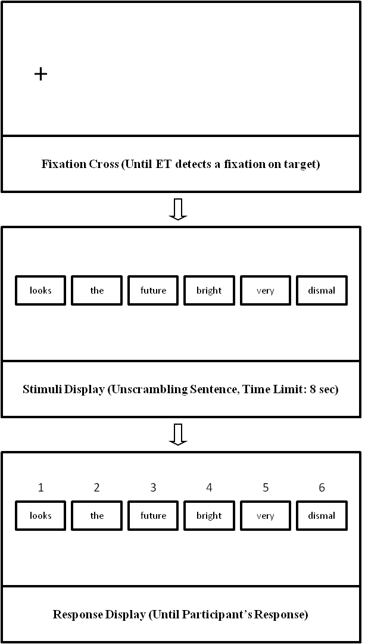
Notes. ET = Eye-tracker; sec = seconds

Supplement Material
Cognitive biases and depressive symptom severity levels
To examine more exhaustively the relationships between depressive symptom severity and attention and interpretation biases under tendency and ability processes, mean scores of the cognitive measures at each session were calculated by subgroups, according to depressive symptom severity scores. Specifically, participants were divided into 6 subgroups according to their BDI-II scores.
Figure S1 shows mean scores for interpretation bias under tendency (i.e., session 1) and ability processes (i.e., session 2). BDI-II subgroups gradually varied in their interpretation bias during the tendency version of the task. Significance tests to compare each subgroup mean score against a value of 0.5 (i.e., indicative of absence of bias) showed that all subgroups with minimal depression (i.e., subgroups 1, 2, 3 and 4) were characterized by a bias to interpret ambiguous information in a positive manner, all t’s > 3.48, all p’s < .05. The mild depression group (i.e., subgroup 5) did not show any bias, t = 1.01, p = .35, whereas the moderate-to-severe depression subgroup (i.e., subgroup 6) showed a bias to interpret ambiguous information in a negative manner, t = -2.24, p < .05. Regarding to the ability version of the task, all subgroups showed high mean scores on interpretation bias, all showing a bias to interpret information in a positive manner, all t’s > 11.90, all p’s < .01. Thus, all groups were able to follow the instruction during the ability version of the task. However, interestingly, the dysphoric subgroups showed a small proportion of sentences unscrambled as negative during the ability version of the task, even when they had been instructed to always form positive meanings with emotional sentences at that session.
Figure S2 shows mean scores for fixation time (i.e., attention bias) at both sessions. All BDI-II subgroups were characterized by an attention bias toward positive compared to negative material during the tendency version of the task, all t’s > 2.23, all p’s < .05, with the exception of the moderate-to-severe depression subgroup (i.e., subgroup 6), which was characterized by absence of that bias, t = -0.76, p = .47. Interestingly, BDI-II subgroups gradually varied in their attention bias during the ability version of the task. Significance test showed that all subgroups with minimal depression were characterized by an attention bias toward positive compared to negative material, all t’s > 2.34, all p’s < .05, whereas the mild and the moderate-to-severe depression subgroups did not show any bias, t = 1.63, p = .15, and t = 0.92, p = .36, respectively. Overall, results suggest that dysphoric sub-groups were characterized by the absence of a positive emotional bias in attention that was observed in non-dysphoric subgroups. Importantly, this absence of positive attention bias was found under both tendency and ability processing conditions, indicating that this pattern may reflect both tendency influences and ability impairments.

Supplement Figures Caption
Figure S1: Mean interpretation scores at each session by BDI-II subgroups. Notes: Session 1 = Tendency version of the task; Session 2 = Ability version of the task; prop = proportion of sentences unscrambled in a positive manner
Figure S2: Mean fixation time scores (i.e., attention bias) at each session by BDI-II subgroups. Notes: Session 1 = Tendency version of the task; Session 2 = Ability version of the task; prop = proportion of time fixating in positive over negative words

Figure S1

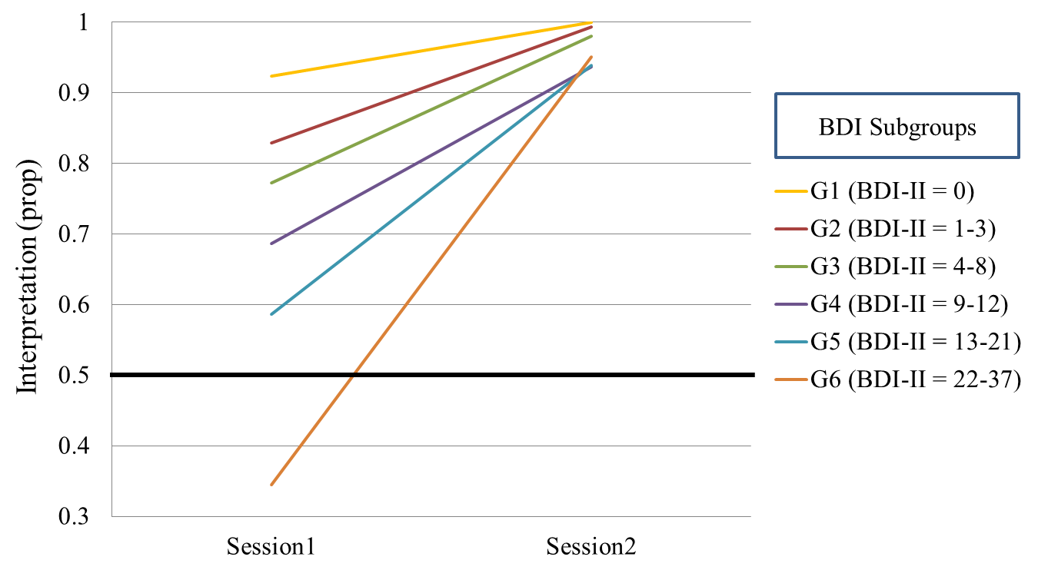

Figure S2

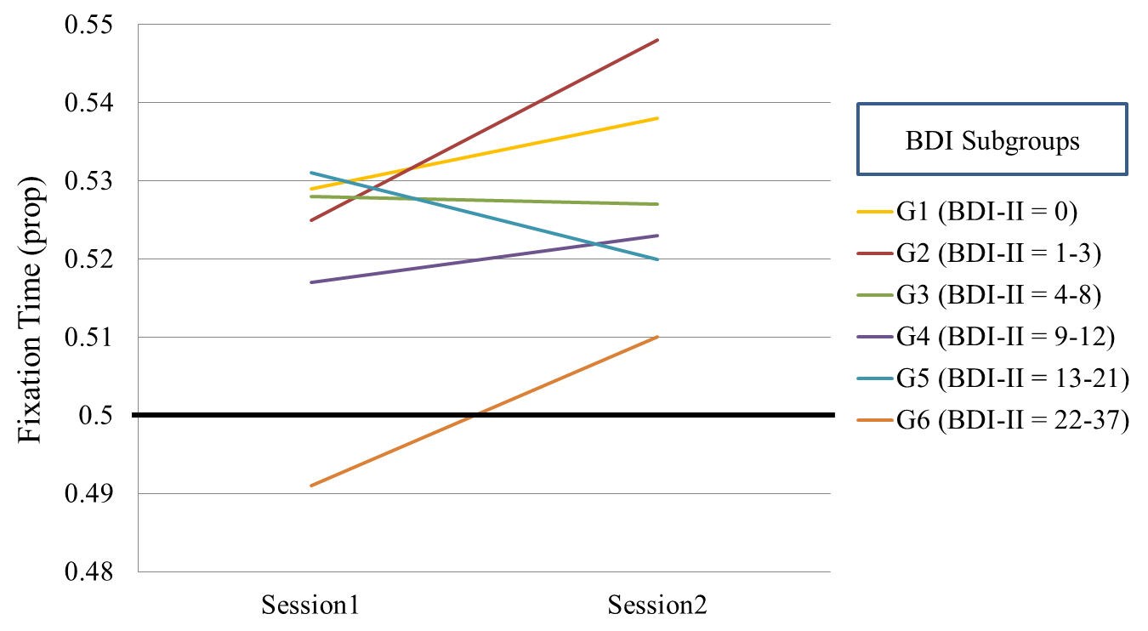

Sixtiles on BDI-II scores were chosen as criteria for group formation as this provided with an optimal gradual differentiation of depressive symptoms subgroups in our sample (Group 1: BDI-II scores of 0, Group 2: BDI-II scores ranging from 1 to 3; Group 3: BDI-II scores ranging from 4 to 8; Group 4: BDI-II scores ranging from 9 to 12; Group 5: BDI-II scores ranging from 13 to 21; Group 6: BDI-II scores ranging from 22 to 37).

