Combining autohydrolysis and ionic liquid microwave treatment to enhance enzymatic hydrolysis of Eucalyptus globulus wood
Victoria Rigual*, Tamara M. Santos, Juan Carlos Domínguez, M. Virginia Alonso, Mercedes Oliet and Francisco Rodriguez
Department of Chemical Engineering, Faculty of Chemistry, Complutense University of Madrid. Avda. Complutense s/n, 28040 Madrid, Spain.
*E-mail: vicrigua@ucm.es ; Tel.: (+34)913948505

ABSTRACT

Biomass pretreatment combinations are alternatives that takes advantages of individual pretreatments characteristics. In this work, the combination of autohydrolysis and ionic liquid microwave treatments of eucalyptus wood have been studied to facilitate sugar production in a subsequent enzymatic hydrolysis step. Three autohydrolysis conditions (150 °C, 175 °C and 200 °C) in combination with two ionic liquid temperatures (80 °C and 120 °C) were compared in terms of chemical composition, enzymatic digestibility and global sugar production. Morphology was measured to implement the concepts of fractal dimensions and lacunarity using SEM, and the biomass surface was visualized with confocal fluorescence microscopy. The synergistic cooperation of both treatments was demonstrated, enhancing cellulose accessibility. At intermediate autohydrolysis conditions (175 °C) and low ionic liquid temperature (80°C), a glucan digestibility of 84.4 % was obtained, due to the formation of a superficial structure with a higher fractal dimension and lower lacunarity.
Keywords: Pretreatment combination, eucalyptus wood, microwave ionic liquid pretretament, fractal dimension, lacunarity
- Introduction
Eucalyptus species are one of the most promising resources in biorefinery processes because of their fast growth and wide adaptability to soils and climates (Carrillo et al., 2017). In the Iberian Peninsula, eucalyptus accounts for a volume of 2.8x10⁶ tons per year (Silva-Fernandes et al., 2015).
Due to the recalcitrance of the cross-linked structure of lignocellulosic biomass, the biorefinery of these resources is still a challenge (Demartini et al., 2015). Pretreatment processes that deconstruct the linkages and disrupt the structure are recquired and involve up to 40 % of the total processing costs of lignocellulosic biomass conversion (Pérez-Pimienta et al., 2017; Raghavi et al., 2016).
Autohydrolysis (AH) is considered an inexpensive, environmentally friendly and easy-to-handle process that removes hemicelluloses (Liu et al., 2015; Silva-Fernandes et al., 2015). The auto ionization of water into hydronium ions and acetyl group hydration, autocatalyze the process (Perez-Pimienta et al., 2016). Due to hemicelluloses removal, the size, surface area, or pore size of the remaining solids is altered (Rissanen et al., 2016). Thus, AH is an adequate pretreatment for the development of integrated biorefining strategies aimed at the fractionation of hemicellulose and the obtention of lignin- and cellulose-rich materials that can be further treated (Silva-Fernandes et al., 2015).
Ionic liquids (ILs) are very promising biomass solvents that reduce recalcitrance, enabling deconstruction of the lignocellulosic network. High chemical and thermal stability and negligible vapor pressure are some of the advantages against other organic solvents (Zhu et al., 2016). ILs also reduce cellulose crystallinity, increasing cellulose accessibility and favoring high cellulose to glucose conversions (Singh et al., 2016; Xu et al., 2016). Some imidazolium aprotic ILs such as [Emim][OAc], [Bmim][Cl] and [Emim][DEP], have been proved to dissolve cellulose and lignocellulosic biomass (Ha et al., 2011; Li et al., 2009). [Emim][OAc] has been found to report the best results in biomass pretreatment and is the most widely used IL used for this purpose to date (Brandt et al., 2017; Elgharbawy et al., 2016). Additionally, ILs are considered good microwave absorbers. The use of this heating method speeds up the treatment (Fang, 2015).
Sequential and combined treatments are being studied in an attempt to improve cellulose to glucose digestibility, extracting also hemicellulose and lignin. The combination of physical (steam explosion, AH, AFEX, etc.) with chemical pretreatments such as alkaline peroxide or ethanol extraction have been tested (Akhtar et al., 2015; Chen et al., 2008). Fewer literature is found combining ILs with other pretreatments. Silveira et al (2015) combined [Bmim][OAc] with supercritical CO₂, obtaining high glucose yields from sugarcane bagasse (Silveira et al., 2015). Rice straw was treated by Nguyen et al (2010), combining ammonia and [Emim][OAc], obtaining high glucose yields and reducing enzyme dosage and incubation time; while Heggset et al. (2016) combined ILs and low temperature alkaline treatment (Heggset et al., 2016; Nguyen et al., 2010). AH and IL treatment of wood was developed by Hauru et al. (2013), focusing on biomass fractionation instead of a pretreatment (prior to enzymatic hydrolysis) approach (Hauru et al., 2013).
To evaluate biomass digestibility, microscopy is commonly used. SEM images are being widely utilized to visually support results obtained in biomass pretreatment (Demartini et al., 2015; Nitsos et al., 2016; Singh et al., 2009). However, digital image analysis (DIA) of these images has not been further investigated. The fractal dimension concept, first introduced by Mandelbrot et al. (1977), is being calculated in many scientific research areas such as (porous) materials characterization, botany, medicine or cellular biology (Liu & Ostadhassan, 2017; Mandelbrot, 1977; Neves et al., 2014; Smith Jr et al., 1996; Utrilla-Coello et al., 2013). In complex objects and textures, the fractal dimension parameter is applied to non-traditional patterns or objects to define the inherent grade of complexity. Fractal dimension can be defined as a scaling rule that indicates how a pattern’s details change with the scale. (Karperien, 2013). Lacunarity, another DIA-employed concept, is described as inhomogeneity, gapiness, visual texture or rotational invariance. This concept introduced by Mandelbrot et al. (1983) has also been previously used to measure changes in the features of the digital image with the level of resolution (Karperien, 2013; Kilic & Abiyev, 2011; Liu & Ostadhassan, 2017; Mandelbrot & Pignoni, 1983; Utrilla-Coello et al., 2013)
In this work, the combination of AH and IL microwave treatments, towards maximizing sugar extraction from Eucalyptus globulus wood, is studied. AH and IL microwave treatments are performed at different temperatures, evaluating glucan and xylan digestibilities in the subsequent enzymatic hydrolysis step. For the first time, the terms of fractal dimension and lacunarity are calculated from SEM images and correlated against enzymatic digestibility, as a measure of cellulose accessibility. Furthermore, surface compositional changes are observed by confocal fluorescence microscopy. Finally, the global mass balance sums up solid recoveries as well as compositional analysis, showing the most favorable conditions to maximize sugars production.
- Materials and methods
  - Materials and reagents
The raw material Eucalyptus globulus sawdust was provided by the National Institute for Agronomic Research (CIFOR-INIA). The IL 1-ethyl-3-methylimidazolium acetate ([Emim][OAc], > 95 %) was supplied by Iolitec GmbH. Lignin was extracted from the raw material Eucalyptus globulus through an organosolv process, using sulfuric acid as a precipitating agent, and was used as reference material for UV/VIS measurements (detailed below). Enzymatic hydrolysis was developed using the enzymatic cocktail Accellerase 1500 ®, kindly donated by Genencor.
  - Experimental
    - Autohydrolysis (AH) treatment
A 450 mL stainless steel pressure reactor (Parr Instrument Company, model 4567) was used to perform AH treatments. The equipment operates with a four-blade turbine impeller. An external electrical mantle was used to heat the reactor vessel, and a silicon fluid oil (100 cSt) was employed in the cooling step. Parr PID controller model 4848 was used to control parameters. All the temperature ramps consist of a heating ramp from ambient temperature to the set temperature (150, 175 or 200 °C) for 50 minutes, a 30-minute isotherm at the set temperature (150, 175 or 200 °C), and a cooling ramp until the reactor temperature decreased to 40 °C. A liquid-to-solid ratio of 8:1 (g water: g dry biomass) was employed according to the literature (García-Domínguez et al., 2013; Romaní et al., 2014).
    - Ionic liquid (IL) microwave treatment
First, AH Eucalyptus globulus samples were milled and sieved to obtain particle sizes < 150 µm. Consequently, 0.8 g of wood samples were mixed with 20 g of [Emim][OAc]. Samples were heated at 80 °C or 120 °C under microwave radiation in a Berghof SpeedWave Four microwave oven, using a two-step programme detailed in a previous work (Casas et al., 2013). Afterwards, 50 mL of deionized water was added as an antisolvent agent at 40 °C. The solution was stirred for 10 minutes. Solid and liquid fractions were separated by vacuum filtration.
To maximize [Emim][OAc] recovery yield and avoid IL residues in the wood samples in the washing step (that distort solid recoveries results), treated samples were washed 5 times with 70 mL of deionized water per wash. Recovered treated samples were stored at 40 °C for further treatments and analysis.
    - Enzymatic hydrolysis
1 % wt/wt of untreated/treated wood was suspended in 50 mM citrate buffer (pH 5.0) containing 0.002 % of sodium azide, in a working volume of 8 mL. 0.25 mL/g glucan of Accellerase 1500 enzymatic cocktail was added to the preparation. The enzymatic hydrolysis was carried out in an IKA KS 4000i orbital incubator at 150 rpm and 50 °C. In parallel, blank assays of each substrate were prepared to control the process in absence of enzymatic cocktail. Hydrolysate aliquots of 150 µL were taken at 3, 6, 12, 24, 48 and 72 h, centrifuged twice consecutive at 9000 rpm for 10 minutes and analyzed by HPLC to obtain monosaccharides composition.
  - Analytical methods
    - Chemical characterization of untreated eucalyptus wood, treated wood, and enzymatic hydrolysis hydrolysates
Untreated eucalyptus wood and treated solids compositions were determined according to the NREL/TP-510-42618 methodology, adapted to small quantities of samples (50 mg) (A. Sluiter, 2011; Ibáñez & Bauer, 2014). A two-step acid hydrolysis was employed to obtain acid-insoluble lignin and ashes (gravimetrically quantified after being dried at 105 °C) and a liquid fraction formed by soluble lignin and sugars. Acid-soluble lignin was quantified by UV spectroscopy at 205 nm, using an absorptivity coefficient of 110 L·g⁻¹·cm⁻¹.
Sugars in hydrolysates were determined using an Agilent 1260 HPLC system operating with a refractive index detector. A 300x7.8 mm Casbosep-CHO 682 column with Micro-Guard cartridges (BioRad, Life Science Group Hercules, Ca) was used to measure sugars concentration in acidic samples. Before analysis, samples were neutralized with CaCO₃ and filtered under 0.45 µm. The column was operating at 80 °C using water as mobile phase, and the flow rate was 0.4 mL/min. The anhydrous corrections to hexoses (162/180) and pentoses (132/150) were applied to each sugar concentration, respectively. Sugar recovery standards (SRS) corrections were applied following the procedure (A. Sluiter, 2011).
In the case of sugars determination in non-acidic samples (enzymatic hydrolysis), the abovementioned CARBOSep CHO-682 Guard kit + lead column was used under the above specified conditions. Glucan and xylan digestibilities were defined as the percentage of glucan or xylan converted into glucose or xylose during enzymatic hydrolysis and were calculated according to Eqs. 1 and 2.
$\text{Glucan digestibility }\left(\text{\%}\right)\text{=}\frac{\text{hydrolyzed gl}\text{u}\text{can (g)}}{\text{glucan introduced in the enzymatic hydrolysis step (g)}}\text{×100}$ (1)
$\text{Xylan digestibility }\left(\text{\%}\right)\text{=}\frac{\text{hydrolyzed xylan (g)}}{\text{xylan introduced in the enzymatic hydrolysis step (g)}}\text{×100}$ (2)
According to the NREL/TP-5100-63351 procedure, anhydro corrections of 0.9 and 0.88 were applied to determine glucan and xylan content in hydrolysates (Resch et al., 2015).
    - IL content in the washing fractions after microwave treatment
Washing fractions were analyzed by HPLC equipped with a UV detector measuring at 235 nm. An Eclipse Plus C18 4.6x100 mm column and a mobile phase of 50/50 % v/v acetonitrile/water at a flow rate of 1 mL/min and at 30 °C was employed. To avoid exceeding the toleration levels of salts in the column, samples were diluted before injection (Hyvärinen et al., 2014).
    - Lignin content in the IL
Lignin content in the recovered [Emim][OAc] and accumulated lignin were defined according to Eqs. 3 and 4.
$\text{Lignin in [}\text{Emim}\text{][}\text{OAc}\text{] (}\text{wt}\text{ \%)=}\left(\frac{\text{Mass of lignin in IL}}{\text{Total mass of IL introduced}}\right)\text{x}\text{100}$ (3)
$\text{Accumulated lignin (}\text{wt}\text{ \%)=}\left(\frac{\text{Mass of lignin in IL}}{\text{Total mass lignin introduced}}\right)\text{x}\text{100}$ (4)
A Buchi R-114 rotavapor was employed to remove water from the washing fractions and recover the IL. The lignin content in the IL was analyzed by UV/VIS spectroscopy using a Varian Cary 50 scan UV/VIS spectrophotometer. Before measuring, water content in the recovered IL was determined using a thermobalance and mass was corrected. Samples were diluted 40-fold in 0.1 N NaOH and filtered, to measure the absorbance at 280 nm (Weerachanchai & Lee, 2014). The total dissolved lignin concentration was obtained from the reference curve of eucalyptus wood organosolv lignin samples prepared following the methodology of Weerachanchai and Lee (2014) (Weerachanchai & Lee, 2014). To avoid an excess in the absorbance measured due to IL treatment, the absorbance measurement of each sample was subtracted from a blank sample prepared with the microwave heated IL at the working temperature.
    - Surface morphology and compositional distribution of processed solids
Scanning electron microscope (SEM) images of untreated and treated samples were acquired using a Jeol JSM 6400 operating at 20 kV. A gold sputtering onto the sample surface was used to impart electrical conductivity. Analyses were developed in the technical facilities of the Spanish National Centre for Electron Microscopy.
Micrographs were processed using ImageJ software to measure fractal dimension and lacunarity. Five micrographs of each sample of 128x128 pixels size were cropped. Based on previous assays, the local thresholding Bernsen method using a radius of 15 was found to be appropriate to convert the grayscale image into a binary image. The FracLac plugin of ImageJ was used to calculate fractal dimension (Db) and lacunarity (Λ) using the box counting method (Alvarez et al., 2013). The smallest grid used was 1 and the largest grid was 45 %.
A Leica SP-2 AOBS confocal laser microscope was used to observe variations in surface samples. A laser at 405 nm was used to observe sample fluorescence. Two wavelength detector sources (428-480 and 547-658 nm) were used to distinguish holocellulose and lignin (autofluorescent). Beta 1-4 polysaccharides linkages were dyed using 0.1 % Calcofluor white stain (Pérez-Pimienta et al., 2017). Afterwards, samples were washed twice with distilled water and dried in the dark overnight. Prolong Gold antifade mountant (1 drop) was used to fix the sample until analysis. Separate samples of dyed (with calcofluor) and non- dyed alkali lignin and Avicel PH-105 were taken as control. Images were acquired at a step size of 2 µm and were coupled, together with the images taken with transmitted light into a z-axis maximum projection using ImageJ software. Images acquisition was developed in the technical facilities of the Centre for Cytometry and Fluorescence Microscopy of the Complutense University of Madrid (UCM).
- Results and discussion
To nominate samples, the AH temperature of the treatment will be designated after “AH” letters (AH150, AH175 and AH200) and IL temperature will be designated afterwards, followed by the microwave treatment temperature (IL80, IL120)
  - Solid recovery and chemical composition of untreated/ treated biomass
Table 1 shows the solid yield recovery and chemical composition of treated and untreated solids. The effects of AH+IL treatments incur in a gradual decrease in the solid recovery that should be taken into account in the global mass balance (explained below). The biggest decrease is produced in the most severe conditions (AH200IL120) to 55 g of treated sample/100 g of untreated eucalyptus wood, while 84 g of treated sample/100 g of untreated eucalyptus wood is obtained in the least treated sample (AH150IL80). Furthermore, it is observed that the AH treatment affects more to the solid recovery more than the IL treatment, where solid yield recoveries decreasing in the range of 1.7 and 3 % are observed between experiments performed at 80 °C and 120 °C. The low solid recoveries variations between samples autohydrolyzed at the same conditions, followed by different IL treatment temperature, supports the statement that ILs pretreat biomass without degrading cellulose (Elgharbawy et al., 2016).
Table 1
The relative composition of biomass compared to the untreated sample, varies in most experiments, indicating that specific biomass fractions are selectively removed (Procentese et al., 2015). The AH step incurs a slight increase in lignin content slight increase, as a consequence of hemicelluloses extraction in the case of the samples autohydrolyzed at 150 °C and 175 °C, and as consequence of hemicellulose and cellulose degradation in samples autohydrolyzed at 200 °C. This is in agreement with the increasing sugar content of the liquid fraction up to a point where degradation products are generated (Nitsos et al., 2016; Silva-Fernandes et al., 2015). The IL temperature variation in the microwave step does not incur in significant changes in lignin compositions. The only relevant variation is observed between AH200IL80 and AH200IL120 samples, with variations of 6 % among them. These results are supported by the UV measurements developed below, where higher lignin accumulation is produced in samples autohydrolyzed at severe conditions. Overall, it can be observed that AH treatments lead to hemicellulose extraction up to a point at which degradation of cellulose and hemicellulose starts. Glucan content is maximized in samples autohydrolyzed at 175 °C, which will contribute to increase final glucose yields in the process. Severe AH conditions produce cellulose degradation, as a consequence of the formation of degradation products (Nitsos et al., 2016).
  - Ionic liquid recovery and lignin extraction
Washing fractions obtained after IL microwave treatment were collected separately and analyzed in order to determine the minimum amount of water required in this treatment. Three washings, plus the regeneration step are required to recover the IL. Despite of operational losses during the process, IL recovery yields are in all the cases higher than 96 %in all cases. [Emim][OAc] accumulation in the solid, could lead into mistakes in the global mass balance (due to overweighting solid fractions) and would cause a decrease in the enzymatic hydrolysis yields as a result of cellulose inactivation (Xu et al., 2016). The problemat of salts accumulation when measuring in the presence of ILs limited the detection of sugars by HPLC at the stablished IL dilution conditions.(Hyvärinen et al., 2014).
Tto reuse the IL in consecutive cycles, antisolvent must be removed. Using vacuum distillation, at least 90 % of the initial IL was recovered. However, differences in the coloration denote the accumulation of impurities (lignin) accumulation after the treatment. The quantity of lignin present in the IL gradually increases from 0.050 to 0.348 g of lignin per 100 g of IL, which corresponds to 10-70 %wt of lignin introduced. Although the IL temperature influences the lignin accumulation in the IL, the biggest differences are observed as an effect of AH conditions. A subsequent step with an additional antisolvent (e.g., iso-propanol or ethanol) that enables lignin precipitation should be assessed not only to obtain a by-product stream in the overall process but also to remove impurities in the IL, enabling the recyclability in the following cycles of use (Auxenfans et al., 2014; Isikgor & Becer, 2015; Weerachanchai et al., 2014).
  - Enzymatic hydrolysis digestibility
Figure 2a shows glucan digestibility during enzymatic hydrolysis of samples subjected to AH + IL treatment. The lowest glucan digestibility is obtained for untreated eucalyptus wood (15 g hydrolyzed glucan/100 g glucan introduced). Differences between untreated and treated samples demonstrate the effectiveness of EmimOAc that has been extensively commented in literature (Elgharbawy et al., 2016; Lynam & Coronella, 2014; Sun et al., 2016). Furthermore, it is also observed how curve aspect differs between samples. While in the untreated wood and AH150IL120 sample digestibility increase only up to 12-24 hours, digestibility continues increasing up to 24-48 hours in the other samples.
The least severe treatment tested already yields 68 g of glucan/100 g glucan, while the highest digestibility is obtained with 175 °C AH treatment followed by an IL step at 120° C. As occurred with solid recovery yields, the effect of AH temperature enzymatic digestibility is greater than the effect of IL temperature. The only case in which IL treatment temperature appears to show a relevant difference is in samples autohydrolyzed at 150 °C. In this sense, treatment at lower IL temperature conditions for samples treated at intermediate or severe AH conditions (AH175IL80 and AH200IL80) would be justified, saving energy costs in future biorefinery processes. The observations between samples autohydrolized at different conditions verify that conditions that are too severe conditions (as studied at AH samples at 200 °C) do not report higher digestibilities, suggesting that intermediate AH conditions in combination with IL microwave treatments may get considerable high glucose digestibilities.
Figure 1
Xylan digestibility for untreated eucalyptus wood and treated samples (excepting samples autohydrolyzed at 200 °C) was also calculated and is shown in Figure 1b. As occurred in glucan, the differences between untreated and treated samples are remarkable. Xylan digestibility varies between 5.7 – 74.3 g glucan/100 g initial glucan introduced for untreated eucalyptus wood and AH175IL80 samples, respectively. Again, the AH conditions are the main effect that cause variation in xylan digestibilities variations. Differences between samples autohydrolyzed under the same conditions but with different IL temperature treatments varies in the range 6-12%. Although digestibilities are shown to be higher in the case of samples autohydrolyzed at 175 °C, the low content of xylan in these samples before hydrolysis (due to hemicellulose extraction under the fixed AH conditions), results in low xylan global yields.
  - Biomass accessibility
SEM and confocal fluorescence microscopy images may help to elucidate the results obtained after enzymatic hydrolysis treatment.
    - Surface texture: fractal dimension and lacunarity
The differences between untreated eucalyptus and treated samples are notorious. The overall surface of untreated eucalyptus wood (image not shown) is smoothed with no visible holes in the structure. Treated samples shown in Figure 2 have a quite homogenous macrostructure with more porosity, possibly due to partial dissolution and regeneration of wood fibers in a fusing structure (Sun et al., 2011). The biggest difference visually observed in SEM micrographs is for AH200 samples. In these cases, the surfaces are rougher and agglomeration of smaller particles are observed. The effect of IL temperature on the solids morphology does not produce clear visual changes, excepting between AH150IL80 and AH150IL120 samples.
Figure 2
To get additional information of the textural images obtained, the terms of fractal dimension and lacunarity using the box counting method were calculated for SEM micrographs and results are shown in Table 2.
Table 2
The fractal dimensions values obtained vary in the range 1.5202 (for untreated eucalyptus wood) to 1.7112 for AH175IL80. Although no previous references of this parameter calculation have been found in treated biomass samples, in other kinds of materials, values are in the range of 1.80 – 1.85 in the case of carbon samples or 1.72 – 1.75 in retrograded starch (Alvarez et al., 2013; Utrilla-Coello et al., 2013). The bigger a fractal dimension is, the more convolutions a porous system has (i.e., twists and turns) and the higher the complexity is (Alvarez et al., 2013; Karperien, 2013). It is curious to observe that fractal dimensions obtained for AH175IL80, AH175IL120, AH200IL80 and AH200IL120 have very similar values (approximately 1.71), in the same way that 72-hour glucan digestibility values are similar. Plotting Db vs 72 h glucan digestibility, including standard deviations, there exists a linear correlation that results in an adjusted r-square of 0.8707.
Lacunarity values are in the range of 0.6955 (for untreated sample) to 0.3410 for AH200IL120. These values are in the range of those obtained with different samples such as rocks (0.05 – 0.20), or carbon samples (0.15 – 0.28) (Alvarez et al., 2013; Liu & Ostadhassan, 2017). In this case, the lower the lacunarity is, the more homogenous textures are obtained, as has been visually confirmed. Again, lacunarity values of AH150IL120, AH175IL80, AH175IL120, AH200IL80 and AH200IL120 are quite similar among themselves, and their reproducibility shows low standard deviations between replicates, while in the case of untreated eucalyptus wood and AH150IL80 samples, the results are more heterogeneous, and the standard deviation is greater. Plotting lacunarity vs 72 h glucan digestibility and including standard deviation values, there is a linear correlation with an adjusted r-squared value of 0.8021. As a consequence, lacunarity and fractal dimension of each sample are also related between themselves. The higher the lacunarity is, the lower fractal dimensions are obtained, with an adjusted r-squared value of 0.9813. In this way, fractal dimension and lacunarity could be correlated against glucan digestibility and become a parameter to take into account in the future as a measurement of cellulose accessibility for enzymatic hydrolysis. However, further studies should be developed in order to verify this tendency in other treatment technologies.
    - Surface chemical distribution
Confocal fluorescence microscopy images shown in Figure 3 expose lignin (green) and holocellulose (blue) surface distribution. Untreated eucalyptus wood surfaces show an ordered and crosslinked lignin and holocellulose distribution, and both components colors are not visually observed to be mixed. As ocurred with other analyses, the effect of the AH treatment used results in more visual differences than the effect of the IL treatment temperature. Samples autohydrolyzed at mild conditions, show an altered structure (already observed in SEM images) where lignin and holocellulose have been rearranged. According to chemical composition, structures “in blue” can be attributed to hemicelluloses still present in the sample and/or superficial cellulose. At intermediate AH conditions, samples are mainly composed of lignin in the surface. Lignin has been noted as an inhibitory agent of cellulases (Rahikainen et al., 2013). However, digestibilities observed under these conditions demonstrate that eucalyptus wood digestibility is not decreased due to the presence of lignin in the surface. Samples autohydrolized under severe conditions show particles agglomeration. The transmitted coupled channel shows that not the whole particle is observed under fluorescence. This may be attributed to the opacity of the sample that limits laser penetration, probably due to the high content of lignin (dark).
Figure 3
  - Process mass balance
Figure 4 summarizes the calculations developed in the whole process with chromatographic, gravimetric, and NREL analyses and spectroscopy techniques. Eucalyptus wood has been divided into three main components: cellulose, hemicellulose and lignin. Minimum, and maximum values of each component have been included as reference. The results underlined corresponds to AH175IL80, which had the highest glucose yield (69.7 g glucose in eucalyptus/100 g glucose in the global process). The highest xylose yield was obtained in the AH150IL120 sample as a consequence of the low hemicellulose removal at mild AH conditions. Due to pseudo lignin formation in some samples, lignin extraction was not included in AH200IL80 and AH200IL120 samples. The global mass balance shows the importance of calculating global yield throughout the process. In this sense, the sample with maximum glucan digestibility (AH175IL120) and maximum glucose yield (AH175IL80) is not the same.

Figure 4
The overall mass balance has shown that lignin has been overestimated in the case of AH200 samples, probably due to “pseudo-lignin” that cannot be distinguished from Klason lignin (Huijgen et al., 2012). This overestimation was observed in the solid characterization analysis and in the lignin quantification in the IL.

Conclusions
In this work, combinations of autohydrolysis and microwave ionic liquid treatments combination, towards sugars production maximization from eucalyptus wood, were tested. The highest glucan digestibilities were obtained for AH175IL80 and AH175IL120 samples (84.4 and 85.5 %). The AH175IL120 sample yielded the highest glucan production (39.6 g of glucose/100 g of untreated wood). Fractal dimension and lacunarity were found to be promising parameters to understand biomass accessibility. Confocal fluorescence microscopy images showed that superficial lignin does not limit glucan digestibility. Mass balance evinced the importance of quantifying solid recoveries along the process towards a realistic glucose quantification in the global process.

Acknowledgements
This work was performed thanks to the financial support of the “Ministerio de Economía y Competitividad” under the funded project CTQ2013-42006-R and the contract BES-2014-067788.

References
A. Sluiter, B.H., R.Ruiz, C.Scarlata, J.Sluitr, D.Templeton and D. Crocker. 2011. Determination of Structural carbohydrates and lignin in biomass. NREL.
Akhtar, N., Gupta, K., Goyal, D., Goyal, A. 2015. Recent advances in pretreatment technologies for efficient hydrolysis of lignocellulosic biomass. Environ. Prog. Sustain. Energy, 35(2), 489-511.
Alvarez, A., Passé-Coutrin, N., Gaspard, S. 2013. Determination of the textural characteristics of carbon samples using scanning electronic microscopy images: comparison with mercury porosimetry data. Adsorption, 19(2-4), 841-850.
Auxenfans, T., Buchoux, S., Husson, E., Sarazin, C. 2014. Efficient enzymatic saccharification of Miscanthus: Energy-saving by combining dilute acid and ionic liquid pretreatments. Biomass Bioenerg., 62, 82-92.
Brandt, A., Gschwend, F., Fennell, P., Lammens, T., Tan, B., Weale, J., Hallett, J. 2017. An economically viable ionic liquid for the pretreatment of lignocellulosic biomass. Green Chemistry, 19, 3078-3102.
Carrillo, I., Vidal, C., Elissetche, J.P., Mendonça, R.T. 2017. Wood anatomical and chemical properties related to the pulpability of Eucalyptus globulus: a review. South. Forests., 1-8.
Casas, A., Alonso, M.V., Oliet, M., Santos, T.M., Rodriguez, F. 2013. Characterization of cellulose regenerated from solutions of pine and eucalyptus woods in 1-allyl-3-methilimidazolium chloride. Carbohydr. Polym., 92(2), 1946-1952.
Chen, H., Han, Y., Xu, J. 2008. Simultaneous saccharification and fermentation of steam exploded wheat straw pretreated with alkaline peroxide. Process Biochem., 43(12), 1462-1466.
Demartini, J.D., Foston, M., Meng, X., Jung, S., Kumar, R., Ragauskas, A.J., Wyman, C.E. 2015. How chip size impacts steam pretreatment effectiveness for biological conversion of poplar wood into fermentable sugars. Biotechnol. Biofuels, 8(1).
Elgharbawy, A.A., Alam, M.Z., Moniruzzaman, M., Goto, M. 2016. Ionic liquid pretreatment as emerging approaches for enhanced enzymatic hydrolysis of lignocellulosic biomass. Biochem. Eng. J., 109, 252-267.
Fang, Z. 2015. Production of Biofuels and Chemicals with microwave. Springer.
García-Domínguez, M.T., García-Domínguez, J.C., Feria, M.J., Gómez-Lozano, D.M., López, F., Díaz, M.J. 2013. Furfural production from Eucalyptus globulus: Optimizing by using neural fuzzy models. Chem. Eng. J., 221, 185-192.
Ha, S.H., Mai, N.L., An, G., Koo, Y.-M. 2011. Microwave-assisted pretreatment of cellulose in ionic liquid for accelerated enzymatic hydrolysis. Bioresour. Technol., 102(2), 1214-1219.
Hauru, L.K.J., Ma, Y., Hummel, M., Alekhina, M., King, A.W.T., Kilpelainen, I., Penttila, P.A., Serimaa, R., Sixta, H. 2013. Enhancement of ionic liquid-aided fractionation of birchwood. Part 1: autohydrolysis pretreatment. RSC Adv., 3(37), 16365-16373.
Heggset, E.B., Syverud, K., Øyaas, K. 2016. Novel pretreatment pathways for dissolution of lignocellulosic biomass based on ionic liquid and low temperature alkaline treatment. Biomass Bioenerg., 93, 194-200.
Huijgen, W., Smit, A., De Wild, P., Den Uil, H. 2012. Fractionation of wheat straw by prehydrolysis, organosolv delignification and enzymatic hydrolysis for production of sugars and lignin. Bioresour. technol., 114, 389-398.
Hyvärinen, S., Mikkola, J.-P., Murzin, D.Y., Vaher, M., Kaljurand, M., Koel, M. 2014. Sugars and sugar derivatives in ionic liquid media obtained from lignocellulosic biomass: comparison of capillary electrophoresis and chromatographic analysis. Catal. Today, 223, 18-24.
Ibáñez, A.B., Bauer, S. 2014. Downscaled method using glass microfiber filters for the determination of Klason lignin and structural carbohydrates. Biomass Bioenerg., 68(0), 75-81.
Isikgor, F.H., Becer, C.R. 2015. Lignocellulosic biomass: a sustainable platform for the production of bio-based chemicals and polymers. Polym. Chem., 6(25), 4497-4559.
Karperien, A. 2013. FracLac for ImageJ, Vol. 2017, FracLac. https://imagej.nih.gov/ij/plugins/fraclac/FLHelp/Introduction.htm.
Kilic, K.I., Abiyev, R.H. 2011. Exploiting the synergy between fractal dimension and lacunarity for improved texture recognition. Signal Process., 91(10), 2332-2344.
Li, Q., He, Y.-C., Xian, M., Jun, G., Xu, X., Yang, J.-M., Li, L.-Z. 2009. Improving enzymatic hydrolysis of wheat straw using ionic liquid 1-ethyl-3-methyl imidazolium diethyl phosphate pretreatment. Bioresour. Technol., 100(14), 3570-3575.
Liu, J., Li, M., Luo, X., Chen, L., Huang, L. 2015. Effect of hot-water extraction (HWE) severity on bleached pulp based biorefinery performance of eucalyptus during the HWE–Kraft–ECF bleaching process. Bioresour. Technol., 181, 183-190.
Liu, K., Ostadhassan, M. 2017. Quantification of the microstructures of Bakken shale reservoirs using multi-fractal and lacunarity analysis. J. Nat. Gas Sci. Eng., 39, 62-71.
Lynam, J.G., Coronella, C.J. 2014. Glycerol as an ionic liquid co-solvent for pretreatment of rice hulls to enhance glucose and xylose yield. Bioresour. Technol., 166, 471-478.
Mandelbrot, B. 1977. Fractals, Form, Chance and Dimension WH Freeman and Co.
Mandelbrot, B.B., Pignoni, R. 1983. The fractal geometry of nature. WH freeman New York.
Neves, L.A., Nascimento, M.Z., Oliveira, D.L.L., Martins, A.S., Godoy, M.F., Arruda, P.F.F., de Santi Neto, D., Machado, J.M. 2014. Multi-scale lacunarity as an alternative to quantify and diagnose the behavior of prostate cancer. Expert Syst. Appl., 41(11), 5017-5029.
Nguyen, T.-A.D., Kim, K.-R., Han, S.J., Cho, H.Y., Kim, J.W., Park, S.M., Park, J.C., Sim, S.J. 2010. Pretreatment of rice straw with ammonia and ionic liquid for lignocellulose conversion to fermentable sugars. Bioresour. technol., 101(19), 7432-7438.
Nitsos, C.K., Choli-Papadopoulou, T., Matis, K.A., Triantafyllidis, K.S. 2016. Optimization of Hydrothermal Pretreatment of Hardwood and Softwood Lignocellulosic Residues for Selective Hemicellulose Recovery and Improved Cellulose Enzymatic Hydrolysis. ACS Sustain. Chem. Eng., 4(9), 4529-4544.
Perez-Pimienta, J.A., Flores-Gómez, C.A., Ruiz, H.A., Sathitsuksanoh, N., Balan, V., da Costa Sousa, L., Dale, B.E., Singh, S., Simmons, B.A. 2016. Evaluation of agave bagasse recalcitrance using AFEX™, autohydrolysis, and ionic liquid pretreatments. Bioresour. Technol., 211, 216-223.
Pérez-Pimienta, J.A., Vargas-Tah, A., López-Ortega, K.M., Medina-López, Y.N., Mendoza-Pérez, J.A., Avila, S., Singh, S., Simmons, B.A., Loaces, I., Martinez, A. 2017. Sequential enzymatic saccharification and fermentation of ionic liquid and organosolv pretreated agave bagasse for ethanol production. Bioresour. Technol., 225, 191-198.
Procentese, A., Johnson, E., Orr, V., Garruto Campanile, A., Wood, J.A., Marzocchella, A., Rehmann, L. 2015. Deep eutectic solvent pretreatment and subsequent saccharification of corncob. Bioresour.Technol., 192, 31-36.
Raghavi, S., Sindhu, R., Binod, P., Gnansounou, E., Pandey, A. 2016. Development of a novel sequential pretreatment strategy for the production of bioethanol from sugarcane trash. Bioresour. Technol., 199, 202-210.
Rahikainen, J.L., Martin-Sampedro, R., Heikkinen, H., Rovio, S., Marjamaa, K., Tamminen, T., Rojas, O.J., Kruus, K. 2013. Inhibitory effect of lignin during cellulose bioconversion: The effect of lignin chemistry on non-productive enzyme adsorption. Bioresour. Technol., 133, 270-278.
Resch, M., Baker, J., Decker, S. 2015. Low solids enzymatic saccharification of lignocellulosic biomass. NREL Laboratory Analytical Procedure.
Rissanen, J.V., Murzin, D.Y., Salmi, T., Grénman, H. 2016. Aqueous extraction of hemicelluloses from spruce - From hot to warm. Bioresour. Technol., 199, 279-282.
Romaní, A., Ruiz, H.A., Pereira, F.B., Teixeira, J.A., Domingues, L. 2014. Integrated approach for effective bioethanol production using whole slurry from autohydrolyzed Eucalyptus globulus wood at high-solid loadings. Fuel, 135, 482-491.
Silva-Fernandes, T., Duarte, L.C., Carvalheiro, F., Marques, S., Loureiro-Dias, M.C., Fonseca, C., Gírio, F. 2015. Biorefining strategy for maximal monosaccharide recovery from three different feedstocks: Eucalyptus residues, wheat straw and olive tree pruning. Bioresour. Technol., 183, 203-212.
Silveira, M.H.L., Vanelli, B.A., Corazza, M.L., Ramos, L.P. 2015. Supercritical carbon dioxide combined with 1-butyl-3-methylimidazolium acetate and ethanol for the pretreatment and enzymatic hydrolysis of sugarcane bagasse. Bioresour. Technol., 192, 389-396.
Singh, R., Krishna, B.B., Kumar, J., Bhaskar, T. 2016. Opportunities for utilization of non-conventional energy sources for biomass pretreatment. Bioresour. Technol., 199, 398-407.
Singh, S., Simmons, B.A., Vogel, K.P. 2009. Visualization of biomass solubilization and cellulose regeneration during ionic liquid pretreatment of switchgrass. Biotechnol Bioeng, 104(1), 68-75.
Smith Jr, T.G., Lange, G.D., Marks, W.B. 1996. Fractal methods and results in cellular morphology — dimensions, lacunarity and multifractals. J. Neurosci. Methods, 69(2), 123-136.
Sun, N., Rodríguez, H., Rahman, M., Rogers, R.D. 2011. Where are ionic liquid strategies most suited in the pursuit of chemicals and energy from lignocellulosic biomass? Chem. Commun., 47(5), 1405-1421.
Sun, S., Sun, S., Cao, X., Sun, R. 2016. The role of pretreatment in improving the enzymatic hydrolysis of lignocellulosic materials. Bioresour. Technol., 199, 49-58.
Utrilla-Coello, R.G., Bello-Pérez, L.A., Vernon-Carter, E.J., Rodriguez, E., Alvarez-Ramirez, J. 2013. Microstructure of retrograded starch: Quantification from lacunarity analysis of SEM micrographs. Journal of Food Engineering, 116(4), 775-781.
Weerachanchai, P., Lee, J.-M. 2014. Recyclability of an ionic liquid for biomass pretreatment. Bioresour. Technol., 169, 336-343.
Weerachanchai, P., Lim, K.H., Lee, J.-M. 2014. Influence of organic solvent on the separation of an ionic liquid from a lignin–ionic liquid mixture. Bioresource Technology, 156(0), 404-407.
Xu, J., Xiong, P., He, B. 2016. Advances in improving the performance of cellulase in ionic liquids for lignocellulose biorefinery. Bioresour. Technol., 200, 961-970.
Zhu, C., Richardson, R.M., Potter, K.D., Koutsomitopoulou, A.F., Van Duijneveldt, J.S., Vincent, S.R., Wanasekara, N.D., Eichhorn, S.J., Rahatekar, S.S. 2016. High modulus regenerated cellulose fibers spun from a low molecular weight microcrystalline cellulose solution. ACS Sustain. Chem. Eng., 4(9), 4545-4553.

Tables

Table 1. Solid recovery and compositional analysis. ± values denotes standard deviations
 | Solid Yield | COMPOSITION (g/100g ODW treated biomass)
 | g/100 g ODW* untreated wood | Lignin | Glucan | Xylan | Galactan | Arabinan | Mannan | Acetate
 | % | % | % | % | % | % | % | %
Eucalyptus wood | 100 | 27.21±0.20 | 51.08±1.32 | 18.14±0.35 | 0.62±0.10 | 0.18±0.18 | 0.41±0.41 | 4.12±0.11
AH150IL80 | 84.35 | 28.86±1.31 | 46.54±0.61 | 12.45±0.04 | 0.63±0.05 | 0 | 0.77±0.77 | 9.00±0.71
AH150IL120 | 81.82 | 29.08±0.97 | 53.83±0.08 | 12.86±0.32 | 0.60±0.15 | 0 | 1.74±0.87 | 4.22±0.78
AH175IL80 | 63.11 | 30.51±1.43 | 66.82±1.82 | 1.92±0.02 | 0 | 0 | 0 | 1.16±0.26
AH175IL120 | 62.03 | 31.21±0.79 | 61.22±0.85 | 2.05±0.01 | 0 | 0 | 0 | 3.33±0.34
AH200IL80 | 56.33 | 55.86±1.52 | 46.05±0.98 | 0 | 0 | 0 | 0 | 0
AH200IL120 | 55.19 | 52.54±1.71 | 45.32±0.98 | 0 | 0 | 0 | 0 | 0
*ODW: Oven dry weight

Table 2. Fractal dimension (Db) and lacunarity (Λ) of untreated and treated samples. The results were calculated using the Fraclac plugin from ImageJ software and the box counting method. ± values denotes standard deviations
Sample | Example of micrograph processed | Fractal dimension  (Db) | Lacunarity  (Λ)
Untreated eucalyptus wood |  | 1.5202±0.0859 | 0.6955±0.1200
AH150IL80 |  | 1.6258±0.0447 | 0.4976±0.1357
AH150IL120 |  | 1.6724±0.0163 | 0.3933±0.0354
AH175IL80 |  | 1.7112±0.0304 | 0.3470±0.0351
AH175IL120 |  | 1.7001±0.0201 | 0.3735±0.0340
AH200IL80 |  | 1.7042±0.0230 | 0.3824±0.0554
AH200IL120 |  | 1.7080±0.0225 | 0.3410±0.0287

Figure Captions

Figure 1. a) Glucan digestibility and b) xylan digestibility. Percentages are expressed in grams of glucan per 100 grams of initial glucan/ xylan introduced in the enzymatic hydrolysis step.

Figure 2. SEM micrographs of treated samples. Images taken at x400 magnification. a) AH150IL80 sample, b) AH150IL120 sample, c) AH175IL80 sample, d) AH175IL120 sample, e) AH200IL80 sample, f) AH200IL120 sample

Figure 3. Confocal fluorescence microscopy images of treated samples. Images taken at x63 magnification. a) AH150IL80 sample, b) AH150IL120 sample, c) AH175IL80 sample, d) AH175IL120 sample, e) AH200IL80 sample, f) AH200IL120 sample

Figure 4: Mass balance per 100 g of untreated eucalyptus wood during sequential autohydrolysis and IL microwave treatment. Underlined values represent results for the highest glucose productions (AH175IL80)

Figure 1.
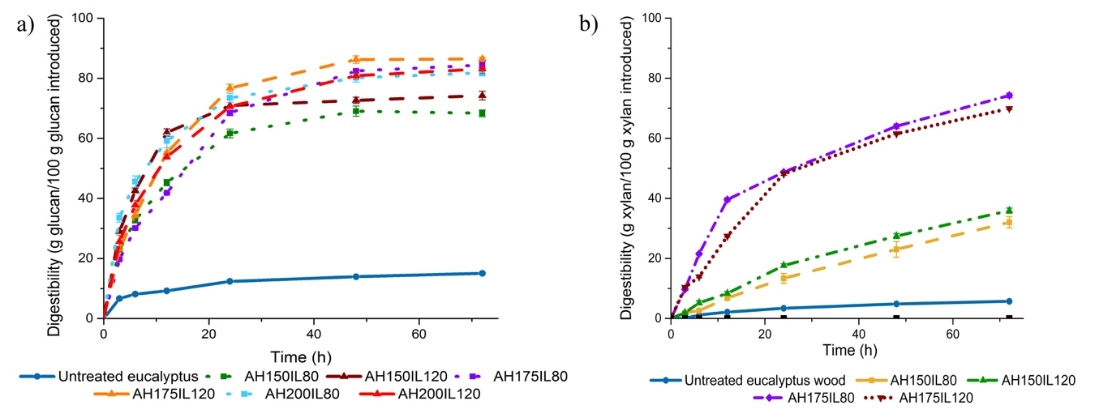

Figure 2.
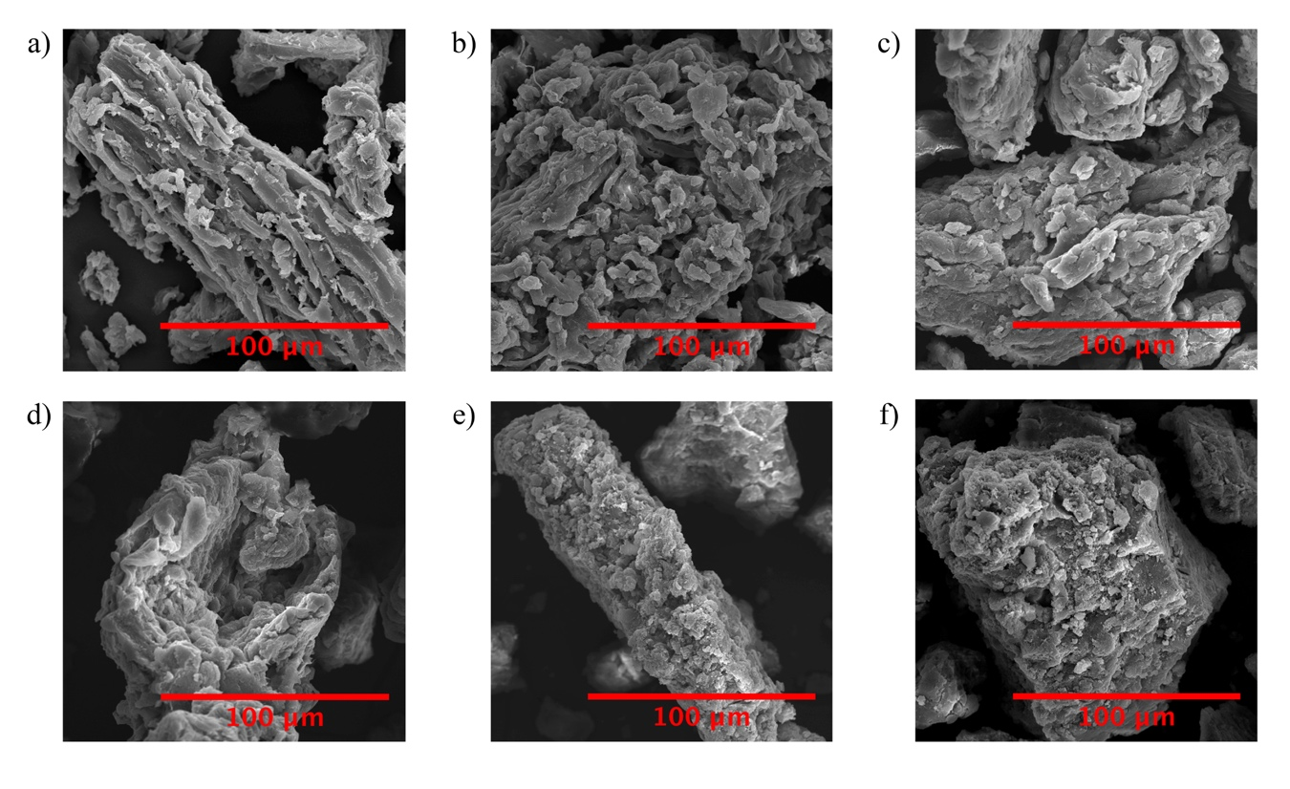

Figure 3.
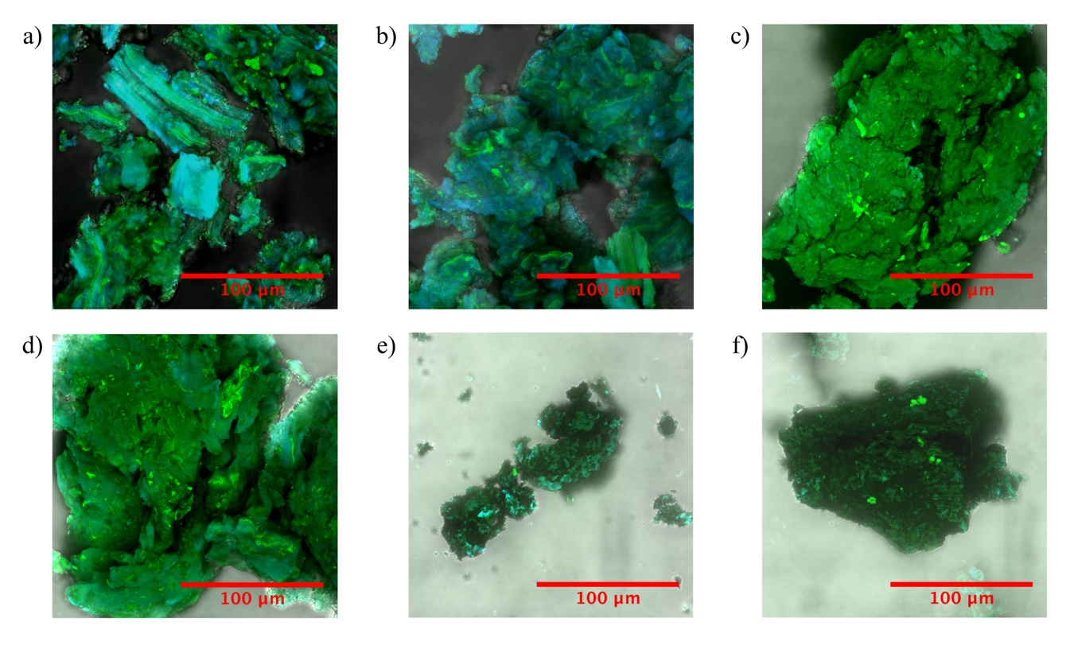

Figure 4.

