THE ROLE OF ANGIOGENIC BIOMARKERS AND DOPPLER-US TO DIFFERENTIATE BETWEEN PREECLAMPSIA AND FLARE IN PATIENTS WITH SYSTEMIC LUPUS ERITHEMATOSUS AND/OR ANTIPHOSPHOLIPID SYNDROME DURING PREGNANCY.
Rodríguez-Almaraz ME¹, Herráiz I², Gómez-Arriaga PI², Vallejo P², Gonzalo-Gil E¹, Usategui A^{1,} López-Jiménez EA³, Galindo A^{2,} Galindo M¹,.
¹Department of Rheumatology. ²Fetal Medicine Unit, Department of Obstetrics and Gynecology. ³Department of Biochemistry. Hospital Universitario 12 de Octubre. Madrid (Spain)
- INTRODUCTION.

Systemic lupus erythematosus (SLE) predominantly affects women during their childbearing years. Pregnancy in patients with SLE, particularly in those with antiphospholipid antibodies (aPL), and in patients with aPL alone, is associated with an increased risk for maternal and fetal morbidity due to insufficient placental support of the developing fetus (1–3). Preeclampsia (PE) and placental insufficiency are associated with adverse pregnancy outcomes (APOs), including maternal complications of PE, intrauterine fetal death, and fetal growth restriction, and preterm delivery.
Women with SLE have increased risk of APOs (4). They have a much higher risk of developing PE (14-23%) and eclampsia, preterm delivery occurs in up to 20-31% of women (1,3,5), and fetal growth restriction rate ranges from 5 to 23% (6,7).
PE is a specific pregnancy syndrome that manifests with hypertension and proteinuria, and resolves following delivery. Severe PE is marked by very high blood pressure and proteinuria, as well as other manifestations, including thrombocytopenia, hemolysis, renal insufficiency, and liver involvement. PE can be classified as early (<34 weeks’ gestation) and late (>34 weeks’ gestation).
Early in pregnancy, trophoblast cells from the placenta transform the uterine spiral arteries into wide vessels to promote low-resistance blood flow to the placenta. If the invasion of the placental cells is inadequate, then the uterine spiral arteries may not enlarge properly, leading to poor placental blood flow with poor oxygenation, ischemia and deficient nutrients transport to the fetus (4,8,9). Several angiogenesis serum factors have been identified and can be used as biomarkers of placental endothelial dysfunction. Changes in ratio between proangiogenic factors as VEGF (vascular endothelial growth factor) and PlGF (placental growth factor) and the antiangiogenic factor sFlt-1 may early detect risk of PE development (9,10). These factors are likely reflecting poor placental perfusion and impaired angiogenesis in the rapidly growing placenta.
Detection of increased vascular resistance in the uterine arteries by doppler (UtA-Doppler) is also a high sensitivity and specificity test for predicting PE in women with SLE (11).
Taking into account both predictive tools, some combined algorithms have been proposed for detecting patients with high risk of developing placental dysfunction-related diseases (12).
In SLE patients, differentiating disease activity, particularly lupus nephritis (LN), and placental dysfunction-related disorders can be complicated because they share symptoms such as hypertension or proteinuria. Previous published results point to ratio between angiogenic and antiangiogenic factors and UtA-Doppler as potential tools to differentiate PE and APS and SLE nephropathies (13)(11).
The aim of our study was to assess the value of mPI-UtA and sFlt-1/PlGF ratio as early markers of PE in pregnant lupus patients and to describe how these angiogenesis markers behave in patients with lupus activity, particularly with LN.

- PATIENTS AND METHODS.

Patients
Pregnant patients with SLE diagnosis, with or without aPL, and with APS referred to the high risk pregnancy clinic were consecutively included. Only patients referred since the first trimester of their gestation were included. SLE and APS diagnosis was established according to ACR 1997 (14,15) and revised Sapporo criteria (16,17), respectively. We excluded patients with poorly controlled arterial hypertension, those who were lost for follow-up during pregnancy and if fetuses were affected by a chromosomal abnormality or major malformation. All included patients signed an informed consent.

Schedule of follow-up
The clinical care of pregnant women with SLE and/or APS was carried out in coordination by obstetricians with experience in high-risk pregnancies and fetal pathophysiology. Coordinated assessment of pregnant patients was performed according to the schedule described in Table 1, including additional visits and test based on the clinical needs of each patient. In preconceptional or basal visit, we collected the medical history of patients, SLE/APS and obstetric history, previous and current treatments, toxic habits and allergies.

Description of variables:
Main variables:
PE and its severity were diagnosed according to the International Society for the Study of Hypertension in pregnancy (ISSHP) criteria (18): a) High blood pressure (HBP) > 140/90 mmHg and proteinuria > 300mg/day in patients with normal baseline parameters; b) Unknown HBP and doubling the previous proteinuria in patients with previous proteinuria but no HBP or; c) worsening of HBP (rise ≥ 15 mmHg in systolic or diastolic pressure) and rise more than twice of baseline proteinuria in patients with HBP and baseline proteinuria. Early or late PE was defined according to the time of gestation in which it was developed, establishing the temporal limit in week 34.
Intrauterine growth restriction (IUGR) was defined as a small for gestational age (SGA) newborn together with a Doppler PI in the umbilical artery above the 95th percentile.
SGA was defined as a birth weight <10th percentile for gestational age (GA).
Preterm is defined as babies born alive before 37 weeks of pregnancy are completed. There are sub-categories of preterm birth, based on gestational age: a) late preterm (32-37 w), b) very preterm (28-32 w), c) extremely preterm (<28 w) (19).

Predictive variables:
Mean uterine arteries pulsatility index (mUtA-PI): it was calculated from three or more consecutive waveforms obtained from a free-floating portion of the umbilical cord. Normal values were considered when it was < 95th centile for GA. Mean UtA-PI was calculated as the average PI of the right and left arteries, and was considered to be abnormal when it was > 95th centile (20,21).

Serum detection of angiogenesis factors:
Serum levels of sFlt-1 and PlGF were quantified by ELISA according to manufacturer instructions (Roche …)), and the sFlt-1/PlGF ratio was calculated for each sample (22).
Confusing variables:
Demographic variables: age, ethnicity, academic formation.
Disease activity: according to SLEDAI adapted to pregnancy (SLEPDAI) (23). We considered moderate activity when SLEPDAI ≥ 6.
Risk factors associated with PE: high body mass index (), previous PE, multiple pregnancy, familiar history of PE (mother), smoking, alcohol consumption, other toxic habits (cannabis, cocaine), chronic HBP, diabetes, thrombophilia, and the use of some drugs (antihypertensive, antidepressant, antiepileptic drugs, non-steroid anti-inflammatory drugs, insulin, lithium, antithyroid drugs and thyroxine).
Concomitant treatment: glucocorticoids, platelet anti-aggregation, oral anticoagulants, antimalarials and azathioprine.

Statistical analysis:
A descriptive analysis of sociodemographic and clinical characteristics, treatment of included patients, and of event survival will be firstly presented.
The quantitative biochemical and ultrasound parameters will be expressed in absolute values ​​and in multiples of the median (MoM) with respect to values ​​in normal pregnancies. Categorical variables will be expressed as n (%) and continuous variables are expressed as mean and standard deviation (SD) unless otherwise stated. The association between the presence of alterations in the flow of uterine arteries by Doppler ultrasound and the plasma levels of sFlt1 and PlGF-1, measured in the first, second and third trimesters, and the development of PE, prematurity and IUGR will be assessed by logistic regression. For categorical variables, comparisons will be performed across all columns using Fisher´s exact test, and Kruskal-Wallis test for categorical variables, followed by post-hoc Bonferroni´s adjustment.
Statistical analysis was performed with IBM SPSS Statistics 20 .
This study was consistent with the Helsinki Declaration and its amendments. All patients included should sign the informed consent approved by the Ethics Committee of our institution. The study itself did not interfere with usual clinical practice.
- RESULTS.
Globally, 57 patients were consecutively included. Their demographic and baseline clinical characteristics are detailed in table 2.
Pregnancy outcome
From these 57 patients followed in our High Risk Unit between January-2008 and July-2016, 46 (81%) patients had diagnosis of SLE and 11 (19%) patients of APS. Thirteen (23%) patients suffered a miscarriage (10 SLE and 3 APS patients). In 35 (61%) patients (25 SLE and 6 APS) the pregnancy was uneventful. Among SLE patients, 5 (11%) developed a flare being severe in two of them (SLEPDAI 25 and 12). An emergency cesarean section had to be performed in these patients at 27 y 33 weeks, respectively. Placental dysfunction-related disorders happened in 4 patients (2 PE, and 2 IUGR) (Figure 1).
Patients who developed an adverse pregnancy outcome (APO) showed a non significant trend towards to have a shorter time with stable disease before conception. The characteristics of these patients are shown in Table 2.
In first visit (11-14 weeks) the values of both index (ratio and mPIUtA) were similar in the 3 groups.
Ratio and mPI-UtA leves were higher in patients with APOs that in the other 2 groups, and that was statiscally significant for mPIUtA in visit 19-22 weeks and 32-34 and for ratio in 24-29 weeks.
On the other hand, there are not differences in scores between patients with lupus activity and normal pregnancy (Graphic 1 A/B).
Patients whith lupus flare or an APO had a preterm delivery and in the 50% of these pregnancys were before 34 weeks’ gestation, being this association statistically significant. Similarly, newborns of mothers who suffered a flare or APO had lower weight , especially in PE with a median percentile of 1 and worse APGAR and this was statistically significant (table 3).
- DISCUSSION.
Pregnancy in SLE and APS patients are a high risk situation. These patients are more susceptible to suffer flares or gestational complications like preeclampsia. In some cases, it’s very difficult to differentiate them just with clinical and laboratory manifestations and the treatment for both entities it’s so different. Nowadays, the only test that can completely differentiate them is the kidney biopsy, but it should be used only in selected cases because it’s an invasive technique and its complications may endanger the life of the mother or the fetus.
Several studies have demonstrates the utility of the mean pulsatility index in the uterine arteries (mPI-UtA) and sFlt-1/PlGF ratio logarithmic values in early diagnosis of PE in healthy pregnant and patients with other risk factors like hypertension, obesity, kidney diseases,…(20,24,25).
There are some studies that have compared angiogenic biomarkers or Doppler ultrasound in patients with SLE and/or APS finding similar results (11,13,26–28), but this is the first study that compare both markers in these patients.
The limitation of our study is that there are few complications, both lupus flare as PE / IUGR. This may be related to a closer and multidisciplinary management of patients.
In our patients, ratio and mPI-UtA in SLE and / or APS patients behave as in the general population in early diagnosis of PE. In addition, they seem to be useful in the differential diagnosis between PE and lupus flare.

- BIBLIOGRAPHY.
1. Clowse MEB, Jamison M, Myers E, James AH. A national study of the complications of lupus in pregnancy. Am J Obstet Gynecol. 2008 Aug;199(2):127.e1–127.e6.
2. Petri M, Allbritton J. Fetal outcome of lupus pregnancy: a retrospective case-control study of the Hopkins Lupus Cohort. J Rheumatol. 1993 Apr;20(4):650–6.
3. Georgiou PE, Politi EN, Katsimbri P, Sakka V, Drosos AA. Outcome of lupus pregnancy: a controlled study. Rheumatol Oxf Engl. 2000 Sep;39(9):1014–9.
4. Petri M. The Hopkins Lupus Pregnancy Center: ten key issues in management. Rheum Dis Clin North Am. 2007 May;33(2):227–35, v.
5. Khamashta MA. Systemic lupus erythematosus and pregnancy. Best Pract Res Clin Rheumatol. 2006 Aug;20(4):685–94.
6. Chakravarty EF, Nelson L, Krishnan E. Obstetric hospitalizations in the United States for women with systemic lupus erythematosus and rheumatoid arthritis. Arthritis Rheum. 2006 Mar;54(3):899–907.
7. Ambrósio P, Lermann R, Cordeiro A, Borges A, Nogueira I, Serrano F. Lupus and pregnancy--15 years of experience in a tertiary center. Clin Rev Allergy Immunol. 2010 Apr;38(2-3):77–81.
8. Cetin I, Mandò C, Calabrese S. Maternal predictors of intrauterine growth restriction. Curr Opin Clin Nutr Metab Care. 2013 May;16(3):310–9.
9. Trogstad L, Magnus P, Stoltenberg C. Pre-eclampsia: Risk factors and causal models. Best Pract Res Clin Obstet Gynaecol. 2011 Jun;25(3):329–42.
10. Leslie K, Thilaganathan B, Papageorghiou A. Early prediction and prevention of pre-eclampsia. Best Pract Res Clin Obstet Gynaecol. 2011 Jun;25(3):343–54.
11. Pagani G, Reggia R, Andreoli L, Prefumo F, Zatti S, Lojacono A, et al. The role of second trimester uterine artery Doppler in pregnancies with systemic lupus erythematosus: Uterine artery pulsatility in pregnant SLE patients. Prenat Diagn. 2015 May;35(5):447–52.
12. Gómez-Arriaga PI, Herraiz I, López-Jiménez EA, Escribano D, Denk B, Galindo A. Uterine artery Doppler and sFlt-1/PlGF ratio: prognostic value in early-onset pre-eclampsia. Ultrasound Obstet Gynecol Off J Int Soc Ultrasound Obstet Gynecol. 2014 May;43(5):525–32.
13. de Jesus G, de Jesus N, Levy R, Klumb E. The use of angiogenic and antiangiogenic factors in the differential diagnosis of pre-eclampsia, antiphospholipid syndrome nephropathy and lupus nephritis. Lupus. 2014 Oct;23(12):1299–301.
14. Hochberg MC. Updating the American College of Rheumatology revised criteria for the classification of systemic lupus erythematosus. Arthritis Rheum. 1997 Sep;40(9):1725.
15. Petri M, Magder L. Classification criteria for systemic lupus erythematosus: a review. Lupus. 2004;13(11):829–37.
16. Kaul M, Erkan D, Sammaritano L, Lockshin MD. Assessment of the 2006 revised antiphospholipid syndrome classification criteria. Ann Rheum Dis. 2007 Jul;66(7):927–30.
17. Bobba RS, Johnson SR, Davis AM. A review of the sapporo and revised Sapporo criteria for the classification of antiphospholipid syndrome. Where do the revised sapporo criteria add value? J Rheumatol. 2007 Jul;34(7):1522–7.
18. American College of Obstetricians and Gynecologists, Task Force on Hypertension in Pregnancy. Hypertension in pregnancy. Report of the American College of Obstetricians and Gynecologists’ Task Force on Hypertension in Pregnancy. Obstet Gynecol. 2013 Nov;122(5):1122–31.
19. WHO | Preterm birth [Internet]. WHO. [cited 2017 Jul 23]. Available from: http://www.who.int/mediacentre/factsheets/fs363/en/
20. Lobmaier SM, Figueras F, Mercade I, Perello M, Peguero A, Crovetto F, et al. Angiogenic factors vs Doppler surveillance in the prediction of adverse outcome among late-pregnancy small-for- gestational-age fetuses. Ultrasound Obstet Gynecol Off J Int Soc Ultrasound Obstet Gynecol. 2014 May;43(5):533–40.
21. Gómez O, Figueras F, Fernández S, Bennasar M, Martínez JM, Puerto B, et al. Reference ranges for uterine artery mean pulsatility index at 11-41 weeks of gestation. Ultrasound Obstet Gynecol Off J Int Soc Ultrasound Obstet Gynecol. 2008 Aug;32(2):128–32.
22. Verlohren S, Herraiz I, Lapaire O, Schlembach D, Zeisler H, Calda P, et al. New gestational phase-specific cutoff values for the use of the soluble fms-like tyrosine kinase-1/placental growth factor ratio as a diagnostic test for preeclampsia. Hypertens Dallas Tex 1979. 2014 Feb;63(2):346–52.
23. Ruiz-Irastorza G, Khamashta MA. Evaluation of systemic lupus erythematosus activity during pregnancy. Lupus. 2004;13(9):679–82.
24. Herraiz García I, López Jiménez AE, Gómez Arriaga PI, Escribano Abad D, Galindo Izquierdo A. Doppler de arterias uterinas y marcadores angiogénicos (sFlt-1/PlGF): futuras implicaciones para la predicción y el diagnóstico de la preeclampsia. Diagnóstico Prenat. 2011 Apr;22(2):32–40.
25. Schlembach D, Wallner W, Sengenberger R, Stiegler E, Mörtl M, Beckmann MW, et al. Angiogenic growth factor levels in maternal and fetal blood: correlation with Doppler ultrasound parameters in pregnancies complicated by pre-eclampsia and intrauterine growth restriction. Ultrasound Obstet Gynecol Off J Int Soc Ultrasound Obstet Gynecol. 2007 Apr;29(4):407–13.
26. Kim MY, Buyon JP, Guerra MM, Rana S, Zhang D, Laskin CA, et al. Angiogenic factor imbalance early in pregnancy predicts adverse outcomes in patients with lupus and antiphospholipid antibodies: results of the PROMISSE study. Am J Obstet Gynecol. 2016 Jan;214(1):108.e1–108.e14.
27. Leaños-Miranda A, Campos-Galicia I, Berumen-Lechuga MG, Molina-Pérez CJ, García-Paleta Y, Isordia-Salas I, et al. Circulating Angiogenic Factors and the Risk of Preeclampsia in Systemic Lupus Erythematosus Pregnancies. J Rheumatol. 2015 Jul;42(7):1141–9.
28. Le Thi Huong D, Wechsler B, Vauthier-Brouzes D, Duhaut P, Costedoat N, Andreu MR, et al. The second trimester Doppler ultrasound examination is the best predictor of late pregnancy outcome in systemic lupus erythematosus and/or the antiphospholipid syndrome. Rheumatol Oxf Engl. 2006 Mar;45(3):332–8.

TABLES, FIGURES AND GRAPHICS.
Table 1. Scheduled visits during pregnancy
 | Basal or Preconcepcional | 10-14 w | 19-22 w | 24-29 w | 32-34 w | Postpartum
Lab test | BC, LFT, Cr, complement, anti-DNA, Anti-Ro, Anti-la, aPL, urianalisis and P/C, | BC, LFT, Cr,  urianalisis and P/C | BC, LFT, Cr,  complement, anti-DNA,  urianalisis and P/C | BC, LFT, Cr, urianalisis and P/C | BC, LFT, Cr,  complement, anti-DNA,  urianalisis and P/C | BC, LFT, Cr,  complement, anti-DNA,  urianalisis and protein ratio
Phisical examination | Complete with BP | Complete with BP | Complete with BP | Complete with BP | Complete with BP | Complete with BP
Angiogenic factors | - | √ | √ | √ | √ | -
Doppler-US | - | √ | √ | √ | √ | -
BC: blood count; LFT: liver function test; Cr: creatinina, P/C: urine protein/creatinine ratio; BP: blood pressure; Doppler-US: Doppler ultrasound.

Figure 1. Flow chart of the study population from enrollment to final outcome
PE/IUGR
N = 4
SLE flare
N = 5
Not complicated with PE/IUGR or SLE flare
N = 35
Ongoing pregnancies with APS
N = 8
Ongoing pregnancies with SLE
N = 36
N = 10
N = 2
N = 29
N = 2
N = 5
N = 6
N = 3
Pregnant women with SLE
N = 46
Pregnant women with APS
N = 11

Spontaneous miscarriage

APS, antiphospholipid syndrome; PE/IUGR, preeclampsia or intrauterine growth restriction; SLE, systemic lupus erythematosus

Table 2. Characteristics of the study population according to the pregnancy outcome
Variable |  | Normal pregnancy outcome (n= 35) |  |  | SLE flare (n= 5) | PE/IUGR (n = 4)
Baseline demographic and clinical characteristics
Maternal age (y) |  |  | 33.0 (5.4) |  | 36.1 (5.4) | 33.1 (4.0)
Race / Ethnic group  Caucasian  Hispanic  Asian |  |  | 28 (80)  5 (14.3)  2 (5.7) |  | 5 (100)  0 (0)  0 (0) | 3 (75)  1 (25)  0 (0)
Height (cm) |  |  | 164.0 (6.6) |  | 160.0 (5.8) | 164.5 (1.3)
Weight (kg) |  |  | 63.3 (12.2) |  | 60.0 (5.9) | 63.9 (2.7)
Pregestational  BMI (kg/m²) |  |  | 23.7 (4.8) |  | 23.6 (3.6) | 23.6 (4.1)
Nulliparous |  |  | 18 (51.4) |  | 3 (60.0) | 0 (0.0)
Smoker |  |  | 2 (5.7) |  | 0 (0.0) | 0 (0.0)
Aspirin (before 16 weeks´gestation) |  |  | 26 (74.3) |  | 3 (60.0) | 3 (75.0)
LMWH (before 16 weeks´gestation) |  |  | 8 (22.9) |  | 0 (0.0) | 2 (50.0)
Hydroxychloroquine (before 16 weeks´gestation) |  |  | 27 (77.1) |  | 4 (80.0) | 1 (25.0)
In vitro fertilization |  |  | 2 (5.7) |  | 2 (40.0) | 0 (0.0)
Previous PE/IUGR |  |  | 0 (0.0) |  | 0 (0.0) | 1 (25.0)
Chronic hypertension |  |  | 0 (0.0) |  | 0 (0.0) | 0 (0.0)
Pregestational DM |  |  | 0 (0.0) |  | 0 (0.0) | 0 (0.0)
Lupus nephritis |  |  | 11 (31.4) |  | 2 (40.0) | 0 (0.0)
Thrombosis |  |  | 1 (2.9) |  | 0 (0.0) | 2 (50.0)
Autoimmune Disease Features
SLE |  |  | 29 (82.9) |  | 5 (100) | 2 (50)
APS |  |  | 6 (17.1) |  | 0 (0) | 2 (50)
Anti SSA/Ro antibodies |  |  | 11 (31.4) |  | 2 (40) | 0 (0)
Months since last flare |  |  | 35.8 (40.6) |  | 48.3 (48.7) | 7.7 (6.4)
SLEPDAI at first visit (median, IQR) |  |  | 0.5 (0 – 2) |  | 0 (0 – 0.5) | 0.5 (0 – 2.5)
Markers of PE/IUGR
10- 14 weeks ´gestation | mPI-UtA |  |  | 1.52 (0.45) | 1.28 (0.49) | 2.08 (0.36)
10- 14 weeks ´gestation | sFlt-1 |  |  | 1746.7 (916.6) | 2067.8 (1647.3) | 1422.1 (510.7)
10- 14 weeks ´gestation | PlGF |  |  | 78.6 (124.4) | 36.0 (21.7) | 58.4 (54.8)
10- 14 weeks ´gestation | sFlt-1 /PlGF |  |  | 47.9 (34.8) | 53.1 (13.4) | 45.3 (35.5)
19 – 22 weeks ´gestation | mPI-UtA |  |  | 0.95 (0.22) | 0.76 (0.10) | 1.52 (0.64)*
19 – 22 weeks ´gestation | sFlt-1 |  |  | 1883.8 (788.2) | 2335.9 (1167.2) | 1777.0 (795.7)
19 – 22 weeks ´gestation | PlGF |  |  | 481.4 (305.6) | 403.1 (175.4) | 184.1 (167.4)
19 – 22 weeks ´gestation | sFlt-1 /PlGF |  |  | 5.2 (2.9) | 6.5 (2.9) | 15.4 (11.4)
24 – 29 weeks ´gestation | mPI-UtA |  |  | 0.70 (0.16) | 0.68 (0.23) | 1.43 (0.43)
24 – 29 weeks ´gestation | sFlt-1 |  |  | 1869.8 (789.7) | 3131.9 (2323.7) | 5808 (4642.4)
24 – 29 weeks ´gestation | PlGF |  |  | 795.0 (506.2) | 408.4 (174.4) | 163.4 (218.7)*
24 – 29 weeks ´gestation | sFlt-1 /PlGF |  |  | 3.1 (1.8) | 9.2 (9.8) | 191.1 (274.4)*
32 – 34 weeks ´gestation | mPI-UtA |  |  | 0.68 (0.12) | 0.65 (0.13) | 1.13 (0.15)*
32 – 34 weeks ´gestation | sFlt-1 |  |  | 2041.3 (842.7) | 4085.3 (2522.0) | 3055.5 (1481.4)
32 – 34 weeks ´gestation | PlGF |  |  | 775.8 (446.5) | 249.2 (73.9) | 136.8 (140.0)
32 – 34 weeks ´gestation | sFlt-1 /PlGF |  |  | 3.5 (2.8) | 19.2 (15.1) | 58.3 (70.3)
APS, antiphospholipid syndrome; DM, diabetes mellitus; IQR, interquartile range; LMWH, low molecular weight heparin; mPI-UtA, mean pulsatility index of the uterine arteries; PE/IUGR, preeclampsia or intrauterine growth restriction; PlGF, placental growth factor; SLE, systemic lupus erythematosus; sFlt-1, soluble fms-like tyrosine kinase-1; SLEPDAI, Systemic Lupus Erythematosus Disease Activity Index in Pregnancy.
*p<0.05 (vs. normal pregnancy outcome).

Graphic 1A
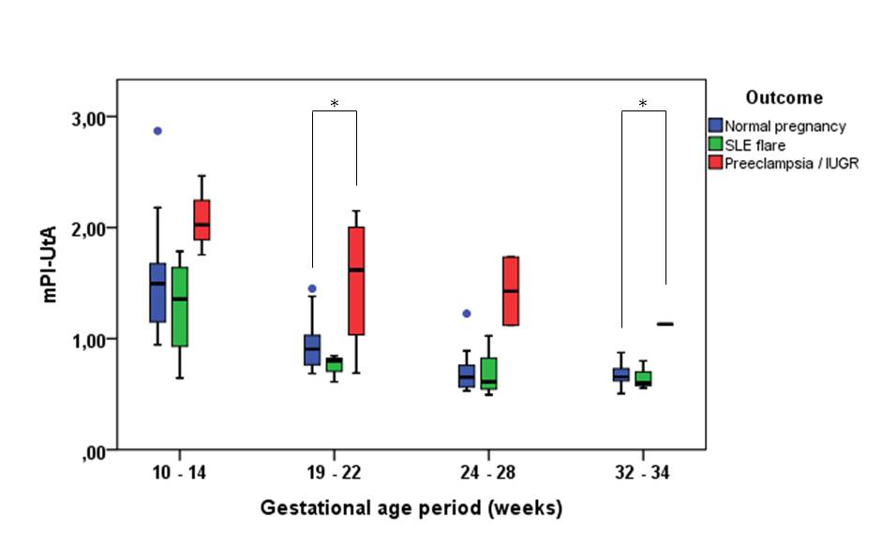
Graphic 1B
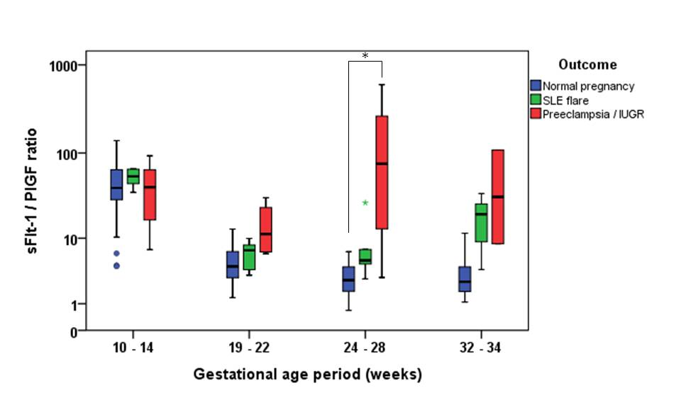
Table 3. Neonatal characteristics according to the pregnancy outcome
Variable | Normal pregnancy outcome (n= 35) | SLE flare (n= 5) | PE/IUGR (n = 4)
Gestational age at delivery (weeks) | 38.5 (2.9) | 34.8 (5.5)* | 34.1 (7.5)*
Delivery before 34 weeks | 2 (5.7) | 2 (40)* | 2 (50)*
Birthweight (g) | 3095.6 (683.9) | 2201.0 (991.8)* | 1772.7 (1066.0)*
Birthweight, customized centile (median, IQR) | 54 (24 – 74) | 32 (9 – 56) | 1 (1 – 5)*
SGA neonate (%) | 5 (14.3) | 1 (20.0) | 4 (100.0)*
5-min Apgar score (median, IQR)† | 10 (9 – 10) | 9 (8 – 10) | 5 (0– 9)*
Arterial pH† | 7.23 (0.10) | 7.26 (0.13) | 7.05 (0.35)
Perinatal mortality | 0 (0.0) | 0 (0.0) | 1 (25.0)
IQR, interquartile range; PE/IUGR, preeclampsia or intrauterine growth restriction; SLE, systemic lupus erythematosus; SGA; small for gestational age.
*p<0.05 (vs. normal pregnancy outcome). †In liveborn neonates.

