Pornhub searches during the covid-19 pandemic
Abstract: The SARS-CoV-2 virus was first registered in the Chinese city of Wuhan in December, 2019. Its subsequent spread to Europe, America and the rest of the world has generated hundreds of thousands of infections and deaths. It was at this moment when the porn website Pornhub offered free Premium services for fifteen days with the slogan: "Let's help flatten the curve", encouraging citizens to stay at home to reduce the infection and death counts. This article investigates the repercussions that the Covid-19 pandemic has had on the searches of pornography. Pornhub and Google trend’s data was used to compare global search traffic between March and May 2020 with the same period of 2019 through regression analysis. The results demonstrate a correlation (R² = 1) in the increase in Pornhub searches in women and men during the pandemic compared to the same dates in 2019.
Keywords: Coronavirus, Covid-19, SARSCoV2, Pornhub, Videos, Pornography, Big data, Audiovisual content.
Pornhub and the Covid-19
Parallel to the expansion of the Covid-19 pandemic, PornHub, the second largest pornographic web site in the world, announced that its Premium services would be free to citizens of Italy and Spain because of government-imposed lockdown measures. The offer was for fifteen days, a duration that was supposed to coincide with the mandatory confinement ordered by the governments of Spain and Italy. As the pandemic’s spread became global, the website expanded the offer to all countries in the world. The website started using the slogan: "let's help flatten the curve", referring to the epidemiological graphs of those infected and killed by the disease, to encourage citizens to stay at home and consume pornography without limitation through its services. Other slogans followed including "touch yourself, not others", or "thank you for flattening the curve" (PornHub, 2020).
The slogan “flatten the curve” was used in the scientific field to mitigate and / or postpone transmission of coronavirus infections (Lee, Han & Jeong, 2020; Kramer & Retnakaran, 2020). In parallel the media used it to inform and raise awareness among citizens of the exponential expansion of the pandemic (Arshed, Meo & Farooq, 2020) and the purpose of imposed restrictions. PornHub took advantage of this scientific concept to use it as a slogan for its advertising campaign during the spread of Covid-19. The appropriation of these scientific concepts has been studied previously (Escobar, 2018), and sometimes criticized for the trivialization of public health emergencies.
The 2019 data (PornHub, 2020) show that the countries with the highest consumption of pornography on the aforementioned website were the United States, Japan, United Kingdom, Canada, France, Germany, Italy, Philippines, Australia, Mexico, Brazil, Spain, Holland, Poland and India. These 20 countries with the highest consumption of pornography in 2019 on PornHub represent 79% of the site's traffic. Several countries with the highest number of Covid-19 infections are within this group, including the United States, the United Kingdom, Italy, Spain, Germany, Russia and France (Google, 2020).
Figure 1. Pornhub’s banners during the Covid-19 pandemic.
With the intention of showing the consumption of pornography, Pornhub published data about the use of their content from the year 2019 (PornHub, 2019). The website had 42 billion total visits (115 million visits per day) which lead to 1.36 million hours of consumed audiovisual content. If you started watching 2019’s recent videos in 1850, you would still be watching them today (PornHub, 2019). The average time that a user stayed on PornHub was 10 minutes, with women (32%) staying longer than men (68%). Individuals between the ages of 25 and 34 were the largest porn users with 36% of visits, followed by the age range, 18 and 24, with 25%. Adults between 35 and 44 years old represented 17% of the total visits and those between 45 and 54 years old, 11%. Finally, individuals between 55 to 64 years old represented 7% of visits and those over 65, 4% of visits. According to these data, the preferred device for visiting the website was the smartphone (76%), followed by the computer (16.3%) and the tablets (7.1%) (PornHub, 2019).
The application of mandatory or voluntary confinement to citizens around the world has, according to Pornhub (2020), caused an incredible increase in the creation of new audiovisual porn content. The Covid-19 Pandemic has already affected billions of people worldwide. It is not just affecting those who are at risk of contracting the illness, but many of us are doing our part to help flatten the curve by staying at home and social distancing. Over 150,000 verified models upload their own videos to Pornhub, receiving payments whenever their content is viewed. More time at home means more time to make homemade porn, so during the past weeks there has been a surge in video uploads from verified models.
Compared to a period of typical uploads from before the pandemic, daily uploads from models have now increased by over 30%. This first chart shows uploads of paid videos, which models can sell to their fans for whatever price they choose. To help support their verified models during this tough time, Pornhub elected to give them a 100% payout for the entire month of April (Pornhub Insights, 2020).
The pandemic affected a wide variety of searches. Compared to the same period in 2019, new questions appear on Google directly related to health, hygiene and social-distancing measures. Questions such as “how to make a mask with fabric”, “how to make hand sanitizer”, “where did coronavirus come from”, “how many cases of coronavirus”, “how many people died from coronavirus”, “what is zoom”, or “where to buy toilet paper” appear in this period (Fowers, 2020). Some are related to the search for information, but others to new habits and circumstances that came as consequences of COVID-19 pandemic.
The spread of the pandemic around the world
The Chinese city of Wuhan has become internationally known as the origin of the first registered cases of SARSCoV2, the virus associated with the COVID-19 disease. It all started in December, 2019, when the first cases of a pneumonia with unknown cause were reported in Wuhan (Jin, Z., et al., 2020). Recent studies have analyzed the clinical repercussions of Covid-19 in Asia (Guan et al., 2020; Liu et al., 2020, Wei et al., 2020; Corman et al., 2020; Dong et al., 2020, Wang et al., 2020) and the spread of the virus to Spain (Tagarro et al., 2020), to other countries of the European Union (Hodcroft, 2020) and to Latin America (Escalera-Antezana, 2020).
Outbreaks of severe acute respiratory syndromes (SARS) in 2002 and 2003, and the 2012 respiratory syndrome (MERS) showed the possibility of transmission of this disease from animals to humans, and subsequently between people. Although in 2002 SARS spread only in China, in 2003 it spread to 29 countries through international travel, infected 8098 individuals with a mortality rate of 9.6% (Chen, Y. et al., 2020).
The virus first spread internationally on December 31, in Wuhan, China, when the Wuhan Municipal Health Commission reported several cases in the city of the then unknown pneumonia (WHO, 2020). That same day, the World Health Organization alerted the health authorities of Hong Kong, Macau and Taiwan to strengthen their border surveillance as the unknown virus could become a serious threat to public health (WHO, 2020a), as a measure that could prevent an outbreak similar to the SARS and MERS. However, shortly thereafter, this cluster of pneumonia cases was determined to have been caused by a new coronavirus.
On January 30, the WHO Director-General declared the Covid-19 outbreak a public health emergency of international concern (PHEIC), recognizing the by de facto as an epidemic. Despite all the measures, on March 11, the virus’s high level of instability and global spread raised its classification to pandemic. Italy was the first country in Europe to impose measures to contain the outbreak and on February 31, the country declared a state of emergency, approving a series of urgent measures to prevent the spread of the virus. Ten days later, it imposed the limitation of the movement of citizens. This situation was completely unexpected to most of its citizens. On March 22, they extended the measures to close hospitality and business premises, suspension of face-to-face work activities to those considered essential, and an imposition of social distancing in the centers where these activities take place (WHO, 2002b). In April and May 2020, the virus spread throughout the world causing governments to compel and/or recommend their citizens not to go outside, except to make essential purchases, go to the doctor, work in basic services, or for greater cause. Quickly, the United States, United Kingdom, Italy, Spain and France became the countries with the most deaths from the pandemic.
Parallel to the spread of the pandemic around the world, various big data platforms (PornHub Insghts, 2020; Google Trends, 2020) collected data on searches related to pornographic audiovisual content. Several studies (Xue & Liu, 2019) have used big data to understand various social behaviors during the Covid-19 crisis. Likewise, recent studies have investigated the consumption of pornography through the PornHub website (Séguin et al., 2017; Shor & Seida, 2018; Seida & Shor, 2019). However, no studies to date have analyzed the impact of the Covid-19 pandemic on pornography use, nor on the marketing value of a health crisis in pornography website promotion.
The principal objective of this article is to investigate the evolution of searches for pornographic audiovisual content on PornHub during the months in which the virus spread through Europe and the United States. The secondary aim is to find out the evolution of pornography consumption in the countries most affected by Covid-19 (the United States, Spain, Italy and the United Kingdom) and its effects by age range and gender.
Material and methods
This research performs a quantitative analysis through big data from the platforms PornHub Insights and Google Trends. Pornhub Insights is research and analysis directly provided by Pornhub. The website offers these data arguing that they have compiled data from billions of hits, all to explore the intricacies of online porn viewership (PornHub, 2019). Very few recent studies (Castro Calvo et al., 2018) have used PornHub Insights big data to analyze the behaviour of porn consumers. The PornHub Insights platform allows the analysis of search data in a graph where the horizontal axis corresponds to time and the vertical axis to the percentage of searches compared to the previous year (PornHub, 2020). Likewise, it provides the opportunity for comparative graphs of the variables of region, age group and gender.
In regards to Google Trends, several recent studies (Yag ̆mur Lena; Furkan Dindarog lu, 2017; Bokelmann; Lessmann, 2018; Mahroum et al., 2018; Kamiński; Loniewski; Marlicz, 2019; Quintanilha et al., 2019; Cerdán & Padilla, 2019; Villa-Gracia & Cerdán: 2020) have used the platform to investigate trends on topics of social interest. Likewise, several recent investigations in health sciences (Strzelecki, 2020; Ortiz-Martínez et al, 2020; Yuan et al, 2020; Li et al, 2020; Springer et al, 2020; Ayyoubzadeh et al, 2020) use Google Trends data to predict the evolution of the Covid-19 pandemic.
The data provided by Google Trends is an impartial, anonymous and categorized sample of search data on the YouTube platform. This allows to measure interest in one or more topics anywhere in the world (Rogers, 2016). The analysis method has two filtering options. The real-time data is a random sample of searches from the last week of the search day. The non-real-time random sample pulls from the Google data set from 2008 to the last 36 hours, allowing comparison between various topics of interest (Google, 2020). This study integrates all these data into a graph that demonstrates the frequency with which a search is made for a particular term in one or more regions of the world. The horizontal axis of the graph shows the time (since 2008) and the vertical axis, the frequency of YouTube searches measured between 0 and 100, where 0 is the minimum popularity and 100 the maximum. Google Trends also allows one to see the differences in the subject (Google, 2020) of search in regions of the world and also in the territorial areas of each country.
This study performs two descriptive analyses, one using Google Trends data on searches for pornographic websites between 2019 and 2020 and the other with data on the evolution of searches on Pornhub during the pandemic months in the United States, Spain, Italy and the United Kingdom. We will also perform two regression analyses to assess the similarities and / or differences in the Pornhub Insight data in terms of searches for pornography by groups of women and men and also by age. As this is data from Pornhub Insight and Google Trends, this study does not require the approval of any ethical committee.
Results
The results show a peak of 24.4% (Figure 2, A) more searches for pornographic audiovisual material in 2020 compared to 2019 across the same dates (March 1 to April 30) internationally. The graph compares the percentage increase in searches for pornographic material in the following countries: Italy, Spain, the United Kingdom and the United States. In Italy, the peak of searches (57%) is on March 12. In Spain the graph peaks on March 17 with a peak of 61.3%. In the United States a peak 23.2% occurs on March 27. In the UK on March 25 there is a peak of 26.9%.
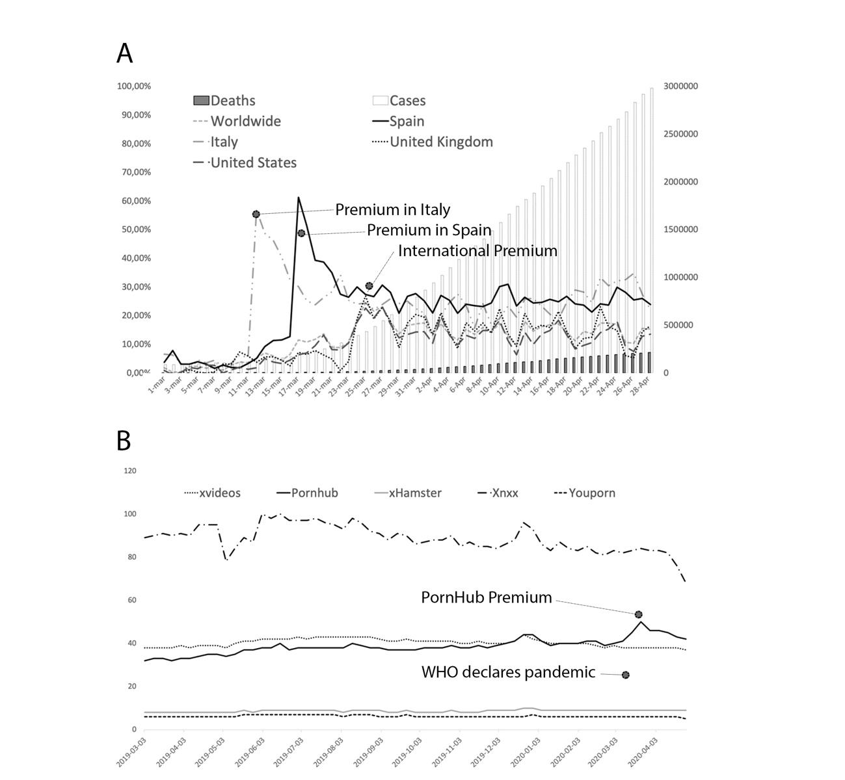
Figure 2. A) Comparative graph between the percentage increase between searches carried out on “Pornhub” in 2019 with the same dates in 2020 (during the Covid-19 pandemic). Worldwide, United States, Italy, Spain and the United Kingdom. Comparison with Covid-19 cases and deaths. B) Searches in Google (03/2019-05/2020) of pornographic websites: Pornhub, Xvideos, XNXX, xHamster and Youporn.
Figure 2 (B) shows a comparison of web searches for pornographic sites on Google during the last year (2019-2020). XNXX remains the most searched site. However, during the 2020 pandemic Pornhub grew noticeably compared to the same months of previous years, while searches for XNXX and other large pornography websites declined.
The maximum peak during the period analyzed on Google searches for pornographic platforms occurs on June 2, 2019. The pornographic portal “XNXX” reaches 100 points, according to Google Trends. The second peak of searches (50) happens in favor of “PornHub” in March 2020. The third is reached by “Youporn” (43) in August 2019. The fourth (xHamster) and the fifth (YouPorn) occur in December 2019 (10) and June 2019 (7).
Regarding the global average of searches during the selected period in 2019, XNXX is the most used (88), followed by xvideos (40), PornHub (38), xHamster (8.6) and YouPorn (6.2).

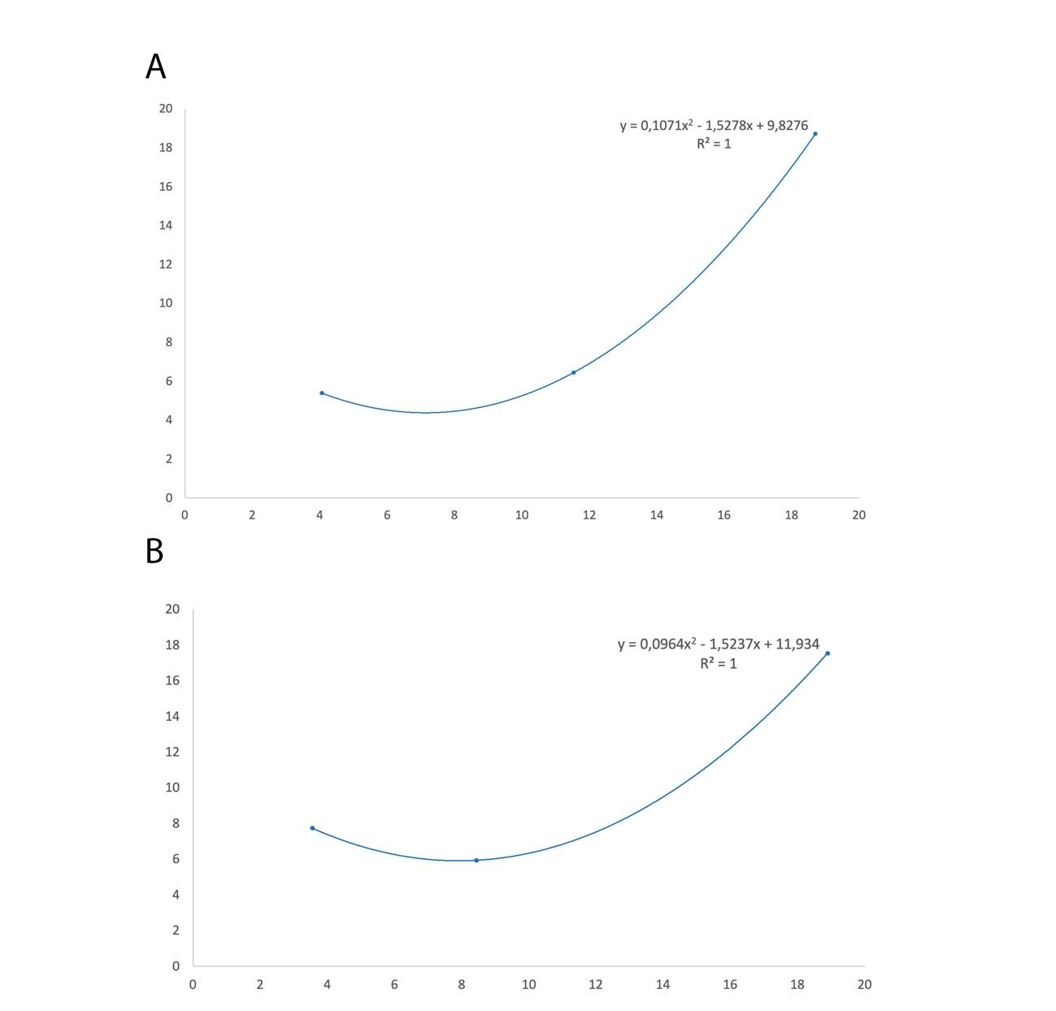
Figure 3. A) Regression analysis between women and men in the percentage of porn searches on PornHub compared to 2019. B) Regression analysis between young people and adults in the percentage of porn searches on PornHub compared to 2019
Regression analysis shows positive correlation (R² = 1) in the increase in porn searches made by women and men on Pornhub during the first months of the pandemic. In the following regression analysis, the means of the groups studied were again correlative (R² = 1), so the comparison of searches between the group of people under 35 and older is statistically similar among pornography searches during the pandemic on Pornhub.
Discussions
This study makes us draw two main conclusions. The first has to do with a large advertising campaign by PornHub, having taken advantage of the Covid-19 pandemic to promote itself internationally. In fact, the results show a peak of 24.4% more searches internationally for pornographic audiovisual material in 2020 compared to 2019 on the same dates (March 1 to April 30). The increase in pornography searches seems to be conditioned by the marketing campaign promoted by PornHub to offer free Premium content to encourage citizens to stay home, consuming pornography. The peak difference in the searches of pornography in Italy falls on March 12, the date on which the website offers its free paid version. The same happened with Spain on March 17, the date on which the portal offered the same product. In the United Kingdom it happens on March 25, the date on which PornHub offered the free Premium worldwide. In the United States that same day it reached its second highest peak, the highest occurring two days later on March 27. Likewise, it should be noted that of the four countries most affected in the number of deaths from the Covid-19 pandemic until May 2020, Spain is the country that shows the greatest increase in searches of pornography compared to the same dates in 2019, with 61.3% more searches. Italy occupies the second position with 57% and finally the United Kingdom (26.6%) and the United States (23.3%).
While there is no increase in searches for pornographic content during the confinement imposed by the pandemic, the efficacy of Pornhub's promotional marketing campaign is evident when comparing its searches to the other popular pornographic websites (XNXX, xHamster, Youporn, Xvideos). Pornhub is the only one that grew during this period, with the most Google searches during a period of time since the website launched. Searches for the other four websites declined. Some papers have studied the appropriation of scientific issues for advertising from critical foundations by distorting the initial concept (Petridis, Muraca & Kallis, 2015; Escobar, 2018). Following this theoretical line, the PornHub campaign “Flatten the curve” would be related to advertising that trivializes public health issues and even emergencies, such as a pandemic. While hundreds of people died every day, Pornhub used a medical slogan to promote pornography. In fact, the link between institutional communication and increase in traffic is clear in the case of Italy. On March 11, Italian Prime Minister G. Conte announced the beginning of lockdown. On the same day, PornHub began offering free access to Premium Service, using the slogan “Flatten the curve” is part of a wider campaign to increase viewers and to convey the image of a brand devoted to promoting socially responsible behaviors. Along this critical line, several recent studies (Zaboski, & Therriault, 2019; Scheufele & Krause, 2019; Neil & Campbell, 2020) analyze the use of other science-based messaging in advertising campaigns.
There was an increase in searches for pornographic audiovisual content on the PornHub website during the first months of the expansion of the Covid-19 pandemic around the world compared to the data from the same time period in 2019. There are two possible factors that led to this change. First, imposing mandatory or recommended confinements by the governments of the affected countries, forcing people to stay at home without having many leisure options may have increased pornography consumption. Second, the marketing campaign carried out by Pornhub, to take advantage of the pandemic, may have increased pornography consumption.
The second conclusion has to do with the behavior of users in searches for pornographic content on PornHub during the pandemic. The regression analysis results show a correlation between the percentage increase in searches for pornography made by men and women during the pandemic. Something similar occurs by age, where the results give an R² = 1 in the regression analysis, something that shows the correlation between the evolution of the searches of both groups.
Our conclusion is that the PornHub advertising campaign, besides improving its popularity on the internet, was equally effective on women and men, and on younger and older adult users.
However, this study does not show the reasons for the increased consumption. Several studies agree that during the early months of the pandemic, certain groups reported decreased sexual intercourse (Schiavi et al., 2020, Stephenson et al., 2020). Also, it has been noticed that the confinement and reduction of the number of social contacts has created stress and anxiety patterns in a significant percentage of people (Shilo et al., 2020, Starks et al., 2020). This study may serve as a basis for analyzing the extent to which pornography consumption serves to alleviate these feelings among the population.
This research is limited to the data provided by Google and PornHub, so it does not include data from other platforms such as: XNXX, Youporn, xHamster or xvideos, and Yadex, Yahoo, or Bing search engines, among others. Further analysis of these platforms could deepen understanding of search behavior relating to pornographic content during the Covid-19 pandemic. Likewise, the data extracted from PornHub Insights could not be compared in the methods used for its collection, and therefore they were compared with those from Google Trends, to assess whether there were similarities between the two.

References
Arshed, N., Meo, M. S., & Farooq, F. 2020. ‘Empirical assessment of government policies and flattening of the COVID 19 curve’. Journal of Public Affairs. DOI:10.1002/pa.2333
Asaad, A. M., El-Sokkary, R. H., Aedh, A. I., Ali Alzamanan, M. A., Khalil, F. O. 2019. ‘Exploring Knowledge and Attitude toward Middle East Respiratory Syndrome-Coronavirus (MERS-CoV) Among University Health Colleges’ Students, Saudi Arabia: A Cross-Sectional Study’. American Journal of Infectious Diseases, 15(1), 37–43. DOI:10.3844/ajidsp.2019.37.43
Ahrefs. 2020. Top Google searches (as of 2020). Ahrefs. https://ahrefs.com/blog/top-google-searches/
Ayyoubzadeh, S. M., Zahedi, H., Ahmadi, M., R. Niakan Kalhori, S. 2020. ‘Predicting COVID-19 Incidence Through Analysis of Google Trends Data in Iran: Data Mining and Deep Learning Pilot Study’. JMIR Public Health SurveilL, 6(2):e18828. DOI: 10.2196/18828
Basch, C. H., Hillyer, G. C., Meleo-Erwin, Z. C., Jaime, C., Mohlman, J., Basch, C. E. 2020. ‘Preventive Behaviors Conveyed on YouTube to Mitigate Transmission of COVID-19: Cross-Sectional Study’. JMIR Public Health Surveill, 6(2):e18807. DOI: 10.2196/18807
Berrocal-Gonzalo, S., Martín-Jiménez, V., Gil-Torres, A. 2017. ‘Líderes políticos en YouTube: información y politainment en las elecciones generales de 2016 (26J) en España’. El profesional de la información, v. 26, n. 5. https://doi.org/10.3145/epi.2017.sep.15
Bitirim, Y. 2019. ‘An Evaluation on Popularity of the Prioritized Diseases Using Google Trends’. Journal of Medical Imaging and Health Informatics, 9. DOI: 10.1166/jmihi.2019.2613
Brar, J., Ferdous, M., Abedin, T., & Turin, T. C. 2020. ‘Online Information for Colorectal Cancer Screening: A Content Analysis of YouTube Videos’. Journal of Cancer Education. DOI:10.1007/s13187-020-01710-8
Castro-Calvo, J., Ballester-Arnal, R., Potenza, M. N., King, D. L., & Billieux, J. 2018. ‘Does “forced abstinence” from gaming lead to pornography use? Insight from the April 2018 crash of Fortnite’s servers’. Journal of Behavioral Addictions, 7(3). DOI:10.1556/2006.7.2018.78
Cerdán Martínez, V., Padilla Castillo, G. 2019. ‘Historia del fake audiovisual: deepfake y la mujer en un imaginario falsificado y perverso’. Historia y comunicación social, 24 (2).
Chambers, C. T., Dol, J., Parker, J. A., Caes, L., Birnie, K. A., Taddio, A., Campbell-Yeo, M., Halperin, S. A., Langille, J. 2020. ‘Implementation Effectiveness of a Parent-Directed YouTube Video (“It Doesn’t Have To Hurt”) on Evidence-Based Strategies to Manage Needle Pain: Descriptive Survey Study’. JMIR Pediatr Parent, 3(1): e13552. DOI: 10.2196/13552
Corman, V. M., Landt, O., Kaiser, M. 2020. ‘Detection of 2019 novel coronavirus (2019-nCoV) by real-time RT-PCR’. Euro Surveill, 25(3). DOI:10.2807/1560- 7917.ES.2020.25.3.2000045
Dong, Y., Mo, X., Hu, Y. 2020. ‘Epidemiological characteristics of 2143 pediatric patients with 2019 coronavirus disease in China’. Pediatrics. DOI:10.1542/peds.2020-0702
Elkin, L. E., Pullon, S. R. H., Stubbe, M. H. 2020. ‘Should I vaccinate my child?’ comparing the displayed stances of vaccine information retrieved from Google, Facebook and YouTube’. Vaccine. https://doi.org/10.1016/j.vaccine.2020.02.041
Enver, N., Doruk, C., Kara, H., Gürol, E., Incaz, S., Mamadova, U. 2020. ‘YouTube™ as an ınformation source for larynx cancer: a systematic review of video content’. European Archives of Oto-Rhino-Laryngology. DOI:10.1007/s00405-020-05906-y
Escalera-Antezana, J. P., Lizon-Ferrufino, N. F., Maldonado-Alanoca, A., Alarcón-De-la-Vega, G., Alvarado-Arnez, L. E., Balderrama-Saavedra, M. A., … Rodríguez-Morales, A. J. 2020. ‘Clinical features of the first cases and a cluster of Coronavirus Disease 2019 (COVID-19) in Bolivia imported from Italy and Spain’. Travel Medicine and Infectious Disease, 101653. DOI:10.1016/j.tmaid.2020.101653
Escobar, J. 2018. ‘The Social Appropriation of Science and Technology as a Slogan: an Analysis of the Colombian Case’. Revista iberoamericana de ciencia tecnología y Sociedad, 13.
Faoury, M., Upile, T., & Patel, N. 2019. ‘Using Google Trends to understand information-seeking behaviour about throat cancer.’ The Journal of Laryngology & Otology. DOI:10.1017/s0022215119001348
Fowers, A. 2020. ‘Last year, we searched Google for how to tie a tie. Now we’re using it to find toilet paper’. The Washington Post. https://wapo.st/3dcA4ML
Guan, W., Ni, Z., Hu, Y. 2020. ‘Clinical characteristics of coronavirus disease 2019 in China’. N Engl J Med. DOI:10.1056/ NEJMoa2002032
Emma, H. B. 2020. ‘Preliminary case report on the SARS-CoV-2 cluster in the UK, France, and Spain’. Swiss Medical Weekly, 150
Kamiński, M., Łoniewski, I., Marlicz, W., 2019. ‘Global internet data on the interest in antibiotics and probiotics generated by Google Trends’. Antibiotics, 8(3). https://doi.org/10.3390/antibiotics8030147
Khatri, P., Singh, S., Belani, N. K., Leng, Y. Y., Lohan, R., Wei, L. Y., Teo, W. Z. 2020. ‘YouTube as source of information on 2019 novel coronavirus outbreak: A cross sectional study of English and Mandarin content’. Travel Medicine and Infectious Disease, 101636. DOI:10.1016/j.tmaid.2020.101636
Kramer, C. K., Retnakaran, R. 2020. ‘Rates of COVID-19-associated hospitalization in British Columbia and Ontario: time course of flattening the relevant curve’. Canadian Journal of Public Health, 111(5). DOI:10.17269/s41997-020-00405-3
Kuçuk, B., Sirakaya, E. 2019. ‘An Analysis of YouTube Videos as Educational Resources for Patients About Refractive Surgery’. Cornea, 1. DOI:10.1097/ico.0000000000002237
Kwan, Z., Yong, S. S., Robinson, S. 2019. ‘Analysis of Internet searches using Google trends to measure interest in sun protection and skin cancer in selected South East Asian populations’. Photodermatology, Photoimmunology & Photomedicine. DOI:10.1111/phpp.12510
Lee, K.-B., Han, S., Jeong, Y. 2020. ‘COVID-19, flattening the curve, and Benford’s law’. Physica A: Statistical Mechanics and Its Applications, 559, 125090. DOI:10.1016/j.physa.2020.125090
Cuilian, L., Li Jia, C., Xueyu, C., Mingzhi, Z., Chi Pui, P., Haoyu, C., 2020. ‘Retrospective analysis of the possibility of predicting the COVID-19 outbreak from Internet searches and social media data, China’. Euro Surveill, 25(10):pii=2000199. https://doi.org/10.2807/1560-7917.ES.2020.25.10.2000199
Liou, N. S., M., R., A., M., Odejinmi, F. 2019.’ Google searches and medical publication trends since the 2014 US Food and Drug Administration position on power morcellation: Do these translate into patient awareness?’. European Journal of Obstetrics & Gynecology and Reproductive Biology, 243. DOI:10.1016/j.ejogrb.2019.10.010
Liu, W., Zhang, Q., Chen, J., et al. 2020. ‘Detection of COVID-19 in children in early January 2020 in Wuhan, China’. N Engl J Med. DOI:10.1056/ NEJMc2003717
Mahroum, N., Bragazzi, N-L., Brigo, F., Waknin, R., Sharif, K., Mahagna, H., Amital, H., Watad, A. 2018. ‘Capturing public interest toward new tools for controlling human immunodeficiency virus (HIV) infection exploiting data from Google Trends’. Health Informatics Journal, 25(4). https://doi.org/10.1177/1460458218766573
Mejean, A., Rouprêt, M., Rozet, F., Bensalah, K., Murez, T., Game, X., … Neuzillet, Y. 2020. ‘Recommandations CCAFU sur la prise en charge des cancers de l’appareil urogénital en période d’épidémie au Coronavirus COVID-19’. Progrès En Urologie. DOI:10.1016/j.purol.2020.03.009
Narayanan, S., Neto, F. L., Tanco, K., Lopez, G., Liu, W., Bruera, E., & Subbiah, V. 2020. ‘Cannabidiol (CBD) Oil, Cancer, and Symptom Management: A Google Trends Analysis of Public Interest’. The Journal of Alternative and Complementary Medicine. DOI:10.1089/acm.2019.0428
Neil, S., Campbell, E. M. 2020. ‘Fake science: xmrv, Covid-19 and the toxic legacy of Dr. Judy Mikovits’. Aids Research and Human Retroviruses. DOI:10.1089/aid.2020.0095
Ortiz-Martínez, Y., Garcia-Robled, J. E., Vásquez-Castañeda, D.L., Bonilla-Aldana, D. K., Rodriguez-Morales, A. J. 2020. ‘Can Google Trends predict COVID-19 incidence and help preparedness? The situation in Colombia’. Travel Medicine and Infectious Disease. DOI: https://doi.org/10.1016/ j.tmaid.2020.101703.
Patel, M. S., Halpern, J. A., Desai, A. S., Keeter, M. K., Bennett, N. E., Brannigan, R. E. 2020. ‘Success of Prostate and Testicular Cancer Awareness Campaigns Compared to Breast Cancer Awareness Month According to Internet Search Volumes: A Google Trends Analysis’. Urology. DOI:10.1016/j.urology.2019.11.062
Petridis, P., Muraca, B., Kallis, G. 2015. ‘Degrowth: between a scientific concept and a slogan for a social movement’. Handbook Of Ecological Economics. (Edited by Martinez Alier, J; Muradian, R).
Quintanilha, L., Souza, L., Sanches, D., Senos-Demarco, R., Ferreira-Fukutani, K., 2019. ‘The impact of cancer campaigns in Brazil: a Google Trends analysis’. Ecancer medical science,13(963). https://doi.org/10.3332/ecancer.2019.963
Ryan, P. M., Ryan, C. 2019. ‘Mining Google Trends Data for Health Information: The Case of the Irish “CervicalCheck” Screening Programme Revelations’. Cureus, 11(8): e5513. DOI:10.7759/cureus.5513
Sabuncuoğlu-İnanç, A., Gökaliler, E., Gülay, G., 2020. ‘Do bumper ads bump consumers?: An empirical research on YouTube video viewers’. El profesional de la información, 29(1), e290114. https://doi.org/10.3145/epi.2020.ene.14
Seida, K., Shor, E. 2019. ‘Aggression and Pleasure in Opposite-Sex and Same-Sex Mainstream Online Pornography: A Comparative Content Analysis of Dyadic Scenes’. The Journal of Sex Research. DOI:10.1080/00224499.2019.1696275
Séguin, L. J., Rodrigue, C., Lavigne, J. 2017. ‘Consuming Ecstasy: Representations of Male and Female Orgasm in Mainstream Pornography’. The Journal of Sex Research, 55(3). DOI:10.1080/00224499.2017.1332152
Shor, E., Seida, K. 2018. ‘Harder and Harder? Is Mainstream Pornography Becoming Increasingly Violent and Do Viewers Prefer Violent Content?’. The Journal of Sex Research. DOI:10.1080/00224499.2018.1451476
Springer, S., Menzel, L. M., Zieger, M. 2020. ‘Google Trends reveals: Focus of interest in the population is on treatment options rather than theories about COVID-19 animal origin’. Brain, Behavior, and Immunity. DOI: https://doi.org/10.1016/j.bbi.2020.05.005
Scheufele, D. A., Krause, N. M. 2019. ‘Science audiences, misinformation, and fake news’. Proceedings of the National Academy of Sciences, 201805871. DOI:10.1108/idd-08-2018-0:10.1073/pnas.1805871115
Schiavi, M. C., Spina, V., Zullo, M. A., Colagiovanni, V., Luffarelli, P., Rago, R., Palazzetti, P.(2020. ‘Love in the Time of COVID-19: Sexual Function and Quality of Life Analysis During the Social Distancing Measures in a Group of Italian Reproductive-Age Women’. The Journal of Sexual Medicine. DOI:10.1016/j.jsxm.2020.06.006
Shilo, G., Mor, Z. 2020. ‘COVID-19 and the Changes in the Sexual Behavior of Men Who Have Sex With Men: Results of an Online Survey’. The Journal of Sexual Medicine. DOI:10.1016/j.jsxm.2020.07.085
Starks, T. J., Jones, S. S., Sauermilch, D., Benedict, M., Adebayo, T., Cain, D., Simpson, K. N. 2020. ‘Evaluating the impact of COVID-19: A cohort comparison study of drug use and risky sexual behavior among sexual minority men in the U.S.A’. Drug and Alcohol Dependence, 216, 108260. DOI:10.1016/j.drugalcdep.2020.108260
Stephenson, R., Chavanduka, T. M. D., Rosso, M. T., Sullivan, S. P., Pitter, R. A., Hunter, A. S., Rogers, E. 2020. ‘Sex in the Time of COVID-19: Results of an Online Survey of Gay, Bisexual and Other Men Who Have Sex with Men’s Experience of Sex and HIV Prevention During the US COVID-19 Epidemic’. AIDS and Behavior. DOI:10.1007/s10461-020-03024-8
Strzelecki, A. 2020. ‘The Second Worldwide Wave of Interest in Coronavirus since the COVID-19 Outbreaks in South Korea, Italy and Iran: A Google Trends Study’. Brain, Behavior, and Immunity. DOI:10.1108/idd-08-2018-0: https://doi.org/10.1016/j.bbi.2020.04.042
Szmuda, T., Rosvall, P., Hetzger, T. V., Ali, S., Słoniewski, P. 2020. ‘YouTube as a Source of Patient Information for Hydrocephalus: A Content-Quality and Optimization Analysis’. World Neurosurgery. https://doi.org/10.1016/j.wneu.2020.02.149.
Tagarro, A., Epalza, C., Santos, M., Sanz-Santaeufemia, F. J., Otheo, E., Moraleda, C., Calvo, C. 2020. ‘Screening and Severity of Coronavirus Disease 2019 (COVID-19) in Children in Madrid, Spain’. JAMA Pediatrics. DOI:10.1108/idd-08-2018-0:10.1001/jamapediatrics.2020.1346
Verelst, F. Kuylen, E., Beutels, P. 2020. ‘Indications for healthcare surge capacity in European countries facing an exponential increase in coronavirus disease (COVID-19) cases, March 2020’. Euro Surveill, 25(13):pii=2000323. https://doi.org/10.2807/1560-7917.ES.2020.25.13.2000323
Villa-Gracia, D., Cerdán, V. 2020. ‘Evolución de la popularidad de Donald Trump y otros mandatarios internacionales en Google Trends (2016-2019)’. El profesional de la información, 29(1), e290212. https://doi.org/10.3145/epi.2020.ene.12
Wang, W., Xu, Y., Gao, R. 2020. ‘Detection of SARS-CoV-2 indifferent types of clinical specimens’. JAMA. DOI:10.1108/idd-08-2018-0:10.1001/jama. 2020.3786
Wei, M., Yuan, J., Liu, Y., Fu, T., Yu, X., Zhang, Z.-J. 2020. ‘Novel coronavirus infection in hospitalized infants under 1 year of age in China’. JAMA. DOI:10.1108/idd-08-2018-0:10.1001/jama.2020.2131
Wong, J., Goh, Q. Y., Tan, Z., Lie, S. A., Tay, Y. C., Ng, S. Y., Soh, C. R. 2020. ‘Preparing for a COVID-19 pandemic: a review of operating room outbreak response measures in a large tertiary hospital in Singapore’. Canadian Journal of Anesthesia/Journal Canadien D’anesthésie. DOI:10.1108/idd-08-2018-0:10.1007/s12630-020-01620-9
Xue, T., & Liu, H. 2019. ‘The prediction of petition based on Big Data’. Information Discovery and Delivery. DOI:10.1108/idd-08-2018-0031
Yan, Y., Chen, H., Chen, L., Cheng, B., Diao, P., Dong, L., …Li, H. 2020. ‘Consensus of Chinese experts on protection of skin and mucous membrane barrier for healthcare workers fighting against coronavirus disease 2019’. Dermatologic Therapy. DOI:10.1111/dth.13310
Yuan, X., Xu, J., Hussain, S., Wang, H., Gao, N., Zhang, L. 2020. ‘Trends and Prediction in Daily New Cases and Deaths of COVID-19 in the United States: An Internet Search-Interest Based Model’. Exploratory Research and Hypothesis in Medicine 2020;000(000):000–000. DOI: 10.14218/ERHM.2020.00023.
Zaboski, B. A., Therriault, D. J. 2019. ‘Faking science: scientificness, credibility, and belief in pseudoscience’. Educational Psychology, 1–18. DOI:10.1080/01443410.2019.1694646
Zhang, J., Zheng, Z., Wang, Y., & Zhu, Y. 2020. ‘A study on users’ preference towards diabetes-related video clips on YouTube’. BMC Medical Informatics and Decision Making, 20(1). DOI:10.1186/s12911-020-1035-1

