Precipitation and encapsulation of β-sitosterol using supercritical antisolvent (SAS) method for controlled nutraceutical release.

Daniela Cerro^{a,b,c,*}, Albertina Cabañas^{d,*}, Alejandra Torresª, Fouad Zahran^{d,e}, Luisa Sepúlveda^{c}, Patricia Rivera^{b}, Julio Romero^{b}
ª Technology Center for Food Packaging Innovation LABEN-CHILE. CEDENNA-USACH, University of Santiago de Chile, Chile.
^{b} Laboratory of Membrane Separation Processes (LabProSeM), Department of Chemical Engineering and Bioprocesses, Engineering Faculty, University of Santiago de Chile, Chile.
^{c} Chemical Engineering and Bioprocess Department, Faculty of Engineering, University of Santiago of Chile (USACH), Santiago, Chile.
^{d} Physical Chemistry Department, Universidad Complutense, E-28040 Madrid, Spain.
^{e} Chemistry Department, Faculty of Science, Helwan University, El Cairo, Egypt.

*Corresponding authors:
daniela.cerro@usach.cl; +56 22 7181825
a.cabanas@quim.ucm.es; + 34 91 3945225/4200
Abstract
β-sitosterol (βsit) is a plant-derived phytosterol with recognized health-promoting properties, but its low aqueous solubility and limited bioavailability constrain its use in nutraceuticals and functional foods. This study aimed to precipitate and encapsulate βsit within polycaprolactone (PCL) using the Supercritical AntiSolvent (SAS) process in order to develop a controlled delivery system for nutraceutical bioactives. First, βsit was precipitated from a 2% ethyl acetate solution at 40 ºC and pressures ranging from 9 to 13 MPa to identify suitable operating conditions; 9 MPa was selected as optimal due to its lower βsit solubility in the CO₂/solvent mixture. These conditions were then applied for the precipitation of βsit with PCL. The SAS mechanism relied on the anti-solvent action of supercritical CO₂, promoting rapid precipitation and the formation of βsit:PCL microparticles. The inclusion of Tween 80 (T80) enhanced incorporation efficiency, promoted uniform microparticle morphology, and increased overall process yield. Formulation variables modulated both the release kinetics and underlying mechanisms. Incorporation within PCL slowed βsit release, while T80 accelerated it, likely due to reduced matrix crystallinity. Overall, βsit was successfully micronized along with PCL using SAS-based precipitation, highlighting its potential for the combination of bioactive compounds in functional foods and nutraceutical applications.

Keywords: β-sitosterol, supercritical CO₂, antisolvent, micronization, polycaprolactone, controlled nutraceutical release.
- Introduction
β-sitosterol (βsit), is a plant-derived phytosterol widely recognized for its potent cholesterol-lowering effects and broad therapeutic potential. Its incorporation into functional foods and nutraceutical products has been extensively explored, particularly due to its ability to reduce low-density lipoprotein (LDL) cholesterol levels, support cardiovascular health (Pavani et al., 2022), to help manage diabetes (Babu & Jayaraman, 2020) and urinary symptoms associated with benign prostatic hyperplasia (Berges et al., 2000).
Structurally, βsit possesses a steroidal structure with multiple carbon rings and only a hydroxyl group (Fig. 1), which confers low polarity and pronounced hydrophobicity, resulting in high solubility in organic solvents (Wei et al., 2010), but poor solubility in aqueous media of only 2-4 mg/L (Malaviya & Gomez, 2008). Consequently, the effective application of βsit is restricted, limiting its bioavailability and overall physiological efficacy. In response to these limitations, recent studies have focused on food-grade encapsulation strategies for βsit to improve its stability and gastrointestinal bioaccessibility. Protein–polysaccharide nanoparticles and core–shell systems have shown particular promising, as intermolecular interactions can induce partial or complete amorphization of βsit, resulting in enhanced dissolution and in vitro release behavior (Li et al., 2025; Lu et al., 2023). In addition, food-grade colloidal systems such as Pickering emulsions stabilized by protein–polysaccharide complexes have been explored to improve the physical stability and retention of βsit in oil–water systems, offering an alternative strategy for its incorporation into functional food matrices (Pokorski et al., 2025). Lipid-based carriers, particularly liposomes, have also been investigated for βsit delivery, where the phytosterol may contribute to membrane stabilization and enhanced oxidative stability, while enabling controlled release in food and nutraceutical applications (Chang et al., 2025; Jovanović et al., 2025). Despite these advances, many βsit delivery systems still rely on multistep wet-processing routes or complex carrier architectures, and offer limited control over particle morphology and crystallinity through processing variables.
Micronization has been proposed as an effective strategy to enhance dissolution rates and reduce the required daily dose of βsit (Moreno-Calvo et al., 2014). Conventional solvent-based micronization techniques often present drawbacks such as poor control over particle morphology and size distribution, difficulties in removing residual solvents, and the potential for thermal degradation of the compound during processing (Prosapio et al., 2018).
In this context, micronization techniques using supercritical CO₂ (sc-CO₂) have emerged as a sustainable alternative. These processes minimize the use of toxic organic solvents, offer enhanced control over particle size and morphology, and yield solvent-free final products (Padrela et al., 2018). Sc-CO₂ is particularly attractive due to its moderate critical conditions (31 °C, 7.4 MPa), and its tunable physicochemical properties, which can be modified by adjusting the operating conditions (Zahran et al., 2014). Its low viscosity and high diffusivity promote uniform particle formation while minimizing thermal degradation (Cerro et al., 2024). Moreover, CO₂ is non-toxic, non-flammable and easily removed upon depressurization, ensuring the absence of harmful residues in the final product (Cerro et al., 2023).
Among micronization techniques, the Supercritical AntiSolvent (SAS) process is particularly suitable for compounds that are poorly soluble or insoluble in sc-CO₂. The sc-CO₂ acts as an antisolvent by being introduced into a solution of the target compound dissolved in an organic solvent. Efficient precipitation requires that the solute be fully soluble in the organic solvent but insoluble in sc-CO₂. Additionally, the organic solvent must be fully miscible with sc-CO₂ to enable phase expansion and reduce the solubility of the solute, thereby promoting its controlled precipitation. Particle size and morphology can be tuned by adjusting pressure, temperature, flow rates, as well as nozzle diameter. This method produces micronized particles with tailored physicochemical properties, while enhancing the compound’s physiological efficiency through increased specific surface area and improved dissolution (Moreno-Calvo et al., 2014). It also allows co-precipitation with polymeric excipients, providing protection against degradation and potential controlled release (Zahran et al., 2014; Prosapio et al., 2018).
Although SAS has not been previously applied to the micronization of βsit, related supercritical techniques provide useful insights into its phase behavior and precipitation feasibility. According to Turk et al. the solubility of βsit in CO₂ at 50°C ranges from 2.99x10⁻⁵ to 1.88x10⁻⁴ in mol fraction at 14 and 25 MPa (Turk et al., 2006), although relatively low, this solubility was sufficient to enable the coprecipitation of βsit with L-poly(lactic acid) using the Rapid Expansion of Supercritical Solutions (RESS) method. Concerning the combined use of βsit and organic solvents in CO₂, Temelli et al. have studied the phase behaviour of phytosterols in carbon dioxide-expanded ethanol. CO₂ acted as a co-solvent at concentrations of up to ∼0.8 mol fraction but showed an antisolvent effect at higher CO₂ concentrations (Temelli et al., 2012). These data were used to guide the precipitate of phytosterols using the Depressurization of an Expanded Liquid Organic Solution (DELOS) technique developed by Moreno-Calvo et al. (Moreno-Calvo et al., 2014).
In this study, polycaprolactone (PCL) was used as the encapsulating agent to coprecipitate along with βsit. PCL is a biocompatible and biodegradable polymer approved by the Food and Drug Administration (FDA) (Prieto & Calvo, 2017a, 2017b). Previous studies have successfully trapped bioactive compounds such as α-lipoic acid, eugenol, resveratrol, green tea polyphenols, and β-carotene in PCL using supercritical techniques, producing microparticles with controlled dissolution and high encapsulation efficiency (Palazzo et al., 2020; Sakata et al., 2021; Sosa et al., 2011; De Paz et al., 2013). In previous studies, we have successfully produced βsit/PCL microparticles using the Supercritical Fluid Extraction of Emulsions (SFEE) process with process efficiencies higher 60% (Cerro et al., 2024). Moreover, PCL microcapsules have been successfully applied in functional foods, such as yogurt, to encapsulate polyphenols extracted from olive leaves, enhancing their stability and enabling controlled release of the bioactive compounds (El‐Messery et al., 2021)
To our knowledge, the micronization of βsit using the SAS method and its co-precipitation with PCL, has not been previously reported. In this work, sc-CO₂ is employed as an antisolvent to precipitate βsit from ethyl acetate or acetone solutions using food-compatible materials. Initially, the antisolvent effect of sc-CO₂ in βsit was evaluated using a high-pressure view cell, guiding subsequent precipitation with the SAS process. The influence of pressure, PCL incorporation, and Tween 80 surfactant (T80) addition on the structural, thermal, and functional properties of the particles, is systematically investigated, with the aim of establishing structure–process–function relationships relevant to food and nutraceutical applications.
- Materials and Methods
  - Chemicals and raw materials
The materials employed were CO₂ (99.98 mol% pure) obtained from Carburos Metálicos, and βsit (≥70%, Product No. 85451-100G, Merck), which contains campesterol and β-sitostanol as residual plant-derived sterol impurities. Polycaprolactone (PCL) (MW 80,000) and Tween®80 (T80) were purchased from Sigma Aldrich. Ethyl acetate, acetone (≥99.5% (GC)), sulfuric acid (≥95%), dichloromethane (≥95%) acetic anhydride (≥95%) and methanol (≥99.9%) were purchased from Merck. All water used was pretreated using the Milli-Q Elix water purification system (Millipore Ibérica, Madrid, Spain). For the dissolution test Phosphate Buffer Solution (PBS) pH 7 was obtained from Merck.
  - High-pressure view cell
A high-pressure variable volume view cell was employed to evaluate the antisolvent effect of CO₂ on βsit solutions prepared in different organic solvents. A schematic of the experimental setup is shown in Fig. 2, and a detailed description has been previously described (Pérez et al., 2023). Briefly, the apparatus consists of a cylindrical high-pressure cell of approximately 15 mL, sealed with a sapphire window in one side and a movable piston in the other.
The temperature was measured using a type J thermocouple placed within the cell and the pressure using a relative pressure transducer (Druck, model PTX7511-1). The cell was heated using a heating tape connected to a PDI temperature controller. The pressure varied by displacing the piston within the cell using a high-pressure manifold and water as hydrostatic fluid. The content of the cell was observed using a Fiegert Endotech boroscope attached to the sapphire window and a digital camera connected to a computer.
The photograph on the right (Fig. 2) shows a representative view inside the high-pressure cell. The bright outer ring observed at the front corresponds to an artefact image caused by the reflection of the boroscope light on the sapphire window. The visualization of the cell walls and the piston sealing the cell appears as a small bright circle. The small protruding element on the left side is the tip of the temperature sensor. The small white rod visible below the central area is the magnetic stirring bar used to ensure homogeneous mixing during CO₂ addition.
The experiments were performed by introducing 2 g of a 2 % w/v solution of the active compound in the organic solvent (ethyl acetate or acetone) into the cell, which was purged several times at room temperature with CO₂ to remove entrapped air. The cell was then heated to 40ºC, and 10 g of CO₂ were added using a thermostated high-pressure ISCO syringe pump until the target pressure was reached. The solution was further compressed to the desired operating pressure by displacing the movable piston. The thermostat stability was ± 0.2 °C and the pressure uncertainty ± 0.1 MPa.
  - Supercritical AntiSolvent (SAS) micronization.
The micronization/encapsulation experiments were performed using a high-pressure SAS equipment from Thar Technology. Fig. 3 shows a schematic of the laboratory-scale apparatus used and a detailed diagram of the precipitation chamber, illustrating the CO₂ and solution inlets, the 100-µm nozzle geometry, the precipitation zone inside the collection basket, and the CO₂ + solvent outlet. A detailed description of the equipment has been previously reported (Zahran et al., 2014; Cuadra et al., 2019). The equipment consists of two high-pressure pumps (one for CO₂ and the other for the liquid solution), a 500 mL precipitation chamber containing a basket and a frit for particle collection heated with a resistance heater and a Back-Pressure Regulator (BPR Thar-SCF ABPR-20) to control the pressure. One-way and relief valves allow a safe operation in case of blockages.
Sc-CO₂ was initially incorporated into the precipitation cell using the high-pressure pump (Thar-SCFP-5), preceded by a chiller for CO₂ liquefaction and followed by a heat exchanger to ensure supercritical conditions at a constant flow rate of 20 g/min until a steady state was reached. Subsequently, the solution containing βsit or βsit/PCL was sprayed into the chamber at 1 mL/min through a 100 μm diameter nozzle using the liquid HPLC-type pump (Lab Alliance Series III Pump). This pump provides a flow accuracy of ± 2% and a flow precision of 0.2% RSD, together with a pressure accuracy of ±1% of full-scale, ensuring stable and reproducible delivery of the solution into the precipitator. Acetone and ethyl acetate were assayed as possible solvents. To prevent βsit degradation, the precipitation temperature was fixed at 40ºC. Temperature regulation in the precipitation chamber was achieved through a CAL-9400 controller coupled to an internal thermocouple, which ensures tight and stable temperature control during operation; more details may be found in (Zahran, 2012). Flow rates were adjusted to achieve CO₂ mole fractions above 0.98, as the CO₂/solution molar ratio is controlled solely by the relative flow rates delivery by both pumps, while pressure was varied between 9 and 13 MPa to ensure complete miscibility of the solvent in sc-CO₂ and to minimize βsit solubilization in the mixture (Chang et al., 1997; da Silva et al., 2000). Under these operating conditions, the resulting sc-CO₂/solvent mixture inside the precipitator is strongly CO₂-rich. Although the system studied is ternary, the low solute concentration in the solvent allows the phase behavior to be assumed equivalent to that of the binary system in the CO₂-rich region (Zahran et al., 2014; Zahran et al., 2010).
Once injected, micro-droplets of the solution entered the precipitation chamber and mixed with sc-CO₂. Given the high solubility of the organic solvent in sc-CO₂ and the low solubility of the solute in the supercritical fluid, sc-CO₂ diffused into the solution, inducing supersaturation and subsequent solute precipitation. The resulting CO₂+solvent mixture passed through the BPR and was directed to a cyclone separator for solvent recovery. After a given amount of solution had passed through the precipitator (typically 30 mL), the precipitate was washed and dried with pure sc-CO₂ to remove residual solvent. The volume of CO₂ circulated during the washing step was three times the volume of the precipitator. This washing protocol follows established SAS procedures, where circulating several chamber volumes of pure sc-CO₂ effectively removes trapped organic solvent from the precipitated particles (Reverchon et al., 2003; Zahran et al., 2014). Finally, the system was depressurized and the micronized powder was collected from the bottom and walls of the precipitation chamber.
This apparatus has previously been employed for the micronization of various pharmaceutical compounds (Cuadra et al., 2019; Zahran et al., 2025). The process yield was calculated as the ratio between the recovered mass and the initial mass of solute fed into the system, expressed as a percentage. The experimental conditions of the SAS tests are summarized in Table 1.
  - Incorporation Efficiency (IE) and Loading Capacity (LC) of βsit
Since the process involved co-precipitation without the formation of defined core–shell capsule structures, the classical concept of encapsulation efficiency was not applicable. Instead, incorporation efficiency was used to quantify the fraction of βsit retained in the final solid relative to the theoretical amount added. In addition, the bioactive loading capacity (LC) was expressed as the mass ratio of βsit in the total powder mixture. The overall βsit content, including all phytosterols compounds present in the starting material, was determined following the method described by Cerro et al. (Cerro et al., 2024).
Briefly, 3 mg of powder were mixed with 5 mL of dichloromethane, followed by the addition of 2 mL of Liebermann–Burchard reagent (a solution composed of 10 mL of acetic anhydride and 0.5 mL of sulfuric acid) until a clear solution was obtained. The mixture was stored in the dark for 15 minutes to allow the reaction βsit with the reagent, producing a characteristic green color. Absorbance was measured at 640 nm using a UV-Vis spectrophotometer (Shimadzu UV-1900i, Kyoto, Japan), with quantification based on a previously established calibration curve. All measurements were performed in triplicate and expressed as mean ± standard deviation.
The incorporation efficiency (IE) was calculated using Equation (1):
IE = $\frac{C_{t}}{C_{o}}100$ (Eq. 1)
where 𝐶_{t} is the concentration of βsit in the solvent after processing and 𝐶_{𝑜} is the theoretical initial concentration.
The Loading Capacity (LC) was calculated as the mass percentage ratio between the bioactive compound and the total mass (bioactive compound plus polymer) and was calculated using Equation (2):
LC = $\frac{m_{βsit}}{m_{total}}100$ (Eq. 2)
where m_{βsit} is the mass of βsit in the final solid and m_{total} is the total mass of the formulation (βsit + PCL). This value reflects the actual bioactive loading in the final powder, as opposed to the initial bioactive loading in the feed solution.
  - Thermal properties (DSC-TGA)
The thermal properties of the materials before and after precipitation were measured by Differential Scanning Calorimetry (DSC), using a TA Instruments DSC model Q-20, connected to an RCS cooling unit. Hermetically sealed aluminum pans were used. Samples were heated from 0 to 200 °C at a heating rate of 10 ºC/min under a dry N₂ flow rate of 50.0 mL/min. A Mettler MT5 microbalance was used to weigh the samples, ranging from 1 to 3 mg (with an error of ± 0.001 mg). The reported results correspond to the first heating cycle. The calorimeter was calibrated in temperature and enthalpy using standard samples of the element In, supplied by TA Instruments (purity > 99.999%).
The onset temperature (T_{on-set}), peak temperature (T_{m}), and enthalpy (∆H_{m}) of fusion were determined. An approximate value of the crystallinity percentage of βsit was determined following the equation (3):
$Xc\left(\%\right)= \frac{{ΔH}_{m}}{{ΔH}_{m}^{0}}100$ (Eq. 3)
where, X_{c} corresponds to the crystallinity percentage (%), ΔH_{m} is the enthalpy of fusion of the sample (J/g), and ${ΔH}_{m}^{0}$ is the enthalpy of fusion of pure βsit, estimated as 91.4 J/g (equivalent to 37.87 kJ/mol) using the Joback method (Joback & Reid, 1987.). In the case of precipitated samples, the reference ΔH_{m}⁰ value was adjusted according to the βsit content, based on the determined loading capacity percentage.
Thermogravimetric analysis (TGA) was also used to determine the composition of the materials and establish their thermal stability. The TGA studies were performed using a Delta Series Model Q-600 TA-SD. Between 3.0 and 7.0 mg of sample was subjected to a sweep from 30 to 600 °C at a 10 °C/min N₂ flow to avoid thermo-oxidative degradation, using high-temperature open Pt pans. The parameters determined were the decomposition onset temperature at 5% mass loss (T_{onset 5%}) and the maximum degradation temperature values (T_{max}) which were taken from the first derivative curve.
  - X-ray Diffraction Characterization (XRD) patterns of powders
Powder X-ray Diffraction (XRD) analysis was performed with an X-ray diffractometer coupled to a radiation counter that detects the angle and intensity of the diffracted beam. XRD patterns of the powders before and after micronization were obtained using a Philips X'pert model MPD powder diffraction system. The X-ray source was a copper Kα emission (1.54060 Å). Samples were scanned at room temperature over a 2θ range of 5 to 30 degrees using a Bragg-Brentano geometry.
  - Fourier transform infrared spectroscopy
Fourier‐transform infrared (FTIR) spectra of the powders were obtained using a Perkin-Elmer model Spectrum 100 FTIR spectrophotometer using an ATR attachment to study possible bioactive-polymer interactions. 16 scans were performed per sample in the frequency range from 4000 to 400 cm⁻¹.
  - Morphological characterization by Scanning Electron Microscopy (SEM)
The particle shape and surface morphology of the powders were evaluated using a JEOL-6400 electron microscope operating at 20 kV. Before the measurements, the prepared samples were coated by vacuum sputtering with a thin layer of 3–5 mA of gold or carbon to give them conductive properties. Particle sizes were measured from the SEM images using ImageJ software by analyzing at least 50 individual particles per sample to determine size distribution and average values.
  - βsit release kinetic
    - In vitro Release Assay
The in vitro release of βsit from the SAS-precipitated microparticles at different conditions was determined in a phosphate-buffered saline (PBS) medium (0.01 M, pH 7.4). Given the very low aqueous solubility of the βsit compound in aqueous medium (Malaviya & Gomes, 2008), the release medium was supplemented with 2% w/v T80 and 20% v/v acetone as co-solvents to maintain sink conditions. At the acetone fraction employed (20% v/v) and under the experimental conditions used, PCL is largely stable in aqueous–organic media over experimental timescales used, with significant solvent-induced dissolution considered unlikely. Under these conditions, βsit release was expected to occur predominantly by diffusion from an intact polymeric matrix. This strategy is consistent with recommendations for release testing of poorly water-soluble drugs to ensure sink conditions and was not intended to reproduce physiological conditions (Andima et al., 2018; Abouelmagd et al., 2015). Each experiment was performed in triplicate. For this purpose, 1 mg of powder and 2 mL of release medium were added into Eppendorf tubes and incubated at 37 ± 0.5 °C in a rotational shaker (LabTech LSI-3016R) at 100 rpm. The release was monitored for 120 hours, which was sufficient to capture the release profile of βsit under the selected conditions. Each sample was drawn at preselected time intervals. The completed tube was centrifuged at 14.000 g for 10 min and 1 mL of the supernatant was removed for analysis. Subsequently, the quantification of the released compound was measured by high-performance liquid chromatography (HPLC).
The HPLC equipment was an Agilent HPLC™ series-1100 with a diode array detector (DAD) using a Purospher Star RP-18 endcapped column (125 mm × 4 mm; 5 μm) from Merck (Darmstadt, Germany). The mobile phase consisted of a mixture of methanol and distilled water (98:2) at a flow rate of 1 mL/min, fitted with a 20 μL injection loop. The detection of βsit was carried out at room temperature at 209 nm in isocratic elution mode and the run time was 25 minutes. The calibration curve was constructed for peak areas against the βsit concentration of standard solutions from 100 to 1000 ppm. Given the commercial purity of βsit (≥70%), containing campesterol and β-sitostanol as residual sterol impurities, the relative proportions of the main chromatographic peaks were consistent across analyses, indicating that the sterol mixture composition was not affected by sample handling or processing.
2.9.2. Kinetic Modeling and Mechanism Analysis of βsit Release
To elucidate the release mechanisms of the bioactive compound and compare the powders obtained under different SAS conditions, four kinetic models were evaluated (Tai et al., 2019). The zero-order model (equation 4) describes the release of the active compound as constant over time, where the concentration of the bioactive does not depend on its concentration. The first-order model (equation 5) considers the release rate proportional to the remaining bioactive in the system, resulting in an exponential decrease over time. The Higucci model (equation 6) describes bioactive release from flat, homogeneous, porous matrices, where release is proportional to the square root of time. Finally, the Ritger-Peppas model (equation 7) accounts for bioactive release from polymeric systems, with the exponent n indicating the release mechanism.
$C_{t}/C_{o}= k_{o}t$ (Eq. 4)
$C_{t}/C_{o}= 1-e^{-kt}$ (Eq. 5)
$C_{t}/C_{o}= kt^{0,5}$ (Eq. 6)
$C_{t}/C_{o}= kt^{n}$ (Eq. 7)
where, C_{t} is the amount of compound released at a given time, C_{o} is the initial amount of compound and k is the release constant (k_{o} for a zero-order kinetics) and n is the exponent describing the release mechanism. The correlation coefficient (R²) was calculated to assess the degree of fit between each release model and the experimental data.
  - Statistical Analysis
All experimental results were expressed as mean ± standard deviation (SD), based on n=2 or n=3 independent measurements depending on the analysis, as specified in the corresponding tables and figures. Statistical analysis was performed using one-way analysis of variance (ANOVA) to evaluate the effect of processing conditions on particle properties and release behavior. When significant differences were detected (p < 0.05), Tukey's post hoc test was applied for multiple comparisons between samples. All statistical analyses were conducted using GraphPad Prism 5.01 (GraphPad Software Inc., USA).
- Results and discussions
  - Antisolvent effect of sc-CO₂ in the βsit solution
In order to confirm the feasibility of precipitating βsit using the SAS technique, preliminary experiments were performed in the view cell, adding CO₂ to solutions of βsit in ethyl acetate or acetone. In both cases, the concentration of βsit in sc-CO₂ was close to 0.4% by weight, while the sc-CO₂ mole fraction was 0.9. At 40 bar, as CO₂ was introduced in the view cell, βsit precipitated as a white powder in both solvents, indicative of the antisolvent effect. Fig. 4 shows images of the cell recorded at different pressures. These observations indicate that the antisolvent effect was maximum at 8 and 10 MPa of CO₂ for ethyl acetate and acetone, respectively, where a white and cloudy βsit precipitate was observed. The amount of precipitate decreased as the pressure increased up to 15 and 20 MPa, becoming almost negligible at the highest pressures. Thus, SAS precipitation conditions were selected between 9-13 MPa. Maximum antisolvent effect upon CO₂ addition for acetone took place at a lower pressure than that found for ethyl acetate, probably due to the lower solubility of βsit in the most polar solvent (acetone) (Wei et al., 2010).
Although the view-cell results showed that βsit precipitation occurred in both solvents, acetone was not suitable for the SAS experiments. Its higher polarity and the lower solubility of βsit in acetone favored an earlier onset of supersaturation, which in turn caused excessive and premature precipitation when CO₂ contacted the βsit–acetone solution inside the high-pressure line. This led to the formation of solid deposits in the liquid pump and upstream tubing, ultimately clogging the system and preventing stable operation. For this reason, acetone was discarded, and ethyl acetate was selected as the processing solvent in subsequent SAS and encapsulation experiments.
  - SAS micronization experiments
Micronization of βsit was performed at 40ºC and 9, 11 and 13 MPa (samples labelled as βsit–pressure), while encapsulation experiments using PCL and T80 were only performed at 9 MPa. Different βsit:PCL mass ratios (2:1, 1:1, 1:2) were used. Similarly, different T80 concentrations were assayed (0.1% and 0.5% with respect to βsit). These two concentrations were selected because they fall within the typical range reported for polymer–surfactant systems and SAS formulations, with 0.1% representing a minimal surfactant condition and 0.5% a higher loading level. The sample code used for these samples is the mass ratio βsit:PCL followed by the % T80. Table 1 shows the precipitation yield under the different conditions. The experiment 1:1 βsit:PCL 0.1T80 was performed in triplicate to evaluate the uncertainty in the determination.
  - Effect of CO₂ pressure on the properties of βsit microparticles
The effect of process pressure on the properties of βsit microparticles is summarized in Table 1. In this section, untreated βsit (βsit-NT) is systematically compared with SAS-processed samples to evaluate the effect of supercritical precipitation on chemical structure, crystallinity, thermal stability, and morphology. Increasing the pressure from 9 to 13 MPa resulted in a pronounced decrease in precipitation yield, from 68.4 to 1.4 %. This reduction is attributed to the higher solubility of βsit in the sc-CO₂ mixture under high-pressure conditions. Despite the lower recovery at the highest pressure, FTIR spectra of untreated βsit (βsit-NT) and the precipitates (Run 1 and 2) shown in Fig. 5 indicate that the chemical structure was preserved. Characteristic bands can be observed in all spectra include: aromatic C=C-bends at 1300 and 1400 cm⁻¹; stretching bands of aromatic and aliphatic -CH groups at 1100 cm⁻¹; aliphatic -CH stretches of alkyls between 2851-2933 cm⁻¹, as well as bands at 3427 cm⁻¹ due to the stretch of -OH groups (Badea et al., 2023) confirming that the SAS process is an effective method to preserve the chemical integrity of βsit. This invariance of spectral features indicates that the SAS process, dominated by physical supersaturation, does not induce significant chemical modifications typically associated with thermally or chemically intensive methods. This observation is consistent with recent reports, by Cerro et al. who demonstrated that βsit encapsulated in PCL particles using the SFEE process maintained its characteristic FTIR peaks, indicating that the molecular structure was preserved under sc-CO₂ processing at 9 and 13 MPa (Cerro et al., 2024). Similarly, the preservation of phytosterol chemical structure after sc-CO₂-based processing, with no evidence of specific molecular interactions, has been reported for phytosterols impregnated into nanoporous matrices (Ubeyitogullari & Ciftci, 2016). Consequently, the SAS process, even at pressures associated with lower precipitation yields, appears suitable for preserving the bioactive compound.
The thermal properties of βsit precipitated at different pressures were evaluated by DSC. Fig. 6.A shows the thermograms of the starting material and the SAS precipitates, while the thermal parameters are summarized in Table 2. Untreated βsit (βsit-NT) exhibited a melting onset (T_{on-set}) at 137.1°C and a peak melting temperature (T_{m}) at 138.5 ºC. These values are consistent with the melting behavior previously reported by Cowins et al. (Cowins et al., 2015). Also, a decrease in the enthalpy of fusion and, consequently, in the degree of crystallinity, was observed in the samples precipitated by the SAS process. The crystallinity degree (Xc) of the untreated βsit (βsit-NT) was 75%, while the samples precipitated at 9, 11, and 13 MPa, showed reduced crystallinity degrees of 59%, 60%, and 41%, respectively. This reduction was accompanied by a noticeable broadening of the melting peak, particularly at the highest pressure (βsit-13 MPa, see Fig. 6.A). At this condition, the melting onset (T_{on-set}, 130.7 °C) and peak melting temperature (T_{m}, 135.5 °C) shifted slightly to lower values, confirming that higher pressure reduces crystallinity and alters the thermal behavior of βsit. This phenomenon can be attributed to the fast nucleation during precipitation, where crystalline growth is limited, which prevented reaching a degree of crystallinity similar to that of the untreated material (Rojas et al., 2018; Cowins et al., 2015). This behavior is consistent with previous reports on the supercritical fluid-based processing of phytosterols for impregnation into nanoporous starch aerogels (Ubeyitogullari & Ciftci, 2016). Additionally, in the DSC curves of the precipitated samples (Fig. 6.A), a very weak endothermic peak was observed at around 76 °C for the βsit-9MPa sample, and to a lesser extent in the βsit-13MPa. This signal could be associated with the presence of residual solvent (ethyl acetate) entrapped within the precipitated particles during the SAS process. No significant mass loss was however observed by TGA in this temperature range in the same samples (Fig. 6.B). Moreover, according to ICH Q3C guidelines, ethyl acetate is classified as a Class 3 residual solvent with low toxic potential (limited to 5000 ppm or 0.5% mass), indicating that any residual solvent, if present, would pose minimal toxicological risk.
Regarding thermal stability, the lower crystallinity degree of the SAS precipitates also caused changes in the TGA thermograms (see Fig. 6.B). The TGA thermal parameters are summarized in Table 3.
βsit-NT showed a single degradation step starting at 268°C (T_{on-set 5%}) with a T_{max} of 345.2 °C. In contrast, SAS samples precipitated at 9 and 11 MPa exhibited lower T_{on-set 5%} and T_{max} values, with T_{max} decreasing to 330.8 °C at 9 MPa and 324.6 °C at 11 MPa. These results suggest that the SAS process not only reduced crystallinity, as indicated by DSC, but also affected the thermal stability of βsit which decomposed at slightly lower temperatures than the starting material, a typical feature of amorphous materials lacking a defined structural order.
The X-ray diffraction (XRD) patterns of βsit-NT and the samples precipitated at 9 and 11 MPa are shown in Fig. 7. It is important to note that the raw material was reported as a mixture of phytosterols, containing approximately 76% βsit, and 24% campesterol and β-sitostanol. These compounds are structurally very similar and have been reported to crystallize together as mixed phytosterol phases rather than as individual pure components (Moreno-Calvo et al., 2014). Thus, the βsit-NT XRD pattern likely reflects the crystalline arrangement of the entire mixture. The most characteristic reflections of βsit-NT appeared at 5.0, 15.0 (the most intense), 16.9, 18.4, 18.7 and 19.2 2θ values. The βsit-9MPa sample exhibited a pattern closely resembling that of the untreated material. XRD patterns did not match the patterns reported by Christiansen et al. for the anhydrate, hemihydrate and monohydrate forms of pure βsit (Christiansen et al., 2002). In contrast, XRD patterns were very similar to those previously reported for the crystallization of phytosterols from organic solvents (Kong et al., 2025; Moreno-Calvo et al., 2014).
βsit-11MPa sample, however, showed pronounced modifications to the previous pattern, including an increase in the intensity of the peaks at 5° and 17° and the appearance of new reflections at around 7.5° and 10°. Furthermore, many weaker peaks appeared in the vicinity of the reflection at 15.0°, which decreased in intensity, resulting in a distinct diffraction pattern. This pattern was quite different to the previous one, indicating the precipitation of a different polymorphic phase.
The preparation of different polymorphic forms by SAS has been previously shown (Cuadra et al., 2019). The SAS process, employing sc-CO₂ as an antisolvent, involves rapid supersaturation of solutes followed by nucleation and particle growth, with pressure playing a critical role in solubility, nucleation kinetics, and crystallization pathways (Zahran et al., 2025). These pressure-dependent effects may explain the formation of different polymorphic forms under the evaluated conditions. Furthermore, the presence of different phytosterols in the mixture may play a role in the nucleation process.
The Scanning Electron Microscopy (SEM) analysis also revealed morphological changes in βsit precipitated by SAS (Fig. 8). The βsit-NT (Fig. 8.A) exhibited a globular morphology consisting of large aggregates up to ~100 µm in diameter. Particle size distribution ranged from ~9 to 93 µm, with a significant proportion of particles between 19–46 µm, being the maximum at 28 µm. Overall, the untreated material showed compact aggregates with a generally smooth surface. As observed in the higher magnification images (Fig. 8.B–C), this globular structure appears to result from the agglomeration of smaller rod- and plate-like crystals, with widths of around 1 µm, consistent with the findings reported by Moreno-Calvo et al. that described similar phytosterol aggregates. These microstructures tend to cluster into larger spherical shapes, possibly as a consequence of processes such as spray drying during industrial manufacturing (Moreno-Calvo et al., 2014).
In contrast, after the SAS process, a significant modification in the morphology of the composite was observed, highly influenced by the process pressure. At 9 MPa (Fig. 8.D), well-defined fibers characterized by elongated, needle-shaped structures with widths close to 1 µm and lengths of around 20 µm from end to end were obtained. The fibers appeared partially agglomerated. This fibrous morphology corroborates the high degree of crystallinity previously demonstrated by the thermal and structural analyses. Then, at pressures of 11 and 13 MPa (Fig. 8.E and 8.F), the fibrous morphology is lost, giving way to shorter and more compact particles, along with a markedly more aggregated structure. At these pressures, the ~20 µm fibers observed at 9 MPa evolve into larger aggregates, reaching estimated dimensions of approximately 120–160 µm at 11 MPa and forming irregular clusters of approximately 50–60 µm at 13 MPa. This morphological transition from elongated needle-like fibers toward broader, plate-like structures and flaky crystals, is indicative of a significant rearrangement in the crystallization pathway which leads to a different polymorphic phase (Fig. 7). This trend aligns with the observations of Moreno-Calvo et al. who reported that under CO₂-expanded conditions βsit forms plate-like crystals with submicrometric thickness (150–450 nm). These thin lamellae tend to stack and aggregate into irregular clusters (Moreno-Calvo et al., 2014). Although our particles appear larger, the observed size ranges are consistent with the formation of aggregated lamellar structures rather than individual primary crystals. Such lamellar growth followed by stacking and aggregation during solvent expansion would explain why βsit does not form perfectly uniform SAS particles, unlike other more soluble solutes. The increased aggregation observed at higher pressure may be attributed to the enhanced solubility of βsit in the supercritical mixture, which can alter the supersaturation dynamics and particle growth mechanisms. Changes in product morphology due to an increase in operating pressure (SAS) have also been reported by some authors for the precipitation of compounds such as diflunisal and polyphenolic compounds (Zahran et al., 2014; Villanueva-Bermejo et al., 2017).
Finally, based on these results, the selected condition for βsit encapsulation with polycaprolactone (βsit:PCL) was 40 °C and 9 MPa. At this pressure and temperature, the SAS process achieved the highest precipitation yield, while the precipitates exhibited only minor chemical, thermal, and structural changes compared to the starting material.
  - Effect of βsit:PCL composition on the properties of encapsulated microparticles.
The yield process, incorporation efficiency and loading capacity (Table 1) were evaluated for the encapsulated material at different ratios of βsit:PCL and T80. Yields slightly lower than those found for pure βsit but above 50% were obtained at all conditions. As the polycaprolactone content increased, a slight decrease in yield was observed, partly due to material loss during collection. This behavior is attributable to the inherent film-forming tendency of PCL, which can adhere to the surfaces of the precipitation apparatus during SAS processing, reducing the amount of material that can be recovered. Such adhesion and surface coating phenomena are characteristic of polymeric excipients in supercritical processes (Zahran et al., 2014). Also, it was observed that the process yield increased when incorporating T80 with a lower polymer amount, especially at the 2:1 and 1:1 βsit:PCL ratios. T80 may promote the mixing of βsit in the polymer, facilitating its incorporation and reducing the losses of encapsulated material.
In terms of incorporation efficiency, values above 90% were obtained in all cases. A slight decrease was observed as the PCL content increased. The bioactive loading capacity decreased as the βsit content increased in the composites varied from 66 to 30%. Addition of T80 did not increase the loading capacity, but increased the precipitation yield. These values however remained within the loading capacity range described for other supercritical encapsulation processes (Prieto & Calvo, 2017a, 2017b; Cerro et al., 2024).
DSC thermal analysis of the untreated PCL (Fig. 6.A) showed an endothermic peak at 66 °C corresponding to its melting temperature (Table 2). PCL precipitated by SAS at 9 MPa (PCL-9MPa), melted at a slightly lower temperature, suggesting smaller crystal domains caused by the rapid recrystallization of the biopolymer when subjected to high pressures sc-CO₂ (Shieh & Yang, 2005; Sakata et al., 2021). This was also observed in the Fig. 6.C for the different βsit:PCL precipitates. There was also a decrease of the enthalpy of fusion of both PCL and βsit with respect to the not treated compounds. The heat of fusion decreased further with increasing the polymer content and the use of T80, implying that the crystallinity of the composite decreases, caused by the dispersion of the PCL and βsit molecules preventing them from forming a well-ordered crystalline structure, as well as leading to a partial amorphization of the composite (Cruz et al., 2020). A similar disruption of the crystalline structure of βsit has been reported in βsit-loaded foxtail millet prolamin–pectin nanoparticles produced by an antisolvent precipitation method, where DSC and XRD analyses showed the transition of βsit from a crystalline to an amorphous state upon encapsulation (Li et al., 2025). Additionally, T80 may further influence the structural organization of the composite by acting as a plasticizing agent, thereby reducing the stiffness of the polymeric matrix, as previously reported (Anwar et al., 2015).
TGA thermograms of PCL-9MPa (green curve in Fig. 6.D) showed a two-step decomposition with maxima decomposition at 300.0 °C and 412.5 °C, respectively (Table 3). The first stage involved the degradation of small fragments of the polymeric chain and the second stage, could correspond to the complete decomposition of the main polymeric chain (Persenaire et al., 2001).
In addition, TGA analyses (Fig. 6.D) revealed a slight decrease in the onset degradation temperature of the coating polymer in the SAS precipitates at the different βsit:PCL ratios. The encapsulated material also decomposed in two stages, at 310 and 410 ºC. The first stage was mainly attributed to the decomposition of βsit, with a minor contribution from PCL, while the second stage was associated with the degradation of PCL. The T_{onset 5%} increased slightly with the polymer content, from 259 °C for 2:1 βsit:PCL to 279 °C for the 1:2 βsit:PCL. Samples precipitated using T80 were also thermally more stable and decomposed at a higher temperature, with a degradation T_{onset 5%} that changed from 263ºC for sample 1:1 βsit:PCL to 280 °C for βsit:PCL 0.5T80 and a maximum degradation temperature of the first stage increasing from 312 to 353 °C for the same samples(see Table 3). Therefore, the use of polycaprolactone and T80 positively affected the thermal properties of the product, with an improvement in their thermal stability with respect to βsit alone which decomposes at 345.2 °C. These higher degradation temperatures suggest that the encapsulated compounds were more resistant to thermal variations and could also retain their integrity during storage and processing at elevated temperatures. Thus, this stability is highly favorable under all tested conditions, ensuring that the functional properties of the encapsulated compound are preserved during normal storage.
As for XRD analysis, Fig. 7 shows the main diffraction peaks of PCL precipitated by SAS at 2θ values of 21.4°, 22.0°, and 23.7° (Baptista et al., 2020). The mixtures at 1:1 and 2:1 βsit:PCL mass ratios presented the characteristic peaks of PCL and βsit, in particular the polymorphic form observed in βsit-11MPa previously discussed, with intensities proportional to their relative content, confirming that the SAS process led to the co-precipitation of both components . In contrast, the addition of Tween 80 modified the crystallographic profile, with noticeable changes in the pattern associated to βsit, particularly at the highest T80 content (Run 9), which resembled the pattern of βsit-NT and βsit-9MPa samples.
Summarizing, two different polymorphic forms for βsit have been found in the SAS precipitates. One form fits the pattern of the starting material (βsit-NT) and is found in βsit-9MPa and βsit:PCL T80 SAS samples. It has been suggested that this form may incorporate solvent molecules (Moreno-Calvo et al., 2014). The second polymorphic form, however, is found in βsit-9MPa, 2:1 βsit:PCL and 1:1 βsit:PCL samples. Further studies would be required to characterize this new polymorphic form.
FTIR analysis (Fig. 5) shows that the encapsulated βsit:PCL co-precipitates, with or without T80, display spectra similar to the pure compounds. Key peaks include the carbonyl stretch of PCL at 1734 cm⁻¹ (Teng et al., 2014), the carbonyl band of T80 at 1700 cm⁻¹ (Rezaei et al., 2019), and characteristic aliphatic and aromatic C–H stretches and bends of βsit. Overall, the encapsulation process does not significantly alter the chemical structure of the individual components.
Fig. 9 shows the morphologies of the encapsulated materials. Upon SAS precipitation with βsit at different βsit:PCL mass ratios, the morphology of the coprecipitates appears to reflect either a blend of both components or be dominated by the one present in higher proportion. For the 2:1 βsit:PCL ratio (Fig. 9.A), the aggregates measured approximately 50–100 µm from end to end in some representative particles, and individual fibers within these aggregates showed widths ranging from ~1–10 µm. A more defined fibrillar morphology becomes evident, a structures combined with sheets like. In contrast, when the polymer content is higher (Fig. 9.B and 9.C), this morphology is progressively lost, giving rise to aggregated sheet-like structures. Approximate sizes of these aggregates measured from end to end ranged from ~50–110 µm for 1:1 βsit:PCL and ~80–190 µm for 1:2 βsit:PCL, based on observations of selected particles. This behavior can be attributed to the nature of PCL, a semi-crystalline polymer known for its film-forming capability and a relatively low melting point of approximately 55 ± 2 °C (Cerro et al., 2024). Under supercritical conditions, CO₂ acts as a plasticizing agent and this could lead to partial melting of the polymer during precipitation, resulting in a softened or molten phase at the point of particle formation, explaining the observed decrease in process yield with increasing PCL content (Table 1), as well as the swollen, film-like appearance of the matrix in samples with higher polymer concentrations (1:2 βsit:PCL). Also, it was observed that when PCL-9MPa was precipitated, it adhered to the inner walls of the precipitation vessel as a continuous film (Figure not shown). Therefore, increasing the PCL content likely promotes the formation of a smooth and cohesive polymeric matrix that masks or suppresses the characteristic microstructure of the βsit-rich precipitates. A similar tendency was reported by Sosa et al. which encapsulated green tea extracts in PCL using the SAS process and observed that higher polymer concentrations led to morphologies resembling that of the pure polymer (Sosa et al., 2011). This behavior is consistent with previous reports on supercritical CO₂ processing of PCL, where CO₂ acts as a plasticizer, promoting partial melting and morphological reorganization of the semicrystalline polymer, potentially influencing material cohesion and recoverable yield (Salerno et al., 2014; Shieh & Yang, 2005). Modifications in product morphology as a function of SAS operating conditions have also been widely reported (Zahran et al., 2014; Villanueva-Bermejo et al., 2017). Fig. 9.D to 9.G show that the use of T80 does not significantly alter the final morphology of the precipitates at the different βsit:PCL mass ratios. The structures remain predominantly sheet-like, with a tendency to form aggregated but more homogeneous morphologies compared to those without T80.
From a functional perspective, the morphological transition from predominantly fibrillar structures at high βsit content (2:1 βsit:PCL) to compact, sheet-like matrices at higher PCL ratios (1:2 βsit:PCL) is expected to directly influence βsit release behavior. Fibrous morphologies provide higher surface area and more accessible diffusion pathways, favoring faster release, whereas aggregated, sheet-like polymeric structures reduce porosity and increase diffusion path length, imposing greater resistance to mass transfer. Therefore, although these morphological changes are mainly driven by PCL melting and plasticization under supercritical CO₂ conditions, they are intrinsically linked to the diffusion-controlled release mechanisms discussed in Section 3.5. In this context, XRD and SEM provide complementary information, and no simple one-to-one correlation between crystalline structure and final morphology is observed.
  - Dissolution profile
Fig. 10.A shows the effect of varying βsit-to-polymer ratios (βsit:PCL) on the release profiles over 120 hours. At the last measured point, the formulation with the highest polymer content (1:2 βsit:PCL) reached a cumulative release of 69 %, while the 1:1 and 2:1 ratios reached 61 % and 57 %, respectively. These results indicate that increasing the polymer fraction favors a more prolonged and sustained release. The upward trend observed, particularly for the 1:2 formulation, suggests that release was still ongoing at 120 h, possibly due to extended release kinetics or deviations from ideal sink conditions at later stages. Table 4 presents the fitted release kinetics parameters and correlation coefficients for the βsit:PCL formulations.
Fitting the release kinetics data (Table 4) shows that the Ritger-Peppas model provides the best fit, with an R² > 0.94. The kinetic constant 𝑘 decreases as the PCL content increases, suggesting that a higher polymer fraction results in a slower release rate. This is likely due to the formation of a denser and less porous matrix by the PCL, which imposes a greater barrier to compound diffusion, as corroborated by the SEM images (Fig. 9), where the transition toward compact, sheet-like structures at higher PCL contents is associated with reduced accessible surface area and increased diffusion path length. The diffusional exponent 𝑛 was found to be less than 0.45 in all cases, indicating a restricted Fickian diffusion mechanism. In practical terms, this means that a significant portion of the compound is released rapidly, most likely from the polymer surfaces, followed by a slower release from the interior of the dense matrix. In addition, thermal analysis revealed a reduction in βsit crystallinity within the composites. This decrease in crystalline order increases the fraction of amorphous domains, which are characterized by higher chain mobility and greater free volume, facilitating penetration of the dissolution medium and molecular diffusion, particularly during the initial release stage. Similar effects have been reported for amorphous βsit encapsulated in polymeric matrices, where loss of crystallinity was directly linked to improved bioaccessibility (Li et al., 2025). From a materials perspective, this provides a physicochemical basis for the diffusion-controlled release mechanism inferred from the Ritger–Peppas model (n < 0.45). Although the crystallinity of PCL remained essentially unchanged, DSC results show a reduction in the crystalline order of βsit in the coprecipitates. Together with the compact polymeric microstructure observed by SEM, this supports the interpretation that βsit release is primarily governed by diffusion through a dense PCL matrix rather than by polymer degradation. A similar behavior was reported by Sharifpoor & Amsden, who encapsulated vitamin B12 in poly(ε-caprolactone-co-trimethylene carbonate) and poly(trimethylene carbonate) matrices and observed that release was faster and more complete in amorphous, low-viscosity oligomers, with no significant polymer degradation during in vitro assays (Sharifpoor & Amsden, 2007). This supports the idea that the compound is first released from the surface and amorphous regions, while diffusion through denser or more crystalline domains leads to a slower release phase. Similarly, Sosa et al. reported comparable release profiles for green tea extract encapsulated in polycaprolactone via the antisolvent process (Sosa et al., 2011).
Fig. 10.B shows the results for βsit/PCL precipitates at 1:1 mass ratio, with and without incorporation of T80. At 120 h, the cumulative release was approximately 96% for Run 9 (1:1:0.5 T80), 53 % for Run 8 (1:1:0.1 T80), and 61% for the formulation without T80, indicating a clear enhancement of the release process in the presence of the surfactant. Similarly, to Fig. 10.A, in this Fig. 10.B no plateau was reached in any of the formulations, suggesting that equilibrium was not achieved within the tested period and the release process was still in course. The Ritger–Peppas model yielded the best fit for all formulations (R² > 0.96). Notably, the kinetic constant 𝑘 increased with the addition of T80, indicating an accelerated release rate. However, 𝑘 values were similar for both T80 concentrations, suggesting that the release rate plateaus beyond a certain surfactant level (In this case a mass ratio of 1:1:0.1). The diffusional exponent 𝑛 remained below 0.45, consistent with Fickian diffusion as the predominant release mechanism.
Notably, significant reduction in 𝑛 for Run 8 (1:1:0.1 T80) suggests that βsit diffusion through the polymer matrix becomes more restricted into the release medium. In contrast, for the formulation with a mass ratio of 1:1:0.5 (Run 9), 𝑛 increased to 0.376, implying a shift toward a less restrictive release mechanism. This change may be related to alterations in the polymer structure or improved solubility of βsit, as T80 enhances wettability and compound availability in the dissolution medium. Despite the inherent hydrophobicity of βsit (Saeidnia et al., 2014), the addition of T80 was found to enhance its dissolution, which is consistent with the higher k values observed for T80 containing formulations. These findings are consistent with previous reports on curcumin precipitation with T80 by SAS, where the surfactant acted as both a solubilizer and permeation enhancer, ultimately improving the oral bioavailability of nanoscale curcumin particles (Anwar et al., 2015). This interpretation is further supported by thermal and structural analyses, which showed that T80 incorporation decreases the crystallinity of βsit, leading to a higher proportion of amorphous domains. These domains are associated with increased molecular mobility and free volume, which facilitate water penetration and promote more accessible diffusion pathways, thereby explaining the less restrictive diffusional behavior observed.
Overall, the release behavior of βsit from the SAS-precipitated composites is governed by the combined effects of polymer content, crystallinity, and resulting morphology. The progressive transition from fibrillar to sheet-like matrices with increasing PCL content leads to denser microstructures that favor diffusion-controlled release. At the same time, the concurrent reduction in βsit crystallinity increases the fraction of amorphous regions, enhancing molecular mobility and facilitating diffusion. In addition, the presence of T80 modulates both crystallinity and wettability, partially counteracting diffusion resistance and enhancing βsit availability in the dissolution medium.
- Conclusions
This study demonstrated the successful precipitation of βsit using the supercritical AntiSolvent (SAS) process, showing that operating pressure significantly influenced particle properties, with precipitation yield decreasing from 68.4% at 9 MPa to 1.4% at 13 MPa. SEM, TGA, DSC and XRD analyses of the precipitated βsit indicated changes in particle shape, thermal stability and crystallinity, while FTIR confirmed the preservation of its chemical structure, indicating pressure-dependent changes in βsit crystallization behavior induced by SAS processing. 9 MPa at 40 °C was identified as the optimal operating pressure and subsequently used for the precipitation of βsit with PCL. Under these conditions, the anti-solvent action of supercritical CO₂ promoted rapid precipitation, yielding βsit:PCL coprecipitated particles with high incorporation efficiencies (>90%). The βsit:PCL mass ratios significantly impacted process yield, remaining around 50% but tended to decrease with increasing PCL content due to polymer film-forming, and promoted the formation of microparticles with more uniform morphology, with T80 enhancing both yield and thermal stability. The release mechanism was governed by Fickian diffusion (Ritger–Peppas fits with R² > 0.94; diffusional exponent n < 0.45 in all cases), with polymer encapsulation slowing down βsit release, while surfactant addition accelerated it. These findings highlight SAS coprecipitation as a versatile platform for producing nutraceutical bioactive delivery systems, supporting the development of functional foods and dietary supplements enriched with plant-derived phytosterols. Further, the process operates at mild temperatures and is inherently scalable, although ensuring efficient solvent–CO₂ mass transfer at larger volumes remains an engineering challenge. Future studies should incorporate accelerated stability testing to evaluate the long-term stability of βsit microparticles.

Funding
This work was supported by the Ministry of Science, Innovation & Universities of Spain [PID2022-137847OB-I00], the Technology Center for Packaging Innovation ANID CTI 250002 and the Center for Nanoscience and Nanotechnology ANID Project CIA250002.

Acknowledgments
The authors acknowledge the support of the Technology Center for Packaging Innovation, Membrane Separation Processes Laboratory (LabProSem) and Center for Nanoscience and Nanotechnology. We thank Prof. E. Enciso at Universidad Complutense de Madrid (UCM) for the use of FTIR facilities. We also acknowledge the Centers of Scientific Instrumentation at UCM (X-ray diffraction) and the CNME (Centro Nacional de Microscopía Electrónica), part of the ICTS National Microscopy Center network, and their staff for access to technical facilities at the Complutense University of Madrid. Daniela Cerro acknowledges financial support from the ANID [grant number 21201365].
Declaration of generative AI and AI-assisted technologies in the writing process
During the preparation of this work, the author(s) used ChatGPT (OpenAI) in order to slightly improve the wording and clarity of some ideas. After using this tool, the authors reviewed and edited the content as needed and take full responsibility for the content of the published article.
References
Abouelmagd, S. A., Sun, B., Chang, A. C., Ku, Y. J., & Yeo, Y. (2015). Release kinetics study of poorly water-soluble drugs from nanoparticles: are we doing it right? Molecular Pharmaceutics, 12(3), 997-1003. https://doi.org/10.1021/mp500817h
Andima, M., Costabile, G., Isert, L., Ndakala, A. J., Derese, S., & Merkel, O. M. (2018). Evaluation of β-sitosterol loaded PLGA and PEG-PLA nanoparticles for effective treatment of breast cancer: Preparation, physicochemical characterization, and antitumor activity. Pharmaceutics, 10(4), 232. https://doi.org/10.3390/pharmaceutics10040232
Anwar, M., Ahmad, I., Warsi, M. H., Mohapatra, S., Ahmad, N., Akhter, S., Ali, A., & Ahmad, F. J. (2015). Experimental investigation and oral bioavailability enhancement of nano-sized curcumin by using supercritical anti-solvent process. European Journal of Pharmaceutics and Biopharmaceutics, 96, 162-172. https://doi.org/10.1016/j.ejpb.2015.07.021
Babu, S., & Jayaraman, S. (2020). An update on β-sitosterol: A potential herbal nutraceutical for diabetic management. Biomedicine & Pharmacotherapy, 131, 110702. https://doi.org/10.1016/j.biopha.2020.110702
Badea Albadri, H. M., Saleh, I., & Mohammed Hasan, Z. Y. (2023). Isolation, identification, and structure elucidation of Beta-sitosterol from Iraqi Plantago major using GC-MS, HPTLC, NMR, and FTIR. F1000Research, 12, 1349. https://doi.org/10.12688/f1000research.141463.1
Baptista, C., Azagury, A., Shin, H., Baker, C. M., Ly, E., Lee, R., & Mathiowitz, E. (2020). The effect of temperature and pressure on polycaprolactone morphology. Polymer, 191, 122227. https://doi.org/10.1016/j.polymer.2020.122227
Berges, R. R., Kassen, A., & Senge, T. (2000). Treatment of symptomatic benign prostatic hyperplasia with β‐sitosterol: An 18‐month follow‐up. BJU International, 85(7), 842-846. https://doi.org/10.1046/j.1464-410x.2000.00672.x
Cerro, D., Rojas, A., Torres, A., Villegas, C., Galotto, M. J., Guarda, A., & Romero, J. (2023). Nanoencapsulation of food-grade bioactive compounds using a supercritical fluid extraction of emulsions process: Effect of operational variables on the properties of nanocapsules and new perspectives. LWT-Food Science and Technology, 115115. https://doi.org/10.1016/j.lwt.2023.115115
Cerro, D., Torres, A., Romero, J., Streitt, C., Rojas, A., Matiacevich, S., & Machuca, S. (2024). Supercritical fluid extraction of emulsion-assisted encapsulation of hypocholesterolemic bioactive compounds. The Journal of Supercritical Fluids, 211, 106306. https://doi.org/10.1016/j.supflu.2024.106306
Chang, C. J., Day, C. Y., Ko, C. M., & Chiu, K. L. (1997). Densities and Pxy diagrams for carbon dioxide dissolution in methanol, ethanol, and acetone mixtures. Fluid Phase Equilibria, 131(1-2), 243-258. https://doi.org/10.1016/S0378-3812(96)03208-6
Chang, K., Gao, P., Jiang, X., Huang, C., Zhang, X., Yin, J., Zhong, W., & Reaney, M. J. (2025). β‐Sitosterol‐Enhanced Walnut Oil Liposomes: Optimization, Stability, and Applications. European Journal of Lipid Science and Technology, 127(10), e70059. https://doi.org/10.1002/ejlt.70059
Christiansen, L. I., Rantanen, J. T., von Bonsdorff, A. K., Karjalainen, M. A., & Yliruusi, J. K. (2002). A novel method of producing a microcrystalline β-sitosterol suspension in oil. European Journal of Pharmaceutical Sciences, 15(3), 261-269. https://doi.org/10.1016/S0928-0987(01)00223-8
Cuadra, I. A., Zahran, F., Martín, D., Cabañas, A., & Pando, C. (2019). Preparation of 5-fluorouracil microparticles and 5-fluorouracil/poly (l-lactide) composites by a supercritical CO₂ antisolvent process. The Journal of Supercritical Fluids, 143, 64-71. https://doi.org/10.1016/j.supflu.2018.07.027
Da Silva, M. V., Barbosa, D., Ferreira, P. O., & Mendonça, J. (2000). High pressure phase equilibrium data for the systems carbon dioxide/ethyl acetate and carbon dioxide/isoamyl acetate at 295.2, 303.2 and 313.2 K. Fluid Phase Equilibria, 175(1-2), 19-33. https://doi.org/10.1016/S0378-3812(00)00439-8
De Paz, E., Rodríguez, S., Kluge, J., Martín, Á., Mazzotti, M. & Cocero, M. J. (2013). Solubility of β-carotene in poly-(ε-caprolactone) particles produced in colloidal state by Supercritical Fluid Extraction of Emulsions (SFEE). The Journal of Supercritical Fluids, 84, 105–112. https://doi.org/10.1016/j.supflu.2013.09.017
El‐Messery, T. M., Aly, E., López‐Nicolas, R., Sánchez‐Moya, T., & Ros, G. (2021). Bioaccessibility and antioxidant activity of PCL‐microencapsulated olive leaves polyphenols and its application in yogurt. Journal of Food Science, 86(10), 4303-4315. https://doi.org/10.1111/1750-3841.15893
Joback, K. G., & Reid, R. C. (1987). Estimation of pure component properties from group contributions. Chemical Engineering Communications, 57(1-6), 233–243. https://doi.org/10.1080/00986448708960487
Jovanović, A. A., Balanč, B., Petrović, P. M., Čutović, N., Marković, S. B., Djordjević, V. B., & Bugarski, B. M. (2025). Liposome-Based Encapsulation of Extract from Wild Thyme (Thymus serpyllum L.) Tea Processing Residues for Delivery of Polyphenols. Foods, 14(15), 2626. https://doi.org/10.3390/foods14152626
Kong, F., Lin, Z., Zhang, Y., Suo, H., Yan, L., & Zou, B. (2025). Efficient cooling crystallization of phytosterol assisted by solubility and thermodynamics analysis in organic solvents. Journal of Molecular Liquids, 420, 126840. https://doi.org/10.1016/j.molliq.2024.126840
Li, Y., Liu, Y., Qiao, J., Xing, B., Yun, J., Niu, J., Chen, M., Yang, P., Zhao, S & Zhang, L. (2025). Foxtail millet prolamin-pectin nanoparticles enhanced the stability and bioavailability of β-sitosterol. Food Research International, 205, 115998. https://doi.org/10.1016/j.foodres.2025.115998
Lu, W., Wang, M., Chen, J., & Wang, J. (2023). Subcritical water-treated soy protein-gum Arabic core-shell nanoparticles as phytosterol carriers. International Journal of Food Science and Technology, 58(12), 6496-6506. https://doi.org/10.1111/ijfs.16763
Malaviya, A., & Gomes, J. (2008). Nutrient broth/PEG200/TritonX114/Tween80/Chloroform microemulsion as a reservoir of solubilized sitosterol for biotransformation to androstenedione. Journal of Industrial Microbiology & Biotechnology, 35(11), 1435-1440. https://doi.org/10.1007/s10295-008-0444-4
Moreno-Calvo, E., Temelli, F., Cordoba, A., Masciocchi, N., Veciana, J., & Ventosa, N. (2014). A new microcrystalline phytosterol polymorph generated using CO2-expanded solvents. Crystal Growth & Design, 14(1), 58-68. https://doi.org/10.1021/cg401068n
Padrela, L., Rodrigues, M. A., Duarte, A., Dias, A. M., Braga, M. E., & de Sousa, H. C. (2018). Supercritical carbon dioxide-based technologies for the production of drug nanoparticles/nanocrystals–a comprehensive review. Advanced Drug Delivery reviews, 131, 22-78. https://doi.org/10.1016/j.addr.2018.07.010
Palazzo, I., Trucillo, P., Campardelli, R., & Reverchon, E. (2020). Antioxidants entrapment in polycaprolactone microparticles using supercritical assisted injection in a liquid antisolvent. Food and Bioproducts Processing, 123, 312-321. https://doi.org/10.1016/j.fbp.2020.07.010
Pavani, M., Singha, P., Dash, D. R., Asaithambi, N., & Singh, S. K. (2022). Novel encapsulation approaches for phytosterols and their importance in food products: A review. Journal of Food Process Engineering. 45(8), e14041. https://doi.org/10.1111/jfpe.14041
Pérez, E., Rato, S., Loaisa, G., & Cabañas Poveda, A. (2023). Phase equilibria for the mixtures of the deep eutectic solvent L-menthol+thymol plus CO₂ at high pressure. Journal of Industrial and Engineering Chemistry, 121, 312-321. https://doi.org/10.1016/j.jiec.2023.01.034
Persenaire, O., Alexandre, M., Degée, P., & Dubois, P. (2001). Mechanisms and kinetics of thermal degradation of poly (ε-caprolactone). Biomacromolecules, 2(1), 288-294. https://doi.org/10.1021/bm0056310
Pokorski, P., Strojny-Cieślak, B., Domian, E., Załęcki, M., Grygier, A., Pruchniewski, M., Zakrzewska, A., Aktaş, H., Aljewicz, M., Kmiecik, D., Custodio-Mendoza, J., Boruszewski, P., & Kurek, M. A. (2025). Fabrication and characterization of novel β-sitosterol-loaded O/W Pickering emulsions stabilized by edible insects protein/chitosan complex coacervates: Retention and stability evaluation. Carbohydrate Polymers, 123892. https://doi.org/10.1016/j.carbpol.2025.123892
Prieto, C., Calvo, L. (2017a). Supercritical fluid extraction of emulsions to nanoencapsulate vitamin E in polycaprolactone. The Journal of Supercritical Fluids, 119, 274-282, https://doi.org/10.1016/j.supflu.2016.10.004
Prieto, C., Calvo, L. (2017b). The encapsulation of low viscosity omega-3 rich fish oil in polycaprolactone by supercritical fluid extraction of emulsions. The Journal of Supercritical Fluids, 128, 227-234, https://doi.org/10.1016/j.supflu.2017.06.003
Prosapio, V., De Marco, I., & Reverchon, E. (2018). Supercritical antisolvent coprecipitation mechanisms. The Journal of Supercritical Fluids, 138, 247-258, https://doi.org/10.1016/j.supflu.2018.04.021
Reverchon, E., Caputo, G., & De Marco, I. (2003). Role of phase behavior and atomization in the supercritical antisolvent precipitation. Industrial & Engineering Chemistry Research, 42(25), 6406-6414. https://doi.org/10.1021/ie0302138
Rezaei, A., Fathi, M. & Jafari, S. M. (2019). Nanoencapsulation of hydrophobic and low-soluble food bioactive compounds within different nanocarriers. Food Hydrocolloids, 88, 146–162. https://doi.org/10.1016/j.foodhyd.2018.10.003
Saeidnia, S., Manayi, A., Gohari, A. R., & Abdollahi, M. (2014). The story of beta-sitosterol-a review. European Journal of Medicinal Plants, 4(5), 590.
Sakata, G. S., Ribas, M. M., Dal Magro, C., Santos, A. E., Aguiar, G. P., Oliveira, J. V., & Lanza, M. (2021). Encapsulation of trans-resveratrol in poly (ε-caprolactone) by GAS antisolvent. The Journal of Supercritical Fluids, 171, 105164. https://doi.org/10.1016/j.supflu.2021.105164
Salerno, A., Fanovich, M. A., & Pascual, C. D. (2014). The effect of ethyl-lactate and ethyl-acetate plasticizers on PCL and PCL–HA composites foamed with supercritical CO2. The Journal of Supercritical Fluids, 95, 394-406. https://doi.org/10.1016/j.supflu.2014.10.007
Sharifpoor, S., & Amsden, B. (2007). In vitro release of a water-soluble agent from low viscosity biodegradable, injectable oligomers. European Journal of Pharmaceutics and Biopharmaceutics, 65(3), 336-345. https://doi.org/10.1016/j.ejpb.2006.09.008
Shieh, Y. T, Yang H. S. (2005). Morphological changes of polycaprolactone with high-pressure CO2 treatment. The Journal of Supercritical Fluids, 33(2), 183-192, https://doi.org/10.1016/j.supflu.2004.06.002
Sosa, M. V., Rodríguez-Rojo, S., Mattea, F., Cismondi, M., & Cocero, M. J. (2011). Green tea encapsulation by means of high pressure antisolvent coprecipitation. The Journal of Supercritical Fluids, 56(3), 304-311. https://doi.org/10.1016/j.supflu.2010.10.038
Temelli, F., Cordoba, A., Elizondo, E., Cano-Sarabia, M., Veciana, J., & Ventosa, N. (2012). Phase behavior of phytosterols and cholesterol in carbon dioxide-expanded ethanol. The Journal of Supercritical Fluids, 63, 59-68. https://doi.org/10.1016/j.supflu.2011.12.012
Teng, S. H., Wang, P. & Dong, J. Q. (2014). Bioactive hybrid coatings of poly(ε-caprolactone)-silica xerogel on titanium for biomedical applications. Materials Letters, 129, 209–212. https://doi.org/10.1016/j.matlet.2014.05.068
Türk, M., Upper, G., & Hils, P. (2006). Formation of composite drug–polymer particles by co-precipitation during the rapid expansion of supercritical fluids. The Journal of Supercritical Fluids, 39(2), 253-263. https://doi.org/10.1016/j.supflu.2006.04.004
Ubeyitogullari, A., & Ciftci, O. N. (2016). Phytosterol nanoparticles with reduced crystallinity generated using nanoporous starch aerogels. RSC Advances, 6(110), 108319-108327. https://doi.org/10.1039/C6RA20675A
Villanueva-Bermejo, D., Zahran, F., Troconis, D., Villalva, M., Reglero, G., & Fornari, T. (2017). Selective precipitation of phenolic compounds from Achillea millefolium L. extracts by supercritical anti-solvent technique. The Journal of Supercritical Fluids, 120, 52-58. https://doi.org/10.1016/j.supflu.2016.10.011
Wei, D., Wang, L., Liu, C., & Wang, B. (2010). β-Sitosterol solubility in selected organic solvents. Journal of Chemical & Engineering Data, 55(8), 2917-2919. https://doi.org/10.1021/je9009909
Zahran, F. (2012). Ph. D. Thesis, Universidad Complutense, Madrid.
Zahran, F., Pando, C., Renuncio, J. A., & Cabanas, A. (2010). Excess Molar Enthalpies of CO2+ Acetone at Pressures from (9.00 to 18.00) MPa and Temperatures from (313.15 to 333.15) K. Journal of Chemical & Engineering Data, 55(9), 3649-3654. https://doi.org/10.1021/je100220c
Zahran, F., Cabanas, A., Cheda, J.A., Renuncio, J. A., & Pando, C. (2014). Dissolution rate enhancement of the anti-inflammatory drug diflunisal by coprecipitation with a biocompatible polymer using carbon dioxide as a supercritical fluid antisolvent. The Journal of Supercritical Fluids, 88, 56-65. https://doi.org/10.1016/j.supflu.2014.01.015
Zahran, F., Marzal, P., Ruiz, H.K., Pérez, E., Calvo, L., & Cabañas, A. (2025). Micronization of ciprofloxacin by the Supercritical Antisolvent (SAS) Technique. The Journal of Supercritical Fluids, 215, 106413. https://doi.org/10.1016/j.supflu.2024.106413

Figures
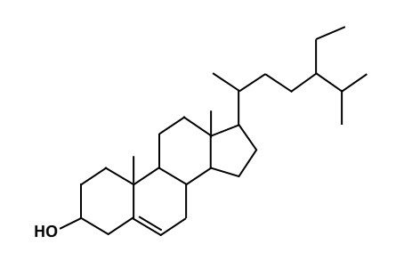
Fig. 1: Chemical structure of the compound β-sitosterol.

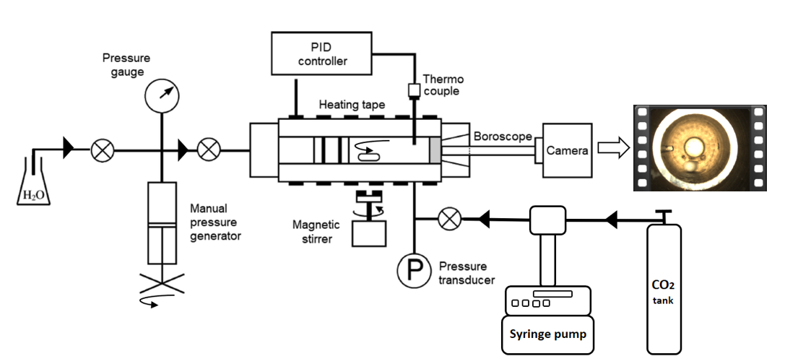
Fig. 2: Scheme of the high-pressure variable-volume view cell used in this work. Adapted from Pérez et al., 2023.

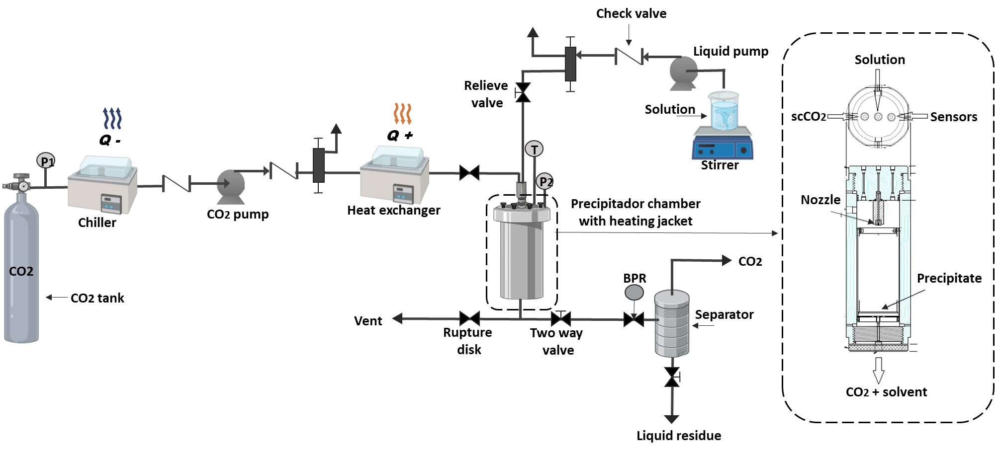
Fig. 3: Schematic diagram of the laboratory scale SAS apparatus used in this study. BPR, back pressure regulator; P1 and P2, manometers; T, thermocouple. Adapted from Zahran et al., 2014.
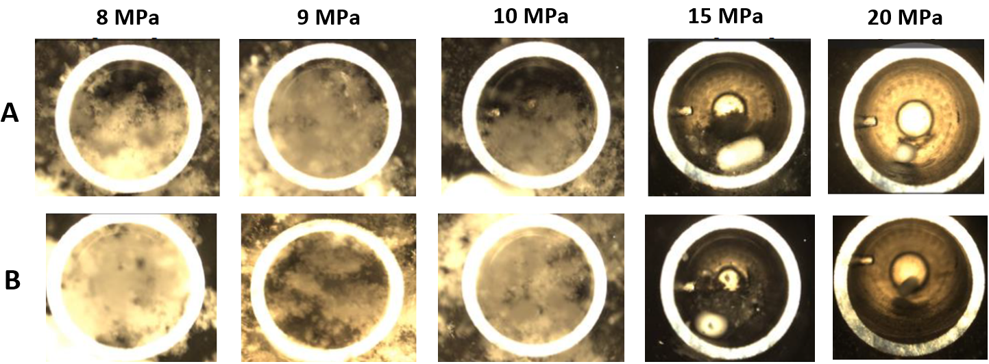
Fig. 4: Precipitation of β-sitosterol inside the view cell at different pressures. A) ethyl acetate; B) acetone.

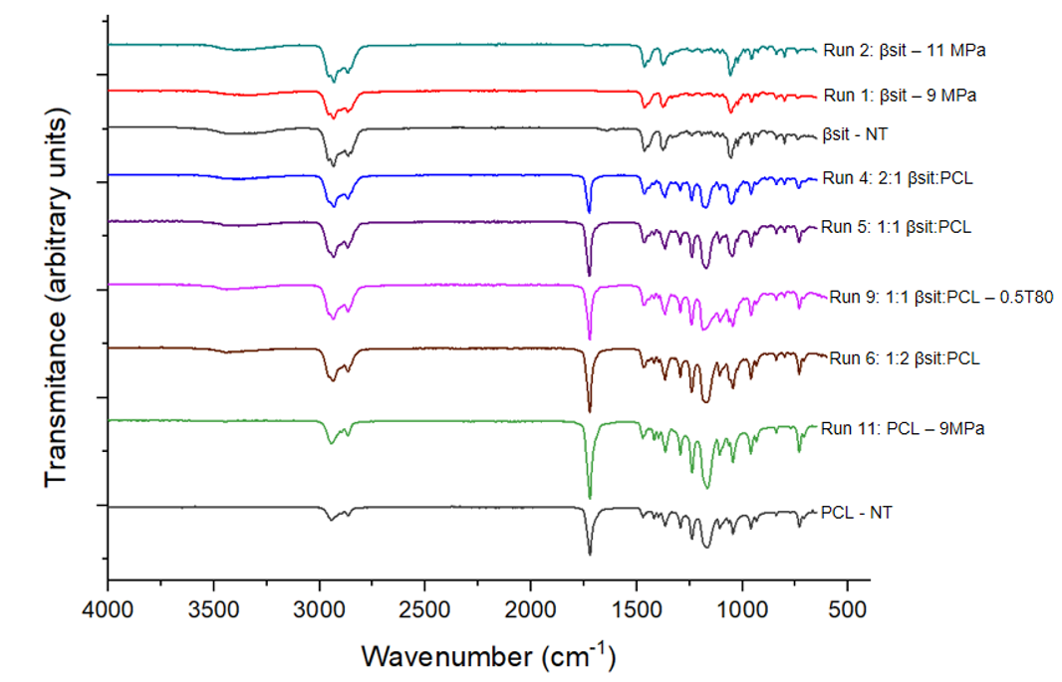
Fig. 5: Fourier Transform Infrared spectra of SAS samples precipitates at different process conditions. βsitosterol (βsit), polycaprolactone (PCL) and βsit:PCL mass ratios. NT: Not treated.

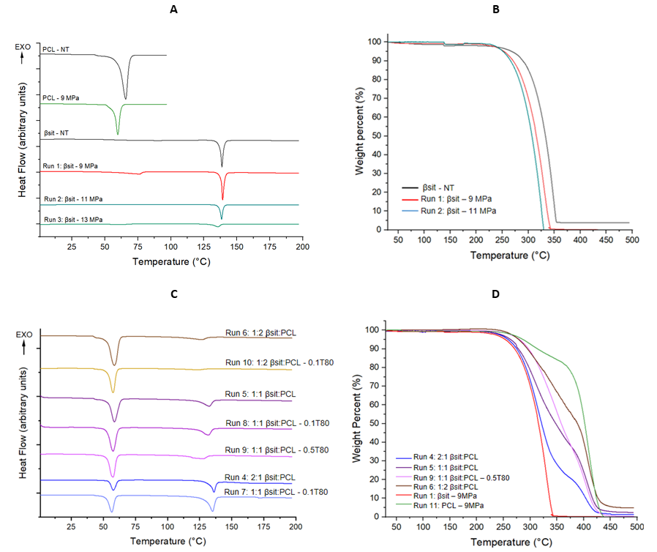
Fig. 6: DSC (left) and TGA (right) thermograms of SAS samples precipitated at different process conditions. (A-B) β-sitosterol (βsit) and polycaprolactone (PCL); (C-D) βsit:PCL mass ratio. NT: Not treated.

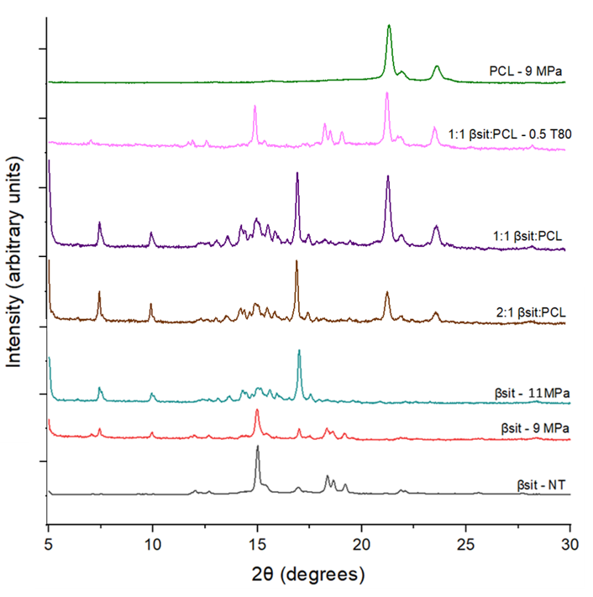
Fig. 7: XRD patterns of SAS precipitates at different process conditions. βsitosterol (βsit), Polycaprolactone (PCL) and βsit:PCL mass ratios. NT: Not treated.

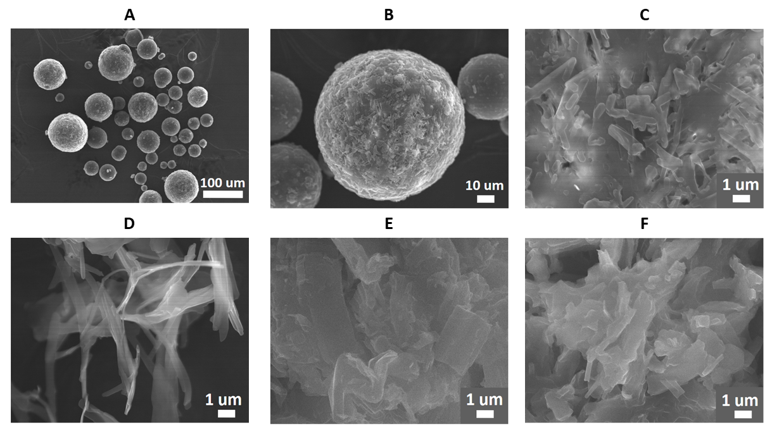
Fig. 8: Scanning electronic microscopy analysis of the SAS precipitates at different process conditions. (A-B-C) βsitosterol not treated (βsit-NT); (D) Run 1: βsit-9 MPa, (E) Run 2: βsit-11 MPa, (F) Run 3: βsit-13 MPa.

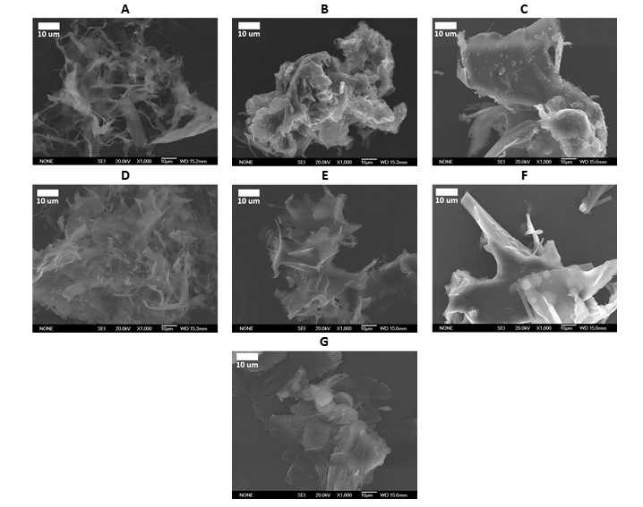
Fig. 9: Scanning electronic microscopy analysis of the SAS precipitates at different process conditions. (A) Run 4: 2:1 βsit:PCL; (B) Run 5: 1:1 βsit:PCL; (C) Run 6: 1:2 βsit:PCL; (D) Run 7: 2:1 βsit:PCL – 0.1T80; (E) Run 8: 1:1 βsit:PCL – 0.1T80; (F) Run 10: 1:2 βsit:PCL – 0.1T80; (G) Run 9: 1:1 βsit:PCL – 0.5T80.

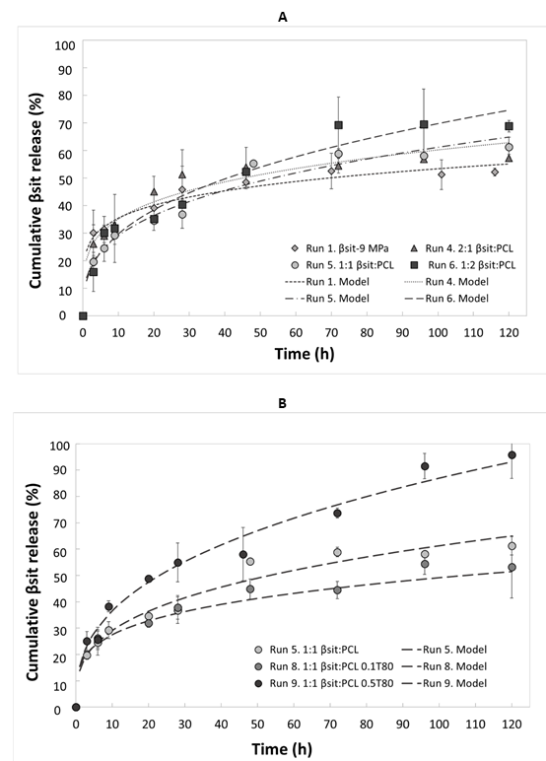
Fig. 10: In vitro release model curves of the SAS precipitates at different process. Release model corresponds to Ritger-Peppas kinetics. Powder-to-dissolution medium ratio: 0.5 mg/mL. Error bars represent standard deviations. βsit: β-sitosterol; PCL: Polycaprolactone; T80: Tween 80.
Table 1: Yield process, incorporation efficiency (IE) and loading capacity (LC) for the different runs of the SAS micronization of β-sitosterol (βsit) and its encapsulation in polycaprolactone (PCL) at different conditions.
Run | Sample | Yield Process  [%] | Incorporation Efficiency  [%] | Loading Capacity  [%]
1 | βsit - 9 MPa | 68.4 | - | -
2 | βsit - 11 MPa | 13.5 | - | -
3 | βsit – 13 MPa | 1.4 | - | -
4 | 2:1 βsit:PCL | 56.6 | 98.3 ± 1.1 ª | 65.5 ± 0.8 ª
5 | 1:1 βsit:PCL | 52.0 | 93.2 ± 0.8 ^{abc} | 46.6 ± 0.4 ^{b}
6 | 1:2 βsit:PCL | 47.6 | 92.3 ± 1.2 ^{bc} | 30.8 ± 0.4 ^{de}
7 | 2:1 βsit:PCL 0.1T80 | 69.5 | 99.8 ± 1.5 ^{ab} | 64.4 ± 1.0 ª
8* | 1:1 βsit:PCL 0.1T80 | 67.0 ± 4.0 | 92.7 ± 1.4 ^{abc} | 44.1 ± 1.7 ^{bc}
9 | 1:1 βsit:PCL 0.5T80 | 49.6 | 96.2 ± 3.0 ^{c} | 37.6 ± 1.2 ^{cd}
10 | 1:2 βsit:PCL 0.1T80 | 65.3 | 89.9 ± 5.1 ^{abc} | 29.0 ± 8.0 e
*Central point: n=3; Different letters above the columns indicate significant differences (p<0.05) by Tukey's test between the means of the samples (n=3).
Table 2: Thermal properties by DSC of βsitosterol (βsit), polycaprolactone (PCL) and its encapsulation obtained by SAS process at different conditions.
Run | Sample | β-sitosterol (βsit) |  |  | Polycaprolactone (PCL)
Run | Sample | T_{On-set} [°C] | T_{m} [°C] | ∆H_{m} [°C]  (Xc) | T_{On-set} [°C] | T_{m} [°C] | ∆H_{m} [°C]
- | βsit – NT | 137.1 ± 0.1 ^{b} | 138.5 ± 0.0 ^{b} | 68.7 ± 6.0 ^{b} (75)
1 | βsit - 9 MPa | 138.1 ± 0.0 ^{b} | 139.1 ± 0.1 ^{c} | 53.7 ± 0.7 ^{b} (59)
2 | βsit - 11 MPa | 138.0 ± 0.4 ^{b} | 139.05 ± 0.1 ^{c} | 54.5 ± 0.8 ^{b} (60)
3 | βsit – 13 MPa | 130.7 ± 0.8 ª | 135.5 ± 0.2 ª | 37.6 ± 6.7 ª (41)
4 | 2:1 βsit:PCL | 132.7 ± 0.8 ^{c} | 136.3 ± 0.3 ^{d} | 28.7 ± 0.7 ^{c} (47) | 53.6 ± 1.2 ^{ab} | 56.5 ± 1.9 ª | 27.8 ± 0.5 ª
5 | 1:1 βsit:PCL | 125.5 ± 3.1 ^{c} | 132.9 ± 0.3 ^{c} | 15.8 ± 0.7 ^{b} (35) | 54.6 ± 0.9 ^{b} | 58.1 ± 0.8 ª | 47.3 ± 1.7 ^{bc}
6 | 1:2 βsit:PCL | 107.5 ± 1.8 ^{ab} | 126.1 ± 0.8 ^{b} | 10.4 ± 0.1 ª (34) | 53.1 ± 0.1 ^{ab} | 58.1 ± 0.7 ^{ab} | 60.5 ± 1.6 ^{d}
7 | 2:1 βsit:PCL 0.1T80 | 131.3 ± 1.4 ^{c} | 135.2 ± 0.3 ^{d} | 32.8 ± 1.9 ^{c} (54) | 50.5 ± 2.6 ª | 56.5 ± 0.1 ª | 24.6 ± 3.7 ª
8 | 1:1 βsit:PCL 0.1T80 | 126.0 ± 2.3 ^{c} | 132.1 ± 0.2 ^{c} | 15.8 ± 2.6 ^{b} (35) | 52.4 ± 0.8 ^{ab} | 56.6 ± 1.4 ª | 39.2 ± 3.9 ^{b}
9 | 1:1 βsit:PCL 0.5T80 | 113.6 ± 3.8 ^{b} | 127.2 ± 0.6 ^{b} | 11.9 ± 0.6 ^{ab} (33) | 52.9 ± 0.2 ^{ab} | 57.1 ± 0.6 ª | 38.8 ± 3.8 ^{b}
10 | 1:2 βsit:PCL 0.1T80 | 103.8 ± 0.3 ª | 123.1 ± 1.0 ª | 7.1 ± 1.6 ª (23) | 53.6 ± 0.1 ^{ab} | 57.6 ± 0.1 ª | 52.3 ± 4.0 ^{cd}
Different letters above the columns indicate significant differences (p<0.05) by Tukey's test between the means of the samples (n=2). T_{m}: Melting point; T_{On-set}: Initial temperature of the melting point. ∆H_{m}: Fusion enthalpy. Xc: Crystallinity percentage (%). NT: Not treated.
Table 3: Thermal properties by TGA of βsitosterol (βsit), polycaprolactone (PCL) and its encapsulation obtained by SAS process at different conditions.
Run | Sample | T_{d}, 5% [°C] | T_{max1}  [°C] | Degradation percentage₁ [%] | T_{max2}  [°C] | Degradation  percentage₂ [%]
- | βsit – NT | 268.3 | 345.2 | 96.2
1 | βsit - 9 MPa | 253.5 | 330.8 | 100
2 | βsit - 11 MPa | 252.5 | 324.6 | 100
4 | 2:1 βsit:PCL | 258.7 | 316.7 | 45 | 408.3 | 98
5 | 1:1 βsit:PCL | 263.4 | 312.0 | 35 | 410.0 | 97
6 | 1:2 βsit:PCL | 278.6 | 310.0 | 25 | 412.5 | 95
8 | 1:1 βsit:PCL 0.1T80 | 273.7 | 318.4 | 64 | 410.5 | 100
9 | 1:1 βsit:PCL 0.5T80 | 279.9 | 353.3 | 65 | 412.5 | 100
11 | PCL - 9 MPa | 286.6 | 300.0 | 11 | 412.5 | 100
T_{d,} 5%: Decomposition temperature at 5% mass loss. T_{max}: Temperature at the maximum degradation rate (peak in the DTG curve). Degradation percentage: Mass loss (%) associated with each degradation step (calculated from the TGA curve).

Table 4: Fitted equations, correlation coefficients (R²) obtained from the application of four kinds of release kinetic models.
Run | Sample | Kinetic Release Models
Run | Sample | Zero Order |  |  | First Order |  |  | Higucci |  |  | Ritger-Peppas
Run | Sample | C_{t}/C_{o} = kt |  |  | C_{t}/C_{o} = 1- e^{-kt} |  |  | C_{t}/C_{o} = kt^{1/2} |  |  | C_{t}/C_{o} = kt^{n}
Run | Sample | k | n | R² | k | n | R² | k | n | R² | k | n | R²
- | βsit – NT | 0.004 | 0 | 0.753 | 0.012 | 1 | 0.609 | 0.052 | 0.5 | 0.891 | 0.071 | 0.479 | 0.933
1 | βsit - 9 MPa | 0.002 | 0 | 0.759 | 0.005 | 1 | 0.727 | 0.027 | 0.5 | 0.887 | 0.236 | 0.177 | 0.939
4 | 2:1 βsit:PCL | 0.002 | 0 | 0.686 | 0.006 | 1 | 0.631 | 0.035 | 0.5 | 0.84 | 0.206 | 0.233 | 0.935
5 | 1:1 βsit:PCL | 0.004 | 0 | 0.836 | 0.009 | 1 | 0.775 | 0.048 | 0.5 | 0.929 | 0.139 | 0.322 | 0.967
6 | 1:2 βsit:PCL | 0.004 | 0 | 0.870 | 0.010 | 1 | 0.746 | 0.058 | 0.5 | 0.942 | 0.127 | 0.370 | 0.940
8 | 1:1 βsit:PCL 0.1T80 | 0.002 | 0 | 0.890 | 0.006 | 1 | 0.845 | 0.032 | 0.5 | 0.948 | 0.154 | 0.252 | 0.961
9 | 1:1 βsit:PCL 0.5T80 | 0.006 | 0 | 0.948 | 0.011 | 1 | 0.839 | 0.077 | 0.5 | 0.979 | 0.154 | 0.376 | 0.970
k: kinetic release constant of different models (concentration^{-n}); n: release exponent (adim).

