Liquid−Liquid Equilibria for the System Acetone + Solketal + Glycerol at (303.2, 313.2, and 323.2) K
Jesus Esteban†, Andreas J. Vorholt‡, Arno Behr‡, Miguel Ladero†,*, and Felix Garcia-Ochoa†
†Department of Chemical Engineering, College of Chemical Sciences, Complutense University of Madrid, 28040, Madrid, Spain
‡Department of Bio- and Chemical Engineering, Technical University of Dortmund, 44227, Dortmund, Germany
Corresponding Author:
*E-mail: mladero@quim.ucm.es. Tel.: +34-913944164. Fax: +34-913944179.
ABSTRACT
Experimental measurements of the liquid−liquid equilibrium of the ternary system consisting of acetone + solketal + glycerol were made. The conditions selected for this study were (303.2, 313.2, and 323.2) K at 101.3 kPa, relevant for the synthesis of solketal from glycerol and acetone through a ketalization reaction. The data obtained were correlated to the nonrandom two liquid (NRTL) model, and the binary interaction parameters of the ternary system were retrieved after the optimization of the nonrandomness binary interaction parameters. The liquid−liquid equilibrium data predicted by the NRTL model agreed adequately with the experimental results.
Keywords: Liquid−liquid equilibrium; Acetone; Solketal; Glycerol; NRTL model; Ternary system; Ketalization reaction; Binary interaction parameters; Experimental thermodynamics

1. Introduction
Despite the fact that glycerol (Gly) has been widely utilized throughout history in countless applications, the development of the biodiesel industry in the early years of this century has given rise to an overabundance that has caused its price to decline¹. Subsequently, capitalization on its outstanding chemical properties has been made as a means to valorize it. The study of several syntheses using glycerol as a building block to yield value-added products has been undertaken.^{2,3}
Among them, the production of 1,2-isopropylideneglycerol (solketal, Sk) has received increasing attention in the past few years. This compound has been put to use as a plasticizer, a green solvent, and stabilizing agent in pharmaceutical and food preparations.⁴ Additionally, the oxygenate nature of Sk has led to its use as a fuel additive. Certain performance parameters were enhanced in biodiesel formulations, where solketal has been reported to improve viscosity, flash point, and oxidation stability.⁵ In gasoline, the inclusion of this ketal has upgraded the octane index and reduced gum formation.⁶ In addition, derivatives of solketal have been synthesized and studied as potential additives to fuels, such as ethers and methylesters.^{7,8} Additionally, the use of this compound as feedstock to further reactions has been explored, leading to chemicals of appreciated value in the pharmaceutical industry such as prostaglandins or certain β-blockers.^{9,10}
Cyclic ketals are obtained by the ketalization reaction between polyols and carbonylic compounds. In this case, solketal is synthesized via the ketalization of glycerol and acetone, as schemed in Figure 1. What appears to be the key of this type of reaction is the presence of an acidic medium that can initialize the mechanism. Therefore, several acidic homogeneous catalysts like p-toluenesulfonic, sulfuric, or hydrochloric acid have been utilized.^{5,8,11} Additionally, acid-functionalized solid catalysts have also been used to study this transformation, such as ion exchange resins,¹² heteropolyacids immobilized on silica,¹³ and sulfonic acidified silicas. Several articles report on very assorted conditions under which this reaction was completed, ranging from temperatures above the boiling point of acetone^{12,14} to milder temperatures close to or slightly above 20−25 °C at atmospheric pressure.^{11,13,15,16}
While some work has already been published regarding kinetic and thermodynamic aspects of the synthesis of solketal,¹⁷ no efforts have been made concerning the physical equilibrium between glycerol, acetone, and solketal. Thus, herein, we developed a study of the liquid−liquid equilibrium (LLE) existing in the ternary system featuring {Ac + Sk + Gly} at mild conditions that have proven of interest for the reaction to take place: atmospheric pressure and temperatures of (303.2, 313.2, and 323.2) K.
Additionally, once the LLE experimental data had been acquired, fitting to the nonrandom two-liquid model (NRTL) was successfully realized and the corresponding binary interaction parameters were retrieved
2. Experimental section
2.1. Materials
The following chemicals were employed during the experimental process: extra pure glycerol (assay grade 99.88%, purity checked by 1H NMR analysis = 99.88%) from Fischer Chemical; solketal (purity ≥98%, purity checked by GC analysis = 98.1%) from Aldrich; and acetone dry (purity ≥99.5%, purity checked by GC = 99.75%) from Acros Organics. Additionally, dibutyl ether (99 + % extra pure, purity checked by GC = 99.1%) supplied by Acros was used as an internal standard for GC analysis and isopropyl alcohol (99.9% pure, purity checked by GC = 99.9%), also by Acros, for sample dilution.
2.2. Liquid−Liquid Equilibria Measurements
The experimental apparatus put to use throughout the experimentation comprises sealed round-bottom flasks of 50 mL of volume into which the appropriate amounts of the chemicals were added for each individual experiment. The adequate weight of the chemicals to be added was made with a Kern and Sohn ABS-220-4 precision balance with an accuracy of 0.0001 g. Mixing of the content of the flasks was achieved by magnetic stirring and heating with a temperature-controlled glycerol bath. A temperature-controlled IKA Yellow Line TC3 device was used for the mentioned heating and stirring purposes.
The procedure consists of putting the feeds of each individual experiment to stir for 4 h to ensure a good mass transfer between the liquid phases until reaching phase equilibrium conditions. At that point, stirring was stopped and no less than 3 h were allowed for settling of the phases. Separation by decantation given the difference of density of the Gly-rich (I) and Ac-rich (II) phases was easily achievable and no turbidity was observed within any of the phases. Afterward, cautious sample withdrawal through the septa with syringes with fine hypodermic needles was performed. Samples from the Ac-rich phase were taken from the top of the upper phase. As for the heavy phase (Gly-rich), special care to avoid mixing between phases was taken because the needle had to poke through the interphase between the liquid phases. The Gly-rich sample was taken from the very bottom of the flask to prevent proximity with the interphase. Samples withdrawn from each phase were of at least 0.3 mL to ensure that 0.1500 g would be available to prepare the sample for analysis. Temperature was kept constant during the sample withdrawal process. Experimental data from triplicate experiments were procured.
2.3. Analytical Methods
Samples were diluted in isopropyl alcohol using dibutyl ether as internal standard prior to gas chromatography (GC) analysis. The components of the samples from the two phases were analyzed in an Agilent HP6890 Series GC system equipped with a thermal conductivity detector (TCD). Separation of the components was achieved using a HP-INNOWax capillary column (30 m × 0.25 mm i.d. × 0.25 μm) operating at a constant flow of 1.3 mL/min of helium as the carrier gas. The temperatures of the injector and detector were both 250 °C and the split ratio used was 80:1. The programmed temperature ramp for the oven was as follows: an initial hold of 6 min at 40 °C, then a ramp from 40 to 250 °C at 25 °C·min−1, and finally a 8 min hold at 250 °C.

2.4. Data Regression and Correlation with the NRTL Model
Fitting of the experimental data was made using the NRTL model. The tool used to obtain the binary interaction parameters was the data regression module implemented in Aspen Plus, which used a least-squares method based upon the maximum likelihood principle. To retrieve the parameters, the Britt-Luecke ¹⁸ algorithm was used along with the Deming initialization method while setting the regression convergence tolerance at 0.0001. The objective function that the regression procedure minimizes is
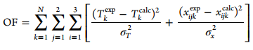 | (1)
where T_{exp} and T_{calc} denote the experimental and calculated values of temperature, respectively; x_{exp} and x_{calc} denote the experimental and calculated values of mole fraction; the subscripts i, j, and k refer to the component, phase, and tie-line, respectively, and N is the number of experimental tie-lines obtained. Finally, σ_{T} and σ_{x} are the standard deviations of temperature and the molar fraction, whose values were fixed from the accuracy of the temperature control system (σ_{T} = 0.05 K) and the uncertainty of the GC-TCD analysis (σ_{x} = 0.019).
Fitting to the NRTL was first completed fixing various sets of values of the nonrandomness binary interaction parameters α_{ij}. Comparison of the goodness of fit with the results obtained from optimizing the α_{ij} was also made, and then a certain set of the parameters was fixed for the rest of the regressions. The goodness-of-fit of the parameters was decided on the basis of the minimization of the root-mean-square deviation (rmsd), defined as follows:
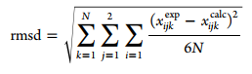 | (2)
3. Results and discussion
3.1. LLE Experimental Data
First, a preliminary experiment was undertaken to ensure that the reaction between Ac and Gly did not take place in the absence of catalyst. For this purpose, an equimolar mixture of Ac and Gly was kept under stirring conditions at 40 °C for 72 h. After that period, two liquid phases were still present and the analysis of both proved that no Sk was present at all. This absence of product agrees with the fact that an acid catalyst is needed to initiate the ketalization mechanism. Hence, it was confirmed that the following results correspond only to the LLE of the ternary system presented
Table 1 compiles the experimental LLE data expressed as molar fractions obtained for the system {Ac + Sk + Gly} at (303.2, 313.2, and 323.2) K and 101.3 kPa. This system would correspond to the reactants of the reaction described in Figure 1 and the main product of the reaction, Sk, which helps the phases to dissolve in each other. Additionally, the global compositions of the feeds of each batch are included.
Despite this work focusing on the physical equilibrium between the liquid phases, the feeds were designed so as to acquire tie-lines that come from simulating the production of Sk in the progress of the chemical reaction. Particularly, each batch was loaded considering compositions that come from increasing assumed conversions of 3.3% from an initial equimolar amount of Ac and Gly to yield only Sk as a product. Figures 2, 3 and 4 represent the tie-lines according to the data shown in Table 1 at (303.2, 313.2, and 323.2) K, respectively. Together with the experimental data, the mentioned figures include the tie-lines and the binodal curve as predicted by the NRTL model.
Verification of the reliability of the experimental LLE results was made applying the Othmer−Tobias correlation, which is defined as follows:
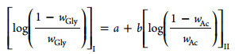 | (3)

in which w_{Gly} is the mass fraction of Gly in the Gly-rich phase (I); w_{Ac} accounts for the mass fraction of Ac in the Ac-rich phase (II); and a and b are the fitting parameters of this linear correlation. Figure 5 is a plot of the correlation in eq 3 at the three temperatures tested for equilibrium, while Table 2 summarizes the values of a and b along with R² values close to 1, proving the goodness of fit
3.2. Influence of the Presence of Solketal and Temperature in the Miscibility of the Biphasic System
It could be assessed that Sk was soluble both in the phase mainly consisting of Gly and that composed of Ac. The presence of increasing amounts of Sk helped the solubilization of one phase into the other, so it can be said that acts somehow as a cosolvent. Notwithstanding, the tendency of Sk to dissolve in each phase was not the same. As can be inferred from the data in Table 1 and Figure 6, Sk is more soluble in the Ac-rich phase (II) than in the Gly-rich phase (I).
Similar situations have been observed in other systems aimed at the valorization of glycerol, in which the initial reactants are not fully miscible in each other and the growing presence of the products leads the system to turn monophasic. Examples of such behavior would be the synthesis of glycerol carbonate from glycerol and dimethyl carbonate or the esterification of rosin and glycerol.²⁰⁻²²
The effect of temperature was also evaluated. The representation in Figure 6 shows that this variable has a very slight effect on the distribution of Sk: the lower is the temperature, the more Sk tends to remain in the Ac-rich phase. As temperature rises, the distribution tends to become a little more even between the two phases, though at 323.2 K it is still far from being equal. Additionally, from the ternary diagrams in Figures 2, 3 and 4, it can be remarked that the area below the binodal curve (i.e., the biphasic region) barely decreased as the temperature increased. Subsequently, temperature does not play a major role in the LLE of the system under study.
3.3. Data Fitting to the NRTL Model and Retrieval of Binary Interaction Parameters
The NRTL was used to correlate the experimental data for the ternary system. Fitting of the model with three components leads to three nonrandom binary interaction parameters, α_{ij} (α_{ij} = α_{ji}), and six binary interaction parameters, Δg_{ij} and Δg_{ji}.
Optimization of the αij was made by giving fixed data at 303.2 K. For this purpose, first the three nonrandom binary interaction parameters were fixed at 0.2 and 0.3. These values are the rule of thumb proposed in literature for nonpolar substances or nonpolar with polar nonassociated liquids and saturated hydrocarbons with polar nonassociated liquids and systems that exhibit liquid−liquid immiscibility.²³ Table 3 shows the goodness of fit, described by the root of the mean squares deviation or rmsd, both after fitting the data with the eight possible combinations, fixing the αij parameters, and leaving the mentioned parameters floating. When these parameters were floating, it was observed that the retrieved values were α₁₂ = 0.18, α₁₃ = 0.29, and α₂₃ = 0.19, which are very similar to the rule of thumb mentioned above. Moreover, the rmsd value was virtually the same as that obtained when fixing the values at α₁₂ = 0.2, α₁₃ = 0.3 and α₂₃ = 0.2. Thus, the latter set of values for these parameters was used for subsequent correlations.
Finally, Table 4 compiles the values calculated for the binary interaction parameters at the temperatures tested together with the rmsd values computed from the NRTL model. The low values of such deviations confirm that the NRTL model can describe the behavior observed for this LLE appropriately.
4. Conclusions
The LLE of ternary system formed by {Ac + Sk + Gly} was assessed at (303.2, 313.2, and 323.2) K given its importance in a process to valorize glycerol. It could be seen that Sk plays a role as a solubilizing agent for Ac and Gly, being a little more prone to dissolve in the Ac-rich phase rather than in the Gly-rich. Within the temperature range studied, the effect of temperature was limited concerning the distribution of Sk in each of the phases as well as the global solubilization of both phases.
The LLE experimental data obtained throughout this work fit satisfactorily to the NRTL model. After correlation of the data, sets of binary interaction parameters were retrieved at each temperature.
Acknowledgments
This work is a collaboration thanks to the financial support of the German Academic Exchange Service (DAAD), which made possible Mr. Esteban’s research stay at the Chair of Technical Chemistry at the Technical University of Dortmund.
References
(1) Pagliaro, M.; Rossi, M. The Future of Glycerol. New Uses for a Versatile New Material.; RSC Publishing: Cambridge, 2008.
(2) Behr, A.; Eilting, J.; Irawadi, K.; Leschinski, J.; Lindner, F. Improved utilisation of renewable resources: New important derivatives of glycerol. Green Chem. 2008, 10, 13−30.
(3) Zhou, C.; Beltramini, J.; Fan, Y.; Lu, G. Chemoselective catalytic conversion of glycerol as a biorenewable source to valuable commodity chemicals. Chem. Soc. Rev. 2008, 37, 527−549.
(4) Merck Index, 11th ed.; Merck & Co. Inc.: Rahway, NJ, 1989.
(5) Garcia, E.; Laca, M.; Perez, E.; Garrido, A.; Peinado, J. New Class of Acetal Derived from Glycerin as a Biodiesel Fuel Component. Energy Fuels 2008, 22, 4274−4280.
(6) Mota, C. J. A.; da Silva, C. X. A.; Rosenbach, N., Jr.; Costa, J.; da Silva, F. Glycerin derivatives as fuel additives: The addition of glycerol/acetone ketal (solketal) in gasolines. Energy Fuels 2010, 24, 2733−2736.
(7) Selva, M.; Benedet, V.; Fabris, M. Selective catalytic etherification of glycerol formal and solketal with dialkyl carbonates and K2CO3. Green Chem. 2012, 14, 188−200.
(8) Suriyaprapadilok, N.; Kitiyanan, B. Synthesis of solketal from glycerol and its reaction with benzyl alcohol. Energy Procedia 2011, 9, 63−69.
(9) Hof, R. P.; Kellogg, R. M. Synthesis and lipase-catalyzed resolution of 5-(hydroxymethyl)-1,3-dioxolan-4-ones: Masked glycerol analogs as potential building blocks for pharmaceuticals. J. Org. Chem. 1996, 61, 3423−3427.
(10) Jurczak, J.; Pikul, S.; Bauer, T. (R)-2,3-o-isopropylideneglycerol-dehyde and (S)-2,3-o-isopropylideneglycerol-dehyde in stereoselective organic synthesis. Tetrahedron 1986, 42, 447−488.
(11) Bruchmann, B.; Haeberle, K.; Gruner, H.; Hirn, M. Preparation of cyclic acetals or ketals, especially isopropylidene glycerin|comprising distilling off some of aldehyde or ketone during reaction with polyol. Patent EP842929-A, 1999.
(12) Clarkson, J. S.; Walker, A. J.; Wood, M. A. Continuous reactor technology for ketal formation: An improved synthesis of solketal. Org. Process Res. Dev. 2001, 5, 630−635.
(13) Ferreira, P.; Fonseca, I. M.; Ramos, A. M.; Vital, J.; Castanheiro, J. E. Valorisation of glycerol by condensation with acetone over silica-included heteropolyacids. Appl. Catal., B 2010, 98, 94−99.
(14) Vicente, G.; Melero, J. A.; Morales, G.; Paniagua, M.; Martin, E. Acetalisation of bio-glycerol with acetone to produce solketal over sulfonic mesostructured silicas. Green Chem. 2010, 12, 899−907.
(15) Reddy, P. S.; Sudarsanam, P.; Mallesham, B.; Raju, G.; Reddy, B. M. Acetalisation of glycerol with acetone over zirconia and promoted zirconia catalysts under mild reaction conditions. J. Ind. Eng. Chem. 2011, 17, 377−381.
(16) Matsushita, H.; Shibagaki, M.; Takahashi, K.; Kuno, H. Acetal or ketal preparation from aldehyde or ketone using as catalyst a hydrous oxide of an element of gp = IV of the periodic table. Patent EP271091-A1, 1989.
(17) Nanda, M. R.; Yuan, Z.; Qin, W.; Ghaziaskar, H. S.; Poirier, M.-A.; Xu, C. C. Thermodynamic and kinetic studies of a catalytic process to convert glycerol into solketal as an oxygenated fuel additive. Fuel 2014, 117, 470−477.
(18) Britt, H. I.; Luecke, R. H. The estimation of parameters in nonlinear, implicit models. Technometrics 1973, 15, 233−247.
(19) Othmer, D. F.; Tobias, P. E. Toluene and acetaldehyde systems, tie line correlation, partial pressures of ternary liquid systems and the prediction of tie lines. Ind. Eng. Chem. 1942, 34, 693−696.
(20) Esteban, J.; Ladero, M.; Molinero, L.; Garcia-Ochoa, F. Liquid−liquid equilibria for the ternary systems DMC−methanol−glycerol; DMC−glycerol carbonate−glycerol and the quaternary system DMC−methanol−glycerol carbonate−glycerol at catalytic reacting temperatures. Chem. Eng. Res. Des. 2014, DOI: 10.1016/j.cherd.2014.05.026.
(21) Wang, H.; Lu, P. Liquid−liquid equilibria for the system dimethyl carbonate + methanol + glycerol in the temperature range of (303.15 to 333.15) K. J. Chem. Eng. Data 2012, 57, 582−589.
(22) Ladero, M.; de Gracia, M.; Trujillo, F.; Garcia-Ochoa, F. Phenomenological kinetic modelling of the esterification of rosin and polyols. Chem. Eng. J. 2012, 197, 387−397.
(23) Renon, H.; Prausnitz, J. M. Local compositions in thermodynamic excess functions for liquid mixtures. AIChE J. 1968, 14, 135−144

Table 1 Experimental LLE Data Expressed as Mole Fractions (x_{i}) of the Ternary System {Ac + Sk + Gly} at 101.3 kPa

T/K | phase II (Ac-rich) composition |  |  | phase I (Gly-rich) composition |  |  | global composition (feed)
 | x_{Ac} | x_{Sk} | x_{Gly} | x_{Ac} | x_{Sk} | x_{Gly} | x_{Ac} | x_{Sk} | x_{Gly}
303.2 | 0.499 | 0.000 | 0.501 | 0.121 | 0.000 | 0.879 | 0.943 | 0.00 | 0.057
 | 0.493 | 0.016 | 0.491 | 0.125 | 0.008 | 0.867 | 0.908 | 0.035 | 0.057
 | 0.482 | 0.036 | 0.482 | 0.136 | 0.023 | 0.841 | 0.863 | 0.062 | 0.075
 | 0.474 | 0.052 | 0.474 | 0.146 | 0.029 | 0.825 | 0.815 | 0.081 | 0.104
 | 0.464 | 0.071 | 0.465 | 0.159 | 0.044 | 0.796 | 0.767 | 0.110 | 0.123
 | 0.455 | 0.091 | 0.454 | 0.174 | 0.057 | 0.769 | 0.698 | 0.132 | 0.170
 | 0.444 | 0.113 | 0.443 | 0.198 | 0.075 | 0.727 | 0.633 | 0.149 | 0.218
 | 0.432 | 0.135 | 0.433 | 0.251 | 0.102 | 0.647 | 0.551 | 0.162 | 0.288
313.2 | 0.501 | 0.000 | 0.499 | 0.123 | 0.000 | 0.877 | 0.939 | 0.000 | 0.061
 | 0.492 | 0.017 | 0.491 | 0.139 | 0.013 | 0.848 | 0.901 | 0.034 | 0.066
 | 0.481 | 0.034 | 0.485 | 0.151 | 0.025 | 0.824 | 0.860 | 0.054 | 0.086
 | 0.475 | 0.053 | 0.472 | 0.169 | 0.031 | 0.801 | 0.801 | 0.084 | 0115
 | 0.463 | 0.072 | 0.465 | 0.182 | 0.045 | 0.773 | 0.747 | 0.107 | 0.147
 | 0.455 | 0.092 | 0.453 | 0.198 | 0.062 | 0.740 | 0.664 | 0.134 | 0.202
 | 0.445 | 0.111 | 0.444 | 0.250 | 0.084 | 0.666 | 0.601 | 0.143 | 0.255
 | 0.432 | 0.132 | 0.436 | 0.296 | 0.104 | 0.600 | 0.517 | 0.152 | 0.331
323.2 | 0.499 | 0.000 | 0.501 | 0.145 | 0.000 | 0.856 | 0.938 | 0.000 | 0.062
 | 0.490 | 0.017 | 0.493 | 0.148 | 0.014 | 0.838 | 0.880 | 0.039 | 0.081
 | 0.480 | 0.036 | 0.484 | 0.160 | 0.023 | 0.817 | 0.842 | 0.053 | 0.105
 | 0.471 | 0.055 | 0.474 | 0.180 | 0.035 | 0.786 | 0.777 | 0.084 | 0.139
 | 0.465 | 0.070 | 0.465 | 0.202 | 0.053 | 0.745 | 0.727 | 0.101 | 0.172
 | 0.455 | 0.091 | 0.454 | 0.215 | 0.074 | 0.711 | 0.647 | 0.132 | 0.222
 | 0.443 | 0.113 | 0.444 | 0.247 | 0.098 | 0.655 | 0.589 | 0.146 | 0.264
 | 0.428 | 0.140 | 0.431 | 0.288 | 0.120 | 0.592 | 0.510 | 0.159 | 0.331

Standard uncertainties: u(T) = 0.1 K and u(x) = 0.019.

Table 2. Parameters of the Othmer−Tobias Correlation (a and b) and Correlation Coefficients (R²) for the System {Ac + Sk + Gly}

T/K | a | b | R²
303.2 | -0.5376 | 0.5587 | 0.9858
313.2 | -0.6237 | 0.4639 | 0.9941
323.2 | -0.6835 | 0.4250 | 0.9901

Table 3. Optimization of the Nonrandom Binary Interaction Parameters α_ij at 303.2 K
α_{ij} regression | α₁₂ | α₁₃ | α₂₃ | rmsd
fixed | 0.30 | 0.20 | 0.20 | 0.0078
fixed | 0.30 | 0.30 | 0.20 | 0.0068
fixed | 0.20 | 0.30 | 0.20 | 0.0050
fixed | 0.30 | 0.20 | 0.30 | 0.0057
fixed | 0.30 | 0.30 | 0.30 | 0.0069
fixed | 0.20 | 0.20 | 0.20 | 0.0075
fixed | 0.30 | 0.20 | 0.30 | 0.0056
floating | 0.18 | 0.29 | 0.19 | 0.0048

Table 4. Values of the NRTL Binary Interaction Parameters Obtained from the LLE Data by Regression for the System {Ac + Sk + Gly}

T/K | Components i−j | α_{ij} | Δg_{ij} (J·mol⁻¹) | Δg_{ji} (J·mol⁻¹) | rmsd
303.2 | 1−2 | 0.2 | −9652.28 | 3933.58 | 0.0050
 | 1−3 | 0.3 | −5578.47 | 11131.17
 | 2−3 | 0.2 | −13864.14 | 1017.30
313.2 | 1−2 | 0.2 | 9025.11 | −6041.48 | 0.0047
 | 1−3 | 0.3 | 5668.88 | 11050.19
 | 2−3 | 0.2 | 244.37 | 4748.62
323.2 | 1−2 | 0.2 | −2842.21 | −2318.73 | 0.0029
 | 1−3 | 0.3 | 5512.20 | 10901.35
 | 2−3 | 0.2 | −4.82 | 1207.11

Figure 1. Scheme of the ketalization reaction of glycerol and acetone.
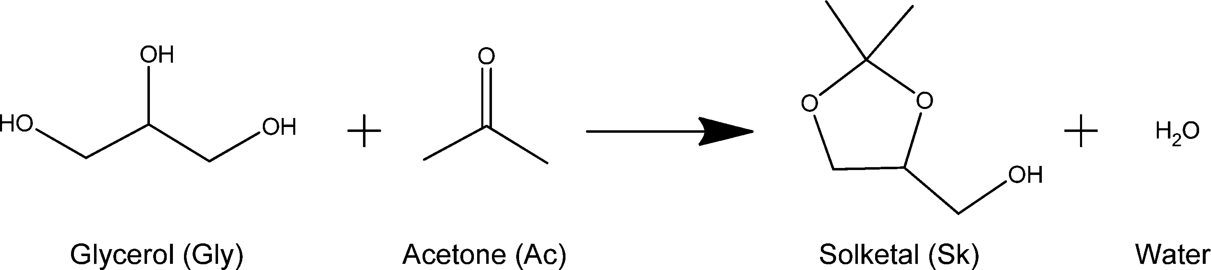

Figure 2. Experimental LLE data and binodal curve using the NRTL model for the system {Ac + Sk + Gly} at 303.2 K and 101.3 kPa: ■, experimental tie-lines; ---, data calculated with the NRTL model.
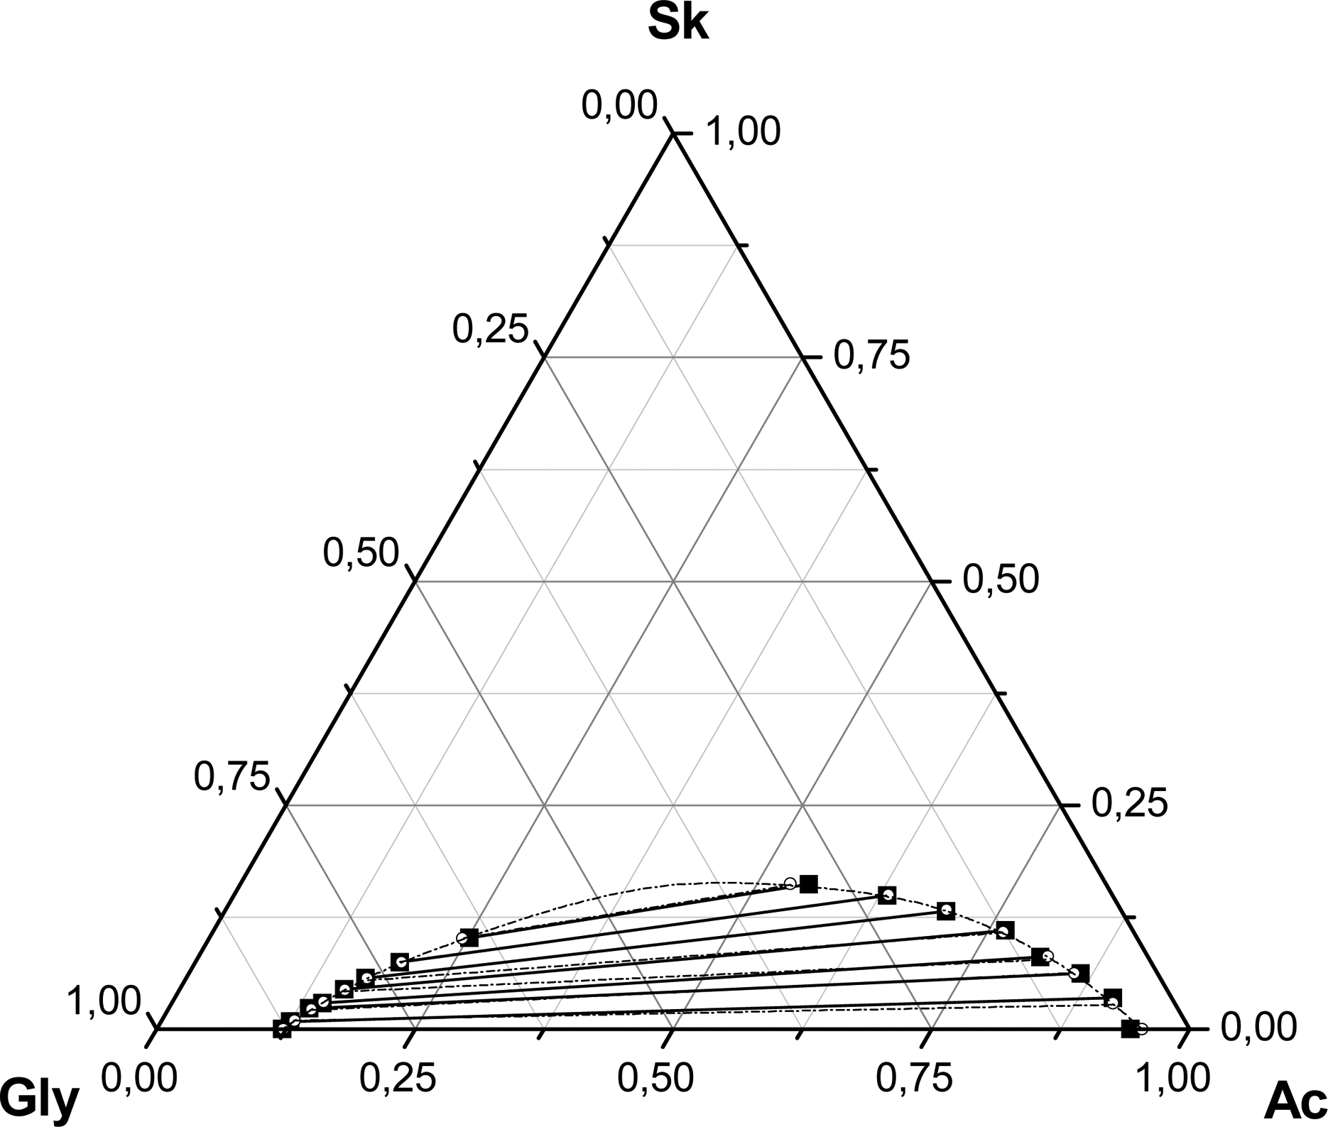

Figure 3. Experimental LLE data and binodal curve using the NRTL model for the system {Ac + Sk + Gly} at 313.2 K and 101.3 kPa: ■, experimental tie-lines; ---, data calculated with the NRTL model.
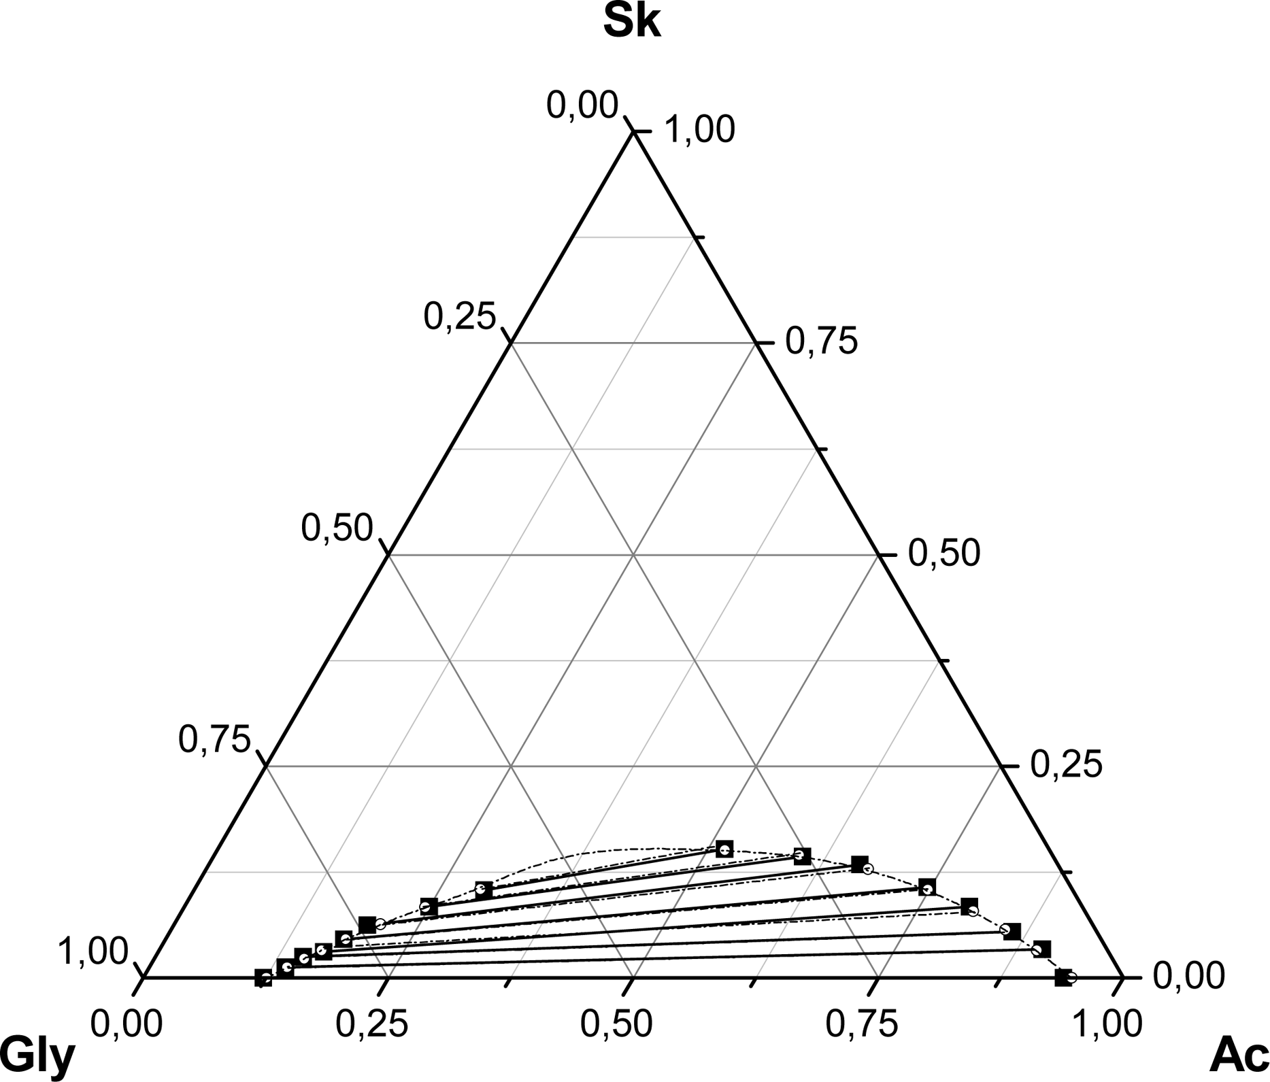

Figure 4. Experimental LLE data and binodal curve using the NRTL model for the system {Ac + Sk + Gly} at 323.2 K and 101.3 kPa: ■, experimental tie-lines; ---, data calculated with the NRTL model.
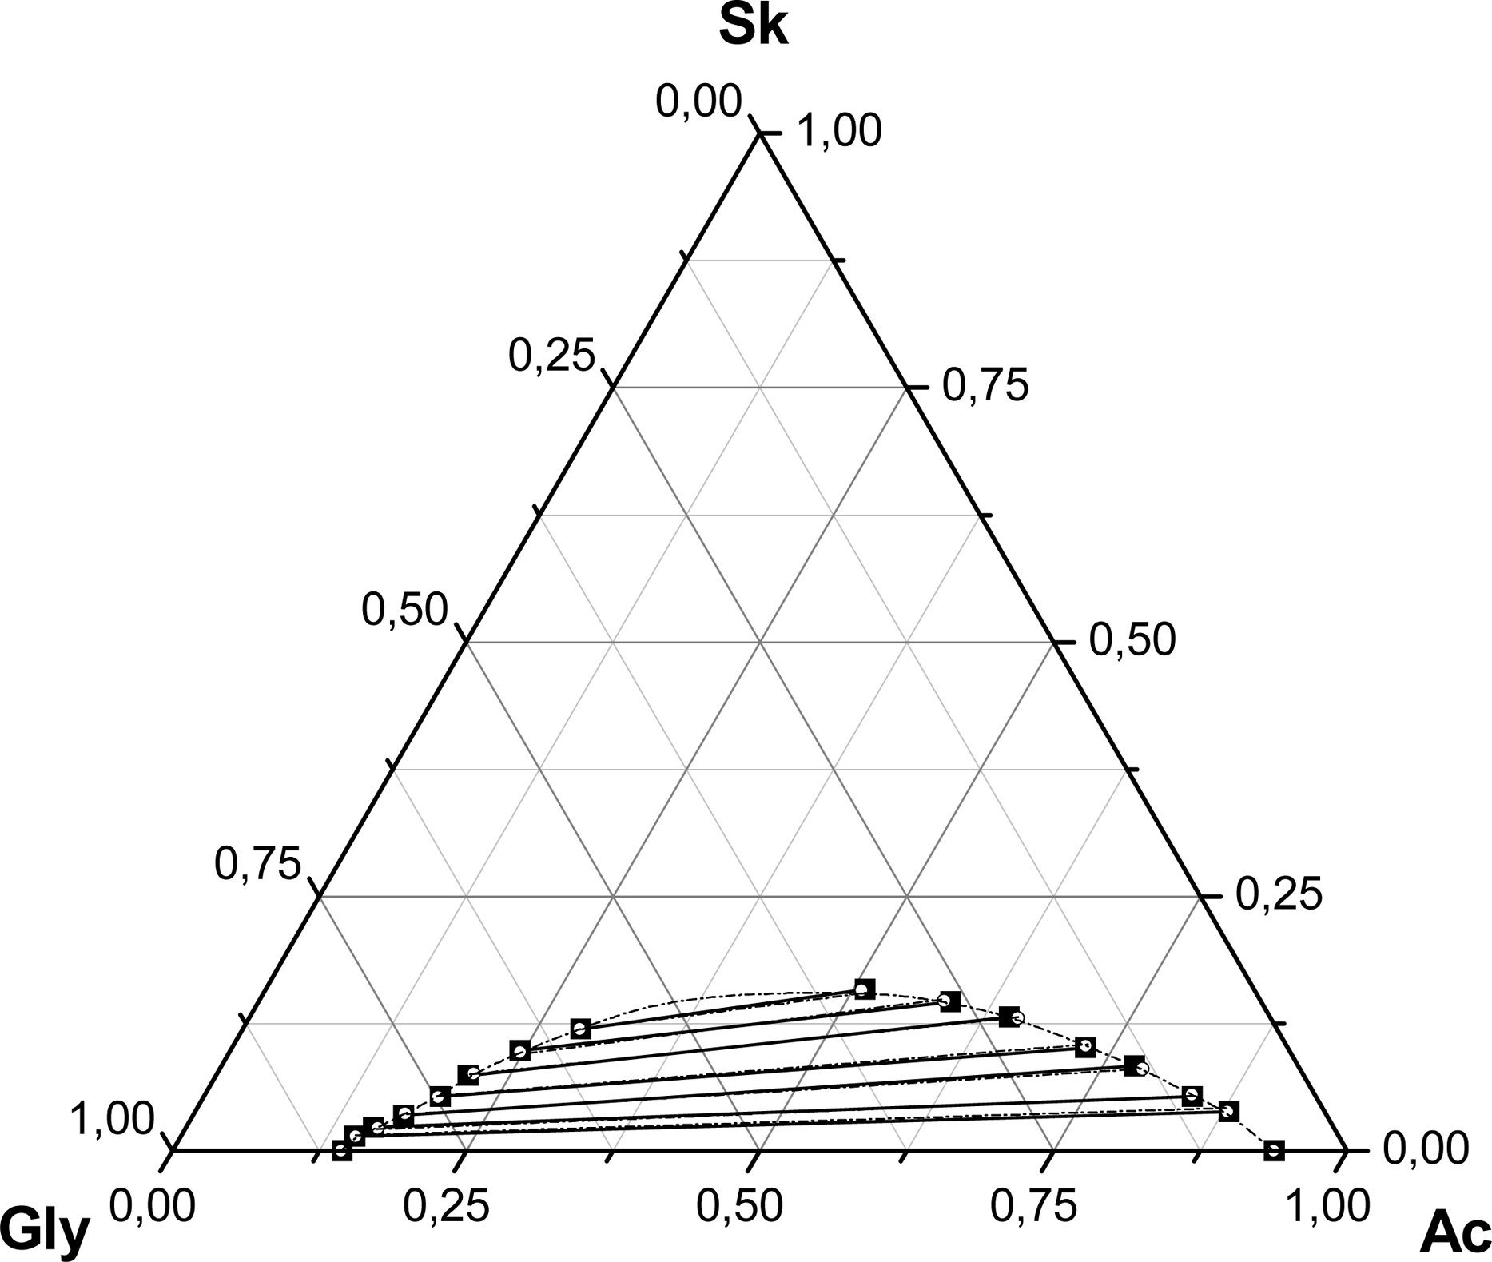

Figure 5. Othmer−Tobias graphs for the system {Ac + Sk + Gly} at the temperatures tested.
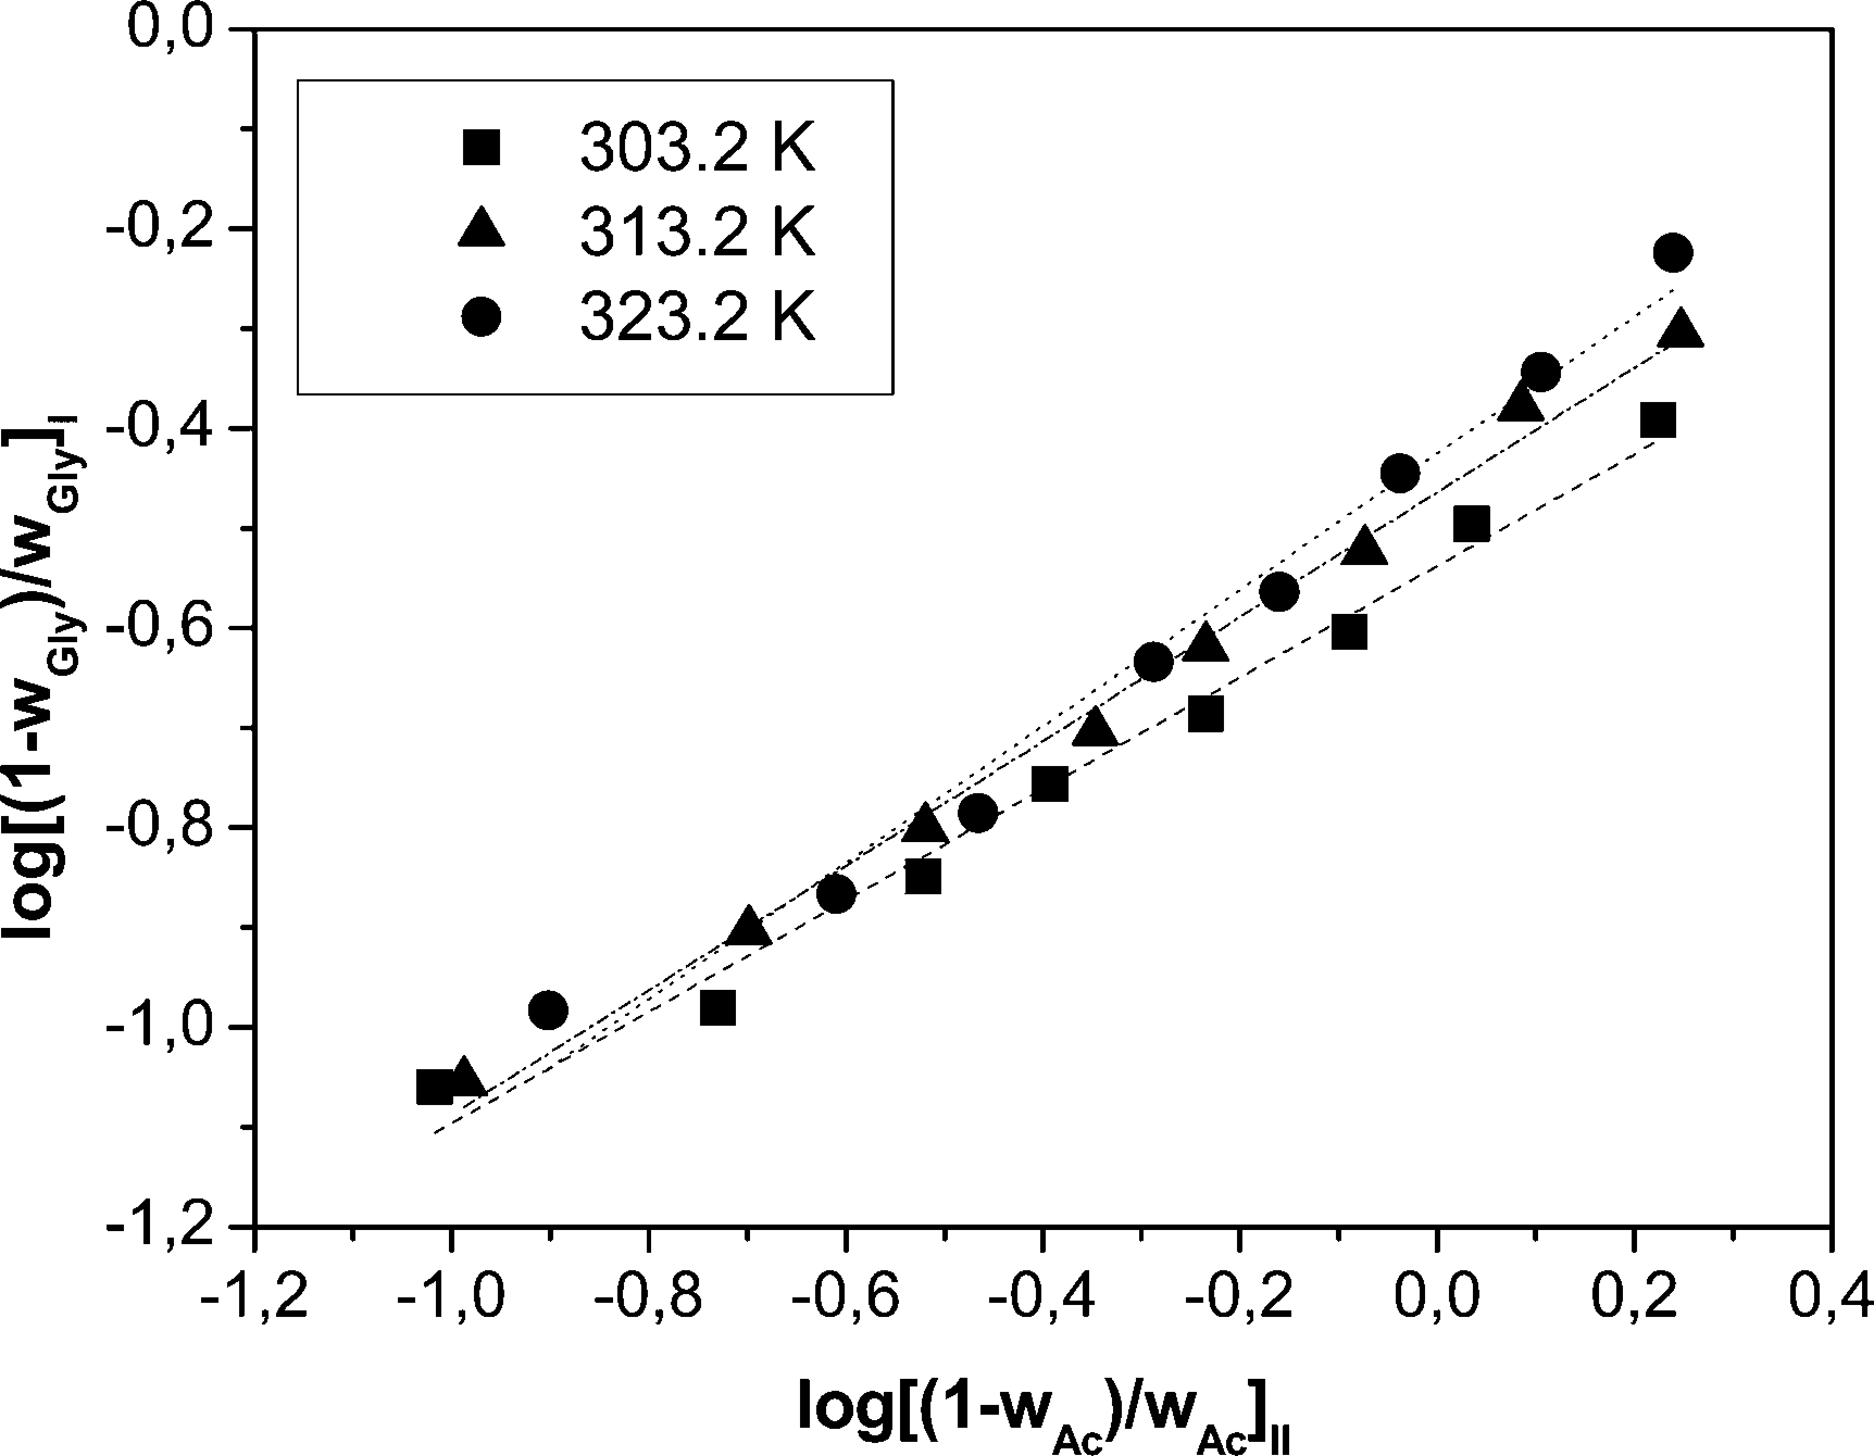

Figure 6. Effect of temperature on the distribution of Sk in the Ac and Gly-rich phases. Symbols represent experimental data, and broken lines represent the prediction of the NRTL model.
